Assignment Topic Translation process of protein synthesis.

Gene in action
A gene can be defined as sequence of bases in DNA that codon for the synthesis of one polypeptide,and gene must somehow transfer their information bfrom the nucleus to cytoplasm where protein synthesis occur.
The protein synthesis process is called central dogma.

Central Dogma
Central dogma having two parts
- Transcription
- Translation
Transcription
Is the synthesis of RNA from DNA template where the DNA is converted into a complementary RNA code.
Transcription involve three steps
Initiation process
Elongation process
Termination process
Initiation process
Initiation is beginning of transcriptionprocess.It occur when the enzyme RNA polymerase bind to the region of gene called promoter.This signal the DNA to unwind so the enzyme can read the bases sequence in one of the DNA strand.The enzyme is ready to make a strand of messenger RNA with a complimentary sequence of bases.The promoter is not a the part of messenger RNA.
Elongation process
Elongation process is the addition of nucleotides in to the messenger RNA strand.
Termination process
Termination process is end of transcription process .As the RNA polymerase transcribed Terminator to detach from the DNA.The formation of messenger RNA is complete after this step.

Translation
It is the synthesis of protein from the messenger RNA template where the code in the messenger RNA is converted into the amino acid sequence of protein.It is also known as the polypeptide synthesis or protein synthesis.
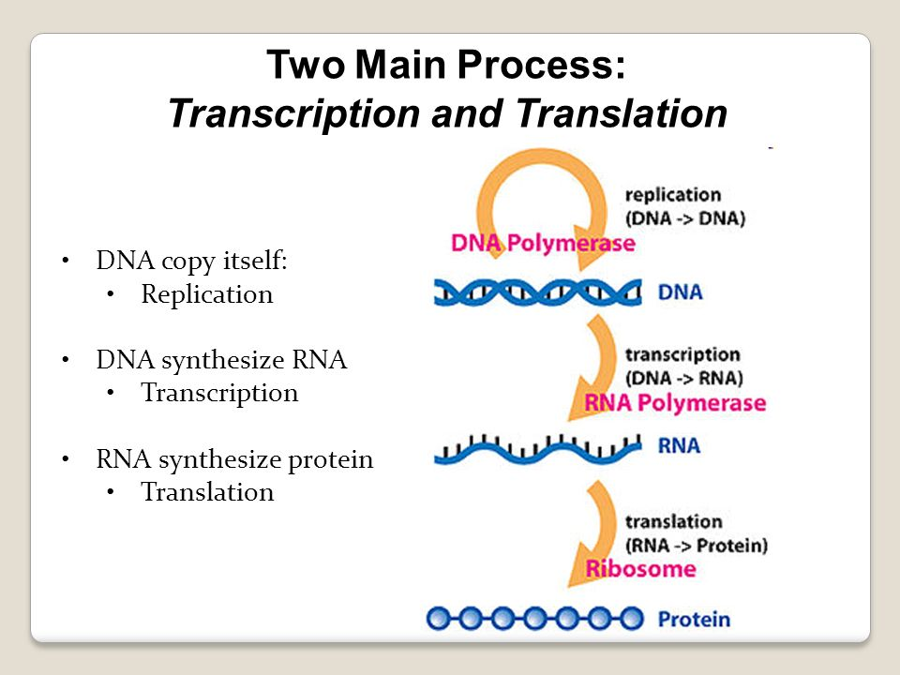
It is uni directional process.

kinds of RNA
Each of the major kind of RNA has a specific role in protein synthesis and it is produced in the nucleus from the DNA.
There are three kinds of RNA which play there function in protein synthesis.
- Messenger RNA
- Transfer RNA
- Ribosomal RNA
Messenger RNA
Messenger RNA is a linear strand that carries a set of genetic instructions for the synthesizing protein to the cytoplasm.
Transfer RNA
Transfer RNA pick Amino acids to the cytoplasm and carries them to ribosomes and help the amino acids to position them for incorporation into a polypeptide chain.
Ribosomal RNA
Ribosomal RNA along with protein make up ribosomes.
Genetic code
DNA must code for the twenty different amino acids in all organisms.The information carrying capabilities of DNA reside in the sequence of nitrogenous bases a triplet cod which reflected in the messenger RNA that will be produced from DNA.Each three combination of bases is called a codon.more then one codon can specify the amino acid because there are sixty four possible codon which are made up of only twenty types of Amino acids.The base sequence UAA UAG and UGA are all the stop signals that indicates where the polypeptide chain synthesis should end.The base sequence AUG codon for the amino acid methionine which is a start signal.

Occurrence
Translation happen on the ribosomes floating in the cytosol or on the ribosomes attached to the tough endoplasmic reticulam.
The ribosomes read the sequence of codon at messenger RNA and molecules of transfer RNA bring amino acid to the ribosomes in the correct sequence.

Raw materials
Raw materials for the protein synthesis are
- amino acids
- messenger RNA
- transfer RNA
- and amino acyl tRNA synthesase.

Tools of translation
Amino acids twenty type of Amino acids are the building blocks of protein synthesis.
Messenger RNA it Carries the coded information from the DNA for the synthesis of one or more polypeptide chain.Its codons are recognized by the transfer RNA.
Transfer RNAs they pick up the specific amino acids from the Amino acids pool and Carrying over the messenger RNA strand.
Amino aycle transfer RNA synthetase
This enzyme is specific for particular amino acids and their transfer RNAs.
Ribosomes are the place where protein synthesised.ribosomes are called protein factory of the cell.

Structure of Ribosomes
Ribosomes having two sub units
Samaller sub unit
Larger sub unit
Having three sites
A called Amino acyle side
P called peptidal site
E called exit site

The A and P are the cavities on the ribosomes where charged transfer RNA molecules bind during the polypeptide synthesis.

E site is the exit site where discharged transfer RNA molecules leaves the Ribosomes.The messenger RNA bind the sequence of Amino acids near the 5 prime end.The binding site present near the interface between the large and small subunit of ribosomes.

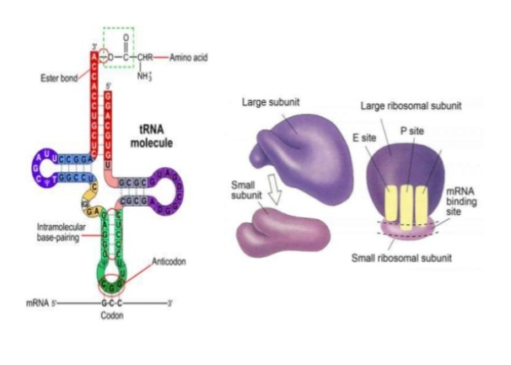

Structure of transfer RNA
To understand the role of transfer RNA we need to know about the structure of transfer RNA.
Each transfer RNA has an anti anticodon (sequence of three unpaired bases)for the amino acid which the transfer RNA carries.An anticodon is complementary to the codon for an Amino acid.
For Example
The amino acid lysine has the codon of AAG so the anticodon is UUC. Therefore lysine would be carried by a transfer RNA molecule with the anticodon UUG.wherever the codon AAG appear in the masseger RNA a UUG anticodon of transfer RNA temporarily bind.while binding to tha masseger RNA, transfer RNA gives up it’s Amino acids with the help of ribosomal RNA and bond form between the amino acids as they brought one by one to the ribosomes for the creation of one or more polypeptide chain.

Steps of translation

- Protein synthesis can be divided into three phases or steps
- Initiation
- Elongation
- Termination

In addition to the messenger RNA template and ribosomes many other molecules contribute to the process of translation such as transfer RNA and various enzymes.
Before start the initiation process firstly we clear concepts about the working of transfer RNA.

Charging of transfer RNA

Step one
The amino acid and a molecule of ATP(Adenosine tri phosphate) inter in the active site of the enzyme.The ATP ( Adenosine tri phasphate) release the pyrophosphate and resulting the AMP ( Adenosine mono phasphate) form bond covelantly to the amino acids.The pyrophosphate will hydrolyzed into two phasphate group.
Step two

Then the transfer RNA covelantly bond to the amino acid to displace the AMP ( Adenosine mono phasphate) and the amino acyl transfer RNA is then release from the enzyme.

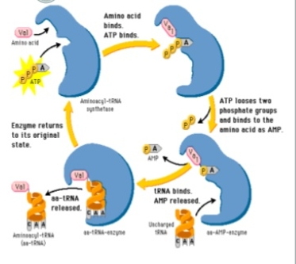
Now the initiation process will start.

Initiation process
Ribosomes the sites of protein synthesis consist of a large and small subunits that organize the pairing between the codon and anticodon.several sites on the ribosomes are the binding site for the messenger RNA and transfer RNA.
At the initiation process of translation messenger RNA bind to the small separate ribosomal subunit.Attachment of the messenger RNA requires the initiation codon methionine( having sequence AUG) of messenger RNA be aligned with the P (peptidal) site of the ribosomes. Amino acyle transfer RNA with a complimentary anticodon for the methionine will bind to the messenger RNA,and a large subunit of ribosome joins forming a complete ribosome.

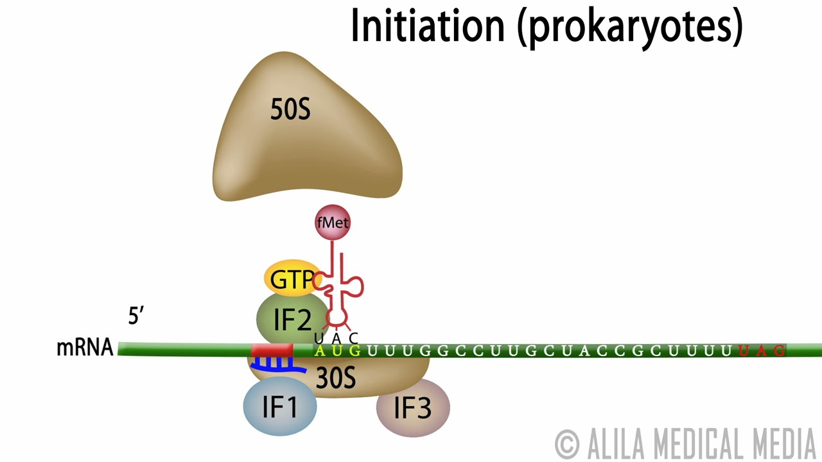

Elongation process

Polypeptide formation can now begin.Another site the A (Amino acyle) is next to the peptidal site .A second transfer RNA whose anticodon is complementary to the codon in the amino acyl site is positioned.Two transfer RNA molecules with their attached amino acids are now side by side. This step require enzyme aid and energy in the form of

ATP (Adenosine tri phasphate).An enzyme peptidyle transferase which is actually a part of larger ribosomal subunit.This enzyme breaks the bond between the amino acid and transfer RNA in the peptidal site and catalyze the formation of peptide bond between these two amino acids in the Amino acyle site.Now the messenger RNA along with the next transfer RNA and it’s attached dipeptide,moves the distance of one codon.The first Transfer RNA is discharged from Exit site leaving it’s Amino acid behind.The next transfer RNA is now on the peptidal site.Amino acyle is ready and expsed to receive the another transfer RNA Amino acid and new peptide bond is formed.This process will continue and one or more polypeptide chain synthesis.This process will continue untill the coded information on messenger RNA complete.This process will stop when stop signal is encounter.

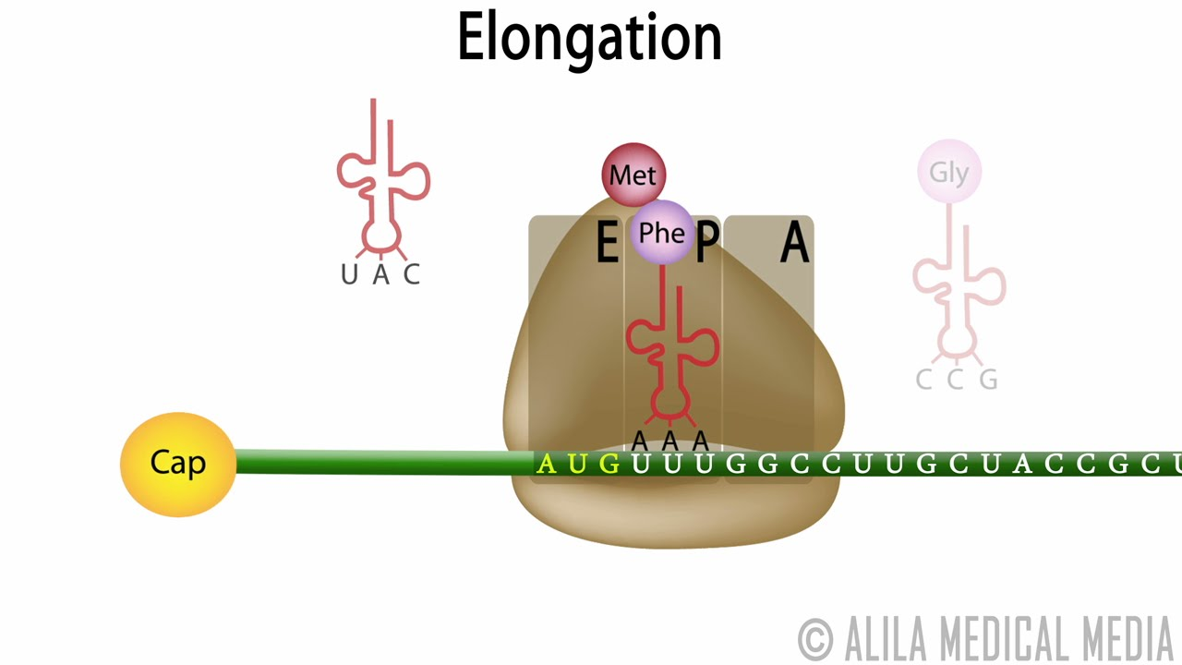

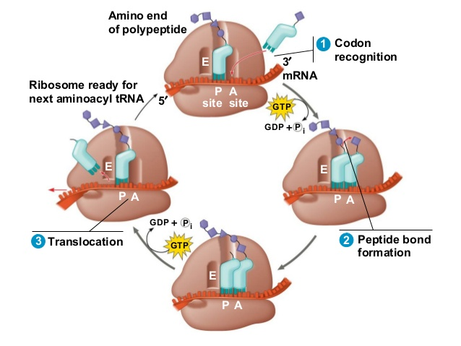

Termination process

Elongation process remain continue untill the stop codon(also called non sense codon) is exposed for example UAA .Non sense codon do not bind the transfer RNA but they are recognized by the releasing factor protein tha that release the newly formed polypeptide chain from the ribosomes.

Stop codon or nonsense codon

There are three nonsense or stop codon.The release of anyone codon will stop the process of polypeptide chain synthesis.These nonsense codon are UAA,UAG and UGA.

Protein synthesis often occur on ribosomes on the surface of rough endoplasmic reticulam.The positioning of ribosomes on the rough endoplasmic reticulam allow proteins to move into the endoplasmic reticulam as the protein is being synthesied.
After synthesis of polypeptide chain

When the formation of polypeptide chain completed. Then protein can be move to the Golgi apparatus for the packing into secretary vesicles or into the lysosomes . Free
When they packed the are organised for their specific function.

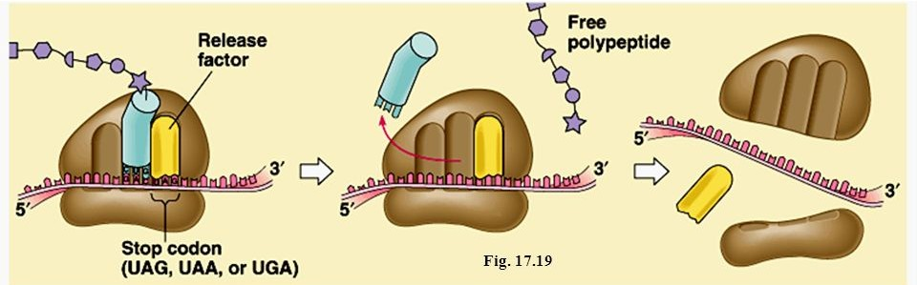

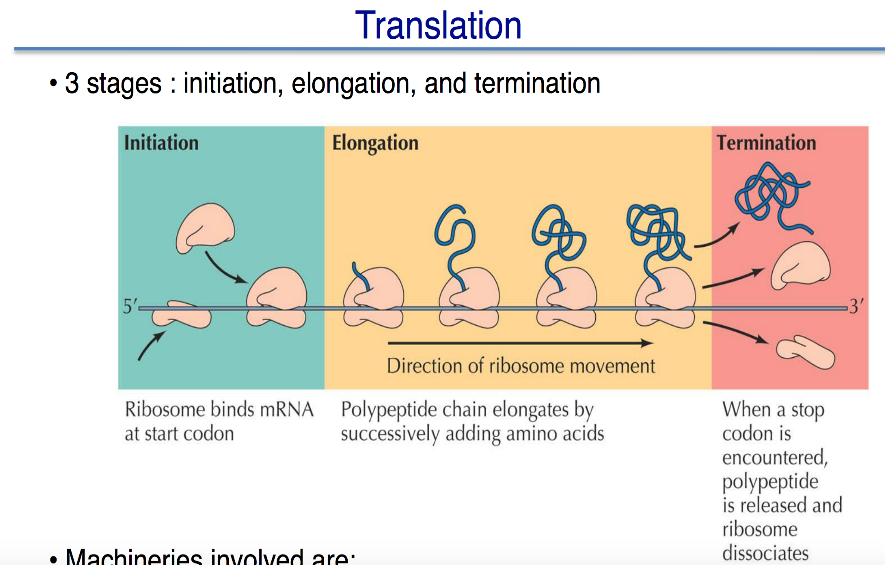

Translation process in eukaryotes
As mentioned above transcription and translation occur in the cytoplasm in prokaryotes.However in eukaryotes the nucleus membrane separate the ribosomes located in the cytoplasm from the transcription process take place in the nucleus.For this reason translation process start when transcription process end an messenger RNA is transferred into the cytoplasm.
- To reach in the cytoplasm messenger RNA passes through the nuclear pore on the nuclear member.In eukaryotes translation also occur in ribosomes located in endoplasmic reticulam.
- In eukaryotes translation process also have three stages
Initiation process
Elongation process
Termination process
While this is similar to the translation process in prokaryotes . There are several component with regards the component involved.

Initiation process
During the initiation phase the smaller subunit of ribosome form a complex with three initial factors.Here however the smaller ribosomal subunit is 40S compared to the much smaller 30S in prokaryotes.Binding of these initiation factor (IF-1,IFA,and IF-3) to the ribosomal subunit produce the termination complex that is turn join the IF-5(initiation factor 5) and transfer RNA.
- Ultimately this complex bind the messenger RNA to form the initial complex .As in the case of prokaryotes the small ribosomal subunit move along the untranslated region of the messenger RNA as it is scans for the start codon the first AUG serve as the start codon in prokaryotes.
- In eukaryotes the messenger RNA sequence located at the start codon is known as Kozak sequence (ACCAUGG).while this sequence serve as similar function to the shine- Dalgarno sequence the two are different in that the Kozak sequence actually cantain the start sequence.
- Once the start codon is recognized the larger ribosomal subunit is recruited to the complex which result in the formation of fully functional ribosomes ( this is an energy dependant process that is involve GTP hydrolyzed and ultimately an 80S ribosomes) once a fully functional ribosomes is formed the initiation factor are released.
- At the end of initiation factor the initiator tRNA is located at the P site while A site remain vacant.

Elongation process

- This is the second phase of translation process which involve the synthesis of polypeptide chain.Elongation in eukaryotes is similar to the prokaryotes.EF.Tu is replaced by EF -13 alpha here elongation factor has three main function.

- The first function of the protein is to recruit the charged Transfer RNAs to the site A.In addition they play an important role in formation of peptide bond between the amino acids as well as translocation of ribosome along the mRNA.

- Progress of the process involves the translocation events.Tn each of these events the charged tRNAs enter the A site before the shifting of the PSite.At the end of each event the tRNA exit the E site so that can be removed.

As the ribosomes move along the mRNA elongation factor promote the peptide bond between the amino acids located at the tRNA and the corboxyl group of the amino acid that located on the tRNA of the P Site.
- Here peptidal transferase serve as to catalyze the reaction.The amino acids associated with the tRNA on the P site is then linked to growing polypeptide chain which allows the chain to continue growing in length.Thus process allow the ribosomes to continue moving along the mRNA as the polypeptide chain continue growing before it stop at the termination phase.

Termination process

This is the last phase of translation process.It occur when the ribosomes arrive at the nonsense codon of the mRNA where the tRNA has no complementary anticodon.Once the stop codon is identified by the release factor the amino acid at the P site is detached from the tRNA where free the peptide which free the polypeptide chain.
On the other hand the ribosomes is not only disassociated from the mRNA but also into two subunit which allows them to inter in the initiation process of another translation process.

MCQs
- Enzymes peptidal transferase help i
a)Catalyzing bonding between two adjecent Amino acids
b)Transferring Amino acid from one to another
c)Shifting of ribosome on mRNA
d)Removal of tRNA after formation of peptide bond

- Messenger RNA direct the building of protein through a sequence of
- Codon
- Exon
- Intron
- Anticodon

- Translation occur in
- Nucleus
- Cytoplasm
- Lysosomes
- Nucleolus

- During translation protein are synthesis by
- Ribosomes by using information on DNA
- Lysosomes using the information on DNA
- Ribosomes using the information on messenger RNA
- Ribosomes using the information on rRNA

- The enzyme which is involved in Amino acids activation
- ATP synthetase
- Amino acyle tRNA synthetase
- Amino acyle mRNA synthetase
- Amino acyle rRNA synthetase

- The anticodon of tRNA bind with the
- Nucleic bases of mRNA
- Codon of transfer RNA
- Nucleic bases of rRNA
- Amino acids

- Which step of translation doesn’t consume high energy phasphate bond
- Translocation
- Amino acids activation
- Amino acyle tRNA bin to A site
- Peptidak transferase reaction

- Which of the following is start codon
  - UAA
  - UAG
  - UGA
  - AUG

- Which of the following statement is true
a)The messenger RNA is translated from 5 to 3 end
b)The messenger RNA is translated from 3 to 5 end
c)both are true
- Which of the following is base pair it thymine
- Adenine
- Guanine
- Cytocine
- Uracil

  - A
  - B
  - B
  - C
  - B
  - A
  - B
  - D
  - A
  - A

