5 Types of Prepositions: An Easy Guide
Main Takeaways:
- There are five types of prepositions in the English language.
- A preposition is a word that helps connect nouns and pronouns with a verb or adjective in a sentence.
- The five types of prepositions are simple, double, compound, participle, and phrase prepositions.
- Prepositional phrases contain a preposition plus a noun or pronoun.
There are five types of prepositions. They are simple, double, compound, participle, and phrase prepositions. A preposition is used to show a relationship between the noun, pronoun, or phrases in a sentence. They are used to connect people, objects, time, and locations.

What is a Preposition?
The definition of a preposition is a word or phrase that connects a noun or pronoun to a verb or adjective in a sentence. They are usually short words, and they normally are found in front of nouns. On rare occasions, prepositions can be found in front of gerund verbs.
If the subject, noun, and verb are the bricks of sentence, then prepositions are the mortar that connects them. They express position, movement, possession, time, and how an action is completed.

How Many Types of Prepositions are There?
There are five types of prepositions:
- Simple preposition
- Double preposition
- Compound preposition
- Participle preposition
- Phrase preposition
These are spoken and written quite often in English. In fact, many of us use all types of prepositions naturally without realizing that they are distinct and have a name.
for, with, on, that, of, to
Common prepositions are also some of the shortest words | Jane Samoilova – Shutterstock.com License

What are the Most Common Prepositions?
The Top 10 most common prepositions in the English language are: of, with, at, from, into, during, including, until, against. These represent the most frequently used prepositions. They are also called “simple prepositions.”

What is a Simple Type of Preposition?
Simple prepositions are the short words used to show the relationship between nouns, pronouns, or to join parts of a clause or sentence.

List of Simple Prepositions
Here are some of the most common, or simple prepositions:
aboard
about
above
across
after
against
along
alongside
amid
among
around
at
before
behind
below
beneath
beside
besides
between
beyond
but
by
concerning
considering
despite
down
during
except
excepting
for
from
in
inside
into
like
near
of
off
on
onto
opposite
out
outside
over
past
regarding
round
save
since
through
throughout
till
to
toward
under
underneath
until
unto
up
upon
via
with
within
without

Examples of Simple Prepositions Used in Sentences
The dog jumped out while the car was moving.
Car is the object of the preposition out.
Dorothy came upon the Tin Man.
Upon is the preposition. Tin Man is the object.
She came home without her homework.
Homework is the object and the preposition is without.

What are Prepositions of Place?
Writers use this type of preposition to describe where something is located. There are four Prepositions of Place. “At” describes a specific point in space. “In” describes an enclosed space. “On” describes an object’s relationship to a surface. “By” describes an object’s proximity to something else.
Many common prepositions are also “Prepositions of Place”. These are used to indicate a noun’s location.

Prepositions of Place Examples
“At”
Meet me at the library.
“In”
[example]I’m trapped in the elevator!
“On”
Is that a cat sleeping on your car?
“By”
I’ve always wanted to try that cafe by the train station.

Prepositions of Direction
If you ask “Where?”, this type of preposition is usually part of the answer. Prepositions of Direction let you know where something is going. They indicate which direction something is moving. There are dozens of examples, but the most common examples of Prepositions of Direction are:
above, across, along, among, around, at, behind, below, beside, over, through, toward, up, down, between, by, inside, in, near, past, under
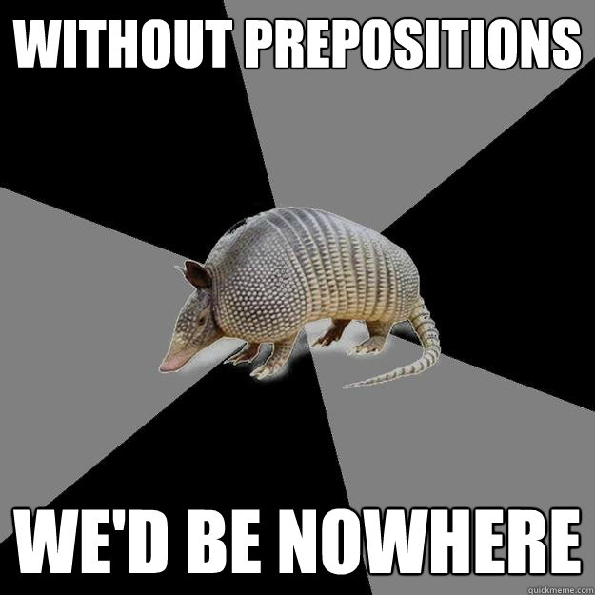“Without” is an example of a preposition of direction, a common preposition, and a simple preposition | QuickMeme – Creative Commons License

What is a Double Preposition?
Easily form a Double Prepositions by joining two simple prepositions.

Examples of Double Prepositions in Sentences
The dog jumped out of the moving car.
The child hid inside of the cabinet.

What is a Compound Preposition?
Double prepositions and compound prepositions are very similar. Both are two-word phrases. The double preposition is formed through the conjunction of two simple prepositions. Whereas the compound preposition is formed through the conjunction of a non-prepositional word and a simple preposition.
Note: Compound prepositions can sound dated or stuffy. For readability’s sake consider attempting to simplify the phrase.
I use INK which is a web content optimization editor. It identifies wordy or complex sentences and suggests that I edit to make my articles easily digestible.
At that point in time I didn’t know the answer.
This sentence can be simplified to:
Then, I didn’t know the answer.
or
I didn’t know the answer.

The Most Common Compound Prepositions
according to
ahead of
along with
alongside of
apart from
around about
as against
as between
as compared with
as compared to
as for
at that point in time
at this point in time
at the point of
at the time of
because of
by force of
by means of
by reason of
by virtue of
by way of
due to
during the course of
except for
for fear of
for lack of
for the purpose of
for the reason that
for the sake of
from above
from among
from behind
from beneath
from between
from the point of view of
in accordance with
in a manner similar to
in care of
in case of
in close connection with
in common with
in comparison to
in compliance with
in connection with
on account of
on behalf of
on the basis of
on the part of
on the point of
on top of
out of
outside of
owing to
previous to
prior to
pursuant to
regardless of
relating to
relative to
short of
similar to
subsequent to
under cover of
what with
with a view to
with regard to
with reference to
with respect to
with the intention of
in consequence of
in consideration of
in contrast to
in default of
in deference to
in exchange for
in excess of
in favor of
in front of
in lieu of
in opposition to
in order to
in place of
in preference to
in receipt of
in regard to
in relation to
in search of
in spite of
in terms of
in the course of
in the event of
in the face of
in the immediate vicinity of
in the nature of
independently of
inside of
instead of
on account of
on behalf of
on the basis of
on the part of
on the point of
on top of
out of
outside of
owing to
previous to
prior to
pursuant to
regardless of
relating to
relative to
short of
similar to
subsequent to
under cover of
what with
with a view to
with regard to
with reference to
with respect to
with the intention of

Participle Prepositions
Participle prepositions have endings such as -ed and -ing.
assuming, barring, considering, during, given, notwithstanding, provided, regarding, and respected.

Prepositional Phrase Example Sentences
The baby cries during the day and sometimes at night.
All the children were in the classroom including the teacher.
Considering she was sick, she still put up her best times.
“Sing along” is an example of a command using a Preposition of Direction | The Bazillions

How do you Identify a Prepositional Phrase?
A prepositional phrase is a group of words that doesn’t contain a verb or a subject. It functions as a unified part of speech. A prepositional phrase normally has a simple preposition and a noun or a simple preposition and a pronoun.
Think of prepositional phrases as making a hamburger. You must have meat (or a protein) and bread. A simple preposition and the object of the preposition are the basics of a prepositional phrase.
You can jazz up your hamburger by adding cheese, grilled onions, mustard, tomatoes, etc. The same can be done for prepositional phrases. Add adverbs and adjectives to make your sentence more enjoyable to read.

Prepositional Phrase Examples
Prepositional phrases contain a preposition followed by an article followed by a noun.
The hamburger with cheese is yours.
Let’s spice up this sentence.
The hamburger with ooey-gooey cheese is yours.
I danced on the stage.
Next, we add more details.
I danced on the concert stage.
The puppy ran through the grass.
Adjectives make the sentence more enticing to read.
The puppy ran through the lush green grass.
Of the types of prepositions, I think simple prepositions are the easiest.
Adding a number adjective makes the sentence for informative.
Of the five types of prepositions, I think simple prepositions are the easiest.

