- Topic:
Mendelian inheritane: law of segregation

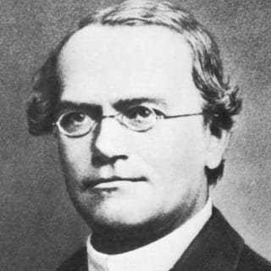
- Mendelian inheritance:Law of segregation
- Life history of Mendal:
- Gregor Mendel known as the “father of modern genetics”. He discovered the basic principles of the heredity in monastry’s garden through his experiments.
- Gregor Johann Mendel was born to a pheasant family in a small village in Moravia of Czechoslovakia.
- At the age of 25 he became a priest.
- In 1854,he started working on garden peas
- He took 34 strains of garden peas and prepared their pure breeds.
- From 1855 to 1866, he performed a series of experiments by crossing different pure breeds in a variety of patterens and explained the “mechanism of inheritance” of parental characteristics to their offsprings.
- He established the certain laws of genetics which we know now that they are true to the plants and animls.
- Mendel presented his work in Brunn society for the study of natural science in 1865.
- His work was published in 1866.
- His work remain neglected for 34 years.
- In 1900, three botanist Correns, De varies and Tschermach re-discovered his work independently.
- He laid the foundation of classical genetics.
- Reasons for the success of Mendelian work:
The reason for the Mendel’s success in unraveling the mechanisms of the heredity are:
- His approach
- Choice of experimental material
- His approach:
Mendels approach was systematic. He started his work from pure or true breeding varities and studied one charater at one time. His approach was statistical and kept all the data in term of the ratio. To get easily recognizable ratio he used a large no of plants.
- The choice of the experimental material:
His choice for the experimental material for his purpose was excellent, garden peas(pisum sativum).
- He used Pisum sativum for his experiments due to the following reasons:
Easy to cultivate.
- Flowers are hermaphrodite.
- It is normally a self fertilizing but the cross fertilization can be made.
- Time gap between the genarations raising is short.
- Pea plants very sharply distinct traits with 2 clear cut ulternative and contrasting pair forms(alleles).
- Mendel studied the 7 traits of garden pea with distinct contrasting the 14 pure breeding lines.
- Numerous varities are available.
- These plants produced a large no of seeds.
- Key points and terminologies:
- Gregor Mendel studied inheritance of traits in pea plants. He proposed a model where pairs of "heritable elements," or genes, specified traits.
- Genes come in different versions, or alleles. A dominant allele hides a recessive allele and determines the organism's appearance.
- When an organism makes gametes, each gamete receives just one gene copy, which is selected randomly. This is known as the law of segregation.
- A Punnett square can be used to predict genotypes (allele combinations) and phenotypes (observable traits) of offspring from genetic crosses.
- A test cross can be used to determine whether an organism with a dominant phenotype is homozygous or heterozygous.
- Genotype:the genetic makeup of the trait is reffered as its genotype. For example:Tallness has its genotype TT andTt.
- Phenotype:External appearance or visible expression of an organism is called phenotype. For example: tallness,dwarfness,roundness and wrinkleness etc.
- Homozygous:An organism having a pair of identical alleles for a character or trait. For example:TT for tallness and tt for dwarfness.
- Heterozygous:Organism having two different alleles for a character. For example:Tt for tallness.
- Gene pool:all the genes or alleles found in a breeding population at a given time are collectively called gene pool.it is a group of individuals of same species that interbreed sexual and live in a same place.The genes distributes among all individuals of a population are collectively called a gene pool.It is ta total genetic information encoded in the total genes in a breeding population.
- Monohybrid cross:A croos involving one trait or character at one time. For example:height of plant( tall or dwarf).
- Dihybrid:A cross involving two traits at a time is aclled dihybrid cross. For example: colour and shape of plant (round and yellow xwrinkled and green).
- F1 generation:The first generation of offsprings resulted from the crosses between two parental types or parents.F1 is symbolized for first filial generation.
- F2 generation: When the F1 hybrid (offsprings of F1 generation) are self pollinated or crossed the next generation in the result of this cross is called F2 generation.
- P-generation: P is symbolized for parental types or generation.
- Pure or true breeds:Pure or true breeds are collected by self pollination and the offsprings of the self pollinating plant are of same variety. For example: a plant having purple flowers is self pollinated then it should yield purple flowers on growing its seeds as a true breed.
- Hybridization:The mating or crossing of two varieties is called hybridization so the offspring produced as such is called hybrid.For example:In a cross of Ttand tt,the offspring is a hybris.For example:Tt.
- Jumping genes:Jumping genes do not settle peacefully on their loci,they keep hopping on different loci on the same chromosome or other chromosome.
- Genome:All the genes or alleles found in an individual is called genome.
- Bean bag genetics:For example apopulation is a group of alleles at a place like beams in a bag.So a bean bag is a gene or alleles bag of entire gene pool.We can discuss gene pool regarding singlr trait.For example:100 diploid plants or 200 alleles for flower,colors out of which some are red flowered while others are white flowered.
- IntrodToday, we know that many of people's characteristics, from hair color to height to risk of diabetes, are influenced by genes. We also know that genes are the way parents pass characteristics on to their children (including things like dimples, or—in the case of me and my father—a terrible singing voice). In the last hundred years, we've come to understand that genes are actually pieces of DNA that are found on chromosomes and specify proteins.
But did we always know those things? Not by a long shot! About 150 years ago, a monk named Gregor Mendel published a paper that first proposed the existence of genes and presented a model for how they were inherited. Mendel's work was the first step on a long road, involving many hard-working scientists, that's led to our present understanding of genes and what they do.
In this article, we’ll trace the experiments and reasoning that led Mendel to formulate his model for the inheritance of single genes.
- Mendel's model: It started with a 3:1 ratio:
- After studying the genetics of the pea plant,Mendel trace the inheritance of the variety of characters including flower position and flower color, seed shape and seed color.After that , he started it by crossing pure breeding parents plants with the different forms of the character such as violet and white flowers.The pure breeding means that the more offsprings will be made by plants itself when it will be self fertilized over many generations.
- The results which Mendel find after making cross between the flower color. Firstly,the cross was made between the pure breeding violet flower plant and the pure breeding white flowered plants in the parental p generation.And then gathered and planted the seeds given in the crosshr found 100 percent of plant in the next generation called F1 generation having violet flowers.
- In formal sagacity,at that time was foretelled that the hybrid flowers should be tha pale violet that are parent traits that should be blend in their offsprings.Mendel result showed that the white flowers were completely disappeared.the traits which were visible in the F1 generation called dominant trait which were violet flowers, and the traits which were hidden and lost called recessive traits which were white flowers.

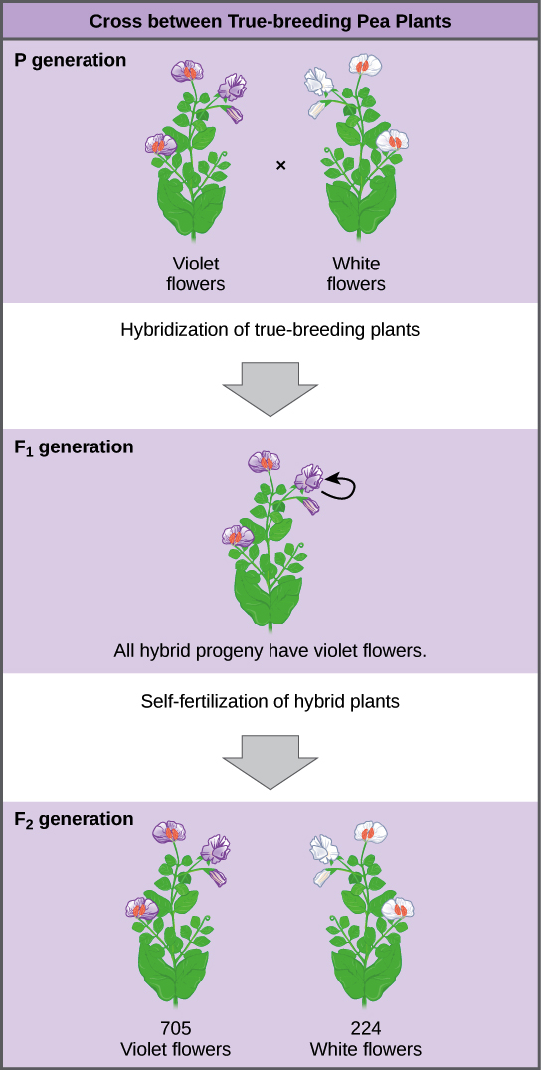

- Importantly,Mendel did not stop his experiments there.Instead, he let the F1 plants to self fertilize.Among their offspring called the F2 generation ,he found that 705 plants had violet flowers and 224 had the white flowers.This was a ratio of 3.15 violet flowers to one white flower, or approximately 3:1.
- This 3:1 ratio was not by mistake. For the other six characteristics the Mendel examined, both the F1 and F2 generations that behaved in the same way that they did for the flower colour.One of the two traits would disappeared completely from the F1 generation only to reappear in the F2 generation in a ration of the roughly 3:1 ratio.

- See Mendels date for all seven characteristics:

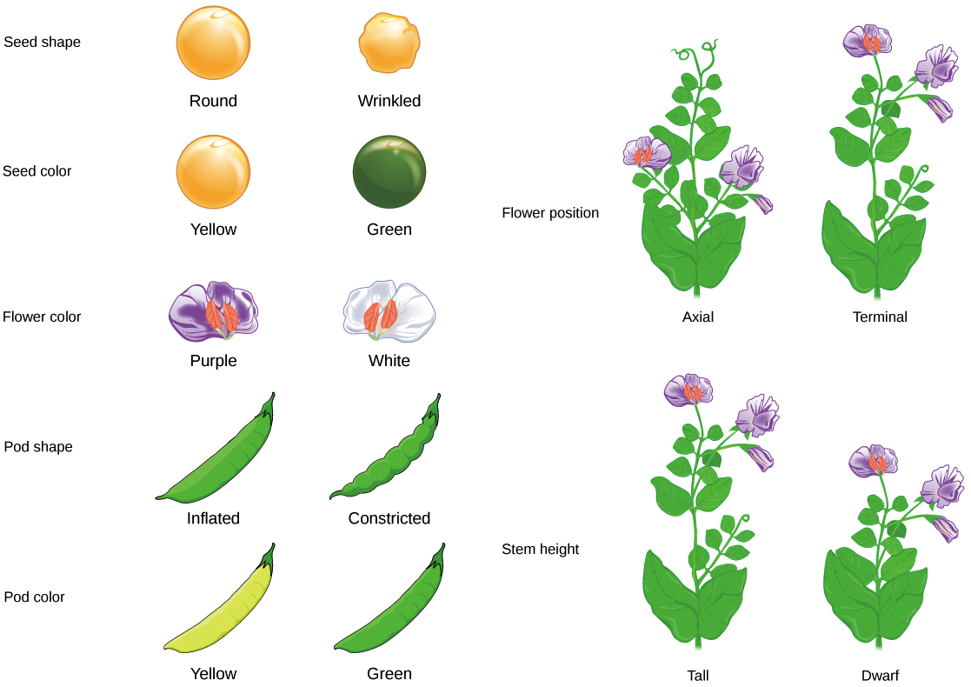

- As it flick off, the 3:1 ratio was a decisive clue that let Mendel solve the riddle of inheritance.
- Mendel's model of inheritance:
- Based on his results (including that 3:1) Mendel came up with a model for the inheritance of individual characteristics, such as flower color. In Mendel's model, parents pass along heritable factors which we now call genes, that determine the traits of the offspring. Each individual has two copies of a given gene, such as the gene for seed color (Y gene). If these copies represent different versions, or alleles, of the gene, one allele the dominant one may hide the other allele the recessive one. For the seed color, the dominant yellow allele Y hides the recessive green allele y.

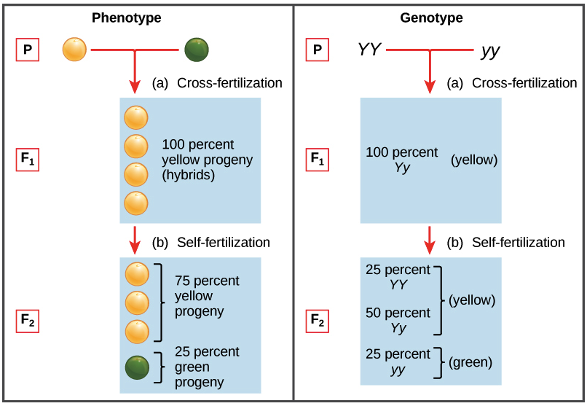
- The set of alleles carried by an organism is known as its genotype. Genotype determines phenotype, an organism's observable features. When an organism has two copies of the same allele (say, YY or yy), it is said to be homozygous for that gene. If, instead, it has two different copies (like Yy), we can say it is heterozygous. Phenotype can also be affected by the environment in many real-life cases, though this did not have an impact on Mendel's work.

- Mendel's model: The law of segregation:

- So for so good.But this model alone does not explain why Mendel saw the exact patterns of inheritance he did. In particular, it doesn't account for the 3:1 ratio. For that, we need Mendel's law of segregation.
- According to the law of segregation, only one of the two gene copies present in an organism is distributed to each gamete (egg or sperm cell) that it makes, and the allocation of the gene copies is random. When an egg and a sperm join in fertilization, they form a new organism, whose genotype consists of the alleles contained in the gametes. The diagram below illustrates this idea:

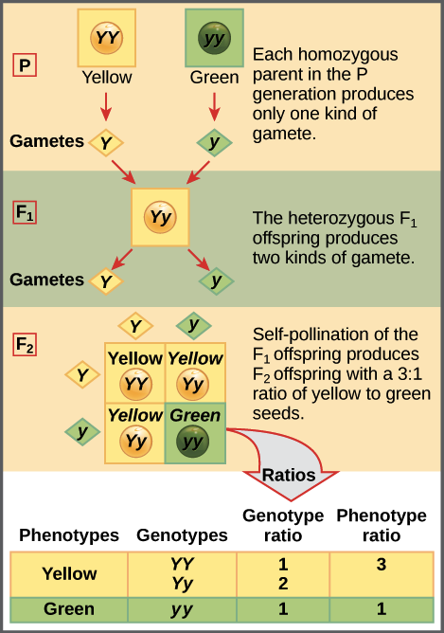
- The four-squared box shown for the F2 generation is known as a Punnett square. To prepare a Punnett square, all possible gametes made by the parents are written along the top (for the father) and side (for the mother) of a grid. Here, since it is self-fertilization, the same plant is both mother and father. The combinations of egg and sperm are then made in the boxes in the table, representing fertilization to make new individuals. Because each square represents an equally likely event, we can determine genotype and phenotype ratios by counting the squares.
- The test cross:
- Mendel also came up with a way to figure out whether an organism with a dominant phenotype (such as a yellow-seeded pea plant) was a heterozygote (Yy) or a homozygote (YY). This technique is called a test cross and is still used by plant and animal breeders today. In a test cross, the organism with the dominant phenotype is crossed with an organism that is homozygous recessive e.g. green-seeded.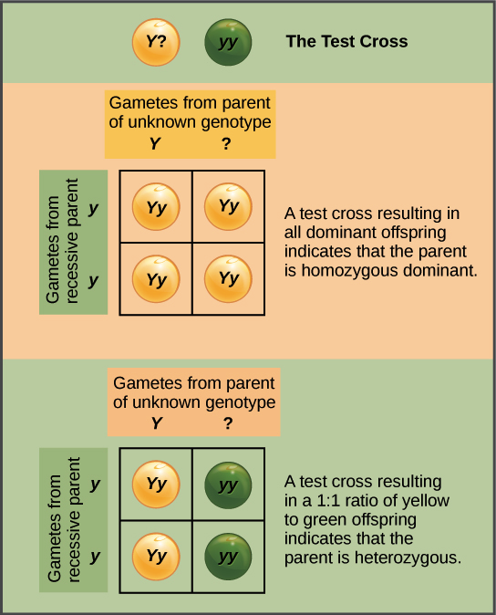

- The organisms will show a dominant phenotype if the organisms with the dominant phenotype is homozygous and the all the F1 offsprings will get a allele which will be dominant from their parents be heterozygous.If the organism with dominant phenotype organism is instead a heterozygous then the F1 offsprings will be half heterozygotes the dominant phenotypes and the half will be recessive homozygotes the recessive one.

- The fact that we get a 1:1 ratio in this second case is another confirmation of Mendels law of segregation.
- Is that Mendel’s complete model of inheritance?
- Not quite we have seen all the mendels model for the inheritance of single genes.However Mendels complete model so adressed whether genes for different characteristics such as flower color and seed shape influence each others inheritance.And the other thing that was amazing to know that the Mendel was able to figure out his entire model simply from his observations of the pea plants.This was not bcz he was some kind of super crazy genius but rather because he was very careful, persistent and curious and also bcz he thought about his results mathematically for instance 3:1 ratio. These are some of the qualities of a great scientist _ones that anyone ,anywhere, can develop.

MCQS
1):Which of the Mendels law is against the theory of Blending inheritance?
a)Law of segregation b)Law of dominance
c)Law of recessive d)Law of independent assortment
Answer:Law of segregation
2):Considering the concept of Multiple alleles,one organism can have how many alleles?
a)one b)two
c)three d)four
Answer:Two
3):Mendel used which plant for his experiment?
a)Pisum sativum b)pisum album
c)oryza sativa d)oryza orientalis
Answer:Pisum sativum
4):Gregor Mendel was:
a)an English scientist who carried out research with Charles Darwin
b)a little known central European monk
c)an early 20th century Dutch biologist who carried out genetics research
Answer:a little known central European monk
5):An allele is:
a)another word for a gene b)a homozygous genotype
c)a heterozygous genotype d)one of several possible forms of a gene
Answer:One of the several possible forms of a gene
6):Who is known as the Father of Genetics?
a)Erich Tschemark b)Carl Correns
c)Gregor Johann Mendel d)Hugo de Vries
Answer:Gregor Johann Mendel
7):The crossing of F1 to homozygous recessive parent is called:
a)Back cross b)Test cross
c)F1 cross d)all of these
Answer:Test cross
8):The test cross is used to determine the:
a)genotype of the plant b)phenotype of the plant
c)both a and b c)none of these
Answer:genotype of the plant
9):Monohybrid test cross ratio is:
a)3:1 b) 2:1
c)1:1 d) 9:3:3:1
Answer:1:1
10):Genetics is a science of:
a)dominance b)genes
c)heredity d)traits
Answe:Heredity

