CONTENTS:

- What is sampling?
- Methods of sampling  What is vegetative sampling?
- Importance of vegetative sampling  Methods of vegetative sampling
- Line intersect method
• Discovery • Description • General steps • Advantages • Disadvantages • procedure
- Quadrat method
  - Quadrat • Shapes of quadrat • Size of quadrat • Types of quadrat
  - General steps • Advantages of quadrat method • Disadvantages  References

METHOD OF SAMPLING VEGETATION (QUADRATE AND LINE INTERSECT METHOD) SAMPLING:
The process in which a predetermined number of observations are obtained from a larger population is called as sampling.
It depends upon the type of analysis being performed.
METHODS OF SAMPLING:
There are two types of sampling methods:
  - Probability sampling
  - Non-probability sampling

- PROBABILITY SAMPLING:
It includes random selection that allow you to make statistical results about the whole group.
- NON-PROBABILITY SAMPLING:
It includes non-random selection based on simple criteria that allow you to collect initial data.
VEGETATIVE SAMPLING:
It is based on the idea that the changes in vegetation (biomass, VWC (volumetric water constant), and plant structure) are negligible within a week that is why same paddock (an enclosed area used for pasturing animals) is re-sampled after one week.
IMPORATANCE OF SAMPLING VEGETATION: -
- They are important in wetlands in many physical and chemical processes.
- For aquatic organisms, they provide habitat and structure.
- They stabilize shorelines (area where water and coast meet) and reduces the erosive force of waves.
- It helps to characterize all types of vegetation in different study areas.
- It helps people to readily identify plants with minimum training as plants are present in almost all the wetlands.
METHODS OF SAMPLING VEGETATION: -
It includes:
- Transect method
It is further divided into:
  - Line transect or line intersect
  - Belt transects
- Bisect method
- Trisect method
- Ring counts method
- Quadrat method
It can be of 4 types:
  - List quadrat
  - List-court quadrat
  - Chart quadrat
  - Clip quadrat

LINE TRANSECT METHOD/ LINE INTERSECT METHOD:

- DISCOVERY:
This method was developed by canfield in 1940 to estimate the cover in the grasslands of S-W USA and it is widely used in shrublands and in the progress of applications.
- DESCRIPTION:
It is a method of sampling elements in a region in which an element is sampled if the transect interacts the element. It is a common way to determine the cover by laying a transect and see how many plants intersects with the transect.
It is a type of transect method.
it is used for the measurement of grass or grass like plants, shrubs, trees.
The following vegetation characteristics are covered by this method:
- Basal cover
- foliar cover
- Canopy cover
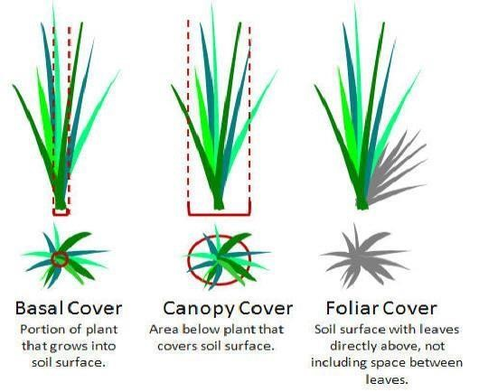
Figure 1 types of cover
- AREAS WHERE IT IS USED:
It is used in semi-arid bunchgrass-shrub vegetation.
- LINES: -
It can be single, multiple, l-shaped or of unequal length.
- TRANSECT LENGTH:
It depends on the vegetation and the type of plants which are to be measured. For example, 15m transects are suitable in dense vegetation whereas 30-50m are required to obtain a representative sample in thin thinly scattered vegetation.
- USE OF LINE INTERSECT METHOD:
It is used in ecology to measure the percent vegetation coverage, coarse woody debris (CWD) coverage, and plant abundance.

General steps to conduct a line intersect in field:
- Take 2 measurements for each item of interest. Now cover the length and width of the items perpendicular to the transect.
- The start and end point for each time a plant intersect the line is recorded as the total distance of the intercept. It can be calculated in the lab.
- When we read the distances along the transect, read only along one edge of the tape. The tape should not be moved inadvertently to include or exclude the certain plants.
- Now in the same way, measure the bare ground.
- If there are multiple items of interest repeat step 1 and 2.
- Lines should be thin; it has no width at all. They are used to calculate the basal and canopy cover but also use to determine the foliar cover for the species having dense canopies and large leaves.
- Now cover is calculated as:
cover of specie = total distance of specie / total distance of line
- Now determine the percentage cover for each line and take average to determine the cover of the total landscape.

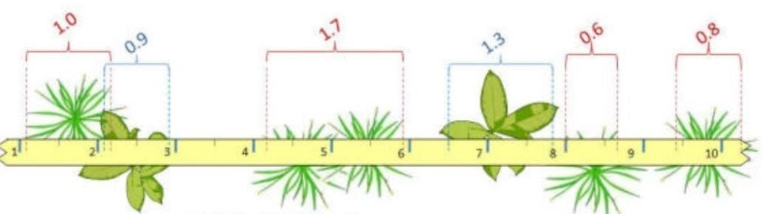
figure 1 : line intersect
INFORMATION COLLECTED FROM LINE TRANSECT METHOD INCLUDES:
- The number of times a specie appears along the line.
- The increase and decrease of distance between the individuals of species.
- The percentage of the occurrence of different species in relation to the total species.
- The appearance and disappearance of different species that are present along the line.

ADVANTAGES OF LINE INTERSECT METHOD:
- It is more economical.
- It is easy to learn and simple to use.
- It provides an accurate estimate of cover.
- It is used as standard comparison when testing other methods for the determination of cover.
- Greater species turnover.
- Larger area is covered in a relatively short time.
- It is applicable throughout the year.
- Use in many types of habitat.
- It can be use in hilly area.
- Permanent transects can cover for a longer period of time
DISADVANTAGES OF LINE INTERSEPT METHOD:
- In this method, distances are not correctly measured.
- Movement of observer may disturb the animals.
- Chances of missing rare species are more.
- It is difficult to detect small changes.
- Rare plant species may not intersect by the points and are not sampled.
- It can be time consuming specially in dense vegetation.

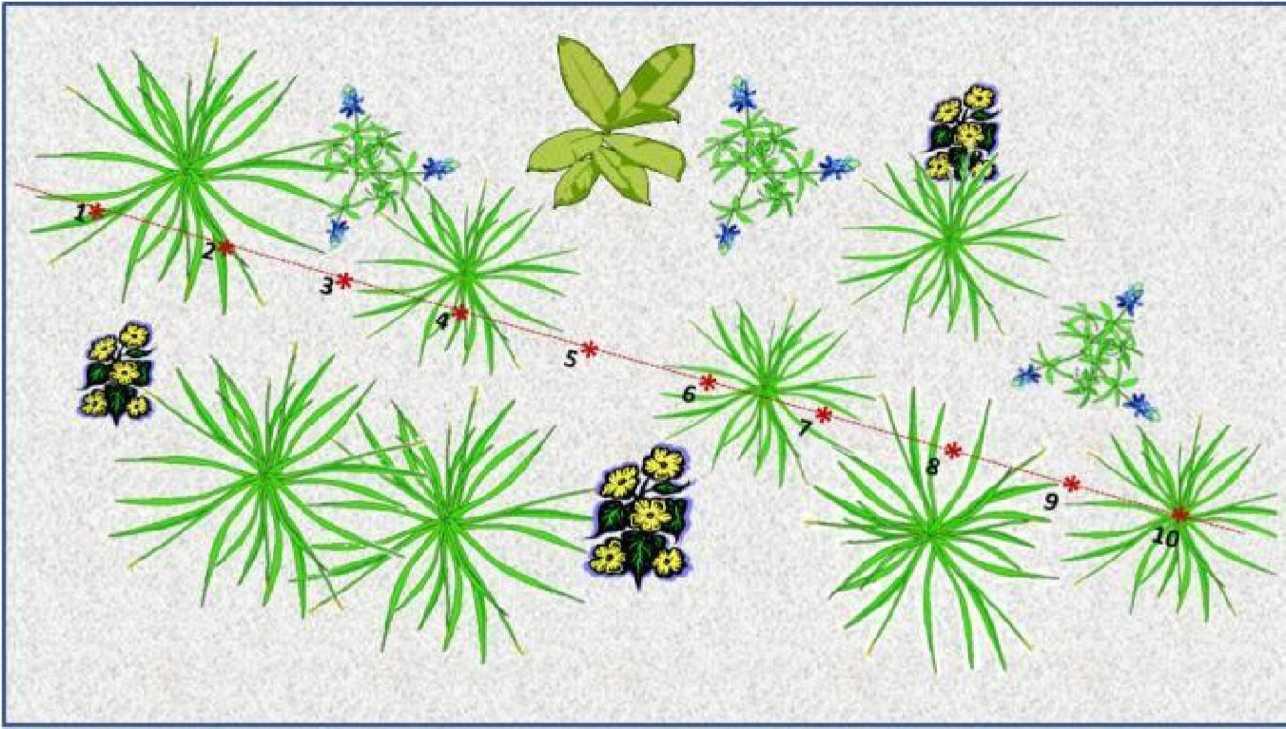
Figure 2 line intercept
TERMS USED IN LINE INTERSECT METHOD:
- Cover = Sum of intersect lengths for a specie/total length of the transect×100

- Density = Ȃ/1 (unit area/total transect length)
(Where M = max width of the plant perpendicular to transect line)

- Relative Density = species density / total density for all species.
PROCEDURE:
- In this the vegetation is sampled only on a line (without any width).
- A line is placed over the vegetation with a steel tape or long rope and it is fixed with the help of a short pin or a bolt or hooks.
- This line touches the plants on its way from one point to other point.
- Now the observer starts recording these plants from one end and will move to the other end.
- Cover is calculated by adding all intercept distances divided by total length of the transect
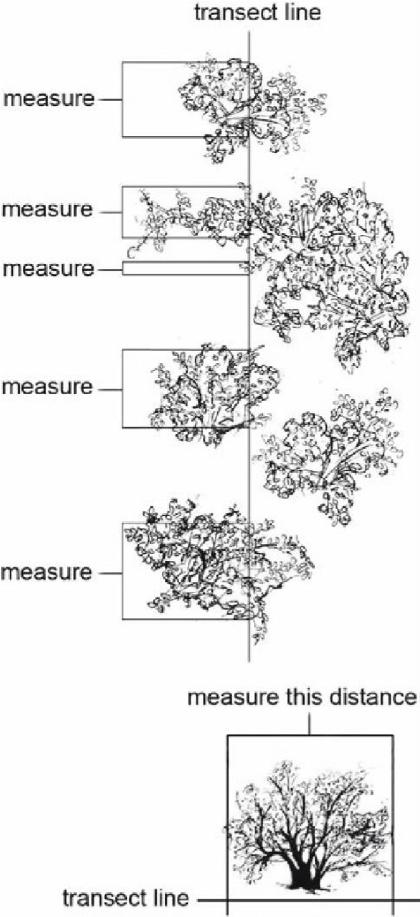
Figure 3 Transect Line

QUADRAT SAMPLING METHOD:

QUADRAT SAMPLING:
It is a method by which we can directly count organisms in a certain proportion of habitat.
It is used for the estimation of
- No. of population
- Population Density
- Population Frequency
- Population distribution
QUADRAT:
- It is a square in which species of interest are counted.
- It is a frame which is laid down to mark out the specific area of community to be sampled.

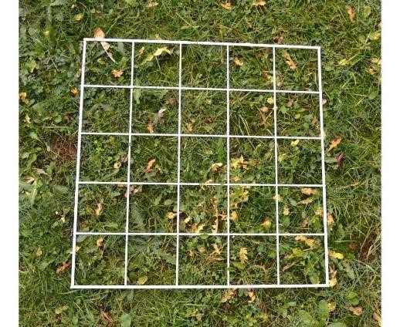
Figure 4 Quadrat
SHAPE OF QUADRAT:
They may be:
- Square
- Rectangular
- Circular
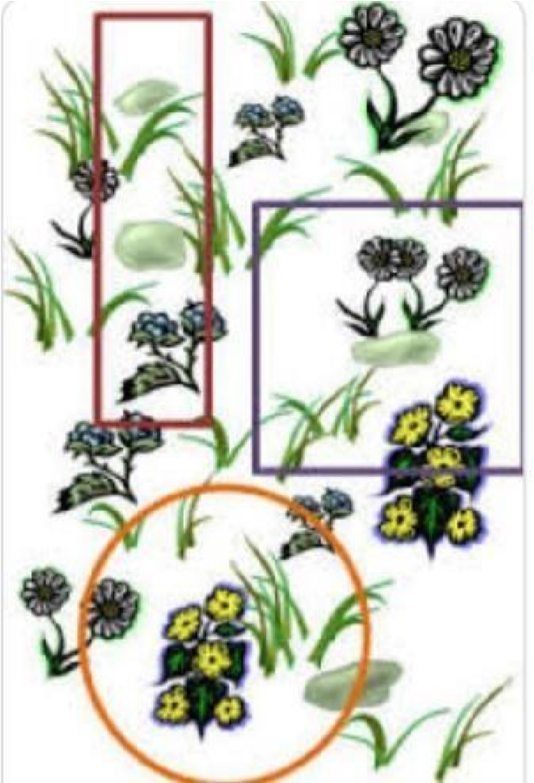
Figure 5 Shapes of Quadrat
USE OF QUADRAT METHOD:
- It is used to determine the differences and similarities in the composition and structure of different plant communities or related or unrelated vegetation.
- It is used for sampling:
- plants
- slow moving animals
- some aquatic organisms.

TYPES OF QUADRATES:

• List quadrat:
In this we enlist the names of species that grow in the quadrat

• List-court quadrat:
In this we record the no. of individuals of each specie present in each quadrat.

• Chart quadrat:
In this we record the areas that are covered by grasses, mosses on a graph paper. This graph helps us to compare any change in the structure of community.

• Clip quadrat:
In this we measure the weight of each specie all species are pulled out of the ground and its dry or fresh weight is measured.

SIZE OF QUADRAT:
It is determined by drawing a species area curve. It is done by sampling the vegetation present inside the quadrat.
Quadrat can be of any size. Common sizes include
- 25 by 25 cm
- 50 by 50 cm
- 1 by 1 m
GENERAL STEPS:
- First of all, choose a sampling region and make a grid line along the area.
- Now select a random area and place the quadrat there.
- Now count the individuals that are present inside the quadrat.

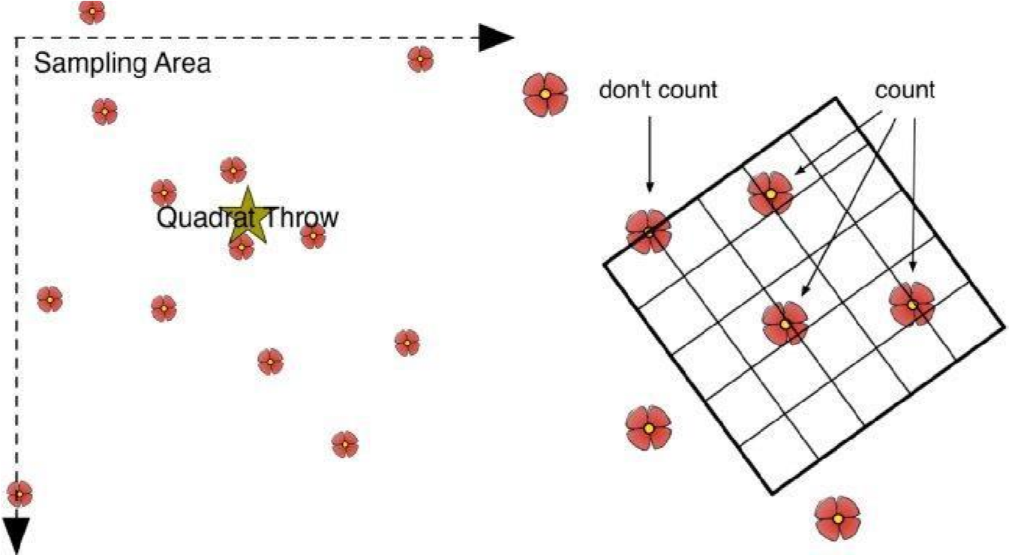
Figure 6 Edge Effect
There is present an edge effect. Species that are present inside the quadrat are counted but those species that are present at the edges or outside the quadrat are not counted.
- Now repeat step 2 and 3.
- Now measure the total size of the area occupied the population in square meter.
- Now calculate the population by using the equation:
Population = average organisms per quadrat × total area ÷ quadrat area
TERMS USED IN QUADRAT METHOD:
- Counts – it tells the number of individuals of a species.
- Cover – the percent (%) area of the quadrat occupied by a plant species.
- Density – estimated by quantifying the number of individuals of a species per unit area.
- Frequency – the proportion of quadrats sampled in which the species is represented.
(frequency = no. of plots in which species occur / total no. of plots sampled)
(relative frequency = frequency value for a specie / total frequency values for all species × 100) • Relative cover- is the proportional cover of an individual species as a percentage of total plant cover so it is expressed as a percentage, ranging from 0 – 100%.

ADVANTAGES OF QUADRAT METHOD:
- It is simple to use.
- Quadrat plots are uniform in size and shape and distributed throughout the area which make it straightforward.
- Affordable because it requires less material.

DISADVANTAGES OF QUADRAT METHOD:
- Not useful to study fast moving animals as they not stay inside the quadrat.
- Too large or too small in size quadrats result in errors because large species require larger plots. randomly spaced quadrats that are too small might miss many individuals.

