The Mode
Mode is the most repeated value in the data set OR that observation in the data that occur most frequently
Example: The mode of the numbers 2, 5, 8, 9, 9, 9, 10 is 9
For Grouped data: $Mode=l_{b}+\frac{f_{m}-f_{1}}{2f_{m}-f_{1}-f_{2}}×h$
$$l_{b}=lower class boundary of modal class \left(class having the greatest frequency\right)$$
$$f_{m}=class frequency of the modal class$$

Class limits | Class boundaries | Frequency (f)
45-49 | 44.5-49.5 | 1
50-54 | 49.5-54.5 | 4
55-59 | 54.5-59.5 | 17=$f_{1}$
60-64 | 59.5-64.5 | 28
65-69 | 64.5-69.5 | 25=$f_{2}$
70-74 | 69.5-74.5 | 18
75-79 | 74.5-79.5 | 13
80-84 | 79.5-84.5 | 6
85-89 | 84.5-89.5 | 5
90-94 | 89.5-94.5 | 2
95-99 | 94.5-99.5 | 1
Sum |  | 120

$$Mode=l_{b}+\frac{f_{m}-f_{1}}{2f_{m}-f_{1}-f_{2}}×h$$
$$Mode=59.5+\frac{28-17}{2(28)-17-25}×5=63.85$$

Type of Variable | Best measure of central tendency
Nominal | Mode
Ordinal | Median
Interval/Ratio (not skewed) | Mean
Interval/Ratio (skewed) | Median

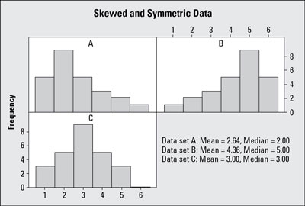S
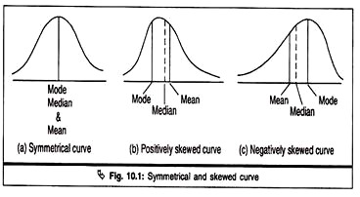

Symmetric Curve: Mean=Median=Mode
Positively Skewed: Mean>Median>Mode
Negatively skewed: Mean<Median<Mode
Empirical relations between mean, median and mode
$$Mean-Mode=3\left(mean-median\right)$$
$$Mean-mode=3mean-3median$$
$$3meadian-3mean+2mean=mode$$
$$Mode=3median-2mean$$

