To study the reaction turbine (Francis Turbine)
Theory:
In a reaction turbine, the water enters the wheel under pressure and goes over the vanes. As the water, flowing over the vanes, is under pressure, therefore wheel of turbine runs full and may be submerged below the trail race or may discharge in the atmosphere. The pressure head of water while flowing over the vanes, is converted into velocity head and is finally reduced to the atmospheric pressure, before leaving the wheel.
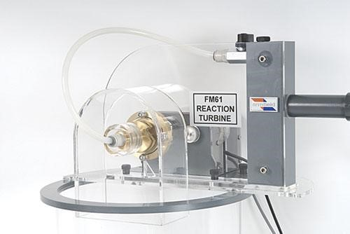

Main Components of a Reaction Turbine
- Spiral Casing
- Guide Mechanism
- Turbine Runner
- Draft Tube
- Spiral Casing
The water, from a pipeline, is distributed around the guide ring in a casing. This casing is designed in such a way that its cross-section area goes on reducing uniformly around the circumference. The cross-sectional area is maximum at the entrance and minimum at the tip. As a result of this, the casing will be of spirals shape. That is why it is called a spiral casing.
- Guide mechanism
The guide vanes are fixed between 2 rings in the form of a wheel. this wheel is fixed in the spiral casing.
The guide vanes are properly designed in order to:
- allow the water to enter the runner without shock
- allow the water to flow over them without forming eddies
- allow the required quantity of water to enter the turbine
- Turbine runner
The runner of a reaction turbine consists of runner blades fixed either to a shaft or rings, depending upon the type of turbine. the blades are properly designed in order to allow the water to enter and leave the runner without shock.
This surface of the runner is made very smooth. The runner maybe cast in one piece or maybe made of separate steel plates and welded together. for Low heads, the runner may be made of cast iron. but for a higher head, the runner is made of steel or alloys
- Draft Tube
The water, after passing through the runner flows down through a tube called draft tube. It is generally drowned approximately one meter blow the tail race level. A draft tube has the following functions
- It increases the head of water by an amount equal to height of the runner outlet above the trail race.
- It increases efficiency of turbine
Procedure:
- Set the flow rate to a low level.
- Set the brake at some level and measure the brake load using the load cell and the rotor speed using a tachometer.
- Repeat for various brake settings. Set the flow rate to a high level and repeat the experiment.
- Using the measured data, calculate the brake torque and the bucket speed: then calculate the brake power output of the turbine. Plot Power P versus RPM for each flow rate. Plot Power Coefficient C P versus Speed Coefficient C S. Compare Actual Power with Theoretical Power.

Observations and calculations
Sr.  No | Turbine  Inlet  Pressure  (P)  kg/cm² | Volume  (V)  (Liters) | Time  (t)  (Sec) | Speed  (n)  (rpm) | Force on spring balance |  | Net  Force (F_{N}) | Flow  Rate  (Q) | Power  Input  (W_{i}) | Power  Output (w_{o}) | Efficiency  (𝜂)
 |  |  |  |  | Left  (F_{L}) | Right  (F_{R})
1
2
3
Relevant Equations:
Turbine power:
This is the power absorbed by the turbine wheel, taken from water,
𝑃_{𝑤}= 2𝜋𝑁𝑇/60 or 𝑃_{𝑤}= 𝜔𝑇
Flow Rate:
The volume of fluid which passes per unit time.
𝑄 = 𝑉𝑜𝑙𝑢𝑚𝑒/𝑡𝑖𝑚𝑒
Efficiency:
𝜂=Turbine Output/Turbine Input×100%

