Granulation
Granulation, a technique of particle enlargement by agglomeration, is one of the most significant unit operations in the production of pharmaceutical dosage forms, mostly tablets and capsules. During the granulation process, small fine or coarse particles are converted into large agglomerates called granules. Generally, granulation commences after initial dry mixing of the necessary powder ingredients along with the active pharmaceutical ingredient (API), so that a uniform distribution of each ingredient throughout the powder mixture is achieved. Although granules used in the pharmaceutical industry have particle size in the range of 0.2-4.0 mm, they are primarily produced as an intermediary with a size range of 0.2-0.5 mm to be either packed as a dosage form or be mixed with other excipients before tablet compaction or capsule filling.
Granules are produced to enhance the uniformity of the API in the final product, to increase the density of the blend so that it occupies less volume per unit weight for better storage and shipment, to facilitate metering or volumetric dispensing, to reduce dust during granulation process to reduce toxic exposure and process-related hazards, and to improve the appearance of the product. Consequently, the ideal characteristics of granules include spherical shape for improved flow, narrow particle size distribution for content uniformity and volumetric dispensing, sufficient fines to fill void spaces between granules for better compaction and compression characteristics, and adequate moisture and hardness to prevent breaking and dust formation during process.
Granulation is an exemplary of particle design and the properties of the particles acquired after granulation depend on particle size of the drug and excipients, the type, concentration, and volume of binder and/or solvents, granulation time, type of granulator, drying rate (temperature and time), etc. The primary methods by which the agglomerated granules are formed include solid bridges, sintering, chemical reaction, crystallization and deposition of colloidal particles. Besides, binding can also be accomplished through adhesive and cohesive forces by utilizing high viscous binders. The series of mechanisms by which granules are formed from the powder particles encompass wetting and nucleation, coalescence or growth, consolidation, and attrition or breakage.
Blend of powders containing pharmaceutical excipients and API can be compressed into tablets either by direct compression or after making granules by agglomeration or granulation techniques (Fig. 1). The granulation technique may be widely categorized in to two types, dry granulation and wet granulation, based on the type of method used to facilitate the agglomeration of powder particles (Fig. 1). Dry granulation uses mechanical compression (slugs) or compaction (roller compaction) to facilitate the agglomeration of dry powder particles, while the wet granulation uses granulation liquid (binder/solvent) to facilitate the agglomeration by formation of wet mass by adhesion. Among these two techniques, wet granulation is the most widespread granulation technique used despite the fact that it involves multiple unit processes such as wet massing, drying and screening, which are complex, time consuming, and expensive requiring large space and multiple equipment.
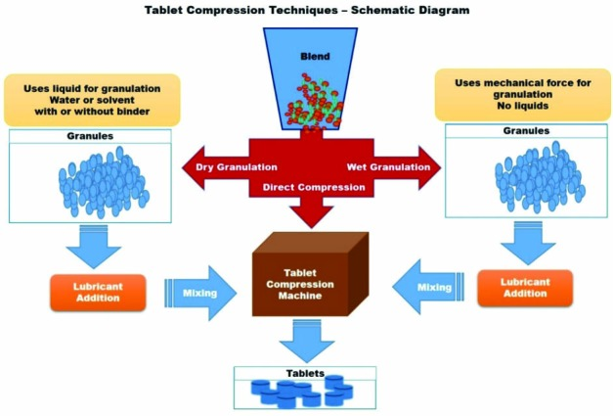
Fig: 1 Schematic diagram of tablet compression techniques
The type of process selection requires thorough knowledge of physicochemical properties of the drug, excipients, required flow and release properties, etc. Granulation technologies like roller compaction, spray drying, supercritical fluid, low/high shear mixing, fluid bed granulation, extrusion/spheronization, etc. have been successful for many decades in the preparation of various pharmaceutical dosage forms. Pharmaceutical granulation technology continues to change, and various improved, modified, and novel techniques and technologies have been made available along the course. This chapter provides latest techniques and technologies with regard to pharmaceutical granulation. Subsequently, this gives a short description about each development along with its significance and limitations, which are summarized in Table 1.
Recent progress in dry granulation
Dry granulation could be achieved either by roller compaction or by slugging. The two different types are illustrated in the schematic diagram Fig. 2. There has not been much progress in the dry granulation technique and technology in comparison to wet granulation, except for one important innovation known as pneumatic dry granulation technology developed by Atacama LabsOy (Helsinki, Finland), which is described below. The description of its significance and limitations are summarized in Table 1.
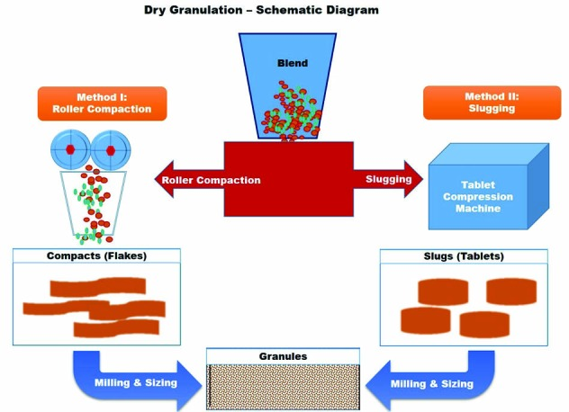
Fig: 2 Schematic diagram of dry granulation and two different techniques. Method I is roller compaction and Method II is slugging.

1. Pneumatic Dry Granulation (PDG)
Pneumatic dry granulation (PDG), an innovative dry granulation technology, utilizes roller compaction together with a proprietary air classification method to produce granules with extraordinary combination of flowability and compressibility. In this method, granules are produced from powder particles by initially applying mild compaction force by roller compactor to produce a compacted mass comprising a mixture of fine particles and granules. The fine particles and/or smaller granules are separated from the intended size granules in a fractioning chamber by entraining in a gas stream (pneumatic system), whereas the intended size granules pass through the fractioning chamber to be compressed into tablets. The entrained fine particles and/or small granules are then transferred to a device such as a cyclone and are either returned to the roller compactor for immediate re-processing (recycling or recirculation process) or placed in a container for reprocessing later to achieve the granules of desired size. The schematic diagram of this process is represented as Fig. 3.
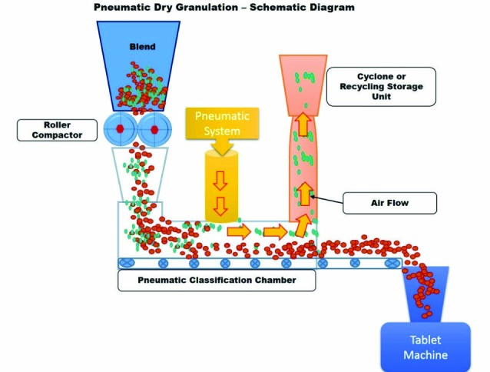
Fig: 3 Schematic diagram of pneumatic dry granulation
PDG technology could successfully be used to produce good flowing granules for any formulations that produce compacts with a tensile strength of ~ 0.5 MPa. Also, this technology enables the use of high drug loads of up to 70-100%, because sufficient flowability could be achieved even at lower roll compaction forces (lower solid fractions) compared to usual roller compaction. In addition to these, this technology avails various other benefits such as faster processing speed, low cost, little or no material wastage, low dust exposure due to the closed nature of this unit, etc. However, the influence of recycling on the granule quality, suitability with low dose formulations, friability, etc. remains major issues regarding this technology. The description of its significance and limitations are summarized in Table 1.
Recent progress in wet granulation
Wet granulation is the widely used technique and the granules are produced by wet massing of the excipients and API with granulation liquid with or without binder. The steps involved in conventional wet granulation technique could be seen in Fig. 4. Wet granulation has witnessed various technical and technological innovations such as steam granulation, moisture-activated dry granulation or moist granulation, thermal adhesion granulation, melt granulation, freeze granulation, foamed binder or foam granulation, and reverse wet granulation. The significance and limitations of the recent wet granulation techniques and technologies are summarized in Table 1.
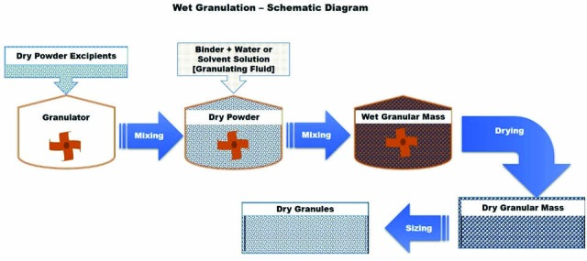
Fig 4: Schematic diagram of conventional wet granulation

1. Steam Granulation
In steam granulation as a new wet granulation technique, water steam is used as binder instead of traditional liquid water as granulation liquid. 5 shows the schematic diagram of steam granulation. Steam, at its pure form is transparent gas, and provides a higher diffusion rate into the powder and a more favorable thermal balance during the drying step. After condensation of the steam, water forms a hot thin film on the powder particles, requiring only a small amount of extra energy for its elimination, and evaporates more easily.
The advantages of this process include the higher ability of the steam to distribute uniformly and diffuse into the powder particles, production of spherical granules with larger surface area, and shorter processing time ecofriendly (no involvement of organic solvents). Equipment such as high-shear mixer coupled with a steam generator would be enough for this technique. However, this method requires high energy inputs for steam generation. Besides, this process is not suitable for all binders and is sensitive to thermolabile drugs. The granules produced by this process have higher dissolution rate due to increased surface area of the granules compared to conventional wet granulation process.
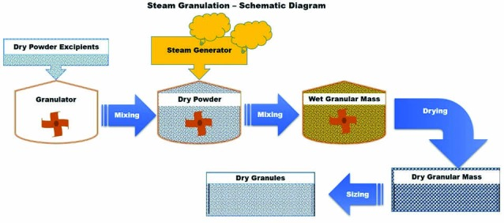
Fig 5: Schematic diagram of steam granulation

2. Moisture-Activated Dry Granulation (MADG)
This technique is a variation of conventional wet granulation technique. It uses very little water to activate a binder and initiate agglomeration. This technique involves two steps, 1) wet agglomeration of the powder particles, and 2) moisture absorption or distribution. Agglomeration is facilitated by adding a small amount of water, usually less than 5% (1-4% preferably), to the mixture of drug, binder and other excipients. The two steps of this MADG are presented in Fig. 6. Agglomeration takes place when the granulating fluid (water) activates the binder. Once the agglomeration is achieved, moisture-absorbing material such as microcrystalline cellulose, silicon dioxide, etc. is added to facilitate the absorption of excess moisture. The moisture absorbents absorb the moisture from the agglomerates, resulting in moisture redistribution within the powder mixture, leading to relatively dry granule mixture. During this moisture redistribution process, some of the agglomerates remain intact in size without change, while some larger agglomerates may break leading to more uniform particle size distribution. It does not require an expensive drying step.
The process does not lead to larger lumps formation since the amount of water used is very small compared to usual wet granulation. The particle size of the agglomerates is mainly accounted to be in the range of 150-500 µm. This technique is also known as “moist granulation technique” leading to confusions with the use of appropriate terminology. Some authors believe that dry granulation involves the use of a roller compaction or a slugging step followed by milling to obtain granules. However, this technique did not use either of those steps. Besides, given that this technique utilizes a small amount of water, the use of the term “dry granulation” would be inappropriate. Therefore, the authors believe that “moist granulation” would be an appropriate terminology for this technique. In either case, the technique is the same and here uses the terminology “Moisture-Activated Dry Granulation (MADG)” coined by the inventors of this technique in 1987.
The application of MADG to an immediate-release and controlled-release dosage forms showed the advantages of wet granulation such as increased particle size, better flow and compressibility. Additional advantages of this technique include wide applicability, time efficiency and less energy input, and involvement of few process variables with suitability of continuous process. However, this technique could not be used for the preparation of granules that require high drug load and for moisture sensitive drugs and hygroscopic drugs due to stability and processing problems associated with these types of drugs. A high-shear mixer coupled with a sprayer would be suitable equipment for the MADG process. An ideal machine should be equipped with efficient impellers, blades, and choppers to allow good mass movement and proper mixing of the granulation mass.
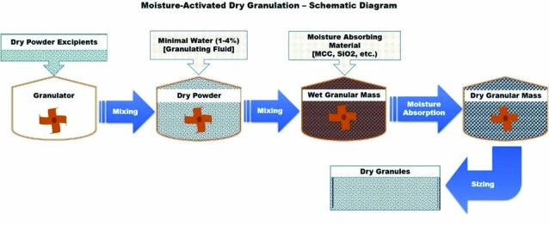
Fig 6: Schematic diagram of moisture-activated dry granulation

3. Thermal Adhesion Granulation (TAG)
Wei-Ming Pharmaceutical Company (Taipei, Taiwan) has developed this technique, and the thermal adhesion granulation, analogous to moist granulation, utilizes addition of a small amount of granulation liquid and heat for agglomeration (7). Unlike moisture activated dry granulation which uses water alone as granulation liquid, this process uses both water and solvent as granulation liquid. In addition to this, heat is used to facilitate the granulation process. In this process, the drug and excipients mixture is heated to a temperature range of 30–130 °C in a closed system under tumble rotation to facilitate the agglomeration of the powder particles. This technique eliminates the drying process due to the addition of low amount of granulation liquid, which is mostly consumed by the powder particles during agglomeration. Granules of the required particle size can be obtained after cooling and sieving.
This technique is quite simple and convenient with low moisture and binder contents in a closed system for preparing highly compressible materials or for modifying the poor characteristics of excipients. Besides, this technique provides granules with better particle size, good flow properties and high tensile strength that could be directly compressed into tablets with adequate hardness and low friability. The limitations of this technique are requirement of considerably high energy inputs and special equipment for heat generation and regulation. This technique is not suitable for all binders and is sensitive to thermolabile drugs.
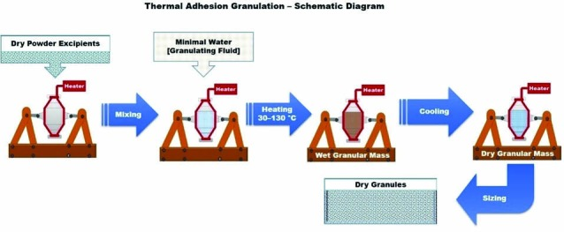
Fig 7: Schematic diagram of thermal adhesion granulation

4. Melt granulation
Melt granulation or thermoplastic granulation is a technique that facilitates the agglomeration of powder particles using melt able binders, which melts or softens at relatively low temperature (50–90 °C). 8 represents the schematic diagram of melt granulation. Cooling of the agglomerated powder and the consequent solidification of the molten or soften binder complete the granulation process. Low melting binders can be added to the granulation process either in the form of solid particles that melt during the process (melt-in procedure or in situ melt granulation) or in the form of molten liquid, optionally containing the dispersed drug (spray-on or pump-on procedure), which displays a variety of options to design final granular properties. More specifically, the melt-in procedure of melt granulation process includes heating a mixture of drug, binder and other excipients to a temperature within or above the melting range of the binder. On the contrary, the spray-on procedure encompasses spraying of a molten binder, optionally containing the drug, onto the heated powders.
Melt granulation is an appropriate alternative to other wet granulation techniques which are used for water sensitive materials. Moreover, in comparison with the conventional wet granulation process, it proposes several advantages. Generally, organic or aqueous solvents are not demanded for the melt granulation process, hence the environmental requirements of organic solvent capture and recycling are eliminated, while the absence of water excludes the wetting and drying phases, making the entire process less energy- and time-consuming. Melt granulation method could be efficiently applied in order to enhance the stability of moisture sensitive drug and further to improve the poor physical properties of the drug substance. The major drawback of this process is the need of high temperature during the process, which can cause degradation and/or oxidative instability of the ingredients, especially of the thermolabile drugs.
The binders used for this process could be either hydrophilic or hydrophobic. The selection of a melt able binder with a hydrophilic/hydrophobic feature is critical factor for the dissolution behavior of the drugs. The equipments that could be used for melt granulation are high-shear mixer and fluidized bed granulator. Interest in melt granulation has increased in recent years, owing to the numerous advantages of this technique over conventional wet granulation process.
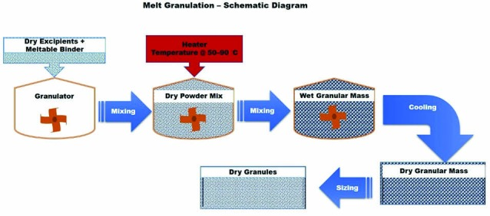
Fig 8: Schematic diagram of melt granulation

5. Freeze granulation
Freeze granulation technology, spray freezing and subsequent freeze drying, involves spraying droplets of a liquid slurry or suspension into liquid nitrogen followed by freeze-drying of the frozen droplets. By spraying a powder suspension into liquid nitrogen, the drops are instantly frozen into granules, and in the subsequent freeze drying process, the granules are dried by sublimation of ice without any segregation effects. The above-mentioned steps are depicted as schematic diagram in 9. This process yields spherical free-flowing granules that could be formed by using both water based and solvent based slurries. The significance of this technology is that the structure and homogeneity of the particles in the slurry or suspension are retained in the granules. Although various kinds of material in dispersed form can be granulated using this technology, it is suitable for the preparation of fine powder mixes with proper additives for subsequent processing.
This technology could be useful for the preparation of granules that needs to be prepared from suspensions whose particle size and homogeneity need to be preserved. Eventually, re-dispersible parenteral formulations, nanomaterials, solid self-emulsifying drug delivery systems, etc. could benefit from this technology given its ability to maintain size and homogeneity. The suspension quality always determines and reflects the granule quality in terms of homogeneity. In pharmaceutical industry, the low-temperature and soft freeze drying has vital advantage to minimize damage of organic compounds and improve stability and/or solubility. According to PowderPro AB, compared with spray drying, freeze granulation obviously produces protein particles with light and porous characteristics, and making powders with superior aerosol performance due to favorable aerodynamic properties.
The major advantages of this process include ability to control the granule density through the solid content of the suspension, preparation of granules with no cavities, a high degree of granule homogeneity due to the absence of migration of small particles and/or binder molecules, use of heat sensitive compounds due to mild drying procedure, high product yield due to low waste of material, and possibility of recycling organic solvents. Although organic solvents with suitable freezing point (-25 to +10 °C) can be used, water as medium is preferred in this process, which could be a limiting criteria given the poor solubility of various drugs and processing excipients. Originally, this process was developed by Swedish Ceramic Institute in the late 1980. Currently, PowderPro AB, the spinoff company (year 2000) from Swedish Ceramic Institute, develops, manufactures, markets, and sells equipment for freeze granulation.
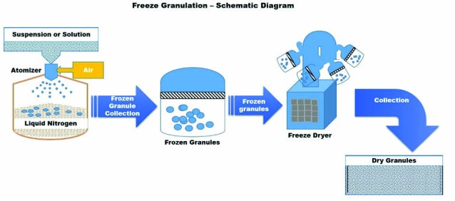
Fig 9: Schematic diagram of freeze granulation

6. Foam granulation
Foam granulation or foamed binder granulation technology, analogous to spray agglomeration, involves the addition of liquid/aqueous binder as foam instead of spraying or pouring liquid onto the powder particles. 10 shows the schematic diagram of this technology. This foam binder technology was first introduced by Dow Chemical Company (Midland, MI) in 2003 for delivering aqueous binder systems in high shear and fluid bed wet granulation applications. A foam generator can be installed in the binder solution tank with high-shear granulator or fluid bed granulator to introduce the binder as foam rather than spraying or pouring in binder onto the moving powder particles. Adding the binder solution as foam rather than a spray eliminates the problems of inconsistent and unpredictable binder distribution that can affect tablet hardness and drug release.
The surface area and volume of the foamed binder/water are phenomenally high compared to the sprayed water. This technology exploits the characteristics of the foamed binder to successfully improve the distribution of binder onto the powder particles, even at a binder amount lower than that required in the conventional spray granulation method. Besides, the sprayed liquid droplets have a low spread-to-soak ratio, which means they tend to soak into powders and cause over wetting rather than spreading on the surface of the particles, requiring high levels of water and binder, and eventually drying to remove excess water. On the contrary, foamed binders have a high spread-to-soak ratio, and because of this the binders are coated onto the particles rather than soaked, leading to less amount of binder and more consistent binder distribution. These factors improve the reproducibility and shorten the processing time. Most importantly, this technology eliminates the spray nozzles and its related processing variables and clogging problems.
In addition to the above-mentioned advantages, this technology would prove useful for high potent/low dose drug formulations due to its ability to distribute drugs evenly. Due to the involvement of low amount of water and short process time, water sensitive formulations could also be prepared using this technology in addition to immediate release and controlled release formulations. Standard equipment such as high/low shear mixer, fluid bed granulator, etc. could be used for this technology in association with a foam generator. Although this technology merits in myriad ways, further understanding of foam quality, process parameters, equipment, flow patterns, mixing behavior, etc. needs to be explored. Besides, the regulatory approval would be a huge hurdle that needs to be overcome.
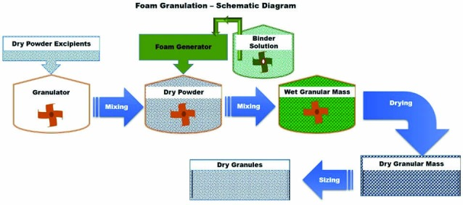
Fig 10: Schematic diagram of foam granulation

7. Reverse wet granulation
Reverse wet granulation or reverse-phase wet granulation is a new development in the wet granulation technique that involves the immersion of the dry powder formulation into the binder liquid followed by controlled breakage to form granules. According to this invention, the binder solution was prepared initially and the dry powder excipients were added to the binder solution under mixing in granulator. Alternatively, the drug was mixed with a solution of hydrophilic polymer and/or binder to form drug-polymer/binder slurry as a granulating fluid. Granules were then formed by immersing a mixture of other dry excipients into the drug-polymer/binder slurry. The resulted wet granules were milled after drying. The granules produced by this process were found to have good flow and handling characteristics like those produced with wet granulation process. In addition, tablets formed from these granules eroded more uniformly during dissolution testing as compared to usual wet granulation technique. The schematic diagram of this process is presented in Fig. 11.
Controlled breakage was proposed to be the predominant granule formation mechanisms in reverse wet granulation technique. It is purported that this technique improves the dissolution characteristics of the poorly water-soluble drugs by allowing uniform distribution of the binder that acts as a wetting agent and enable adequate wetting of the drug substance during granulation. It also increases the chances of adequate and uniform contact between the drug and hydrophilic polymer for better dissolution. These improved granule characteristics result in even erosion of tablets during dissolution.
The advantages of this technique over conventional wet granulation include small and spherical-shaped granules with improved flow properties, uniform wetting and erosion of the granules. This technique could be suitable for poorly water-soluble drugs because of the intimate association between a drug and the polymer. Usability of currently available equipment such as high speed mixer is another merit of this technique. However, this technique produced granules with a greater mass mean diameter and lower intragranular porosity when compared to the conventional wet granulation at lower binder concentrations.
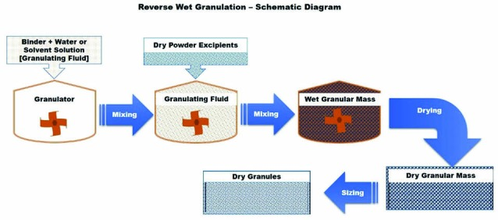
Fig 11: Schematic diagram of reverse wet granulation

