QC TESTS FOR SUPPOSITORIES

SUPPOSITORIES
Definition; “Suppositories are solid bodies of various weights and shapes, adapted for introduction into the rectal, vaginal, or urethral orifice of the human body. They usually melt, soften, or dissolve at body temperature. A suppository may act as a protectant or palliative to the local tissues at the point of introduction or as a carrier of therapeutic agents for systemic or local action.”
DISINTEGRATION OF SUPPOSITORIES AND PESSARIES.
The disintegration test determines whether the suppositories or passaries soften or disintegrate within the prescribed time when placed in a liquid medium in the experimental conditions described below.
Disintegration is considered to be achieved when:
a) dissolution is complete,
b) the components of the suppository or pessary have separated: melted fatty substances collect on the surface of the liquid, insoluble powders fall to the bottom and soluble components dissolve, depending on the type of preparation, the components may be distributed in one or more of these ways,
c) there is softening of the sample that may be accompanied by appreciable change of shape without complete separation of the components, the softening is such that the suppository or passary no longer has a solid core offering resistance to pressure of a glass rod,
d) rupture of the gelatin shell of rectal or vaginal capsules occurs allowing release of the contents,
e) no residue remains on the perforated disc or if a residue remains, it consists only of a soft or frothy mass having no solid core offering resistance to pressure of a glass rod (vaginal tablets).
Apparatus. The apparatus consists of a sleeve of glass or suitable transparent plastic, of appropriate thickness, to the interior of which is attached by means of three hooks a metal device consisting of two perforated stainless metal discs each containing 39 holes 4 mm in diameter; the diameter of the discs is similar to that of the interior of the sleeve; the discs are about 30 mm apart.
The test is carried out using three such apparatuses each containing a single sample. Each apparatus is placed in a beaker with a capacity of at least 4 litres filled with water maintained at 36-37 °C, unless otherwise prescribed. The apparatuses may also be placed together in a vessel with a capacity of at least 12 litres. The beaker is fitted with a slow stirrer and a device that will hold the cylinders vertically not less than 90 mm below the surface of the water and allow them to be inverted without emerging from the water.

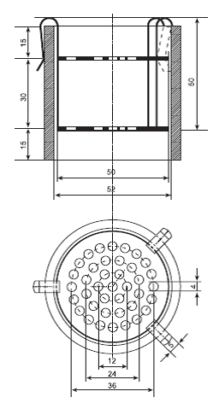
Apparatus for disintegration of
suppositories and pessaries
Dimensions in millimetres

Method. Use three suppositories or pessaries. Place each one on the lower disc of a device, place the latter in the sleeve and secure. Invert the apparatuses every 10 min. Examine the samples after the period prescribed in the monograph. To pass the test all the samples must have disintegrated.
METHOD OF OPERATION FOR VAGINAL TABLETS
Use the apparatus described above, arranged so as to rest on the hooks. Place it in a beaker of suitable diameter containing water maintained at 36-37 °C with the level just below the upper perforated disc. Using a pipette, adjust the level with water at 36-37 °C until a uniform film covers the perforations of the disc. Use three vaginal tablets. Place each one on the upper plate of an apparatus and cover the latter with a glass plate to maintain appropriate conditions of humidity. Examine the state of the samples after the period prescribed in the monograph. To pass the test all the samples must have disintegrated.

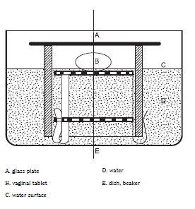
Liquefaction time
Liquefaction testing provides information on the behavior of a suppository when subjected to a maximum temperature of 37◦C. The test commonly used is Krowczynski’s method (see below), which measures the time required for a suppository to liquefy under pressures similar to those found in the rectum (approximately 30 g) in the presence of water at 37◦C. In general, liquefaction should take no longer than about 30 minutes.
For Krowczynski’s method, the apparatuss consists of a 16mm diameter glass tube, 235mm long with an approximately 6mm diameter reduction at the base. One end is blocked with a small rubber stopper to facilitate cleaning after use. A thermostat graduated in tenths of a centigrade is used. The tube and thermometer are held in place by means of a large rubber stopper with two holes in a 225mm long tube with a 50mm diameter, fitted with lateral tubes to allow the water at 37◦C from a constant-temperature water bath to circulate. Another apparatus is equipped with a 30 g glass stem 180mm long and 9mm wide. The base has a ring form with a 14mm diameter. The ring of the stem has a cuneiform shape opening to allow the melted excipient to escape upwards during the test. At a distance of approximately 100mm from the ring, three glass projections support the stem in a vertical position in the tube. The stem is also marked with a dash corresponding to its position with respect to the upper level of the tube
The directions for use are as follows:
(1) obtain a constant temperature in the circulating water bath of 37◦C
(2) pour approximately 5mL of water down the tube so that all the tube is filled below the narrowed part (and so that the suppository to be tested is in relatively humid conditions similar to those in the rectum
(3) after 5 minutes (the time necessary to bring the 5mL of water to 37◦C), insert a suppository with the end pointed downward into the glass tube, insert the glass stem so that it is resting on top of the suppository and start the timer
(4) note the time required for the mark on the glass stem to drop and come in line with the upper edge of the tube
(5) repeat this for two more suppositories
(6) if the difference between the three time measurements is greater than 105 seconds, start again on two more suppositories (making a total of five suppositories)
(7) determine the average liquefaction time.
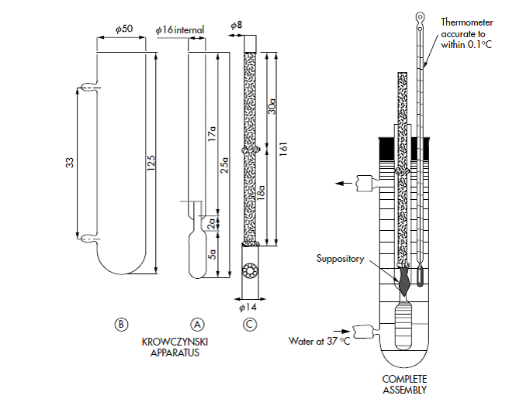
Cellophane bag.
Apparatus using a cellophane bag consists of a glass cylinder with an external diameter of 50mm, narrowing down to 22mm at either end for a length of 30mm. The cylinder is fitted with two connections through which water that is maintained at 37◦C can circulate. A 34–35cm length of cellulose dialyzer tubing, size-inflated diameter of 1.12 inch (2.8 cm), is moistened, opened and placed in the cylinder. The tube is drawn out of either end of the cylinder and secured with two elastic bands.
Tubing is attached to allow the warm water to circulate, maintaining the temperature. When the appropriate temperature is reached, the suppository is placed in the dialysis tubing and the time to liquefaction measured. The apparatus can also be used to determine the melting point of suppositories made with both water-soluble and water-insoluble bases. This can be accomplished by increasing the temperature of the water at a set rate, for example one degree every 10 minutes until the suppository melts.

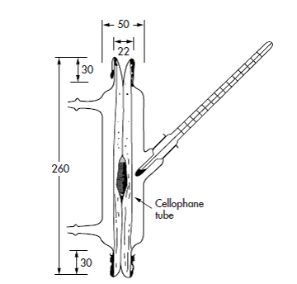

Liquefaction time apparatus using cellophane bag.

Breaking/crushing test
Suppositories can be classified as brittle or elastic by evaluating the mechanical force required to break them. Tests are used that measure the mass (in kilograms) that a suppository can bear without breaking. A good result is at least 1.8– 2 kg pressure. The suppository is positioned in an upright position and increasing weights are placed on it until it loses its structure and collapses. The purpose of the test is to verify that the suppository can be transported under normal conditions, and administered to the patient.
CONTENT UNIFORMITY TESTING
In order to ensure content uniformity, individual suppositories must be analyzed to provide information on dose-to-dose uniformity. Testing is based on the assay of the individual content of drug substance(s) in a number of individual dosage units to determine whether the individual content is within the limits set. “Acceptance value calculations are not required for suppositories.
Assay 10 units individually as directed in the Assay in the individual monograph, unless otherwise specified in the Procedure for content uniformity” The USP 30 “Criteria”17 for suppositories states the following:
Limit A (if the average of the limits specified in the potency definition in the individual monograph is 100.0% or less) – Unless otherwise specified in the individual monograph, the requirements for dosage uniformity are met if the amount of the drug substance in each of the 10 dosage units as determined from the Content Uniformity method lies within the range of 85.0% to 115.0% of the label claim, and the RSD is less than or equal to 6.0%. If 1 unit is outside the range of 85.0% to 115.0% of label claim, and no unit is outside the range of 75.0% to 125.0% of label claim, or if the relative standard deviation is greater than 6.0%, or if both conditions prevail, test 20 additional units. The requirements are met if not more than 1 unit of the 30 is outside the range of 85.0% to 115.0% of label claim, and no unit is outside the range of 75.0% to 125.0% of label claim and the RSD of the 30 dosage units does not exceed 7.8%.
Limit B (if the average of the limits specified in the potency definition in the individual monograph is greater than 100.0 percent)—
- If the average value of the dosage units tested is 100.0 percent or less, the requirements are as in Limit A.
- If the average value of the dosage units tested is greater than or equal to the average of the limits specified in the potency definition in the individual monograph, the requirements are as specified under Limit A, except that the words “label claim” are replaced by the words “label claim multiplied by the average of the limits specified in the potency definition in the monograph divided by 100”.
- If the average value of the dosage units tested is between 100 percent and the average of the limits specified in the potency definition in the individual monograph, the requirements are as specified under Limit A, except that the words “label claim” are replaced by the words “label claim multiplied by the average value of the dosage units tested (expressed as a percent of label claim) divided by 100”.

