Grazing Systems and Important Grazing Systems

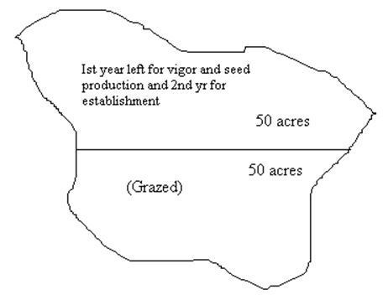
Contents
- Grazing Systems and Important Grazing Systems
- GRAZING SYSTEMS:
  - Grazing Seasons:
  - Grazing Periods:
  - Considerations for the design of Grazing Systems:
  - Objects of Grazing System:
  - Characteristics of a Good Grazing System:
- IMPORTANT GRAZING SYSTEMS:
- In Pakistan:
  - Continuous/ Year long/ Season long Grazing System:
  - Rotational Grazing System:
  - Deferred Grazing System:
    - Difference b/w Rotational and Deferred System:
  - Deferred Rotational Grazing system:

Grazing Systems and Important Grazing Systems

GRAZING SYSTEMS:
It is a way by which animals are grazed in a large area. It is systematic in periodic periods of grazing and deferment of two or more pastures or grazing units.

Grazing Seasons:
It is that portion of the year when grazing is feasible in the range area.

Grazing Periods:
It is that portion of grazing season within which grazing actually occurs over rangeland.

Considerations for the design of Grazing Systems:
- Time of growth of root and shoot i.e. active growth period.
- Time of flowering
- Time of seed maturity
- Germination
- Seedling establishment
When growth rate is high it is necessary that we should protect plants for vigor so that seed maturity and establishment should be received.

Objects of Grazing System:
The main objectives are germination, seed establishment, and vigorous growth.
Other objectives are:
- Distribute utilization
- Restore vegetation on sacrifice area.
- Maintain forage
- Avoid stress on animals
- Reducing supplemented feeding
- Minimize labor cost

Characteristics of a Good Grazing System:
- A good grazing system should be based on morphology and physiology of the plant.
- It should be suitable to kind of plant on a particular range area.
- It should be adoptable to soil conditions
- It should move ie plant successions towards high productivity by favoring the desired and preferred plants.
- It should not be harmful to animal gain.
- Its implementation should be practical in range operations
- It should improve range productivity.

IMPORTANT GRAZING SYSTEMS:

In Pakistan:
- Continuous/ Year long/ Season long Grazing System
- Rotational Grazing System
- Deferred Grazing System
- Deferred Rotational Grazing system
Not in Pakistan:
- Rest Rotational Grazing System
- Merril four pastures, three herd grazing system
- Switch back grazing systems
- Short duration/ Savary/ Holistic resource grazing system
- High intensity and low-frequency grazing system

Continuous/ Year long/ Season long Grazing System:
- In this system, an area is kept open to graze throughout the year or season
- Animals are taken to range area by a family member or communal herder daily
- Animals are allowed to graze freely on whole range area and the herder only protects them from the hazardous animals.
- Animals are not guided to the best available area
- Under favorable conditions (climate) such ranges remain in fair conditions in spite of heavy grazing.
- Under adverse climatic conditions, serious damage may be caused to range under this system
Advantages:
- Less labor is required
- There is no stress on animals
- Animal selectivity is high because the animal is grazing in the whole area
- Nutritious food is available
- Animal gain is greater as animals feed on regrowth
- Less expensive
- Less cost on fencing, water ponds, and labor
- Efficient use of all food.
- In adverse conditions when animal feed on favorable spp the animal gain will be high
- Overuse of palatable spp and preferred spp
Disadvantages:
- More erosion occur
- More trampling effect
- Less infiltration; more runoff
- Less seed production takes place
- Less seedling establishment occurs
- Productivity decline
- Overutilization of preferred spp throughout the grazing season
- Spp composition is changed
- If some range improvement practices are carried out then this system is not recommended.

Rotational Grazing System:
- In this system whole range area is divided into units and each unit is grazed periodically or rotation wise (As for every type of system there should be at least two units)
- Animals are rotated b/w grazing units periodically and systematically
- Minimum of two grazing units are needed for implementation of this system
- Generally, the no of grazing units depend upon the available resources ie funds and objectives of the owner
- Carrying capacity is calculated for the whole range area, and then the range is divided into grazing units.
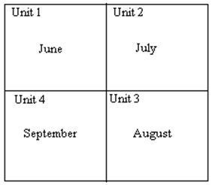If we divide the range into 4 units and season of grazing is also 4 months then each unit will be grazed rotation wise.
- If in one range area heterogeneous vegetation is present, then mixed type of livestock can be used to obtain uniform utilization of all spp.
- Modification: A modification of this grazing system is through rotation kind of animals instead of the time of grazing.
- 1st graze with cattle in the first unit, then move the cattle to the next unit and put goats in that unit.
- Similarly, sheep replace goats; camels replace sheep and the cycle repeats
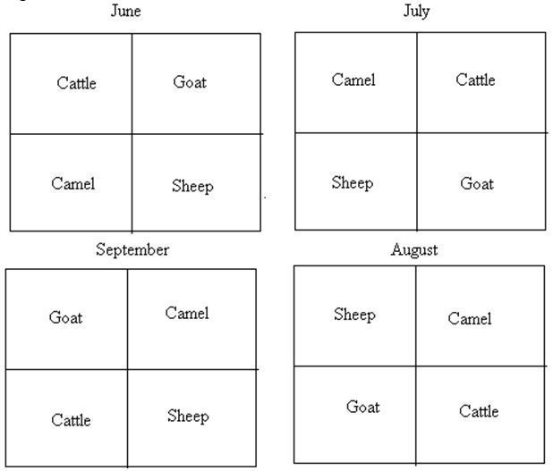
Advantages of Rotational Grazing System:
- Plant vigor is obtained
- Uniform utilization occur
- Animal gain weight
- It is easy to operate
Disadvantages of Rotational Grazing System:
- It is expensive

Deferred Grazing System:
- In this system, some portion from the whole rangeland is deferred (postponed) from grazing.
Objectives:
- To get vigor of vegetation
- Seed production occurs
- Establishment of seedling also occur
The range area is deferred for some time in order to gain these objectives
If our range of land has an area of 100 acres then we will divide it into two units. The 1st unit will be deferred from grazing and 2nd unit will be allowed to graze. As illustrated:

Difference b/w Rotational and Deferred System:
- In the rotational system, grazing in units occurs systematically ie in consecutive units.
- In the deferred system, only those areas are deferred which require improvement
Advantages and Disadvantages:
(For Rotational, Defer, Deferred-Rotational and Rest Rotational Systems)
Advantages:
- Better livestock distribution is obtained by dividing the area into smaller units
- Complete use of all forage spp is obtained
- Help in obtaining natural reseeding
- Trampling effects are reduced b/c animals are restricted in smaller areas.
- Handling of animal is easy on smaller areas.
- Range improvement occurs
- Effects of drought are minimized as mature forage is available on deferred or resting units.
Disadvantages:
- Fencing and water development are needed on each allotment, therefore costly
- More watering points are needed during the grazing season to get uniform utilization of all parts of grazing allotments or units
- Low-quality feed is available to an animal at the late growth stage of production
- Management flexibility is limited with deferred rotational and rotation grazing system
- Stocking density is increased on the grazed subunits or allotments, therefore, grazing intensity is increased.

Deferred Rotational Grazing system:
- This system is a combination of the deferred and rotational grazing system.
Objectives:
- To get vigor plants
- Seed production
- Seed establishment
This system is based on the concept of providing seasonal deferment which is rotated among the grazing units
Procedure:
- In this system, range area is divided into 4 units
- 1st unit is deferred for two years and grazing is done in rest of three units according to the rotation.
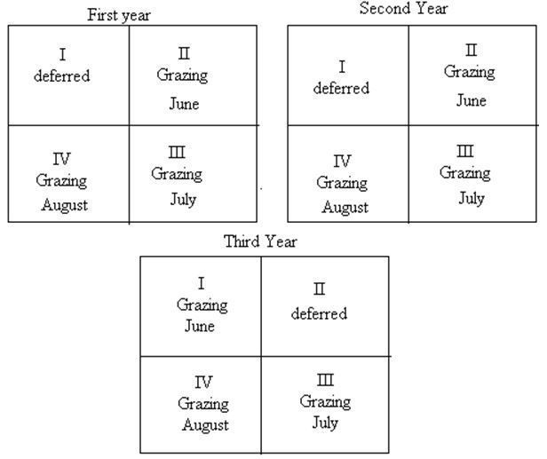
- Carrying capacity is calculated on the total range area in this system.
- Deferment period varies from 2 years or 3-6 months depending upon the situation.
- Generally, grazing units are based on the principle that the number of allotment may be equal to the number of grazing periods.

