

Presented by: Alia Sana

Subject:
Litrature on Social Sciences and Islam

Topic:
Information Need and Seeking Behaviour of Social Scientist

Information:
The word Information is derived from Latin word 'Informatio'
which means to " to give form to mind ",'instruct' or 'teach'.
Information is a basic need of human being.

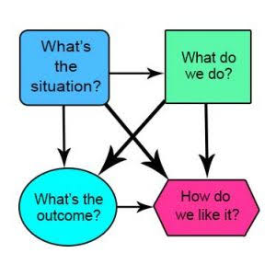
Characteristics of Information:
- Availability
- Accuracy
- Authenticity
- Confidentiality
- Integrity

Need:
A need is something that is necessary for an organism to live
a healthy life. Maslow's hierarchy of needs is a motivational theory in
psychology comprising a five-tier model of human needs, often
predicted as hierarchical levels within a pyramid.

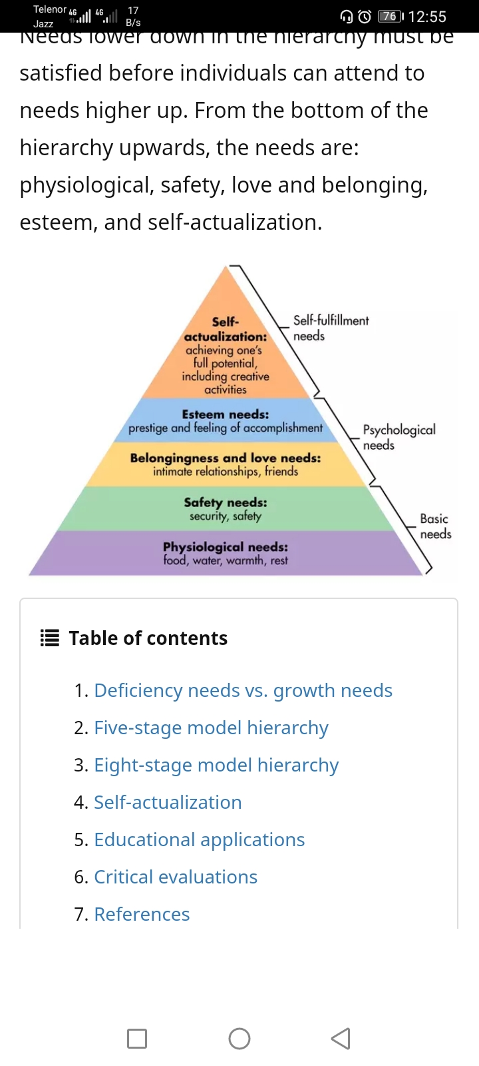

Information Need:
The term information need is often understood as an
individual or group's desire to locate and obtain information to satisfy a
conscious or unconscious need.

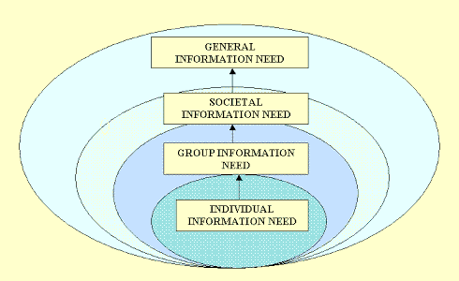

Information Seeking Behaviour:
Information seeking behaviour it specifically focuses
on searching, finding and retrieving information. Information seeking
behaviour is a process where people search information and utilize
the same to complete their assigned task.

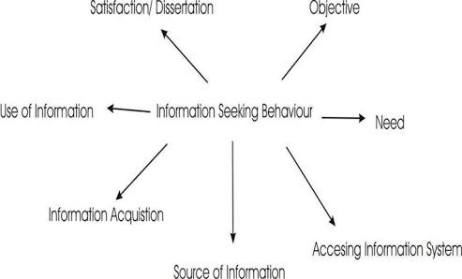

Types of barrier to information seeking:-
There are three types of barrier to information seeking
which may be different from those faced by their counterparts in Western
countries. These include:
- Limited availability of resources, especially full text resources;
- Poor Internet connection speed or Internet availability; and
- a lack of sufficient Arabic language sources.

Ellis's model of information-seeking of social scientist:
David Ellis ( born 23 june 1939) is an 
English academic and writer. Ellis was the first to model the process of
information-seeking behaviour of social scientist. He described six
fundamental of information seeking practiced by social scientist:

- Starting
- Chaining
- Browsing
- Differentiating
- Monitoring
- Extracting

Eight generic stages:
Al- Suqri revealed that several studies have also provided
evidence of the ways in which the information-seeking behaviour
of social scientist is being changed by the availability of Information
Technology and electronic resources. Al-Suqri actually developed an
integrated model of social science information-seeking behaviour
based on a synthesis of established models.
The synthesized model describes a pattern of information-
seeking behaviour that includes eight generic stages:

- Initiating
- Exploration
- Monitoring
- Categorization
- Shifting
- Selecting resources
- Collecting
- Ending





