The text coherence is characterized for having a defined structure and correlation among its sentences and ideas. Established patterns such as Theme and Rheme and thematic choices are used to give a coherent sense to the text. But these resources are nor the only ones, cohesive ties are other elements which combined with structural ones "give sense", in other words, they give texture to the text.
Texture then is considered what makes a text a real text instead of a group of sentences with no relation among them.
This blog's objective is to explain the different patterns used to order ideas and at the same time excercise the textual function applying and recognizing the Theme and Rheme.
Definitions Of Theme And Rheme
Theme: The main idea that you are talking about and lets the reader or listener know what the clause is going to be about.
Rheme: What you say about the main idea.
Patterns of the thematic progression
Constant-------> A common Theme is shared by Rhemes.
-------> Cohesive ties are very used to replace the subject and not be repetitive.
-------> Usually found in textbooks, descriptions, etc.
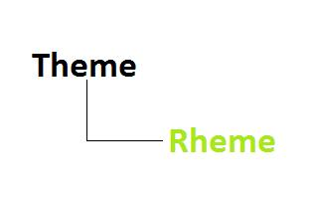
Linear -------> The Rheme of one clause is taken up as Theme of the subsequent clause.
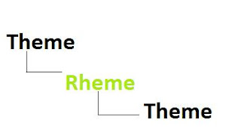
Split Rheme -> The Rheme of a clause has two components,

each of which is taken in turn as Theme of a subsequent clause.
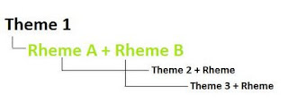
Derived Themes -> When two or more Themes alternate within a text.
* Usually found in large texts.
