Getting Started
Screen Layout
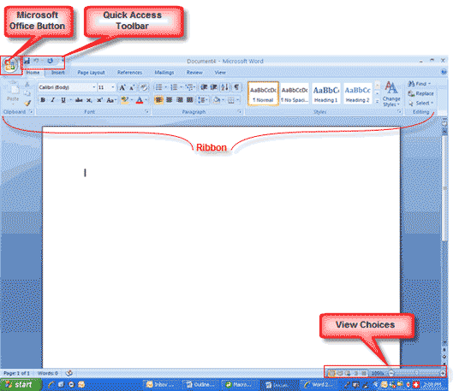
Menus
When you begin to explore Word 2007 you will notice a new look to the menu bar. There are three features that you should remember as you work within Word 2007: the Microsoft Office Button, the Quick Access Toolbar, and the Ribbon. These three features contain many of the functions that were in the menu of previous versions of Word. The functions of these three features will be more fully explored below.
The Microsoft Office Button
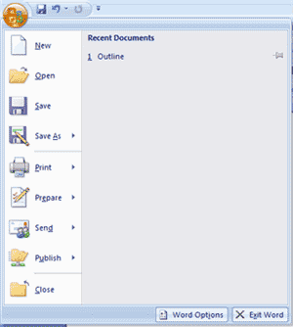
The Microsoft Office button performs many of the functions that were located in the File menu of older versions of Word. This button allows you to create a new document, open an existing document, save or save as, print, send (through email or fax), publish or close.

The Ribbon
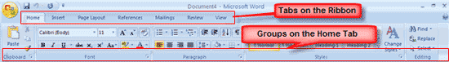
The Ribbon is the panel at the top portion of the document. It has seven tabs: Home, Insert, Page Layout, References, Mailings, Review, and View that contain many new and existing features of Word. Each tab is divided into groups. The groups are logical collections of features designed to perform functions that you will utilize in developing or editing your Word document. Commonly used features are displayed on the Ribbon, to view additional features within each group, click on the arrow at the bottom right of each group.
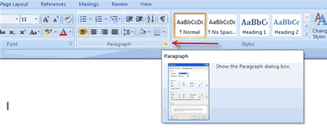
Each of the tabs contains the following tools:
Home: Clipboard, Fonts, Paragraph, Styles, and Editing.
Insert: Pages, Tables, Illustrations, Links, Header & Footer, Text, and Symbols
Page Layout: Themes, Page Setup, Page Background, Paragraph, Arrange
References: Table of Contents, Footnote, Citation & Bibliography, Captions, Index, and Table of Authorities
Mailings: Create, Start Mail Merge, Write & Insert Fields, Preview Results, Finish
Review: Proofing, Comments, Tracking, Changes, Compare, Protect
View: Document Views, Show/Hide, Zoom, Window, Macros

Quick Access Toolbar
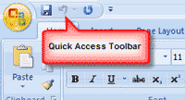
The quick access toolbar is a customizable toolbar that contains commands that you may want to use. You can place the quick access toolbar above or below the ribbon. To change the location of the quick access toolbar, click on the arrow at the end of the toolbar and click on Show Below the Ribbon.
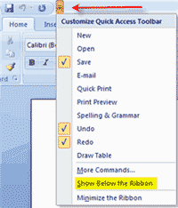
You can also add items to the quick access toolbar. Right click on any item in the Office Button or the Ribbon and click on Add to Quick Access Toolbar and a shortcut will be added to the Quick Access Toolbar.
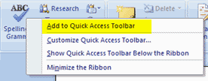
Create a New Document
There are several ways to create new documents, open existing documents, and save documents in Word:
- Click the Microsoft Office Button and Click New or
- Press CTRL+N (Depress the CTRL key while pressing the “N”) on the keyboard
You will notice that when you click on the Microsoft Office Button and Click New, you have many choices about the types of documents you can create. If you wish to start from a blank document, click Blank. If you wish to start from a template you can browse through your choices on the left, see the choices on center screen, and preview the selection on the right screen.
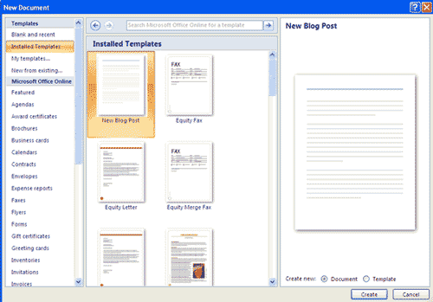
Opening an Existing Document
- Click the Microsoft Office Button and Click Open, or
- Press CTRL+O (Depress the CTRL key while pressing the “O”) on the keyboard, or
- If you have recently used the document you can click the Microsoft Office Button and click the name of the document in the Recent Documents section of the window Insert picture of recent docs
Saving a Document
- Click the Microsoft Office Button and Click Save or Save As (remember, if you’re sending the document to someone who does not have Office 2007, you will need to click the Office Button, click Save As, and Click Word 97-2003 Document), or
- Press CTRL+S (Depress the CTRL key while pressing the “S”) on the keyboard, or
- Click the File icon on the Quick Access Toolbar
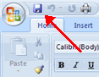
Renaming Documents
To rename a Word document while using the program:
- Click the Office Button and find the file you want to rename.
- Right-click the document name with the mouse and select Rename from the shortcut menu.
- Type the new name for the file and press the ENTER key.
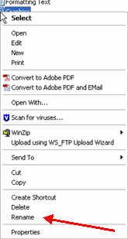
Document Views
There are many ways to view a document in Word.
- Print Layout: This is a view of the document as it would appear when printed. It includes all tables, text, graphics, and images.
- Full Screen Reading: This is a full view length view of a document. Good for viewing two pages at a time.
- Web Layout: This is a view of the document as it would appear in a web browser.
- Outline: This is an outline form of the document in the form of bullets.
- Draft: This view does not display pictures or layouts, just text.

To view a document in different forms, click the document views shortcuts at the bottom of the screen or:
- Click the View Tab on the Ribbon
- Click on the appropriate document view.
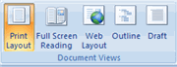

Close a Document
To close a document:
- Click the Office Button
- Click Close
Typing and inserting Text
To enter text, just start typing! The text will appear where the blinking cursor is located. Move the cursor by using the arrow buttons on the keyboard or positioning the mouse and clicking the left button. The keyboard shortcuts listed below are also helpful when moving through the text of a document:
Move Action | Keystroke
Beginning of the line | HOME
End of the line | END
Top of the document | CTRL+HOME
End of the document | CTRL+END
Selecting Text
To change any attributes of text it must be highlighted first. Select the text by dragging the mouse over the desired text while keeping the left mouse button depressed, or hold down the SHIFT key on the keyboard while using the arrow buttons to highlight the text. The following table contains shortcuts for selecting a portion of the text:
Selection | Technique
Whole word | double-click within the word
Whole paragraph | triple-click within the paragraph
Several words or lines | drag the mouse over the words, or hold down SHIFT while using the arrow keys
Entire document | choose Editing | Select | Select All from the Ribbon, or press CTRL+A
Deselect the text by clicking anywhere outside of the selection on the page or press an arrow key on the keyboard.
Inserting Additional Text
Text can be inserted in a document at any point using any of the following methods:
- Type Text: Put your cursor where you want to add the text and begin typing
- Copy and Paste Text: Highlight the text you wish to copy and right click and click Copy, put your cursor where you want the text in the document and right click and click Paste.
- Cut and Paste Text: Highlight the text you wish to copy and right click and click Cut, put your cursor where you want the text in the document and right click and click Paste.
- Drag Text: Highlight the text you wish to move, click on it and drag it to the place where you want the text in the document.
You will notice that you can also use the Clipboard group on the Ribbon.
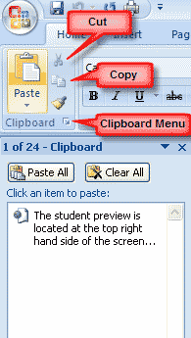
Rearranging Blocks of Text
To rearrange text within a document, you can utilize the Clipboard Group on the Home Tab of the Ribbon.
Insert picture of clipboard group labeled
- Move text: Cut and Paste or Drag as shown above
- Copy Text: Copy and Paste as above or use the Clipboard group on the Ribbon
- Paste Text: Ctrl + V (hold down the CTRL and the “V” key at the same time) or use the Clipboard group to Paste, Paste Special, or Paste as Hyperlink
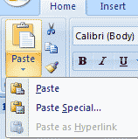
Deleting Blocks of Text
Use the BACKSPACE and DELETE keys on the keyboard to delete text. Backspace will delete text to the left of the cursor and Delete will erase text to the right. To delete a large selection of text, highlight it using any of the methods outlined above and press the DELETE key.
Search and Replace Text
To find a particular word or phrase in a document:
- Click Find on the Editing Group on the Ribbon
- To find and replace a word or phrase in the document, click Replace on the Editing Group of the Ribbon.
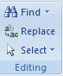
Undo Changes
To undo changes:
- Click the Undo Button on the Quick Access Toolbar
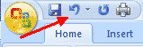
Styles
A style is a format enhancing tool that includes font typefaces, font size, effects (bold, italics, underline, etc.), colors and more. You will notice that on the Home Tab of the Ribbon, that you have several areas that will control the style of your document: Font, Paragraph, and Styles.
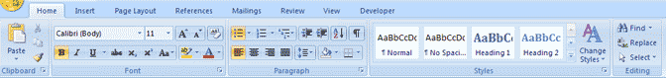
Change Font Typeface and Size
To change the font typeface:
- Click the arrow next to the font name and choose a font.
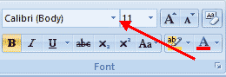
- Remember that you can preview how the new font will look by highlighting the text, and hovering over the new font typeface.
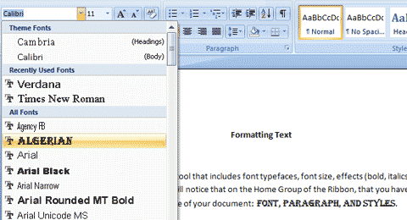
To change the font size:
- Click the arrow next to the font size and choose the appropriate size, or
- Click the increase or decrease font size buttons.
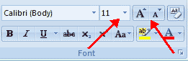
Font Styles and Effects
Font styles are predefined formatting options that are used to emphasize text. They include: Bold, Italic, and Underline. To add these to text:
- Select the text and click the Font Styles included on the Font Group of the Ribbon, or
- Select the text and right click to display the font tools
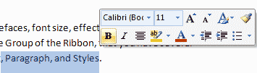
Change Text Color
To change the text color:
- Select the text and click the Colors button included on the Font Group of the Ribbon, or
- Highlight the text and right click and choose the colors tool.
- Select the color by clicking the down arrow next to the font color button.
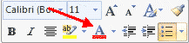
Highlight Text
Highlighting text allows you to use emphasize text as you would if you had a marker. To highlight text:
- Select the text
- Click the Highlight Button on the Font Group of the Ribbon, or
- Select the text and right click and select the highlight tool
- To change the color of the highlighter click on down arrow next to the highlight button.
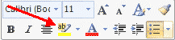
Copy Formatting
If you have already formatted text the way you want it and would like another portion of the document to have the same formatting, you can copy the formatting. To copy the formatting, do the following:
- Select the text with the formatting you want to copy.
- Copy the format of the text selected by clicking the Format Painter button on the Clipboard Group of the Home Tab
- Apply the copied format by selecting the text and clicking on it.
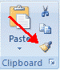
Clear Formatting
To clear text formatting:
- Select the text you wish to clear the formatting
- Click the Styles dialogue box on the Styles Group on the Home Tab
- Click Clear All
Formatting paragraphs allows you to change the look of the overall document. You can access many of the tools of paragraph formatting by clicking the Page Layout Tab of the Ribbon or the Paragraph Group on the Home Tab of the Ribbon.
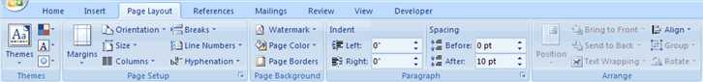
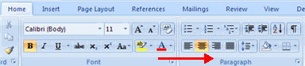
Change Paragraph Alignment
The paragraph alignment allows you to set how you want text to appear. To change the alignment:
- Click the Home Tab
- Choose the appropriate button for alignment on the Paragraph Group.
  - Align Left: the text is aligned with your left margin
  - Center: The text is centered within your margins
  - Align Right: Aligns text with the right margin
  - Justify: Aligns text to both the left and right margins.
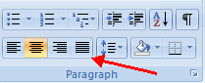
Indent Paragraphs
Indenting paragraphs allows you set text within a paragraph at different margins. There are several options for indenting:
- First Line: Controls the left boundary for the first line of a paragraph
- Hanging: Controls the left boundary of every line in a paragraph except the first one
- Left: Controls the left boundary for every line in a paragraph
- Right: Controls the right boundary for every line in a paragraph
To indent paragraphs, you can do the following:
- Click the Indent buttons to control the indent.
- Click the Indent button repeated times to increase the size of the indent.
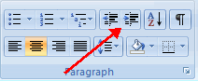
- Click the dialog box of the Paragraph Group
- Click the Indents and Spacing Tab
- Select your indents
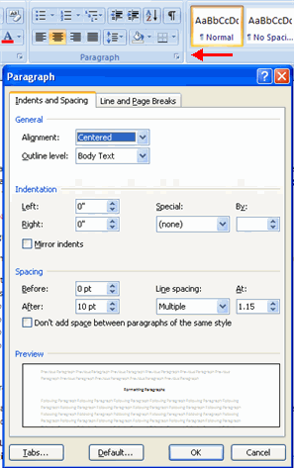
Add Borders and Shading
You can add borders and shading to paragraphs and entire pages. To create a border around a paragraph or paragraphs:
- Select the area of text where you want the border or shading.
- Click the Borders Button on the Paragraph Group on the Home Tab
- Choose the Border and Shading
- Choose the appropriate options
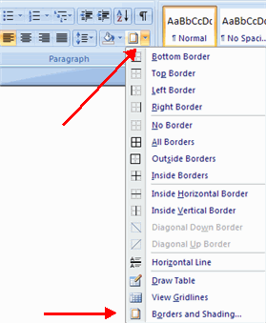
Apply Styles
Styles are a present collection of formatting that you can apply to text. To utilize Quick Styles:
- Select the text you wish to format.
- Click the dialog box next to the Styles Group on the Home Tab.
- Click the style you wish to apply.
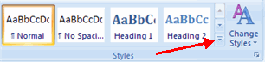
Create Links
Creating links in a word document allows you to put in a URL that readers can click on to visit a web page. To insert a link:
- Click the Hyperlink Button on the Links Group of the Insert Tab.
- Type in the text in the “Text to Display” box and the web address in the “Address” box.
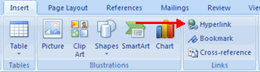
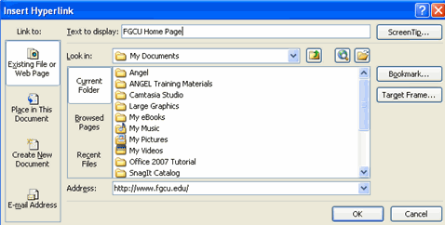
Change Spacing Between Paragraphs and Lines
You can change the space between lines and paragraphs by doing the following:
- Select the paragraph or paragraphs you wish to change.
- On the Home Tab, Click the Paragraph Dialog Box
- Click the Indents and Spacing Tab
- In the Spacing section, adjust your spacing accordingly
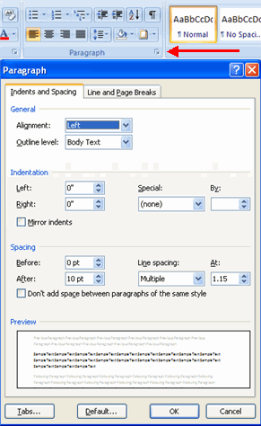

Create a Table
To create a table:
- Place the cursor on the page where you want the new table
- Click the Insert Tab of the Ribbon
- Click the Tables Button on the Tables Group. You can create a table one of four ways:
  - Highlight the number of row and columns
  - Click Insert Table and enter the number of rows and columns
  - Click the Draw Table, create your table by clicking and entering the rows and columns
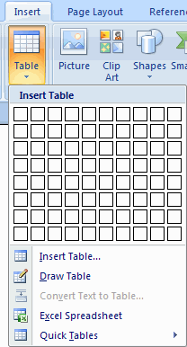
  - Click Quick Tables and choose a table
Enter Data in a Table
Place the cursor in the cell where you wish to enter the information. Begin typing.
Modify the Table Structure and Format a Table
To modify the structure of a table:
- Click the table and notice that you have two new tabs on the Ribbon: Design and Layout. These pertain to the table design and layout.
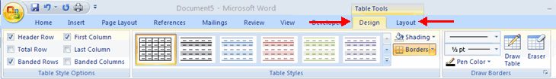
On the Design Tab, you can choose:
- Table Style Options
- Table Styles
- Draw Borders
To format a table, click the table and then click the Layout Tab on the Ribbon. This Layout tab allows you to:
- View Gridlines and Properties (from the Table Group)
- Insert Rows and Columns (from the Rows & Columns Group)
- Delete the Table, Rows and/or Columns (from the Rows & Columns Group)
- Merge or Split Cells (from the Merge Group)
- Increase and Decrease cell size (Cell Size Group)
- Align text within the cells and change text directions (Alignment Group)
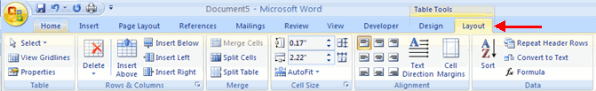
Word 2007 allows you to insert special characters, symbols, pictures, illustrations, and watermarks.
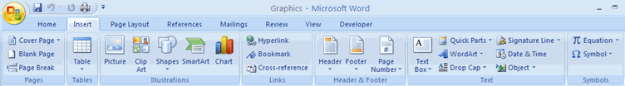
Symbols and Special Characters
Special characters are punctuation, spacing, or typographical characters that are not generally available on the standard keyboard. To insert symbols and special characters:
- Place your cursor in the document where you want the symbol
- Click the Insert Tab on the Ribbon
- Click the Symbol button on the Symbols Group
- Choose the appropriate symbol.
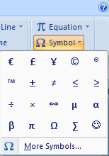
Equations
Word 2007 also allows you to insert mathematical equations. To access the mathematical equations tool:
- Place your cursor in the document where you want the symbol
- Click the Insert Tab on the Ribbon
- Click the Equation Button on the Symbols Group
- Choose the appropriate equation and structure or click Insert New Equation
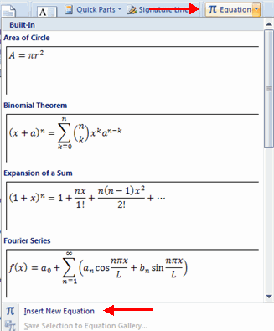
- To edit the equation click the equation and the Design Tab will be available in the Ribbon
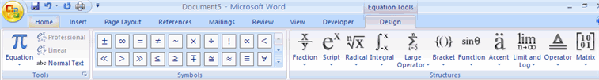
Illustrations, Pictures, and SmartArt
Word 2007 allows you to insert illustrations and pictures into a document. To insert illustrations:
- Place your cursor in the document where you want the illustration/picture
- Click the Insert Tab on the Ribbon
- Click the Clip Art Button
- The dialog box will open on the screen and you can search for clip art.
- Choose the illustration you wish to include
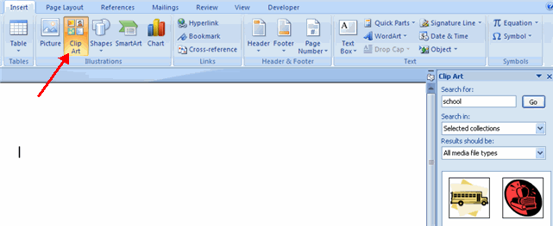
To insert a picture:
- Place your cursor in the document where you want the illustration/picture
- Click the Insert Tab on the Ribbon
- Click the Picture Button
- Browse to the picture you wish to include
- Click the Picture
- Click Insert
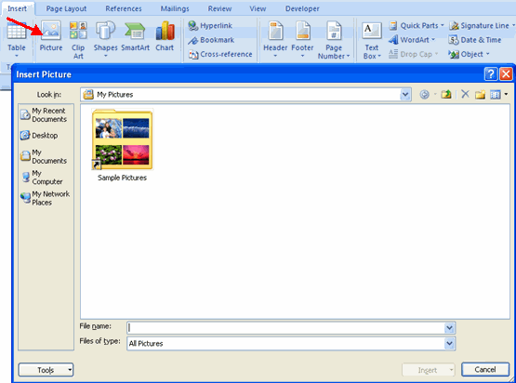
Smart Art is a collection of graphics you can utilize to organize information within your document. It includes timelines, processes, or workflow. To insert SmartArt
- Place your cursor in the document where you want the illustration/picture
- Click the Insert Tab on the Ribbon
- Click the SmartArt button
- Click the SmartArt you wish to include in your document
- Click the arrow on the left side of the graphic to insert text or type the text in the graphic.
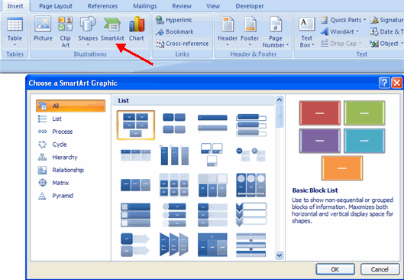
Resize Graphics
All graphics can be resized by clicking the image and clicking one corner of the image and dragging the cursor to the size you want the picture.
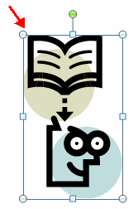
Watermarks
A watermark is a translucent image that appears behind the primary text in a document. To insert a watermark:
- Click the Page Layout Tab in the Ribbon
- Click the Watermark Button in the Page Background Group
- Click the Watermark you want for the document or click Custom Watermark and create your own watermark
- To remove a watermark, follow the steps above, but click Remove Watermark
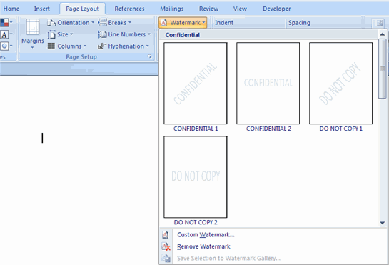

Apply a Page Border and Color
To apply a page border or color:
- Click the Page Layout Tab on the Ribbon
- On the Page Background Group, click the Page Colors or Page Borders drop down menus
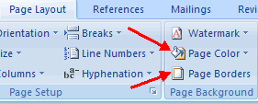
Insert Common Header and Footer Information
To insert Header and Footer information such as page numbers, date, or title, first, decide if you want the information in the header (at the top of the page) or in the Footer (at the bottom of the page), then:
- Click the Insert Tab on the Ribbon
- Click Header or Footer
- Choose a style
I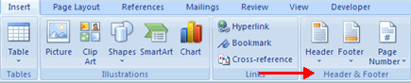
- The Header/Footer Design Tab will display on the Ribbon
- Choose the information that you would like to have in the header or footer (date, time, page numbers, etc.) or type in the information you would like to have in the header or footer
Create a Table of Contents
To create the table of contents:
- Put your cursor in the document where you want the Table of Contents
- Click the References Tab
- Click the Table of Contents button
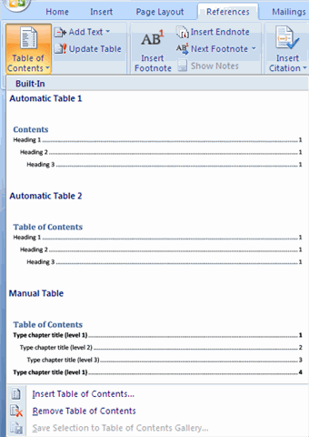
Update Table of Contents
If you have added or removed headings or other table of contents entries you can update by:
- Apply headings or mark individual entries as directed above
- Click the References Tab in the Ribbon
- Click Update Table
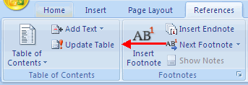
Delete Table of Contents
To delete a table of contents:
- Click the References Tab on the Ribbon
- Click Table of Contents
- Click Remove Table of Contents
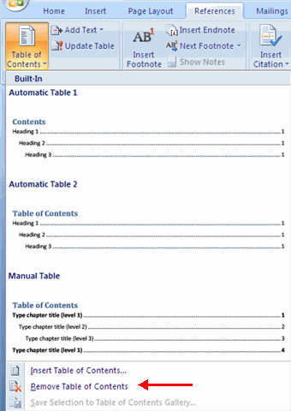
Simple web pages can be created in Word using the Save as Feature. In a web document, you can insert pictures and hyperlinks. To view the document as you would a web page:
- Click the View Tab on the Ribbon
- Click the Web Layout Button in the Document Views Group
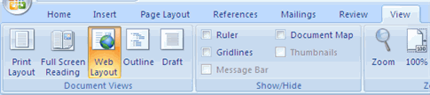
Entering Text
To enter text into the document, simply begin typing. If you want to adjust the layout of the page and text, you should use tables to format the page properly.
Hyperlinks
Hyperlinks, or links, allow the reader to click on text and go to another web site. To create a hyperlink:
- Select the text that will be the link
- Click the Insert Tab of the Ribbon
- Click the Hyperlink Button on the Links Group
- Type in the web address, or URL, of the link
- Click OK
Bulleted and Numbered Lists
Bulleted lists have bullet points, numbered lists have numbers, and outline lists combine numbers and letters depending on the organization of the list.
To add a list to existing text:
- Select the text you wish to make a list
- From the Paragraph Group on the Home Tab, Click the Bulleted or Numbered Lists button
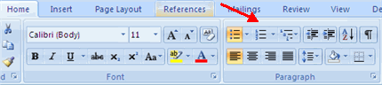
To create a new list:
- Place your cursor where you want the list in the document
- Click the Bulleted or Numbered Lists button
- Begin typing
Nested Lists
A nested list is list with several levels of indented text. To create a nested list:
- Create your list following the directions above
- Click the Increase or Decrease Indent button
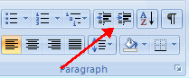
Formatting Lists
The bullet image and numbering format can be changed by using the Bullets or Numbering dialog box.
- Select the entire list to change all the bullets or numbers, or
Place the cursor on one line within the list to change a single bullet
- Right click
- Click the arrow next to the bulleted or numbered list and choose a bullet or numbering style.
