WHAT IS A VIRUS
- Infectious
- Intracellular
- RNA or DNA genome, not both
- Protein coat*
- May of may not have lipid envelope
- May have broad or narrow host range
- Replication involves eclipse (breaking apart of virus particles) and reassembly
Viruses may be simple or complex
- Genome sizes 0.3 - 300 kb; average sizes vary with host organism types
- May have single-stranded or double-stranded RNA or DNA genome
- If RNA, may be + or – sense
- May have one or many proteins in particles
- May or may not have lipid envelope
Composition of viruses infecting different kingdoms
- No “rules” about virus families that may or may not be present in a given kingdom
- Some types of viruses are found more in some kingdoms than in others
  - Many plant viruses contain ssRNA genomes
  - Many fungal viruses contain dsRNA genomes
  - Many bacterial viruses contain dsDNA genomes
- Host properties determine the types of viruses that tend to be found in members of a biological “kingdom”
- Complexity of viruses in different families varies considerably
Types of viral genomes
- double-stranded (ds) DNA
  - Rarely segmented
  - Often large
- single-stranded (ss) DNA
  - Rarely large
  - Less common than dsDNA
- ssRNA, negative sense
  - Often found in viruses with broad host ranges
- ssRNA, positive sense
  - Most common overall
- dsRNA
  - Often segmented
  - Particle structure often critical
VIRUS STRUCTURE
- Basic rules of virus architecture, structure, and assembly are the same for all families
- Some structures are more complex than others
- The capsid (coat) protein is the basic unit of structure; functions that may be fulfilled by the capsid protein are to:
  - Protect viral nucleic acid
  - Interact specifically with the viral nucleic acid for packaging
  - Interact with vector for specific transmission
  - Interact with host receptors for entry to cell
  - Allow for release of nucleic acid upon entry into new cell
  - Assist in processes of gene regulation
Nucleoprotein has two basic structure types:
- Virus structure is studied by:
  - Transmission electron microscopy (EM)
  - Cryo-EM – one of the most powerful methods currently available
  - X-Ray diffraction
  - Neutron scattering
  - Primary sequence analysis
  - Protease and foot printing
  - Site-directed mutagenesis
Nucleoprotein has two basic structure types:
- HELICAL: Rod shaped, varying widths and specific architectures; no theoretical limit to the amount of nucleic acid that can be packaged
- CUBIC (Icosahedral): Spherical, amount of nucleic acid that can be packaged is limited by the of the particle
Principles of virus structure
- Nucleoprotein must be stable but dissociatable
- Capsid is held together by non-covalent, reversible bonds: hydrophobic, salt, hydrogen bonds
- Capsid is a polymer of identical subunits
- Terms:
  - Capsid = protein coat
  - Capsomere = subunit clusters visible in EM
  - Structural unit = protein subunit
  - Nucleocapsid = nucleic acid + protein
  - Virion = virus particle
- Capsid proteins are compactly folded proteins which:
  - Fold only one way, and robustly
  - Vary in size, generally 50-350 aa residues
  - Have identifiable domains
  - Can be described topologically; similar topological features do not imply evolutionary relationships
Helical symmetry
- Tobacco mosaic virus is typical, well-studied example
- Each particle contains only a single molecule of RNA (6395 nucleotide residues) and 2130 copies of the coat protein subunit (158 amino acid residues; 17.3 kilodaltons)
  - 3 nt/subunit
  - 16.33 subunits/turn
  - 49 subunits/3 turns
- TMV protein subunits + nucleic acid will self-assemble in vitro in an energy-independent fashion
- Self-assembly also occurs in the absence of RNA

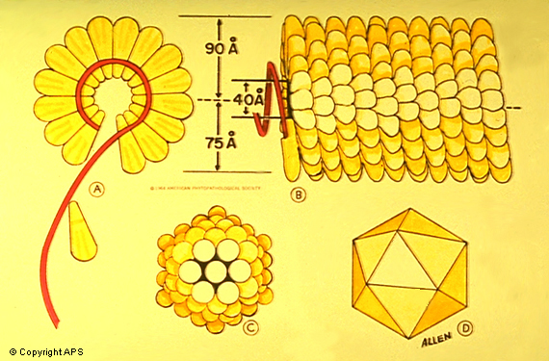
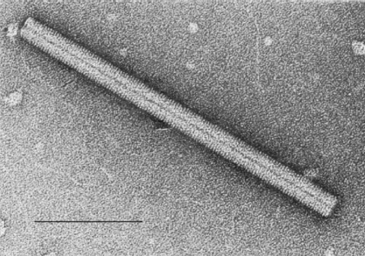
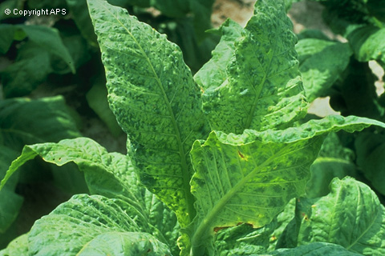

Cubic (icosahedral) symmetry
- Tomato bushy stunt virus is typical, well-studied example
- Each particle contains only a single molecule of RNA (4800 nt) and 180 copies of the coat protein subunit (387 aa; 41 kd)
- Viruses similar to TBSV will self-assemble in vitro from protein subunits + nucleic acid in an energy-independent fashion
TBSV icosahedron is 35.4 nm in diameter

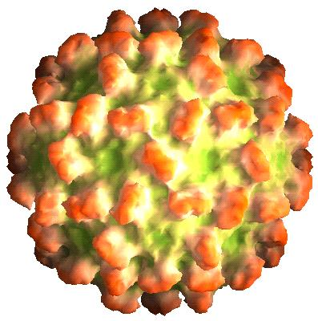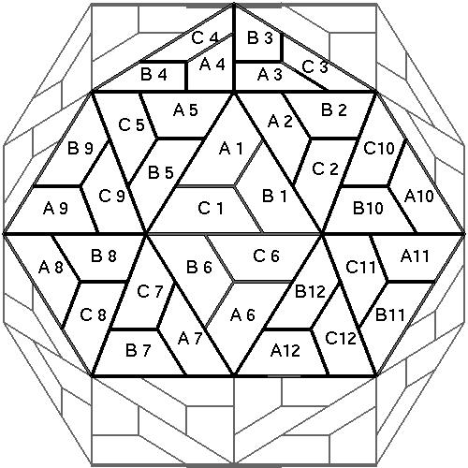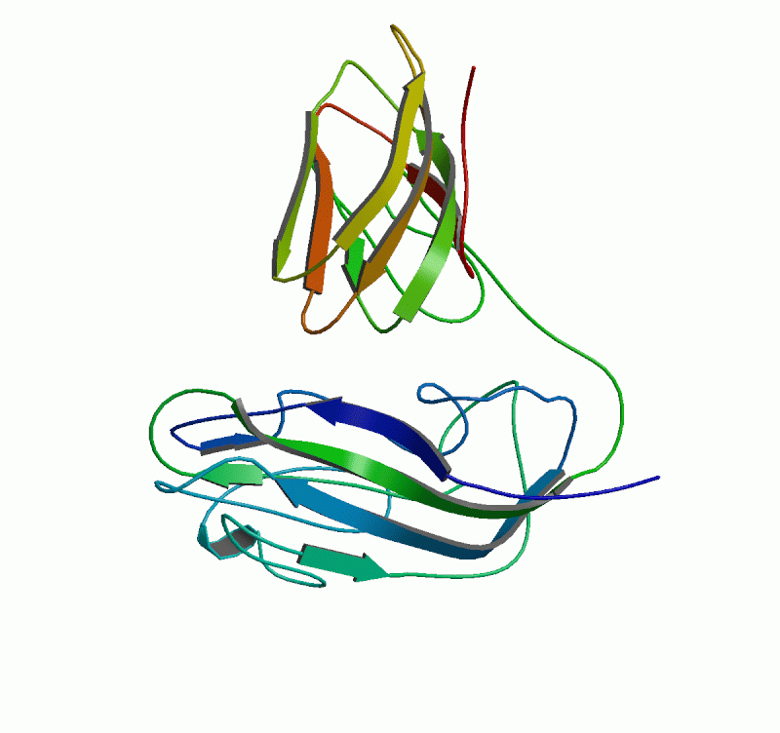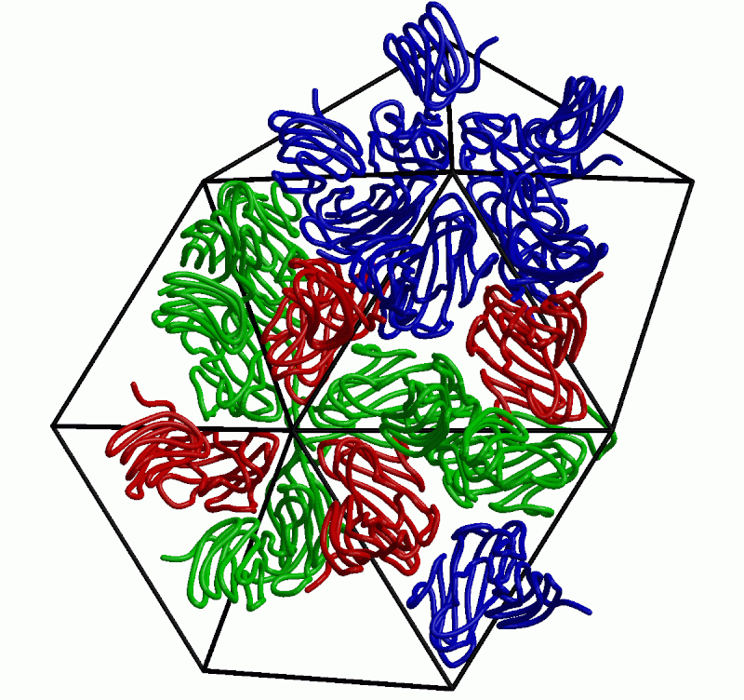
CLASSIFICATION & NOMENCLATURE of VIRUSES

A large number of morphologically and physico-chemically distinct types of viruses that infect virtually all classes of living organisms have been described. Generating some order from the chaos that existed with respect to the naming and cataloguing of viruses became the task of the International Committee on the Nomenclature of Viruses (ICNV), which first met in 1966. In keeping with the spirit of taxonomy, the committee changed its name to the International Committee on the Taxonomy of Viruses in 1973, which is what it is today. The 7th Report of the ICTV was published in Spring, 2000. It contained three orders, 56 families, 9 subfamilies, 233 genera, and 1550 virus species. Descriptions of satellite viruses, viroids, prions, and retrotransposons are included.
The concept of classifying viruses on the basis of virus properties as opposed to host affinities or biological effects has integrated the field and allowed for a sensible approach to the study of comparative virology. A centralized repository of virus information, the ICTV database (ICTVdb) is under construction and nearly completed. It includes information gathered from several large databases from around the world. The availability of such information has facilitated the job of accurate identification and diagnosis of new and important virus diseases. The characterization of viruses and their assignment to specific groups and families has had a major impact on what properties virologists must examine in order to properly identify and classify the causal agent of a specific virus disease. Our understanding of the interrelationships among different viruses, genera, and families continues to increase, much through comparative sequence analysis. We therefore continue to gain more confidence in the system we use to classify viruses.
Until recently, many viruses were not associated with specific taxa and most plant viruses were categorized into groups rather than families or genera. As more sequence data have accumulated, more viruses have been placed in newly described or existing taxa, and the “group” designation has given way to categorization into families or genera of existing families. Some viruses are still are not associated with named families, but with the current taxonomic framework solidly in place, this number is being reduced with each report of the ICTV.

Virus Orthography: Orthography is how something is written. Virus orthography changed in 1999, when the ICTV decided that virus names should be italicized, just as true Latin binomials are. This is a matter of considerable controversy among virologists, since virus nomenclature and orthography do not lend themselves to the binomial structure otherwise. Section IX of the ICTV Code reads as follows:
3.39 In formal taxonomic usage, the accepted names of virus Orders, Families, Subfamilies, and Genera are printed in italics and the first
letter capitalized.
3.40 Species names are printed in italics and have the first letter of the first word capitalized. Other words are not capitalized, unless they are proper nouns or parts of proper nouns.
3.41 In formal usage, the name of the taxon shall precede the taxonomic unit.
Classification, nomenclature, and orthography
- What is the purpose of classification?
  - To make order
  - To be able to communicate with each other
  - To assemble like members with each other
- Various virus classification schemes have been used
  - Host & symptoms have been important considerations
  - Particle morphology was important after EM developed
  - Physico-chemical properties became important later
    - Sedimentation coefficient and density of particles
    - Protein compositions and sizes
    - Nucleic acid types, numbers, and sizes
- Sequence analysis confirmed most relationships that were inferred otherwise, and revealed new ones
  - Molecular phylogeny now a primary tool for classifying viruses
  - Complete genomes can be analyzed relatively quickly
Classification, nomenclature, and orthography
- Latin binomials were proposed first by Holmes in 1939
- Various other schemes proposed between 1940 and 1966
- 1966 the International Committee for the Nomenclature of Viruses formed; met in 1970
- Changed to the International Committee for the Taxonomy of Viruses in 1973
- 7th Report of the ICTV was published in 2000
  - 56 families, 9 subfamilies, 233 genera, and 1550 virus species
  - Includes retrotransposons, satellites, viroids, prions
- Rules of orthography changed in 1999 to require italics, but no true binomial – only modified binomial e.g.
  - Family Reoviridae
    - Genus Orbivirus
      - Species Bluetongue virus (24 named strains: BTV-1 to BTV-24)
- Criteria for species demarcation vary for different families

Typical +sense RNA virus replication cycle

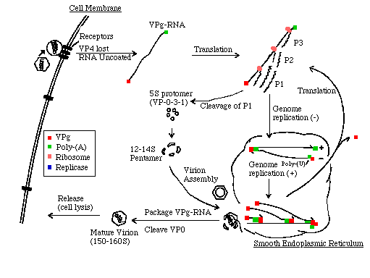
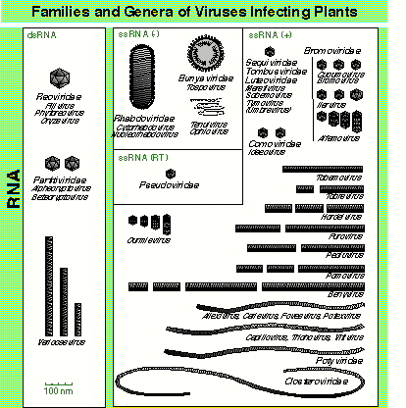

From 7th Report of the ICTV (Academic Press, 2000)

