Phylum Oomycota
Phylum Oomycota contains a single class i.e. Oomycetes
Characters of Class Oomycetes:
- On the basis of different biochemical and molecular characteristics they can be separated from true fungi.
- Biflagellate zoospores are present (anterior flagellum directed forward is tensil type while the posterior flagellum directed backward is whiplashed type). Due to the presence of two different types of flagella they are termed as Heterokont.
- Ultra structure of zoospores separates them from Chytridiomycetes.
- There are two types of zoospores:
    - Primary spores (Pyriform): These are pear shaped.
    - Secondary spores (Reniform): These are kidney shaped.
- Those members in which both types of spores are formed are called dimorphic and those having only one type are called monomorphic.
- Species may be aplanetic, Monoplanetic, Diplanetic, or polyplanetic.
- Diploid thallus is present with the presence of gametangial meiosis.
- Members of this class are Eucarpic and holocarpic.
- Their cell-wall contains β− glucans, an amino acid hydroxyproline and cellulose.
- Mitochondria have tubular cristae.
- Sporangia may produce zoospores or can directly germinate and behave as conidia.
Reproduction:
- Asexual Reproduction: It occurs by means of Sporangia, which will directly germinate and at that time called conidia.
- Sexual Reproduction: It occurs by the fusion of two dissimilar gametes i.e. Antheridium and Oogonium. This type of reproduction is known as Oogamous as a result of which thick walled resting spores are produced known as oospores.
Classification:
It has following orders:
- Leptomitales
- Lagenidiales
- Saprolegniales
- Rhipidiales
- Peronosporales
But Peronosporales is the important one.
Peronosporales:
- They are Eucarpic and cause various diseases e.g. Damping off, Downy Mildew, and White Rust.
- Zoospores may be within a sporangium or an evanescent (delicate) vesicle.
- Monomorphic only reniform zoospores are produced.
- This order has following families:
- Pythiaceae
- Peronosporaceae
- Albuginaceae
- Pythiaceae:
- Sporangiophore is of indeterminate type.
- Sporangia are produced singly or in clusters or in whorls on ordinary somatic hyphae.
- They cause group of diseases e.g. Damping off and Late Blight.
- Peronosporaceae:
- Sporangiophore is of determinate type.
- These cause diseases known as Downy Mildew.
- Spores are wind borne.
- This family is divided into five important genera:
- Sclerospora: Sporangiophore is long stout hyphae which up rise branches on which sporangia are produced.
- Plasmopara: Sporangiophores are branched and their subdivisions occur at their right angles on their tips sporangia are produced.
- Peronospora: Sporangiophores are dichotomously branched at acute angles taper towards tips and bear their sporangia and these sporangia directly germenate.
- Pseudoperonospora: Members of this genus are similar to Peronospora but sporangia produce zoospores and do not directly germinate.
- Bremia: At the tip four (4) saucer shaped structures are formed which are known as Sterigmata and each sterigmata bears a sporangium.
- Basidiophora
- Albuginaceae:
- Sporangia are produced on a short, club shaped structure in the form of a chain and are also indeterminate.
- These cause a group of diseases known as White rust.
Family Pythiaceae has two genera: 1) Pythium and 2) Phytophthera
Difference between Pythium and Phytophthera:
Pythium | Phytophthera
- Haustorium is absent. | - Haustorium is present.
- Sporangia are similar to somatic structure. | - Sporangia are different from somatic structure.
- Vesicle is present. | - Vesicle is absent.
- e.g. Pythium debaryanum causes Damping off disease. | - e.g. Pytophthera infestans causes Late blight of Potato.
- Sporangia are producede on ordinary somatic hyphae. | - Sporangia are produced on indeterminate sporangiophores.
Taxonomic Status of;
- Pythium debaryanum Causes: Damping off Disease
- Pytophthera infestans Causes: Late Blight of Potato
- Order: Peronosporales
- Family: Pythiaceae
- Plasmopara viticola Causes: Downy Mildew of Grapes
- Sclerospora graminicola Causes: Gram ear disease of pearl millet
- Pseudoperonospora cubensis Causes: Downy Mildew of Cucurbits
- Peronospora destructor Causes: Downy Mildew of Onions
- Basidiophora sp.
- Bremia luctuca Causes: Downy Mildew of Lettuce
  - Order: Peronosporales
  - Family: Peronosporaceae
- Albugo candida Causes: White rust of Crucifers
  - Order: Peronosporales
  - Family: Albuginaceae

POSITIVE CRITICISM, ERRORS AND SUGGESTIONS ALWAYS WELCOMED.
FUNGI REPRODUCTION

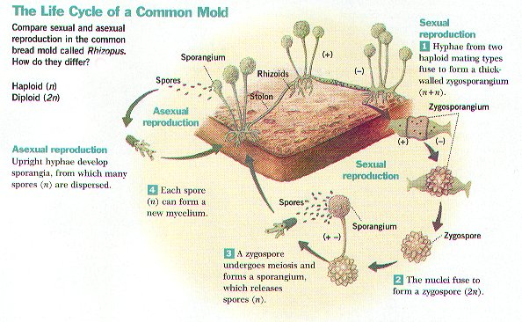
PHYLUM ZYGOMYCOTA 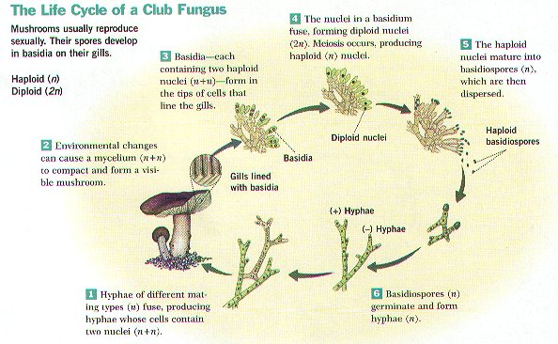

PHYLUM BASIDIOMYCOTA
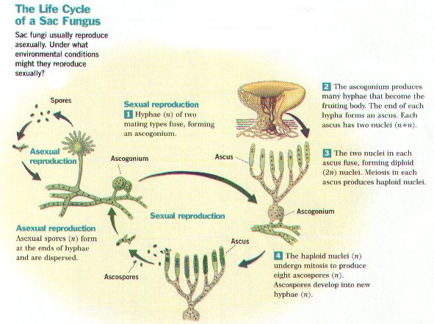
PHYLUM ASCOMYCOTA

