Phylum Zygomycota
Phylum Zygomycota has two classes;
- Zygomycetes
- Trichomycetes

Characteristics of Class Zygomycetes:
- Production of a thick walled resting spore called a zygospore (Gr. Zygos = yoke + spora = seed, spore). These zygospores are produced by the fusion of two iso-gametangia. These Zygospores are produced within Zygosporangium.
- Mycelium is extensive and hyphae are coenocytic.
- Asexual reproduction is by sporangiospores although some species produce other types of spores.
- On the sporangiophore a large no. of small structures are found these are known as sporangiola.
- Some species are dimorphic (having the capacity to grow as a single cell like yeast or to produce mycelia).
- Flagellate (motile) cells and centrioles are absent.
- The tissue that gives rise to spores is called prymordia.

Habitat:
They are found in a variety of habitats such as soil, dung, fruits, flowers, stored grains, fleshy plant organs, mushrooms, invertebrates and vertebrates, including humans.

Nutrition: They are facultative as well as obligate parasites of plants, true fungi and animals and predators of animals. A few species form mycorrhizal association with plant roots.

Classification: [Benjamin].
Class Zygomycetes has following orders;
- Mucorales [important]
- Entomophthorales
- Zoopagales
- Dimargaritales
- Kickxellates
- Endogonales
- Glomales

.
- Mucoraceous fungi have well developed mycelium which is coenocytic.
- They are saprobes that occur on dung, soil, and other organic debris.
- It causes soft rot of potato and strawberry during storage and shipping e.g. Rhizopus and Mucor.

TAXONOMIC STATUS |  | 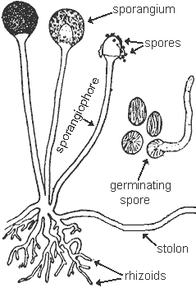
Kingdom  Phylum  Class  Order  Family  Genus  Species  Disease caused | Eumycophyta  Zygomycota  Zygomycetes  Mucorales  Mucoraceae  Rhizopus  Rhizopus stolonifer  Rots
.

Difference between Rhizopus and Mucor
Rhizopus | Mucor
- Rhizoids are present.  - Stolons are present.  - Many sporangiophores arise from one point. | - Rhizoids are absent.  - Stolons are absent.  - One sporangiophore arises from one point.

