CLASSIFICATION OF FUNGI
FUNGAL SYSTEMATICS

Taxonomy is the practice and science of classification

Taxonomy: The study of classification of organisms into taxa or groups on the basis of similarities and differences i.e. morphology, host specialization, physiological characters, genetic characters between organisms is known as taxonomy.

Primitively, living things were classified only into two kingdoms using morphological characteristics:

- Animal kingdom 2. Plant kingdom

[Linnaeus’s classification (1753): He said

- if a thing simply exists, it is mineral,
- if it is living it is vegetable
- if it has some sensations, it is animal.

So simply he classified living things into plants and animals.]

Whittaker’s classification (1969): He classified the living things into five kingdoms on the basis of their morphology, level of organization, and mode of nutrition as followings:

1. Monera 2. Protista 3. Animalia 4. Plantae 5. Fungi

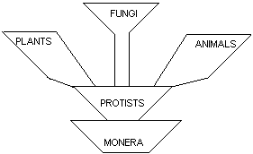

Monophyletic Group: A group that contains an ancestor and all its descendants.

Polyphyletic Group: The groups that do not share a close common ancestor.

Paraphyletic Group: A group that includes some relatives of a common ancestor, but not all of them.

Phylogenetic Classification: A classification based on evolutionary relationship.

Phylogeny: It is the study of genealogy (line of descent from an ancestor) of organisms.

Recent DNA techniques are used to classify the organisms, these techniques include: PCR (Polymerase Chain Reaction), RFLP (Random Fragment Length Polymorphism).

As in earlier five kingdoms classification there was a kingdom Fungi. The organisms of this Kingdom were further divided into three kingdoms by using DNA technology as follows:

Classification of Fungi
Kingdom | Phylum
1. Eumycophyta (True Fungi) | - Chytridiomycota  - Zygomycota  - Ascomycota  - Basidiomycota
2. Stramenopila: (organisms that have phagotrophic mode of nutrition like animals. So these organisms have both animals and fungal properties). | - Oomycota  - Hyphochytriomycota  - Labyrinthulomycota
3. Protists: (unicellular organisms) | - Plasmodiophoromycota  - Dictyosteliomycota  - Acrasiomycota  - Myxomycota

Rules of Nomenclature of Fungi:
All activities concerned with the naming of Fungi and many of those involving their classification fall under the rules contained in “International Code of Botanical Nomenclature”.

Rules of nomenclature important to mention here apply to:
- Typification
- Use of priority
- Citation of authorities.

  - Typification: It involves designating a specimen (a collection dried culture, or slide mount) or, since 1993, a culture preserved in a metabolically inactive state, as the holotype [The specimen used as the basis of the original published description of a taxonomic group and later designated as the type specimen] for each new species or infraspecific taxon. Designating of a type specimen is a requirement for a species to be validly published. In some cases, photographs or drawings may even represent the species and there is a proposal to use DNA samples.

  - Use of Priority: If a single species is described by two mycologists or in some cases more than once by the same mycologist, in such cases the species first described has first priority. Some times the description of a new taxon is unknown to second worker because both publications are in press in different journals at the same time, in such cases exact date of publication or issue of journal is important in determining priority. Some times Mycologists may over look already described taxon; he or she may re-describe a taxon or species. This has happened with very well known fungi in the world. The cultivated mushroom (Button Mushroom), longe known as Agaricus bisporus. But now thought to have been described earlier as Agaricus brnnescens.

  - Citation of Authorities: The name of the person who described a species is cited just after the taxon, e.g. Mucor corymbifer Cohn. was described by Cohn 1884. This species was then placed by Sccardo and Trotter in 1912 in the genus Absidia and is cited correctly as Absidia corymbifer (Cohn) Sacc. & Trotter.

PHYLUM CHYTRIDIOMYCOTA

CLASS: Chytridiomycetes.

Characters of Class Chytridiomycetes:
- About 100 genera & about 1000 species are known.
- Production of motile cells (zoospores) with single, posterior whiplash flagellum.
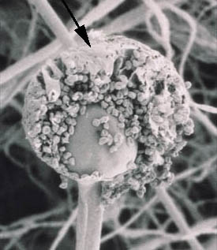
- Coenocytic structure [Non-septate] of thallus, whether a globose or ovoid (oval shaped) structure, an elongated simple hypha, or a well developed mycelium.

- Zygote [A zygote (from Greek zugōtos ‘joined’, from zugoun ‘to join’) is a cell that is the result of fertilization. That is, two haploid cells—usually an ovum from a female and a sperm cell from a male—merge into a single diploid cell called the zygote (or zygocyte)] is converted into resting spore or resting sporangia.
- They have a slippery, glistening (shiny) surface due to the presence of chitin and glucan in their cell walls.
- Period of encystment: Period during which a spore remain in the form of a cyst.
- Swarming period: Period between germination and encystment or between two encystments. During this period spores are motile (able to move or swim). It is also called motility or swimming period.

- There are different types of Species on the basis of no. of swarming periods:
  - Aplanetic: There may be no swarming period.

  - Monoplanetic: These are species that have one swarming period.

  - Diplanetic: These are species that have two swarming periods.

  - Polyplanetic: More than two swarming periods are present.

- Most of the members are morphologically simple and may be endobiotic and epibiotic.

- Endobiotic: Those Chytridiomycetes that live and reproduce entirely within the cell of host.
- Epibiotic: Those producing reproductive structures on the outside surface of living host or dead organic matter.

- They are holocarpic.

Habitat:
They are aquatic or soil inhabiting. Some of the anaerobic species have been known to exist in the guts of herbivores.

Occurrence and Importance:
- Most Chytrids are of little direct importance.
- Some of the members are aquatic and parasitize and destroy algae (that form a link in the food chain of aquatic animals).
- Olpidium, Synchytrium, and Physoderma are parasites on economic plants.
- Allomycetes & blastocladiella are used as research tools in study of morphogenesis.
- Coelomyces parasitize the mosquito larvae.

Somatic Structures:

Mycelium: Some of the members are unicellular and holocarpic with no mycelium, in some species there is only scanty mycelium represented only by a few branches of hyphae.

Thallus: Morphologically complex Chytrids produce true mycelial thallus.

Septation: Mycelium of some species may form pseudosepta (septum like partition or a plug of a chemical composition different from that of hyphal wall deposited as intervals in the hyphae). Hyphae are typically coenocytic.

Cell wall: Lack cell wall in early stages of development.

Rhizoides: The most complex species have a few rhizoids which anchor the substratum.

Rhizomycelium: Some species produce rhizomycelium (extensive system of hyphae like filaments that usually do not contain nuclei but through which nuclei migrate) which connect number of thalli together.

REPRODUCTION
Asexual Reproduction: In majority of flagellate fungi, sporangium is asexual reproductive structure. In early stages of development, sporangium contains uncleaved protoplasm with many nuclei. As the sporangium develops, entire protoplasm undergoes cleavage, producing zoospores. Zoospores swim for sometime, encyst and germinate usually after a short period.

Sexual Reproduction:
- Planogametic Coupulation.
- Conjugation of isogamous planogametes.
- Conjugation of anisogamous planogametes.
- Fertilization of non-motile female gamete (egg) by a motile male gamete (antherozoid).
- Gametangial Coupulation.
- Somatogamy.

Class Chytridiomycetes is divided into four orders but more recently fifth order has also been proposed these orders namely include
- Spizellomycetales
- Chytridiales
- Blastocladiales
- Monoblepharidales
- Neocallimasticales

But the chytridiales being the most important of all so included in the course of PP-401.

Chytridiales:
The members of this order are also known as Chytrids.
Mycelium: In this order mycelium is absent but rhizoides or rhizomycelium may be presenting some species.
Morphologically simple Chytrids are endo-biotic (living entirely within the host). Some of the forms are epi-biotic (producing their reproductive structures on the surface of the host).
Mono-centric: If the rhizoidal system bears only a single reproductive structure, the thallus is mono-centric.
Poly-centric: The thallus is poly-centric if it bears more than one reproductive structures.
Operculate: Some species always form a well defined circular cap or lid like structure at the tip of sporangium for zoospore release, known as operculum and species having this are known as operculate.
Inoperculate: On the other hand species having no operculum are known as inoperculate.
Order is divided into nine families, Synchytriaceae being the most important.
Family Synchytriaceae:
- The members of this family are parasites.
- Thallus is divided into several reproductive organs (sporangia or gametangia), developed in a common membrane and is holocarpic.
- Sorus: The members also form an aggregated mass of sporangia or spores called as a sorus.
Important species is Synchytrium endobioticum causing black wart of potato.

TAXONOMIC STATUS |  | DISEASE
Kingdom  Phylum  Class  Order  Family  Genus  Species  Disease caused | Eumycophyta Chytridiomycota Chytridiomycetes Chytridiales  Synchytriaceae  Synchytrium  Synchytrium endobioticum  Black wart e of potato | 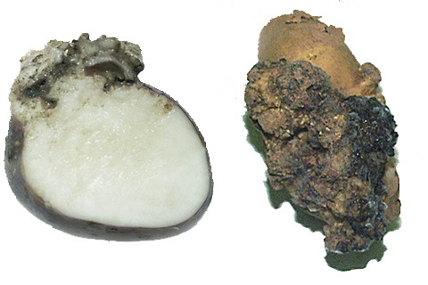

- Most of the members are soil and water inhabiting.
- Causes well known disease Black wart disease of potato.
- Widely distributed in potato growing areas.
- Genus Synchytrium contain more than 100 species.
- These are parasites of flowering plants.
- They are Endobiotic and Holocarpic fungi with Inoperculate sporangium.

Phylum Zygomycota
Phylum Zygomycota has two classes;
- Zygomycetes
- Trichomycetes

Characteristics of Class Zygomycetes:
- Production of a thick walled resting spore called a zygospore (Gr. Zygos = yoke + spora = seed, spore). These zygospores are produced by the fusion of two iso-gametangia. These Zygospores are produced within Zygosporangium.
- Mycelium is extensive and hyphae are coenocytic.
- Asexual reproduction is by sporangiospores although some species produce other types of spores.
- On the sporangiophore a large no. of small structures are found these are known as sporangiola.
- Some species are dimorphic (having the capacity to grow as a single cell like yeast or to produce mycelia).
- Flagellate (motile) cells and centrioles are absent.
- The tissue that gives rise to spores is called prymordia.

Habitat:
They are found in a variety of habitats such as soil, dung, fruits, flowers, stored grains, fleshy plant organs, mushrooms, invertebrates and vertebrates, including humans.
Nutrition: They are facultative as well as obligate parasites of plants, true fungi and animals and predators of animals. A few species form mycorrhizal association with plant roots.

Classification: [Benjamin].
Class Zygomycetes has following orders;
- Mucorales [important]
- Entomophthorales
- Zoopagales
- Dimargaritales
- Kickxellates
- Endogonales
- Glomales

.
- Mucoraceous fungi have well developed mycelium which is coenocytic.
- They are saprobes that occur on dung, soil, and other organic debris.
- It causes soft rot of potato and strawberry during storage and shipping e.g. Rhizopus and Mucor.

TAXONOMIC STATUS |  | 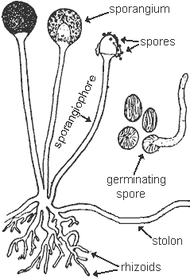
Kingdom  Phylum  Class  Order  Family  Genus  Species  Disease caused | Eumycophyta  Zygomycota  Zygomycetes  Mucorales  Mucoraceae  Rhizopus  Rhizopus stolonifer  Rots
.

Difference between Rhizopus and Mucor
Rhizopus | Mucor
- Rhizoids are present.  - Stolons are present.  - Many sporangiophores arise from one point. | - Rhizoids are absent.  - Stolons are absent.  - One sporangiophore arises from one point.

