INTRODUCTION TO FUNGI
These are eukaryotic, spore-producing, achlorophyllous organisms with absorptive nutrition that generally reproduce both sexually and asexually and whose usually filamentous [cells arranged in long threads], branched somatic structures, known as hyphae, typically are surrounded by cell-walls.
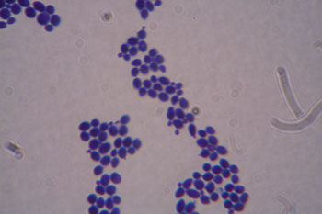
Many fungi produce only single cells (unicells [cells not attached by strong bonds. Independently acting individual cells]. If they lack flagella, such cells are called yeasts [saprotrophic, unicellular fungi of the Ascomycota or Basidiomycota]. Yeasts can reproduce by budding [method of mitotic asexual reproduction in which a new cell is formed as a small outgrowth of the parent cell], which causes the famous "shmoo [describes the shape of budding yeast cells]" morphology.

IMPORTANCE OF FUNGI
Fungi have a lot of harmful as well as beneficial effects on life as a whole
Harmful aspects:
- Lather, paper, timber and textile industry has been destroyed by the fungi.
- Food industry specially pickles and pasteurized foods are destroyed.
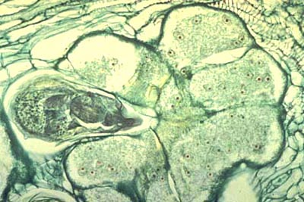
- Cause field crop diseases. Members of Phylum Plasmodiophoromycota cause two important infections i.e. Hypertrophy and Hyperplasia.
Hypertrophy: (adj. hypertrophic)
abnormal increase in the size of cells in a tissue or organ, often resulting in the formation of galls or tumors
(giant-cells in feeding site of root-knot nematode, Meloidogyne incognita).

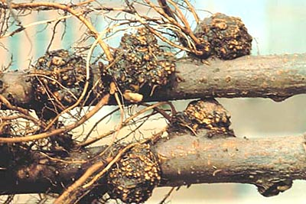
  - Hyperplasia: (adj. hyperplastic)
abnormal increase in the number of cells, often resulting in the formation of galls or tumors
(crown gall caused by Agrobacterium tumefaciens on apple).
- These cause animal & human diseases.
- Produce mycotoxins.
- There are some poisonous mushrooms and if ingested may cause death.
- Stored grains are spoiled by the fungi especially when temperature and humidity are conducive for fungal growth.
- Some mushrooms produce compounds that cause mental illusion.
Beneficial aspects:
- Bakery products are formed by fermentation e.g. yeast.
- Some fungi are edible such as mushrooms.
- Fungi are easy to handle for research purposes.
- Some antibiotics like penicillin is formed from fungus called penicillium.
- Some beneficial fungi are helpful to fertile the soil by forming mycorrhizal association with the roots of certain plants.
- Some fungi are used as insecticides and to control the nematodes i.e. biological control e.g. coelomyces is used to kill mosquitoes (insect control).
- Certain enzymes, vitamins, organic acids and hormones are produced from the fungi.
GENERAL CHARACTERISTICS:
- Heterotrophic [pertaining to organisms that obtain carbon nutrition by consuming organic matter] in nature.
- Resemble with simple plants.
- Do not possess stem, roots and leaves.
- Lack a well developed vascular system.
- Storage of carbohydrates in the form of glycogen.
- These show a little differentiation in structures.
- There is no division of labor.
- Reproduction is through spores.
- These have definite cell-walls.
- Exhibit absorptive nutrition.
- These show exo-cytic mode of nutrition i.e. excrete enzymes to digest food and then absorb the digested food.
- Metabolic activities are possible in the presence of some free water.
- Able to utilize any Carbon source as food.
- Optimum temperature for growth is 25-30ºC with max and mini limits of 10-40ºC.
- Some cold loving or psychrophilic fungi are capable of growing below freezing point.
- They have no need of light for somatic growth but it can enhance growth in a few and may be necessary for induction of asexual or sexual reproductive structures.
- Generally speaking, most seem to grow best at pH levels of 4-7. However, because fungi digest and consume the materials in which they grow and release metabolic products into their environment, they some times significantly alter pH levels in the microenvironments around their thalli.
MORPHOLOGY
THALLUS: Word thallus is derived from a Greek word i.e. ‘Thallos’ means a shoot.
Body of fungus is called thallus.
- It may be defined as relatively simple plant body that lacks stems, shoots and leaves.
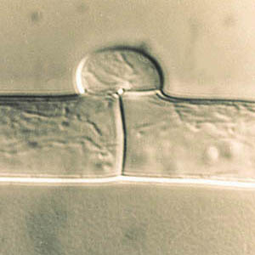
It is the somatic phase of fungi.
HYPHAE [thread of structurally and nutritionally connected cells of fungi]: hypha: (pl. hyphae; adj. hyphal)
single, tubular filament of a fungal thallus or mycelium; the basic structural unit of a fungus (a single Basidiomycete fungal hypha with a septum and clamp connection)
THALLUS [the overall form taken by the mycelium of a fungus. The "body" of the fungus] consists of microscopic threads or filaments that branch in all directions, spreading over or within the substratum, utilized for food. They are known as hyphae. A hypha may be defined as thin, transparent, tubular wall, filled or lined with layer of protoplasm, varying in thickness. OR Single thread-like structures of thallus are called hyphae. It may be branched or unbranched and have protoplasm with nuclei.
Hyphae are filaments that make up all structures of multicellular [made up of multiple or many cells working together, sometimes with one or more specialized functions of individual cell types] fungi. Some and others do not.
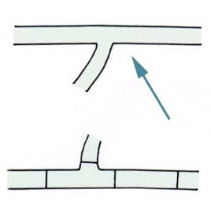
TYPES OF HYPHAE:
- Septate having cross walls.
- Aseptate or coenocytic (Having no septa): The hyphae in which the nuclei lie in a common matrix or the hyphae having no septa.
- SEPTUM: The cross wall or partition, which interrupts the protoplasm at various intervals and divide hyphae into various compartments.
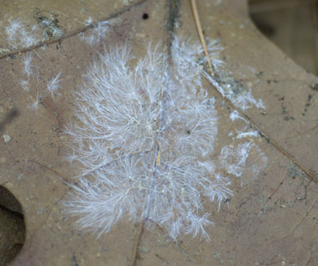
MYCELIUM: The mass of hyphae constituting the thallus of a fungus is called the ‘mycelium’. It may be uni, bi, or multi-nucleate.

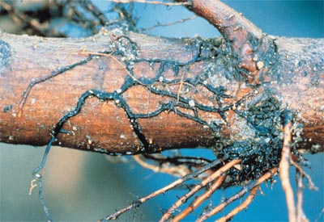
Rhizomorph [root-like organization of hyphae that allows greater potential for environmental exploration and nutrient transport.]: macroscopic rope-like strand of compacted tissue formed by certain fungi (rhizomorphs of Armillaria sp.)
These are string like masses and have thick, hard cortex and a growing tip whose structure is similar to root tip this is resistant to adverse environmental conditions arrives, then the growth is resumed and it attains great length.
Intercellular fungi: The fungi in which mycelium (haustoria) grows between or among cells the host cells).
Intracellular fungi: The fungi in which mycelium (haustoria) grows within the hosts cells).
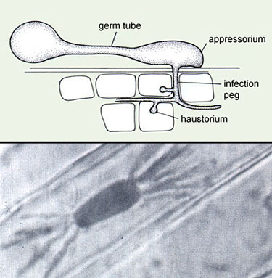
Haustorium: (pl. haustoria)
specialized branch of a parasite formed inside host cells to absorb nutrients
(haustorium of a powdery mildew fungus in a wheat cell)
Appressorium: (pl. appressoria)
swollen, flattened portion of a fungal filament that adheres to the surface of a higher plant, providing anchorage for invasion by a fungus
(germinating conidia of Colletotrichum coccodes with appressoria)
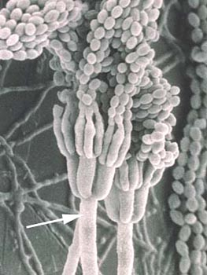
.
Spore: The reproductive unit of fungus. OR It is a minute simple propagating unit like seed but without embryo that serves in the reproduction of fungi.
conidiophore
simple or branched hypha on which conidia are produced
(SEM of Penicillium islandicum)..

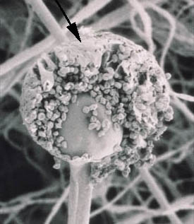
Sporangium: (pl. sporangia)
saclike fungal structure in which the entire contents are converted into an indefinite number of asexual spores
(SEM of Rhizopus stolonifer)

Sporangiospore
non-motile, asexual spore that is borne in a sporangium
(SEM of Rhizopus stolonifer)

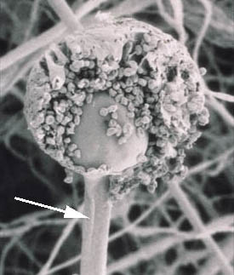

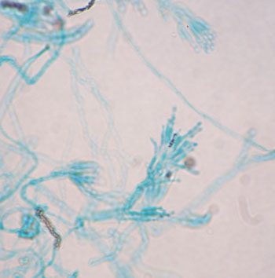

NUTRITION
Fungi exhibit absorptive nutrition.
These show exo-cytic mode of nutrition i.e. excrete enzymes first to digest food and then absorb the digested food.
On the basis of mode of nutrition, the fungi may be divided into the following groups.
- Obligate Parasites: They get food from the living host only and cannot be grown on dead organic matter.
- Facultative Parasites: An organism that is usually a saprophyte but under some conditions, may become a parasite.
- Obligate Saprophyte: They grow on the dead organic matter and are incapable of growing on a living host.
- Facultative Saprophyte: An organism which spends most of its life as a parasite but may become a saprophyte for sometime under certain conditions.

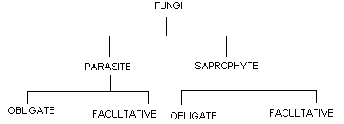

REPRODUCTION
Reproduction is the formation of new individuals having all the characteristics typical of the species.

General types of reproduction in fungi:
1-On the basis of involvement of sexes.
Asexual reproduction: any type of reproduction not involving the union of gametes and meiosis [type of cellular division giving rise to four unique haploid daughter cells].
Some times also called vegetative or somatic reproduction, does not involve karyogamy (Gr. Karyon = nut + gamos = marriage), the fusion of nuclei, and meiosis. Likewise, specialized sex cells or sex organs are not involved.
Importance of Asexual reproduction:
- It produces numerous individuals.
- It is repeated several times during the season, while sexual reproduction in many fungi takes once a year.
Sexual: It is characterized by the union of two nuclei followed by meiosis.
- On the basis of pattern followed:
- Holocarpic (Gr. Holos = whole + karpos = fruit): In the formation of reproductive organs, either male or female, the entire thallus is converted into one or more reproductive structures, so that somatic and reproductive phases do not occur together in the same individual.
OR Those fungi in which whole thallus is converted into reproductive structures.
- Eucarpic (Gr. Eu = good + karpos= fruit): The reproductive organs arise from only a portion of the thallus, while the remainder continues its normal somatic activities. Eucarpic forms are more differentiated than holocarpic forms.
OR those fungi in which only a part of thallus is converted into reproductive structures.
- In Hennebert and Weresub (1977) naming system the term teleomorph [reproductive structure of a fungus growing sexually] is used to describe the sexual stage while for asexual stage term anamorph [reproductive structure of a fungus growing asexually] is used.
- On the basis of thalli involved:
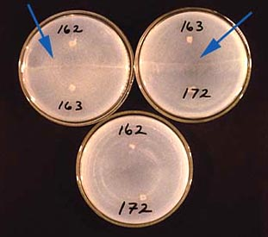
- Homothallic (compatible): Those fungi in which sexual reproduction takes place in single thallus.
Heterothallism: (adj. heterothallic)
condition in which sexual reproduction can occur only in the presence of genetically different mycelia (see homothallism) (a "line" of oogonia forms where compatible mating types of heterothallic
Phytophthora spp. meet; the isolates are compatible in the top two plates, but not in the bottom plate)
ASEXUAL REPRODUCTION:
This type of reproduction is more important because;
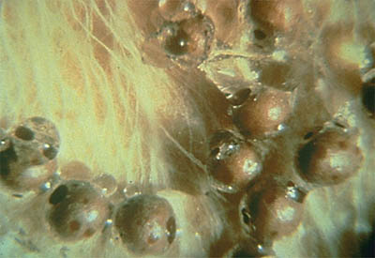
- It produces numerous individuals, and
- It is repeated several times during the season while sexual reproduction in many fungi takes place only once a year.
Following are the different ways through which asexual reproduction takes place.
- Fragmentation: The division of soma or fungal body into different fragments, each growing into a new individual.
Sclerotium: (pl. sclerotia)
a vegetative resting body of a fungus, composed of a compact mass of hyphae with or without host tissue, usually with a darkened rind (sclerotia of Sclerotium rolfsii).
- Fission: [form of cell division in prokaryotes]
Fission of somatic cells into daughter cells just like bacteria.
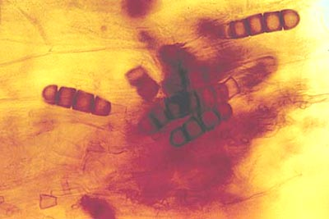
- Budding [method of mitotic (mitosis-type of cellular division giving rise to two identical daughter cells) asexual reproduction in which a new cell is formed as a small outgrowth of the parent cell.]:
Budding of somatic cells or spores, each bud producing a new individual.
- Production of spores: Each spore usually germinating to form a germ tube and grows into the mycelium.
- Color of the spores may be hyaline, green, yellow, orange, and red, brown to black.
- Size of the spore may be minute to large.
- Shape of the spore may be globose, oval to oblong and needle to helical shaped.
- Number of the spores may be one to many.
- Types of spores may be one to four as under:
      - Arthrospores 2. Chlamydospores
Conidioma (pl. conidiomata)
specialized conidia-bearing structure, e.g. acervulus, pycnidium, sporodochium, synnema
1. Arthrospores: The somatic hypha may break up into component cells that behave as spores.
2. chlamydospore
thick-walled or double-walled asexual resting spore formed from hyphal cells (terminal or intercalary) or by transformation of conidial cells that can function as an overwintering stage
(Thielaviopsis basicola)
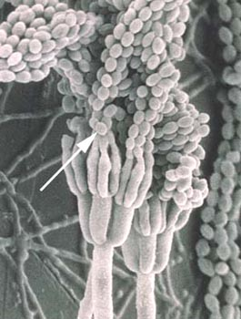
3. Conidium: (pl. conidia): an asexual, nonmotile fungal spore that develops externally or is liberated from the cell that formed it (SEM of Penicillium islandicum).
Sporangiospore: non-motile, asexual spore that is borne in a sporangium (SEM of Rhizopus stolonifer)
These are the spores which are produced within the sporangium (a sac like structure whose entire contents are converted through cleavage into one or more, usually many spores). There are two types of sporangiospores.
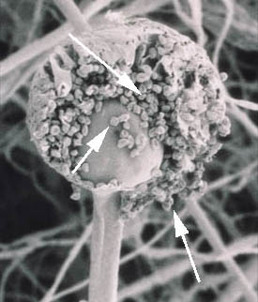

Zoospores [reproductive cell capable of creating its own movement]: If the moist conditions are provided then cleavage of cytoplasm takes place and all the part become round shaped known as zoospore. They are also known as planospores or motile spores. They are equipped with one or more flagella which are of following two types:
    - Whiplash: It is just like a whip and has two parts. Lower and basal portion is much longer than terminal portion, and the terminal portion is usually very short and flexible.
    - Tinsel: Feathery structures consisting of a long rachis with lateral hair like projections known as mastigonemes or flimmers.
- Aplanospores: If the conditions are dry Aplanospores are produced. These are non-motile spores.
SEXUAL REPRODUCTION:
Hermaphrodite: Those fungi, which produce both male and female sex organs on the same thallus.
Dioceous: Those fungi, which produce male sex organs on one-thallus and female sex organs on other thallus.
Gametangia: Fungal sex organs, which produce gametes, are known as Gametangia.
TYPES: There are two types
- Isogametangia: Those sex organs which morphologically similar.
- Heterogametangia: Those sex organs, which are morphologically different.
Gametes: These are the sex cells.
Iso-gametes: They are morphologically (both in size and shape) similar gametes.
Aniso-gametes: They are similar in shape but dissimilar in size.
Hetero-gametes: They are different type of gametes.
Antheridium: The male Gametangia are called Antheridium.
Oogonium: The female Gametangia are called Oogonium.
The process of sexual reproduction consists of following three distinct phases:
- Plasmogamy: It is the union of two protoplasts, which bring the two compatible nuclei close together, within the same cell.
- Karyogamy: The fusion of two nuclei, brought together by Plasmogamy, takes place.
- Meiosis [type of cellular division giving rise to four unique haploid daughter cells]: It is also called reduction division and it again reduces the number of chromosomes to haploid.
Division of fungi on the basis of life cycle:
On the basis of life cycle fungi are divided into two groups:
- Haplobiontic: If there is only one type of free-living thallus, haploid or diploid, present in the life cycle of a fungus, the life cycle will be known as Haplobiontic.
2. Diplobiontic: If haploid thallus alternates with a diploid thallus, the life cycle will be known as Diplobiontic.

Methods of sexual reproduction:
- Planogametic coupulation: In this type the two motile gametes come close and fuse together resulting into a zygote. The gametes may be similar in size and shape (iso-gametes) or may be dissimilar in size (aniso-gametes).
- Gametangial Contact: In this type, the two gametangia come close together, fertilization tube is formed by the male gametangia, which is pushed into the female gametangia and the male nuclei are shed into the female gametangium, where karyogamy takes place.
- Gametangial coupulation: The two gametangia come close together and whole the contents of both get fused by dissolving their walls.
- Spermatization: Some fungi produce numerous minute, uni-nucleate, conidia like structures known as spermatia on spermatiophores, which behave as male gametes. They are carried by insects, wind or water to the receptive hyphae (which act as female gametangia) and fertilize them.
- Somatogamy: In this case specialized / well differentiated sex organs are not produced but somatic hyphae cells function as sex cells which fuse together, interchanging their nuclei.

