INTRODUCTION TO VIRUSES
Virus means "veleno". Viruses are basically a way a form of genetic information insures its continued survival. They are entities which reproduces their DNA/RNA within living cells utilizing mechanisms of cells for this.

VIRUS HISTORY

In 1884 C. Chamberland, in Pasteur's lab, discovered that if you passed a liquid containing bacteria through an unglazed PORCELAIN tube, the bacteria were COMPLETELY RETAINED and the solution that passed through (the FILTRATE) was sterile. The advantages of this tool were immediately apparent, for with it one could sterilize solutions containing heat-sensitive components by filtration through sterile porcelain tubes into sterile containers. By carefully controlling the components of the porcelain tubes you could CONTROL THE PORE SIZE and selectively remove larger organisms while letting smaller ones pass through.
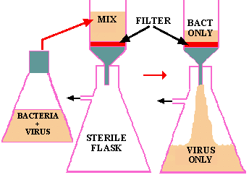
Figure 1. Filtration of a mixture of bacteria and viruses. If a mixture of viruses and bacteria are filtered through a bacterial-proof filter (red), the viruses will pass through into the filtrate in the flask. Filtered beer is produced by a similar process.
This type of filtration immediately became one means of testing the Germ Theory, since if you passed an infected sample through a filter that would hold back all microbes, the filtrate should not induce the disease in a new host if a microbe was responsible. You could then begin to devise ways of growing the suspected pathogen. However, in 1892 D. IWANOWSKI applied this test to a filtrate of plants suffering from TOBACCO MOSAIC DISEASE with shocking results; the filtrate was FULLY CAPABLE of producing the ORIGINAL DISEASE in new hosts. When repeated, filtrations produced the same results and nothing could be seen in the filtrates using the most powerful microscopes, nor could anything be cultivated from the filtrates, Iwanowski and associates concluded that they had discovered a new pathogenic life-form which they called by the unimaginative, but functional, name of "FILTERABLE VIRUS". We now know that viruses range in size from 20 nm (10⁻⁹ meters) to 250 nm. We also know that some of the smallest bacteria such as the chlamydia and mycoplasma are almost as small as the largest viruses and that they too can pass through filters that retard 99% of the other bacteria.
By the early 1900 diseases like foot-mouth-disease in cattle, some cancers (in animals) and yellow fever in humans had been demonstrated to be caused by filterable viruses. The scientific community knew that it had a new group of dangerous pathogens to contend with. The term "VIRUSES" became permanently associated with this life form. You have previously seen that bacterial viruses (view the "Single Burst Graph Animation") or #bacteriophage (phage) were discovered in 1915 & 1917. Viruses, however were not "seen" until the electron microscope was developed in the late 1930s. This site contains electron micrographs of many bacteriophage; view the P2, lambda and P4 phage.
We now know that viruses exist that attack perhaps every form of cellular life on this planet. I haven't seen references to thermophilic phage, but I would be surprised if they didn't exist. We are discovering new viruses all the time and most virologists feel we have only scratched the surface of viral variety. For example, when sea water is concentrated and examined under the electron microscope it teems with VIRUS-LIKE PARTICLES and we have no idea what they are or where they come from or what their hosts are?
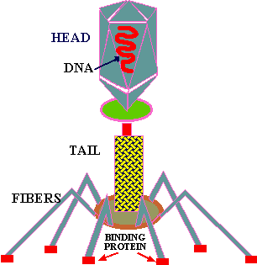
Figure 2. T-EVEN PHAGE. This is a large bacteriophage. It happens to be one of the most complex viruses. Not all phage are large; some are composed of only 7 genes. This is an E. coli phage and it has been studied intensely and much is known about it. Click here for another picture of a bacteriophage.
The nature of viruses became even more confusing when it was observed in 1935 that they could be CRYSTALLIZED like inorganic salts (table salt) and protein molecules. This observation started a spirited, but rather barren, argument as to whether viruses are really "alive" or a "form of life". People have argued that viruses are like salt crystals that grow and reproduce (sort of). In my view this discussion is a waste of time by people who need to "get-a-life". Viruses clearly REPLICATE their genetic material, which like that of all other life forms, is composed of nucleic acid polymers. Viruses have one major characteristic in common: they are OBLIGATE INTRACELLULAR PARASITES. Viruses are UNABLE to grow and reproduce OUTSIDE OF A LIVING CELL. Therefore their survival is absolutely dependent upon the continued survival of their hosts. This poses an interesting dilemma for pathogens that often as not kill their hosts, wouldn't you say?
The intracellular nature of viruses presents a challenge for the investigator who must not only grow the virus but also be able to cultivate the virus' host cell. With plant and bacterial viruses it was possible to extract sufficient virus from an infected host to do analysis on it. These studies showed that viruses were mainly COMPOSED OF PROTEIN AND NUCLEIC ACID. With multicellular eukaryotic viruses the field of virus investigation could only move as rapidly as the advancements in eukaryotic TISSUE CULTURING. The first breakthrough in this problem came with the discovery in 1931 that the fertilized hen's eggs could serve as a "petri dish" for some viruses. This capacity led to the first use of artificially cultivated viruses for vaccine production. Even today many viruses are grown on eggs because they are relatively inexpensive and because the techniques are so well established.

VIRUS MORPHOLOGY
With the discovery of the electron microscope it became possible to study the morphology of viruses. It was quickly realized that the size and shape of an individual virus is a constant and distinguishing characteristic. Therefore, a virus's size and shape is always part of its description. Viruses may consist of circles, ovals, long thick or thin rods, flexible or stiff rods and ones with distinctive heads and tail components. The smallest viruses are around 20 nm in diameter and the largest around 250 nm.

VIRUS COMPOSITION
Viruses are unique from all other life forms in that they can contain ONLY ONE FORM OF NUCLEIC ACID. Some viruses use RNA as their genetic material and other use DNA, but NEVER do they contain both. Further, this nucleic acid polymer may either exist as DOUBLE STRANDED (DS) DNA or RNA or as SINGLE STRANDED (SS) DNA or RNA. Each of these characteristics is a constant for a particular virus and is part of it description. The nucleic acid polymer may contain as few as 4 to 7 genes for very small viruses to 150 to 200 genes for very large viruses. In some viruses the nucleic acid exists in more that one molecule. Some viruses contain a few enzymes and some contain none, but no viruses contain the large numbers of enzymes found even in the smallest bacteria.
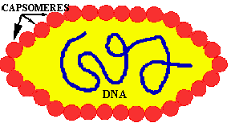  Figure 3. A NAKED virus. The red balls represent the protein subunits that make up the protective covering around the viral genome (DNA in the case). These subunits are called CAPSOMERES and the entire protein coat is called the CAPSID. | 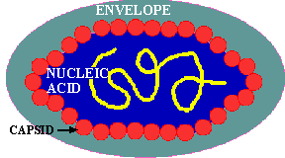  Figure 4. An ENVELOPED virus. Enveloped viruses have a lipid-based membrane surrounding the protein capsid. This envelope is partly composed of the cell membrane within which the virus replicated, and it contains proteins and carbohydrates. Some of the proteins are from the host cell and some are from the virus.
All viruses are covered with a PROTEIN COAT. This protein coat is mainly composed of a FEW TYPES of proteins of which there are many copies per virus; something like the individual threads in a shirt. These identical protein subunits are called CAPSOMERES and they are made so that they spontaneously come together (ASSEMBLE) in a PREDETERMINED way to produce the virus coat which is called the CAPSID.
If a virus has ONLY a protein capsid covering it, it is termed a NAKED CAPSID VIRUS or a NAKED VIRUS. However, some viruses pick up a lipid membrane from the host cell when it is released, that surrounds the capsid. The lipid membrane is called an ENVELOPE and such viruses are termed ENVELOPED VIRUSES. All virus contain one more important proteins type; this is ATTACHMENT PROTEIN or #docking proteins. The attachment protein is needed by the virus to ATTACH TO ITS TARGET CELL before it can enter that cell. Obviously this attachment protein must lie on the outer surface of the virus so that it is available to contact the appropriate RECEPTOR SITES on the target host cells. These attachment proteins are often called SPIKES because they can extend away from the cell so as to better be able to contact the host receptor (think of the viral AP & the host receptor site as being the pairs of a VELCRO SYSTEM). In addition, virus may contain small quantities of carbohydrate (glycoprotein).
VIRUS HOST RANGE
To understand this discussion you may wish to go back over the previous sections on #enzyme specificity and substrate/enzyme complex formation that deal with the basic principle of ligand/receptor binding. All viruses have a LIMITED HOST RANGE and even within a host they attach to and invade only those cells with the APPROPRIATE RECEPTOR SITES. This specificity is the result of the same BASIC PRINCIPLE that controls all the other specific mechanisms of life: LIGAND/RECEPTOR BINDING SPECIFICITY; #Figure at top of chapter. The following are examples of degrees of specificity:
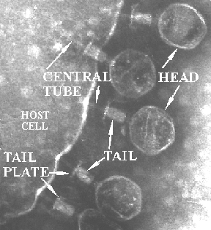
Figure 5. Bacteriophage binding to and injecting their DNA into a bacterial cell.
The basic principle of viral infection of a given cell is that if a cell's OUTER SURFACE contains the RECEPTOR to which a virus's ATTACHMENT PROTEIN (#docking proteins) can BIND, the virus will be able to invade and grow in that cell. This only applies within RELATED SPECIES or to different types of cells within a host. For example, the lambda phage will only naturally invade a few species of Gram negative bacteria, but if you put a plasmid in a G- cell that contains the gene for the lambda receptor, then lambda can bind to and inject its DNA into that cell (see below). Another example is the COMMON COLD VIRUSES. These viruses are specific for the human UPPER RESPIRATORY TRACK because they contain the appropriate AP for binding to the receptors on the cell membrane of the specialized cells in the upper respiratory tract. Other viruses that cause intestinal diseases only bind to certain receptors of cells in the intestine; others bind only to liver cell-receptors and cause hepatitis; while others like herpes only bind to receptors on and live in nerve cells.

