There’s a transformation taking place on farms across the United States.
For decades, we’ve produced the bulk of our food through industrial agriculture—a system dominated by large farms growing the same crops year after year, using enormous amounts of chemical pesticides and fertilizers that damage soils, water, air, and climate. This system is not built to last, because it squanders and degrades the resources that it depends on.
But a growing number of innovative farmers and scientists are taking a different path, moving toward a farming system that is more sustainable—environmentally, economically, and socially. This system has room for farms of all sizes, producing a diverse range of foods, fibers, and fuels adapted to local conditions and regional markets. It uses state-of-the-art, science-based practices that maximize productivity and profit while minimizing environmental damage.
Some proponents of industrial agriculture claim that its impacts are the price we must pay to “feed the world.” In fact, a growing body of scientific evidence has debunked this claim, showing that a more sustainable model can be just as profitable—and can meet our needs for the long haul.

Sustainable agriculture 101
OK, so sustainable agriculture is the wave of the future. But what is it, exactly?
In agriculture, sustainability is a complex idea with many facets, including the economic (a sustainable farm should be a profitable business that contributes to a robust economy), the social (it should deal fairly with its workers and have a mutually beneficial relationship with the surrounding community), and the environmental.
Environmental sustainability in agriculture means good stewardship of the natural systems and resources that farms rely on. Among other things, this involves:
- Building and maintaining healthy soil
- Managing water wisely
- Minimizing air, water, and climate pollution
- Promoting biodiversity
There’s a whole field of research devoted to achieving these goals: agroecology, the science of managing farms as ecosystems. By working with nature rather than against it, farms managed using agroecological principles can avoid damaging impacts without sacrificing productivity or profitability.

Does Sustainable = Organic?
While most Americans may not have heard of hairy vetch, prairie strips, or other core features of sustainable farms, anyone who has been to a supermarket lately knows about organic food. The organic farming movement, which dates back to the early 20th century, incorporates a system of sustainability practices that have been codified into specific certification standards by the US Department of Agriculture. Farms that comply with the standards can label their produce as “USDA Organic”—a feature that more and more food shoppers are looking for.
“Organic” and “sustainable” aren’t quite synonyms: current organic standards leave room for some practices that are not optimal from a sustainability point of view, and not all farmers who use sustainable practices qualify for USDA certification or choose to pursue it.
Still, the certified organic fruits and vegetables at your supermarket are highly likely to have been produced more sustainably than their conventionally grown neighbors. So if your rule of thumb is “look for the organic label”, you’re unlikely to go wrong.

Sustainable agriculture practices
Over decades of science and practice, several key sustainable farming practices have emerged—for example:
Rotating crops and embracing diversity. Planting a variety of crops can have many benefits, including healthier soil and improved pest control. Crop diversity practices include intercropping (growing a mix of crops in the same area) and complex multi-year crop rotations.
Planting cover crops. Cover crops, like clover or hairy vetch, are planted during off-season times when soils might otherwise be left bare. These crops protect and build soil health by preventing erosion, replenishing soil nutrients, and keeping weeds in check, reducing the need for herbicides.
Reducing or eliminating tillage. Traditional plowing (tillage) prepares fields for planting and prevents weed problems, but can cause a lot of soil loss. No-till or reduced till methods, which involve inserting seeds directly into undisturbed soil, can reduce erosion and improve soil health.
Applying integrated pest management (IPM). A range of methods, including mechanical and biological controls, can be applied systematically to keep pest populations under control while minimizing use of chemical pesticides.
Integrating livestock and crops. Industrial agriculture tends to keep plant and animal production separate, with animals living far from the areas where their feed is produced, and crops growing far away from abundant manure fertilizers. A growing body of evidence shows that a smart integration of crop and animal production can be a recipe for more efficient, profitable farms.
Adopting agroforestry practices. By mixing trees or shrubs into their operations, farmers can provide shade and shelter to protect plants, animals, and water resources, while also potentially offering additional income.
Managing whole systems and landscapes. Sustainable farms treat uncultivated or less intensively cultivated areas, such as riparian buffers or prairie strips, as integral to the farm—valued for their role in controlling erosion, reducing nutrient runoff, and supporting pollinators and other biodiversity.
A key theme connecting many of these practices is diversification. “Keep it simple” is good advice in many situations, but when it comes to agriculture, the most sustainable and productive systems are more diverse and complex—like nature itself.
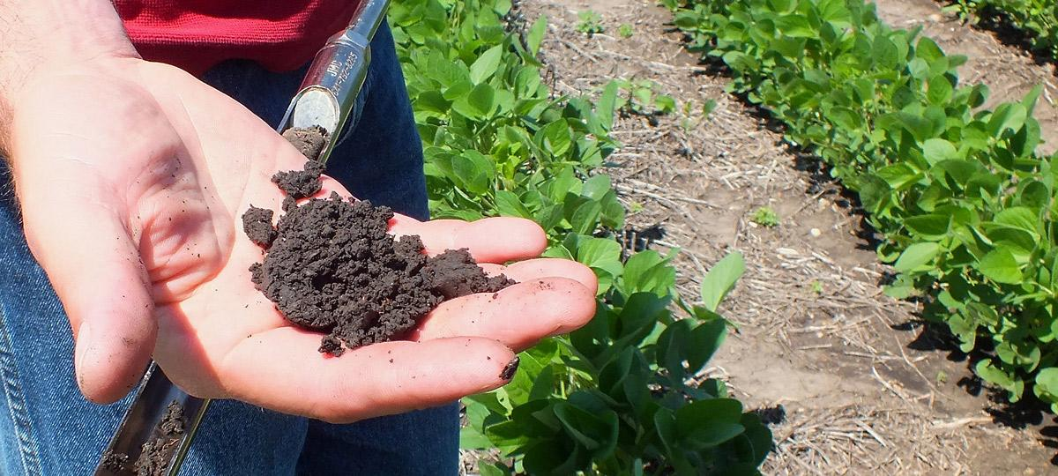

Sustainable agriculture science
The latest science—much of it coming out of research centers in the nation’s bellwether farm states—shows how agroecological practices can support productive, profitable farms. For instance, an ongoing study at Iowa State University’s Marsden Farm research center has shown that complex crop rotation systems can outperform conventional monoculture in both yield and profitability.
Crop breeding research is also crucial to the success of a more sustainable agroecological system, providing farmers with access to a broad range of crop varieties that can be readily adapted to farm-specific conditions and practices. Breeding research programs have dwindled in recent years, leaving farmers increasingly reliant on a limited set of varieties tailored to the needs of industrial farms.
To help farmers adopt sustainable practices, it’s vitally important that we continue to support agroecology research, along with outreach and education to help farmers make effective use of the science. Toward this end, UCS has coordinated a statement, signed by over 450 scientists and other experts, calling for increased public investment in agroecological research.

Photo: NCinDC/CC BY-ND 2.0, Flickr
Photo: NCinDC/CC BY-ND 2.0, Flickr

Sustainable agriculture and farm policy
While US farm policy continues to put the lion’s share of public resources behind subsidizing overproduction of corn and other commodity crops, there have been some encouraging signs. The most recent versions of the Farm Bill have included provisions to support more organic farming, to make it easier for fruit and vegetable farmers to qualify for crop insurance, and to help farmers adopt more sustainable practices on their own working lands.
But if we want to see sustainable farming become the dominant model in the US, we need to go much further. UCS has published a series of reports and issue briefs that offer recommendations for promoting sustainable agriculture through farm policy, as part of our overall goal of transforming our food system to provide healthy, affordable, fairly and sustainably produced food for all Americans. We encourage you to take a look–and then contact your representatives to ask them to support sustainable agriculture.

