Seismic
- Introduction
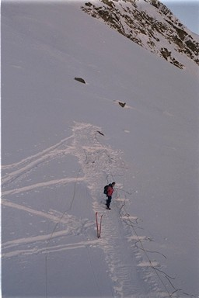
Seismic Survey: A technique for imaging the geological structure beneath the earth's surface using sound energy. The technique is used primarily for oil exploration. An acoustic energy source at the surface transmits an acoustic signal into the earth, which reflects or refracts some of the energy back toward the surface at each geological interface. An array of geophones or hydrophones detects the faint signals reflected or refracted back to the surface, which are recorded for later processing.

1.1 Methods Overview
Seismic methods, as typically applied in exploration seismology, are considered active geophysical methods. In seismic surveying, ground movement caused by some source is measured at variety of distances from the source. The type of seismic experiment differs depending on what aspect of the recorded ground motion is used in the subsequent analysis. This doesn’t imply that any seismic experiment can be done from a given set of observations. On the contrary, the two types of experiments described below have very different acquisition requirements. These acquisition differences, however, arise from the need to record specific parts of the Earth's ground motion over specific distances.

One of the first active seismic experiments was conducted in 1845 by Robert Mallet, considered by many to be the father of instrumental seismology. Mallet measured the time of transmission of seismic waves generated by an explosion. To make this measurement, Mallet placed small containers of mercury at various distances from the source of the explosion and noted the time it took for the surface of the mercury to ripple after the explosion. In 1909, Andrija Mohorovicic used travel-times from earthquake sources to perform a seismic refraction experiment and discovered the existence of the crust-mantle boundary now called the Moho.

The earliest uses of seismic observations for the exploration of oil and mineral resources date back to the 1920s. The seismic refraction technique, described briefly below, was used extensively in Iran to delineate structures that contained oil. The seismic reflection method, now the most commonly used method in the oil industry, was first demonstrated in Oklahoma in 1921. A plaque commemorating this event was erected on the site by the Society of Exploration Geophysicists in 1971.

- Refraction Seismology: Refraction experiments are based on the times of arrival of the initial ground movement generated by a source recorded at a variety of distances. Later arriving complications in the recorded ground motion are discarded. Thus, the data set derived from refraction experiments consists of a series of times versus distances. These are then interpreted in terms of the depths to subsurface interfaces and the speeds at which motion travels through the subsurface within each layer. These speeds are controlled by a set of physical constants, called elastic parameters that describe the material.

- Reflection Seismology: In reflection experiments, analysis is concentrated on energy arriving after the initial ground motion. Specifically, the analysis concentrates on ground movement that has been reflected off of subsurface interfaces. In this sense, reflection seismology is a very sophisticated version of the echo sounding used in submarines, ships, and radar systems. In addition to examining the times of arrival of these, reflection seismic processing extracts information about the subsurface from the amplitude and shape of the ground motion. Subsurface structures can be complex in shape but like the refraction methods, are interpreted in terms of boundaries separating material with differing elastic parameters.

Each of these techniques has specific advantages and disadvantages when compared to each other and when compared to other geophysical techniques. For these reasons, different industries apply these techniques to differing degrees. For example, the oil and gas industries use the seismic reflection technique almost to the exclusion of other geophysical techniques. The environmental and engineering communities use seismic techniques less frequently than other geophysical techniques. When seismic methods are used in these communities, they tend to emphasize the refraction methods over the reflection methods.

1.2 Seismic vs. Other
When compared to the other geophysical methods we've described thus far, the seismic methods have several distinct advantages and several distinct disadvantages. A table listing some of these advantages and disadvantages is shown next page.

If an investigator has deemed that the target of interest will produce a measurable seismic anomaly, you can see from the below list that the primary disadvantages to employing seismic methods over other methods are economically driven. The seismic methods are simply more expensive to undertake than other geophysical methods. Seismic can produce remarkable images of the subsurface, but this comes at a relatively high economic cost.

Seismic Methods
Advantage | Disadvantage
Can detect both lateral and depth variations in a physically relevant parameter: seismic velocity. | Amount of data collected in a survey can rapidly become overwhelming.
Can produce detailed images of structural features present in the subsurface. | Data is expensive to acquire and the logistics of data acquisition are more intense than other geophysical methods.
Can be used to delineate stratigraphic and, in some instances, depositional features. | Data reduction and processing can be time consuming, require sophisticated computer hardware, and demand considerable expertise.
Response to seismic wave propagation is dependent on rock density and a variety of physical (elastic) constants. Thus, any mechanism for changing these constants (porosity, permeability, compaction, etc.) can, in principle, be delineated via the seismic methods. | Equipment for the acquisition of seismic observations is, in general, more expensive than equipment required for the other geophysical surveys considered in this set of notes.
Direct detection of hydrocarbons, in some instances, is possible. | Direct detection of common contaminants present at levels commonly seen in hazardous waste spills is not possible.

1.3 Refraction vs. Reflection
On the table shown above, we attempted to describe some of the advantages and disadvantages of the seismic methods when compared to other geophysical methods. Seismic method encompasses a broad range of activities, and generalizations such as those made on above are dangerous. A better feel for the inherent strengths and weaknesses of the seismic approach can be obtained by comparing and contrasting the two predominant seismic methods, refraction and reflection, with each other.

As you will see from the following table, the reflection technique has the potential for being more powerful in terms of its ability to generate interpretable observations over complex geologic structures. As stated before, however, this comes at a cost. This cost is primarily economic. Reflection surveys are more expensive to conduct than refraction surveys. As a consequence, environmental and engineering concerns generally opt for performing refraction surveys when possible. On the other hand, the petroleum industry uses reflection seismic techniques almost to the exclusion of other geophysical methods.

In this set of notes, we will only consider seismic refraction methods.

Refraction Methods |  | Reflection Methods
Advantage | Disadvantage | Advantage | Disadvantage
Refraction observations generally employ fewer source and receiver locations and are thus relatively cheap to acquire. | Refraction seismic observations require relatively large source-receiver offsets (distances between the source and the receiver). | Reflection seismic observations are collected at small source-receiver offsets. | Because many source and receiver locations must be used to produce meaningful images of the subsurface, reflection seismic is expensive to acquire.
Little processing is done on refraction observations with the exception of trace scaling or filtering to help in the process of picking the arrival times of the initial ground motion. | Refraction seismic only works if the speed at which motions propagate through the Earth increases with depth. | Reflection seismic methods can work no matter how the speed at which motions propagate through the Earth varies with depth. | Reflection seismic processing can be very computer intensive, requiring sophisticated computer hardware and a relatively high-level of expertise.
Because such a small portion of the recorded ground motion is used, developing models and interpretations is no more difficult than our previous efforts with other geophysical surveys. | Refraction seismic observations are generally interpreted in terms of layers. These layers can have dip and topography. | Reflection seismic observations can be more readily interpreted in terms of complex geology. | Because of the large amount of data collected and the complications imposed by some of the data processing schemes interpretations of the reflection seismic observations require more sophistication and knowledge of the process.
 | Refraction seismic observations only use the arrival time of the initial ground motion at different distances from the source (i.e., offsets). | Reflection seismic observations use the entire reflected wave field (i.e., the time-history of ground motion at different distances between the source and the receiver).
 | A model for the subsurface is constructed by attempting to reproduce the observed arrival times. | The subsurface is directly imaged from the acquired observations.

1.4 Elastic Waves
When the is Earth rapidly displaced or distorted at some point, the energy imparted into the Earth by the source of the distortion can be transmitted in the form of elastic waves. A wave is a disturbance that propagates through, or on the surface of, a medium. Elastic waves satisfy this condition and also propagate through the medium without causing permanent deformation of any point in the medium. Elastic waves are fairly common. For example, sound propagates through the air as elastic waves and water waves propagate across the surface of a pond as elastic waves.

In fact, water waves on the surface of a pond offer a convenient analogy for waves propagating through the earth. When a pebble is thrown into a pond, the disturbance caused by the pebble propagates radially outward in all directions. As the ripples move away from their source, notice that there are two distinct ways of looking at the waves as they travel. These two distinct viewpoints are called frames of reference.
- We can view the waves propagating across the surface of the pond from above the pond. At any time, the waves form a circular ring around the source with some radius that is governed by the speed at which the wave propagates through the water and the time elapsed since the wave originated at the source. In this viewpoint, we fix time and we view the wavefield at any location across the entire surface.
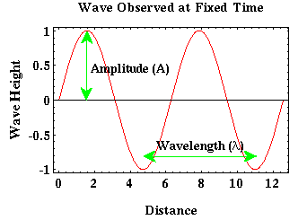
- We can view these same waves as they propagate through some fixed location on the surface of the pond. That is, imagine that instead of observing the waves from above the pond, we are in a small boat on the surface of the pond, and we record how the boat moves up and down with respect to time as the wave propagates past the boat. In this viewpoint, we fix our spatial location and view the wavefield at this location at all times.

These two viewpoints give us two fundamentally different pictures of the exact same wave. Assume that our ripple propagating outward from the source can be approximated by a sine wave. From the first perspective, we can examine the wave at any location on the surface of the pond at some fixed time. That wave would then be described as shown in the figure to the right.

Geophysical Methods Mohamed Rashed

In this reference frame, the wave is defined by two parameters: amplitude and wavelength. Amplitude is the peak to trough height of the wave divided by two. Wavelength is the distance over which the wave goes through one complete cycle (e.g., from one peak to the next, or from one trough to the next).
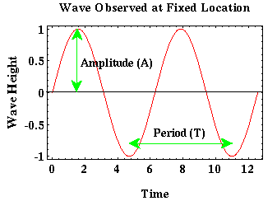
From our second perspective, we can examine the wave at a fixed location on the surface of the pond as it propagates past us. That is, as time varies. That wave would be described as shown to the right.

In this frame of reference the wave is described by an amplitude and a period. The amplitude described in this frame is identical to the amplitude described previously. Period is the time over which the wave is observed to complete a single cycle. Another commonly used description related to period is the frequency. Frequency is nothing more than the reciprocal of the period. If the period is measured in seconds (s), frequency has the units of Hertz (Hz), 1/s.

As you might expect, period and wavelength are related. They are related by the speed at which the wave propagates across the surface of the pond, c, where c equals the wavelength divided by the period of the wave.

1.5 Seismic Waves
Waves that propagate through the earth as elastic waves are referred to as seismic waves. There are two broad categories of seismic waves: body waves and surface waves.

- Body waves: These are elastic waves that propagate through the Earth's interior. In reflection and refraction prospecting, body waves are the source of information used to image the Earth's interior. Like the ripples on the surface of the pond example described previously, body waves propagate away from the source in all directions. If the speed at which body waves propagate through the Earth's interior is constant, then at any time, these waves form a sphere around the source whose radius is dependent on the time elapsed since the source generated the waves. Shown next page is a cross section through Earth with body waves radiated from a source (red circle) shown at several different times.

Seismic

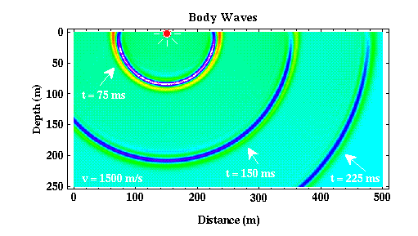
The color being plotted is proportional to the amplitude of the body wave. Light blue-green is zero amplitude, red is a large positive amplitude, and purple is a large negative amplitude. Notice that this plot is explicitly constructed in a reference frame that fixes time, thus allowing us to examine the spatial variations of the seismic wave.

At any given time, notice that the wave is circular with its center located at the source. This circle is, of course, nothing more than a two-dimensional section of the spherical shape the wave has in three-dimensions.

Seismic body waves can be further subdivided into two classes of waves: P waves and S waves.
- P Waves: P waves are also called primary waves, because they propagate through the medium faster than the other wave types. In P waves, particles constituting the medium are displaced in the same direction that the wave propagates, in this case, the radial direction. Thus, material is being extended and compressed as P waves propagate through the medium. P waves are analogous to sound waves propagating through the air.

- S Waves: S waves are sometimes called secondary waves, because they propagate through the medium slower than P waves. In S waves, particles constituting the medium are displaced in a direction that is perpendicular to the direction that the wave is propagating. In this example, as the wave propagates radially, the medium is being deformed along spherical surfaces.

Most exploration seismic surveys use P waves as their primary source of information. The figure shown above could, however, represent either P or S waves depending on the speed chosen to generate the plot.

- Surface Waves: Surface waves are waves that propagate along the Earth's surface. Their amplitude at the surface of the Earth can be very large, but this amplitude decays exponentially with depth. Surface waves propagate at speeds that are slower than S waves, are less efficiently generated by buried sources, and have amplitudes that decay with distance from the source more slowly than is observed for body waves. Shown below is a cross section through a simplified Earth model (the speed of wave propagation is assumed to be constant everywhere) showing how surface waves would appear at various times in this medium.

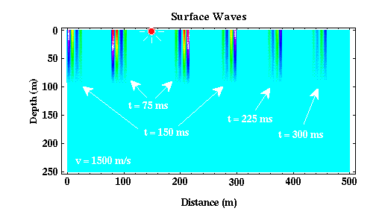
Like body waves, there are two classes of surface waves, Love and Rayleigh waves, that are distinquished by the type of particle motion they impose on the medium. For our purposes, it is not necessary to detail these differences. Suffice it to say that for virtually all exploration surveys, surface waves are a form of noise that we attempt to suppress. For reflection surveys in particular, suppression of surface wave energy becomes particularly important, because the amplitudes of surface waves generated from shallowly buried sources are often observed to be larger than the amplitudes of the body waves you are attempting to record and interpret. For refraction surveys, surface waves are less of a problem because we are only interested in the time of arrival of the first wave. Surface waves are never the first arrival. In all of the remaining discussion about seismic waves, we will consider only body waves.

1.6 Wavefronts and Raypaths
In the previous geophysical methods explored, we often employed two different descriptions of the physical phenomena being observed. For example, when discussing magnetism we looked at both the strength of the magnetic field and the direction of the magnetic field. Similarly, there are two equally useful descriptions of seismic waves: wavefronts and raypaths. The relationship between these two descriptions is shown next page.
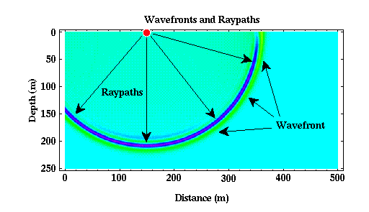

- Raypaths: Raypaths are nothing more than lines that show the direction that the seismic wave is propagating. For any given wave, there are an infinite set of raypaths that could be used. In the example shown above, for instance, a valid raypath could be any radial line drawn from the source. We have shown only a few of the possible raypaths.

- Wavefront: Wavefronts connect positions of the seismic wave that are doing the same thing at the same time. In the example shown above, the wavefronts are spherical in shape. One such wavefront would be the sphere drawn through the middle of the dark blue area. This surface would connect all portions of the wave that have the largest possible negative amplitude at some particular time.

In principle and in practice, raypaths and wavefronts are equivalent to the field direction and strength in magnetism. Notice that in this example, wavefronts are perpendicular to raypaths. This is in general always true. So, given either a set of wavefronts or a set of raypaths, we can construct the other. This was also true for field strength and field direction in magnetism.

Through much of the development to follow, we will use a raypath description of seismic wave propagation. This description will allow for a much easier computation of the propagation times of specific seismic phases, because we will be able to explicitly construct the path along which the seismic wave has traveled before being recorded by our receiver. As we will see next, although the raypaths for the waves shown above are very simple, as we begin to construct models of the Earth that contain speed variations, these raypaths will become more complex.

2. Seismology and Geology

2.1 Waves and Boundaries
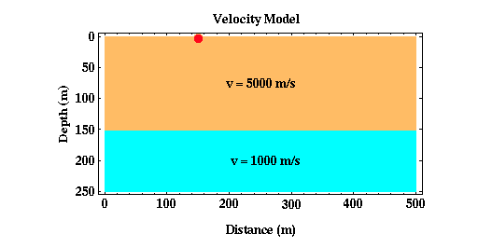
Thus far we have considered body wave propagation through media that has a constant speed of seismic wave propagation. What happens if the media consists of layers, each with a different speed of seismic wave propagation? Consider the simple model shown below.

Although more complex than the homogeneous models considered previously, this model is still very simple, consisting of a single layer over a halfspace. In this particular example, the speed at which seismic waves propagate in the layer is faster than the speed at which they propagate in the halfspace. Let's now watch the seismic waves propagate through this medium and see how they interact with the boundary at 150 meters. Shown next page are three snapshots of the seismic wave at times of 25, 50, and 75 ms.

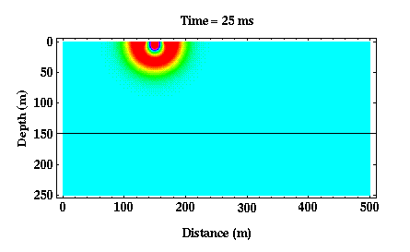
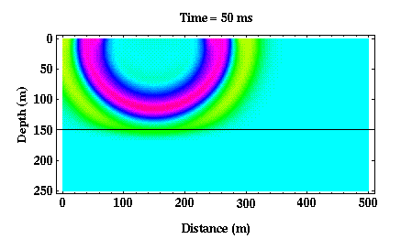
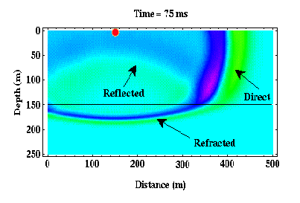
From 0 to 50 ms, the wave propagates solely within the upper layer. Thus, our pictures of the wavefield look identical to those generated previously. After 50 ms, the wave begins to interact with the boundary at 150 meters depth. Part of the wave has penetrated the boundary. The portion of the wavefield that has penetrated the boundary is referred to as the refracted wave. Also notice that part of the wave has bounced off, or reflected off, of the boundary. This part of the wavefield is referred to as the reflected wave. Finally, part of the wavefield has not interacted with the boundary at all. This part of the wavefield is called the direct wave.
There are several interesting features to note about the refracted arrival:

- First, notice that the wavefront defining the refracted arrival is still circular, but its radius is no longer centered on the source. Geophysicists would describe this as a change in the curvature of the wavefront.
- Second, notice that the apparent wavelength of the refracted arrival is much shorter than the direct arrival.

Both of these phenomena are related to the presence of the discontinuity. Remember that the period of a wave is related to its wavelength through the speed at which the wave propagates through the medium. The wavelength is equal to the speed times the period. Thus, if the period of the wave remains constant and the speed of the medium decreases, the wavelength of the wave must also decrease.

The change in curvature of the wavefront as the wave passes through the interface implies that the raypaths describing the direction of propagation of the wave change direction through the boundary. This change in direction of the raypath as it crosses a boundary is described by a well-known law known as Snell's Law.

Finally, of fundamental importance to note is that if you were observing the ground's motion from any point on the Earth's surface, you would observe two distinct waves. Initially, you would observe an arrival that is large in amplitude and that is the direct wave. Then, some time later, you would observe a smaller amplitude reflected wave. The time difference between your observation of these two arrivals is dependent on your distance from the source, the speed of wave propagation in the layer, and the depth to the boundary. Thus, by observing this time difference we may be able to learn something about the subsurface structure.

We have simplified the situation a bit here. In general, when a P wave interacts with a boundary, it generates not only a reflected and a refracted P wave, but it can also generate a reflected and a refracted S wave. Conversely, S waves that interact with boundaries can generate reflected and refracted P waves. These conversions of P waves to S waves and S waves to P waves are called mode conversions. We will assume that no mode conversions occur. For refraction surveys, this is not a seriously flawed assumption, because again, we are considering only the time of arrival of the initial wave. P to S wave mode conversions will never be the first arrival. For reflection surveys, unless we were interested in recording S wave arrivals or mode conversions, we design our survey and choose the recording equipment to minimize their effects.

2.2 Snell's Law
If we include raypaths for the reflected, refracted, and direct arrivals described on the previous page, we would find that a selected set of the raypaths would look like those shown below. These raypaths are simply drawn to be perpendicular to the direction of propagation of the wavefield at all times. As they interact with the boundary, these raypaths obey Snell's Law. Snell's Law can be derived any number of different ways, but the way it is usually described is that the raypath that follows Snell's Law is the path by which the wave would take the least amount of time to propagate between two fixed points.

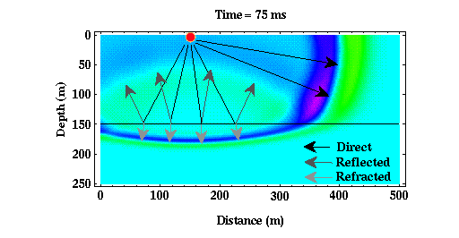
Consider the refracted raypaths shown to the right. In our particular case, v2, the velocity of the halfspace, is less than v1, the velocity of the layer. Snell's Law states that in this case, i2, the angle between a perpendicular to the boundary and the direction of the refracted raypath, should be smaller than i1, the angle between a perpendicular to the boundary and the direction of the direct raypath. This is exactly the situation predicted by the wavefronts shown in the figure above.

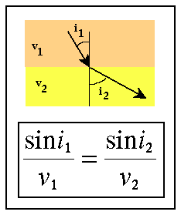
If v2 had been larger than v1, a situation we will consider in some detail later, then Snell's Law predicts that i2 would be greater than i1. In this case, the wavefront of the refracted wavefield would have smaller curvature than the wavefront of the direct field (in the present case, the wavefront of the refracted field has greater curvature than the wavefront of the direct field).

Snell's law can also be applied to the reflected raypath by setting v2 equal to v1. If v2 is equal to v1, then the angle of reflection, i2, should be equal to the angle of the incident wave, i1, as we would expect from our physics classes. Again, this is exactly the situation predicted by the wavefronts of the reflected wavefield shown above.

As one final note for the case under consideration, for a high velocity layer overlying a low velocity halfspace, the waves described previously and shown above (i.e., direct, reflected, and refracted) are the only body waves observed. Notice also that if we were to place receivers at the Earth's surface, we would never observe the refracted arrival. It continues to propagate downward, never returning to the surface.

2.3 Seismic Wave Speeds and Rock Properties
Before pursuing wave propagation issues any further, let's take a moment to describe how all this wave propagation stuff relates to geologic structure. It's clear from the previous examples that variations in the speed at which seismic waves propagate through the Earth* can cause variations in seismic waves recorded at the Earth's surface. For example, we've shown that reflected waves can be generated from a planar boundary in seismic wave speed that can be recorded at the Earth's surface. How do these velocity variations relate to properties of the rocks or soils through which the waves are propagating?

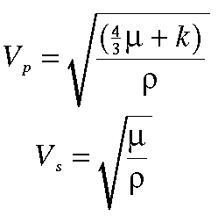
It can be shown that in homogeneous (media whose properties do not vary with position), isotropic (media whose properties at any given position do not vary with direction) media the velocities of P and S waves through the media are given by the expressions shown to the right. Where Vp and Vs are the P and S wave velocities of the medium, &ρηο is the density of the medium, and μ and k are referred to as the shear and bulk modulii of the media. Taken together, μ and k are also known as elastic parameters. The elastic parameters quantitatively describe the following physical characteristics of the medium.

- Bulk Modulus: Is also known as the incompressibility of the medium. Imagine you have a small cube of the material making up the medium and that you subject this cube to pressure by squeezing it on all sides. If the material is not very stiff, you can image that it would be possible to squeeze the material in this cube into a smaller cube. The bulk modulus describes the ratio of the pressure applied to the cube to the amount of volume change that the cube undergoes. If k is very large, then the material is very stiff, meaning that it doesn't compress very much even under large pressures. If k is small, then a small pressure can compress the material by large amounts. For example, gases have very small incompressabilities. Solids and liquids have large incompressabilities.

- Shear Modulus: The shear modulus describes how difficult it is to deform a cube of the material under an applied shearing force. For example, imagine you have a cube of material firmly cemented to a table top. Now, push on one of the top edges of the material parallel to the table top. If the material has a small shear modulus, you will be able to deform the cube in the direction you are pushing it so that the cube will take on the shape

of a parallelogram. If the material has a large shear modulus, it will take a large force applied in this direction to deform the cube. Gases and fluids can not support shear forces. That is, they have shear modulii of zero. From the equations given above, notice that this implies that fluids and gases do not allow the propagation of S waves.

Any change in rock or soil property that causes ρ, μ, or k to change will cause seismic wave speed to change. For example, going from an unsaturated soil to a saturated soil will cause both the density and the bulk modulus to change. The bulk modulus changes because air-filled pores become filled with water. Water is much more difficult to compress than air. In fact, bulk modulus changes dominate this example. Thus, the P wave velocity changes a lot across water table while S wave velocities change very little.

Although this is a single example of how seismic velocities can change in the subsurface, you can imagine many other factors causing changes in velocity (such as changes in lithology, changes in cementation, changes in fluid content, changes in compaction, etc.). Thus, variations in seismic velocities offer the potential of being able to map many different subsurface features.

2.4 Seismic Velocities of Earth Materials
The P and S wave velocities of various earth materials are shown below.

Material | P wave Velocity (m/s) | S wave Velocity (m/s)
Air | 333 | 0
Water | 1400-1500 | 0
Petroleum | 1300-1400 | 0
Steel | 6100 | 3500
Concrete | 3600 | 2000
Granite | 5500-5900 | 2800-3000
Basalt | 6400 | 3200
Sandstone | 1400-4300 | 700-2800
Limestone | 5900-6100 | 2800-3000
Sand (Unsaturated) | 200-1000 | 80-400
Sand (Saturated) | 800-2200 | 320-880
Clay | 1000-2500 | 400-1000
Glacial Till (Saturated) | 1500-2500 | 600-1000

Geophysical Methods Mohamed Rashed

Unlike density, there can be a large variation in seismic velocity between different rock types and between saturated and unsaturated soils. Even with this variation, however, there is still considerable overlap in the measured velocities. Hence, a knowledge of seismic velocity alone is not sufficient to determine rock type.

3. Refraction Basics

3.1 Another Simple Earth Model
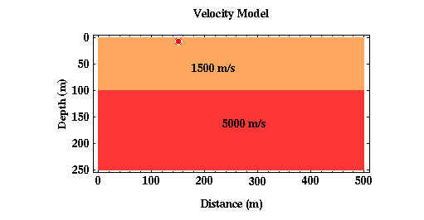
Thus far we have considered body wave propagation through constant velocity media and in media consisting of a high-velocity layer overlying a lower velocity halfspace. As observed on the surface of the Earth, a constant velocity media only generates direct waves while the layered model generates direct and reflected waves. What happens if the media consists of a low-velocity layer overlying a high-velocity halfspace? Consider the Earth model shown below.

Shown below are a few snapshots of the seismic waves as they propagate away from the source at times of 80, 110, and 140 ms. For these times, the wavefield qualitatively looks like that observed for our previous layered model consisting of a high-velocity layer overlying a low-velocity halfspace. This is true with exception to the relative curvature and the wavelength differences of the refracted wavefield compared to the direct and the reflected wavefield. In this particular case, the refracted wavefield is more curved than the direct wavefield as a consequence of the raypaths bending at the boundary in accordance with Snell's Law. Because the velocities

Seismic
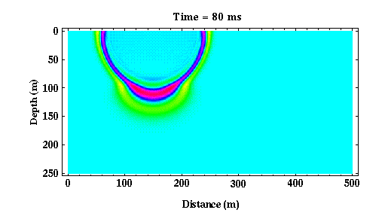
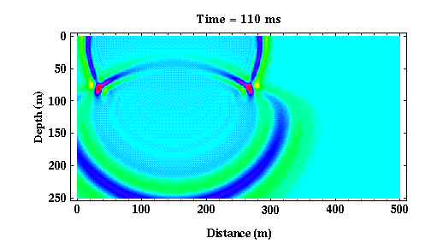
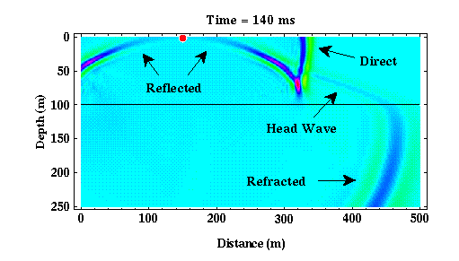
increase across the boundary with depth, the refracted wavefield now has a longer wavelength than the direct or the reflected wavefield. The opposite sense of the velocity contrast across the boundary produced the opposite relationship in wavelengths in our previous layered structure.

From 0 to about 70 ms, the wave propagates solely within the upper layer. After 70 ms, the wave begins to interact with the boundary at 100 meters depth. As before, upon interaction with the boundary, part of the wave is transmitted through the boundary, the refracted wave, and part bounces off of the boundary, the reflected wave. If we allow the waves to propagate further, an interesting phenomenon begins to occur with relation to the refracted arrival.

As the refracted arrival propagates through the halfspace, because it travels faster than the direct arrival in the layer, it begins to move across the layer boundary before the direct arrival. The refracted arrival is propagating horizontally at the velocity of the halfspace and the direct and the reflected arrivals propagate horizontally at the speed of the layer.

As the refracted wave moves across the layer boundary, it generates a new wave type in the layer called a critically refracted or head wave that propagates upward to the surface. In the previously considered layered model, a high-velocity layer overlying a low-velocity halfspace, this arrival never exists. This is primarily because the refracted arrival, the direct arrival, and the reflected arrival all move across the boundary at the same rate (There is never a separation in the arrivals at the boundary that we see above).

In this particular example, note that if you were observing the ground's motion from any point on the Earth's surface, you could observe three distinct waves. The reflected arrival will always be observed after the direct arrival at any distance from the source, thus it can never be the first arriving energy. At short distances between the source and the receiver, the direct arrival would be observed first. At long distances, however, notice that the critically refracted arrival could be observed before the direct arrival.

3.2 Head Waves
In the previous example, we discovered that if a low-velocity layer overlies a higher velocity halfspace that in addition to the direct and reflected arrivals, we also observe what is called a head wave. In refraction seismic surveying, we measure the earliest times of arrival of the seismic waves at various distances from the source. For the layer over a halfspace model, this earliest arriving energy could be associated with either the direct wave or the head wave.
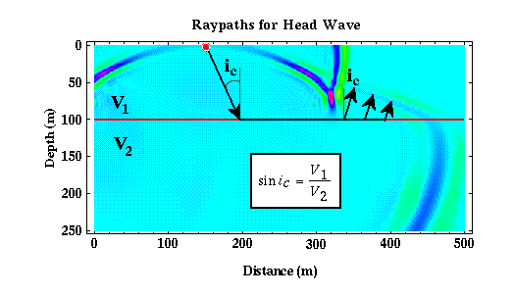
Computing the time of arrival of the direct wave is relatively simple. It is nothing more than the horizontal distance between the source and the receiver divided by the speed at which the wave propagates in the layer. To compute the time of arrival of the head wave, we need to describe the path along which the head wave propagates. The path along which a wave travels is described mathematically by the wave's raypath. Snell's law provides the necessary mathematical framework for developing the raypath of our head wave.

Raypaths must be perpendicular to wavefronts. Thus, as shown in the figure above, we can sketch three raypaths from the boundary between the layer and the halfspace (red) and the wavefront describing the head wave. The angle between each of these raypaths and a perpendicular to the boundary is given by ic.

Substituting ic for i1 into Snell's law and solving for i2, we find that i2 equals 90 degrees. That is, the ray describing the head wave does not penetrate into the halfspace, but rather propagates along the interface separating the layer and the halfspace. ic is called the critical angle, and it describes the angle that the incident raypath, i1, must assume for i2 to be equal to 90 degrees.

From this raypath description of the head wave, it looks as though energy propagates downward to the interface at the critical angle at a speed of v1 (speed of wave propagation in the layer), propagates horizontally along the interface at a speed of v2 (speed of wave propagation in the halfspace), and then is transmitted back up through the layer at the critical angle at a speed of v1.

Although the head wave must travel along a longer path than the direct arrival before it can be recorded at the Earth's surface, it travels along the bottom of the layer at a faster speed than the direct arrival. Therefore, as is apparent in the movie showing the head wave, it can be recorded prior to the time of arrival of the direct wave at certain distances

These observations, if the velocity of the material increases with depth, the seismic waves recorded initially at a given receiver will be of the direct wave at short source/receiver distances and the head wave at long source/receiver distances, form the basis of the seismic refraction method.

3.3 Ground Motion
Thus far, we have shown wave propagation through a variety of media. When seismic waves interact with a boundary in the subsurface, some of the energy is transmitted through the boundary, some is reflected off of the boundary, and if the velocities of the media separated by the boundary represent a velocity increase to the propagating wave, some of the energy is transmitted along the boundary in the form of head waves.

Unfortunately, we can not record the wave field as it propagates through the earth at all points and at all times as was done to produce the snapshots shown previously. Instead, we must be content to record the wavefield along the surface of the Earth. That is, what we will actually

record is the motion of the Earth's surface caused by seismic wave propagation through the Earth generated by our seismic source. Instruments that are capable of recording ground motion are referred to as seismometers or geophones. These instruments will be described in more detail later. Suffice it to say now, that they are capable of recording the ground motion produced by the seismic waves we are interested in studying.

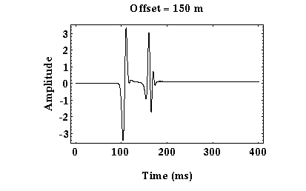
An example of the ground motion we would record from a seismic wave propagating through our layer over a halfspace model is shown to the right. Time runs along the horizontal axis, and amplitude of the ground motion runs along the top. The line in the plot, therefore, represents the time history of ground motion at this one particular location, which is referred to as a seismogram. In this case, the seismometer employed records only up/down ground motion. For this example, trace excursion downward represents ground motion that was upward. A trace excursion upward represents ground motion that was downward.

There are two distinct seismic arrivals recorded on this record: one at a time of about 100 ms, the other at about 150 ms. From this single record along, it is impossible for us to tell what these arrivals actually are. For example, the first arrival could be the direct arrival or the head wave. Usually, we will record ground motion at a number of different receivers and plot this motion as a function of time and as a function of distance from the source. An example of such a plot is shown above.

In this case, time runs along the vertical axis and distance from the source along the horizontal axis. At each appropriate shot and receiver distance, we have plotted the seismogram (record of ground motion at that location). In this particular experiment, receivers are located at five meter distance intervals. Plots such as these are usually referred to as shot records.

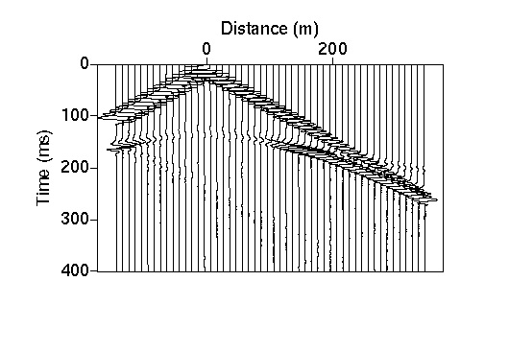
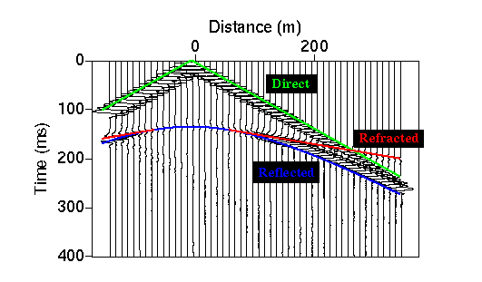
The advantage of looking at shot records is that you can see how the time of arrivals varies as distance from the shot varies. This variation in the time versus distance is commonly referred to as moveout. Arrivals with large moveouts dip steeply on shot records. Those with a small amount of moveout dip less steeply.

If you examine the shot record shown above carefully, you can see the three seismic waves defined previously (i.e., direct, reflected, and refracted). Using the snapshots of wave propagation presented earlier, try to identify the three arrivals on this shot record. Remember that the reflected arrival can never be the first arrival recorded on a given seismogram

3.4 Travel-Time Curves
For this simple model under consideration, we can compute what the arrival times of the various seismic waves should be and overlay these predicted arrival times on top of our shot record.

As expected, the first arrival at short offsets is the direct arrival. This arrival has a very large amplitude and its moveout is constant over all offsets. That is, its arrival times fall along a straight line when plotted versus offset. At larger offsets (>275 m), the first arrival is the refracted arrival. This arrival is characterized by small amplitudes and a constant moveout that is smaller in value than the moveout of the direct arrival. That is, the slope of the line connecting the arrival times of the refracted arrival is smaller (the line is flatter) than the direct arrival. The last arrival recorded at all offsets is the reflected arrival. Notice that the reflected arrival does not have a constant moveout at all offsets. Its moveout is zero at zero offset and it approaches the moveout of the direct arrival at very large offsets.

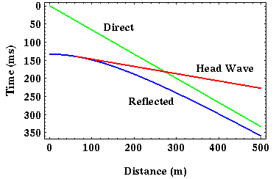
Plots of the times of arrivals of the various recorded waves versus offset from the source are called travel-time curves. We will often show the travel-time curves of seismic arrivals without overlaying them on shot records as shown below.

Determining the shape of the travel-time curves versus offset will be our primary task in the refraction seismic method. Thus, although we are recording the time history of ground motion at a number of stations, for the refraction method, the only thing we will be interested in extracting from these records is the time of arrival of the first wave to be recorded at each geophone. For the example shown above, this arrival would be associated with the direct wave for offsets less than 275 meters , and it would be associated with the head wave for offsets greater than 275 meters. As we will show later, determining these times from your recorded seismograms is not always easy.

3.5 First Arrivals
We will now concentrate on the times of arrival of the first wave to be recorded at each offset. When performing an exploration refraction experiment, this is the only information extracted from the recorded seismograms that is used. Plotting the arrival times of the first arrival versus offset produces the travel-time curve shown below.

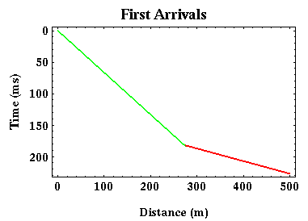
Before proceeding, let me make a comment about the typical plotting conventions used to display seismic observations. As has been done in all of the travel-time plots shown to this point, time is increasing downward. This convention is commonly used when discussing reflection methods. For refraction observations such as those that we will discuss, it is more common to plot time increasing upward. Thus, we can re-plot the travel-time curve shown above in the following way:

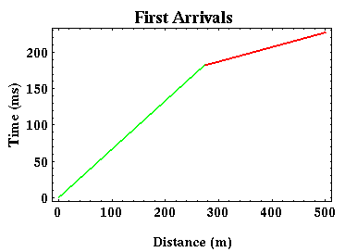
Both of the plots shown here illustrate the same travel-time versus offset features, but they're just presented in two different ways. For the remainder of this set of notes, we will follow the usual refraction convention and plot time increasing upward.

For our simple layer over a halfspace model, notice that the travel-time curve associated with the first arrivals is given by two, straight-line segments. At small offsets (green), the travel-time curve corresponds to the direct arrival. At larger offsets (red),

the travel-time curve corresponds to that of the refracted arrival. The two segments are clearly distinguished from each other by a change in slope at some critical offset commonly called the cross-over distance. This distance represents the offset beyond which the direct arrival is no longer the first arrival recorded.
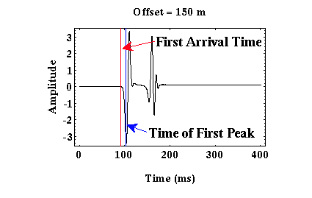

In going from the recorded seismograms to our first arrival travel-time curves, we must determine the time instant at which ground motion was initiated on each seismogram. On the seismogram shown to the right, this time corresponds to the time indicated by the red line. On this record, choosing the first arrival time is not difficult, because the seismogram shows no signal before this time. If, however, there is any type of noise recorded on the seismogram preceeding the time of arrival of the first arrival, this time can be very difficult to pick. In practice, one should consider this choice of first arrival times to be part of the interpretational process rather than part of the data collecting process. Often, geophysicists will not attempt to pick the first arrival time but will rather pick the time of the first prominent peak following the first arrival as shown by the blue line. This will bias your results by a small amount, but the effect of the bias is minimal compared to the effect of picking first arrival times inconsistently from trace to trace.

3.6 Earth Structure From Travel-Times
Now, what can be determined about the structure responsible for producing a first arrival travel-time curve from the travel-time curve itself? With some assumptions, quite a bit. If we assume that the structure responsible for producing the travel-time curve shown below consisted of a single layer over a halfspace and that the boundary separating the layer from the halfspace is horizontal, then we can determine the velocity of the layer and halfspace and the thickness of the layer.

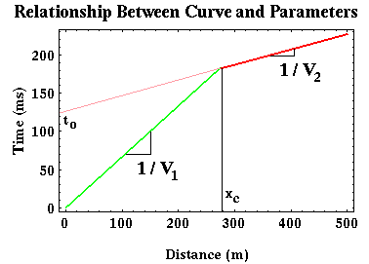
Let's concentrate on that portion of the travel-time curve associated with the direct arrival (green) first. From the wavefield snapshots and movies, as recorded at the Earth's surface, this arrival is one that has propagated horizontally from the source across the surface of the earth at the seismic wave speed associated with the upper layer. Thus, if we knew what the speed of wave propagation was in the layer, we could predict the arrival time of the direct wave by simply dividing the offset of the receiver from the source by the speed. Conversely, given the time of arrival at any offset, the speed can be computed by dividing the offset by the arrival time. Returning to the former description, a better way (better in the sense that it will be more robust to noise) of computing the speed from the arrival times is to realize that the slope of the line describing the arrival times of the direct wave is simply equal to the reciprocal of the speed of the wave in the layer.

Similarly, the slope of the line describing the arrival times of the refracted wave is simply equal to the reciprocal of the speed of the wave in the halfspace. This is because the halfspace interface is horizontal and the head wave appears to travel along this interface at the velocity of the halfspace. Thus, from the slopes of the two line segments describing the travel-time curve, we can compute the two velocities of the media involved.

We can also compute the thickness of the layer. To get a qualitative feeling for how this can be done, consider two models with identical wave speeds but one has a 50 meter thick layer and the other a 100 meter thick layer. How would you expect the travel-time curves for these two models to differ? Would the slopes of the line segments describing the direct and refracted arrivals differ? No, these attributes of the travel-time curve are controlled by the velocities alone. For the model consisting of a thick, 100 meter layer, would you expect to see the head wave at longer or shorter offsets than for the model consisting of a thin, 50 meter layer?

As is shown above, I would expect the head wave off of a thicker layer to be initially observed as a first arrival at longer offsets than would be observed for a head wave generated off of a thinner layer. Why?

Remember that the head wave has to travel down to the boundary separating the layer from the halfspace and back up. These segments of the raypath are completed at the velocity of the layer. The head wave can be observed as a first arrival, because that portion of the raypath traveling along the boundary does so at the speed of the halfspace, which is faster in this example. But this only happens at long enough offsets where the speed differences makes up for the longer path length. Thus, although the head wave travels a greater distance than the direct arrival before it is recorded, it can arrive before the direct arrival because it travels faster along a portion of its raypath. The thicker the layer, more of the head wave's raypath travels at the slower velocity and the farther you have to go in offset to account for this with a portion of the raypath that propagates faster along the interface. You can see that this is exactly what is being shown in the two travel-time curves plotted above.

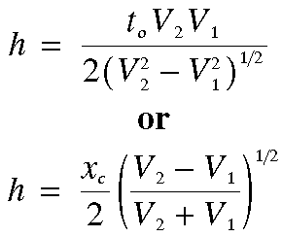
Either one of two parameters is usually used to quantify this offset dependence in where the head wave becomes the first arrival. The first of these is referred to as the cross-over distance,xc (where the white line intersects the distance axis) in the plots above. The cross-over distance simply refers to the offset at which the head wave becomes the first arrival. The second commonly used parameter is called the zero-offset time,to, (where the pink line intersects the time axis) in the plots above. The zero-offset time is nothing more than the time at which the refracted arrival would be observed at a distance of zero meters from the source*. In principle, either of these parameters could be used, but in practice, the zero-offset time is more commonly used because it is easier to estimate with noisy data.

Thus in principle, by measuring xc or to, we can compute the thickness of the layer, h.

Please note that the refracted arrival does not actually exist at zero offset. Instead what is done is to extrapolate the straight line describing the head wave back to zero offset. This is shown as the pink line in the figures above.

3.7 Travel Time Equations
For those who are interested, this page outlines the details of how the equations given on the last page were derived. Although you don't need to memorize this derivation, a working knowledge of its construction is useful, especially when we consider travel time curves produced by more complex Earth models.

To derive the equations for the velocity of the halfspace and the depth to the top of the halfspace shown previously, we first need to be able to construct an equation that defines the time of arrival of a head wave, tT, off of a single interface at some offset, x. To do this we will consider the raypath of the head wave from the source to the receiver as defined by Snell's law.
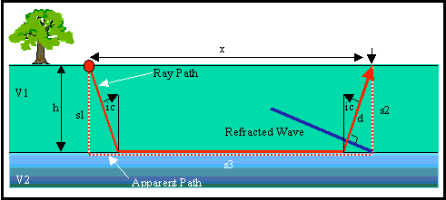
Consider the simple Earth model shown below. It consists of a layer with a velocity of V1 overlying a halfspace with a velocity of V2. The depth to the top of the halfspace is h.

The raypath of the head wave observed at an offset x is shown by the red line. This raypath consists of three segments: one traveling down through the layer, another traveling along the layer itself, and a third (which is identical to the first) traveling back up through the layer to the receiver. We could, as is done in most textbooks, derive our equation for the travel time of this wave by computing the time along each of these segments and summing them up. In this derivation, however, we will consider an alternate method of calculation that makes the analysis through more complex structures much easier.

From the wave propagation movie shown previously, notice that the shape of the head wave as it travels back up through the layer is that of a straight line. A graphical representation of this is shown by the blue line in the figure above. Knowing that the head wave forms a linear wavefront, we can consider an alternate ray path called the apparent raypath. The apparent raypath is shown as the red dashed line. Like the true raypath, it also consists of three segments. These segments, however, are different. One travels downward vertically through the layer from the source. The second travels along the boundary over a distance x. The third travels vertically upward through the layer to the receiver.

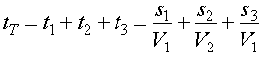
Let's compute the travel time of the head wave by summing up the times along the three segments of the apparent raypath. The time along each segment is nothing more than the length of the segment divided by the velocity the wave travels along that segment. That is,

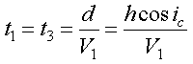
Consider the two segments in the layer. They are identical to each other, so the times the wave spends traveling along each must be identical. The head wave shown by the blue line travels along the distance s1 over the same time period that it travels along the true raypath for a distance d. d is equal to s1 times the cosine of the angle ic, and s1 is simply equal to the thickness of the layer, h. Thus,

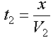
The travel time along the apparent raypath that lies along the layer boundary is nothing more than the distance x divided by the velocity the wave travels along the boundary, V2.

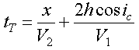
Thus, the total travel time of the head wave is

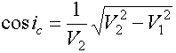
It is easily shown that (we'll leave this one up to you) to get the answer, you use Snell's law to compute the sine of the angle of incidence of the incoming wave, i1 (which we've called ic here) and then use trigometric relations to get an expression for the cosine of the angle.

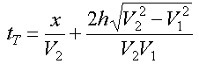
Substituting this into our travel time expression we get the following:

This is nothing more than an equation of a straight line. The slope of the line is given by the first term on the right-hand side and is 1/V2. The intercept of the line is given by the second term on the right-hand side and is what we have called t0. Set the second term on the right-hand side equal to t0 and solve for the layer thickness, h. You will get the expression given on the previous page.

3.8 A Third Model
Now, the first model we considered consisted of a high velocity layer over a lower velocity half-space, as shown below.

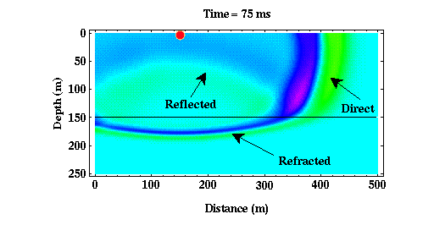
For this model, what first arrivals would you expect to see, and what can you determine about the subsurface structure from these arrivals? A snapshot of the waves produced from a surface source as they interact with the boundary is shown below. This is the same image that was shown previously.

As was described earlier, we need to consider three wave types. The direct arrival, the reflected arrival, and the transmitted (or refracted) arrival. Notice that the difference between the waves produced in this model and those produced when a low velocity layer overlies a higher velocity halfspace is the absence of a head wave.

Let's consider the transmitted (refracted) arrival first. The refracted arrival propagates downward from the boundary. If there is no other structure below our first layer, this wave will continue to move downward. As such, it can never be observed by receivers located on the Earth's surface.

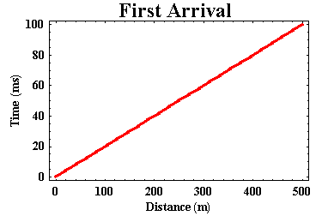
The reflected arrival can be observed on the Earth's surface, but it must always arrive after the direct arrival. Thus, as before, the reflected arrival is never a first arrival, and we therefore do not use it in refraction surveying. The only arrival we'll observe as a first arrival is, therefore, the direct arrival. In this model, the direct arrival propagates away from the source at constant speed (5000 m/s). So, if we were to plot the time of arrival of the first arrivals versus distance from the source, we would get a figure like the one shown to the right.

What can we learn from this plot? Well, not too much. From the plot we could compute the speed at which seismic energy travels in the layer, just as we did previously. But notice that our first arrival information no longer tells us anything about the speed at which seismic waves travel in the halfspace. In fact, they no longer indicate any existence of the halfspace!! By this, I mean the travel times shown above would be identical for a uniform Earth that had a wave propagation speed of 5000 m/s.

This example illustrates one of the fundamental limitations of using the seismic refraction method. To be successfully employed (i.e., to get the correct answers from the recorded data), seismic wave speed MUST increase with depth. If wave speed decreases with depth, you will not be able to detect this wave speed decrease. And you will, as a consequence, almost assuredly interpret the first arrivals incorrectly which would result in an estimate of the subsurface structure that is wrong.

4. Seismic Survey

4.1 Equipment Overview
Compared to the equipment used for gravity and magnetic surveying, the amount and complexity of the equipment used in seismic surveying can be staggering. Due to the complexity of the equipment (which stems from the complexity of the field surveys we would like to employ), seismic surveying can become logistically very intensive.

Typical seismic acquisition systems consist of the following components:
- Seismic Source: This is nothing more than an apparatus for delivering seismic energy into the ground. Sources can vary greatly in their size and complexity. All, however, share the following characteristics:
- They must be repeatable. That is, the nature of the energy delivered into the ground (its amount and the time duration over which it is delivered) should not change as the source is used in different locations and
- Time of delivery must be controllable. We must be able to tell exactly when the source delivered its energy into the ground. In some cases, we can control the time of delivery. In others, we simply note the time the source delivered its energy.

- Geophones: These are devices capable of measuring ground motion generated by the seismic source. As we will describe later, these typically convert the ground motion into electrical signals (voltages) that are recorded by a separate device.

- Recording System: This actually consists of a number of components. In essence, this entire system does nothing more than store the ground motion detected by a number of geophones. This number could be quite large. Today, it is not unusual for oil exploration surveys to record ground motion detected by 1000's of seismometers at a time. In addition to recording ground motion, this system must also control the synchronization of the source. It consists of not only a "black box" to store information but also numerous electrical connections to the geophones and the source and usually a device to select subsets of the installed geophones to record.

4.2 Seismic Sources
Sources of seismic energy come in a variety of sizes and shapes. Virtually anything that impacts, or causes motion on, the surface of the earth will be a source of seismic energy. Unfortunately, most sources are uncontrollable, such as road traffic, wind (this causes noise by making bushes and trees move), aircraft, people walking, etc. For our experiments, we would like to control the source of the ground motion. In this discussion, we will restrict our examples to those sources most commonly used in near-surface (i.e., environmental and engineering) investigations. Three types of sources are most commonly used for both refraction and reflection investigations of the near surface.

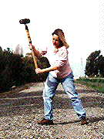
- Impact Sources: Sources that generate seismic energy by impacting the surface of the Earth are probably the most common type employed. Although impact sources can be rather sophisticated in their construction, the most commonly used type of impact source is a simple sledgehammer. In this case, an operator does nothing more than swing the sledgehammer downward onto the ground. Instead of striking the ground directly, it is most common to strike a metal plate lying on the ground. The sledgehammer is usually connected to the recording system by a wire. The moment the sledgehammer strikes the plate, the recording system begins recording ground motion from the geophones.

The principle advantages to using a sledgehammer source are primarily:
- Low cost.
- Simple to operate and maintain.

The principle disadvantages of this source are
- It can be difficult to assure that the source is operated in a repeatable fashion.

Seismic

- Operation is manually strenuous.
- Source outputs relatively small amounts of seismic energy. Therefore, it can be difficult to record reliable observations at great distances.
- Source outputs seismic energy that tends to be low frequency in nature (i.e. this source generates a lot of surface waves).

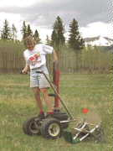
- Gun Sources: Like impact sources, gun sources generate seismic energy by transferring the kinetic energy of a moving object into seismic energy. In this case, the moving object is a bullet or shot-gun slug. Some sources use blanks instead of bullets or slugs. In this case, energy is transferred from the column of air in the gun's barrel that is set in motion by the blank to the ground.

The source shown to the left is a 9-gauge shotgun mounted on a wheeled vehicle. In this case, a 2-oz. steel slug is fired into the ground. Most gun sources are more compact than the source shown to the left. Like the sledgehammer, gun sources must also be connected to the recording system so that you can begin recording ground motion from the geophones at the instant the slug or shell hits the ground.

The principle advantages of gun sources are
- Highly repeatable source.
- Energy imparted into the ground is larger than is possible from a sledgehammer.
- Gun sources generally output higher-frequency energy. This helps to minimize surface wave generation.

The principle disadvantages of gun sources are
- Safety,
- Equipment is more bulky and expensive than simple impact sources, and
- Getting permission (permitting) to use this source may be more difficult.

- Explosive Sources: Explosive sources can impart a large amount of seismic energy into the ground given their relatively small size. These sources can vary in size and type from small blasting caps and shotgun shells to larger, two-phase explosives. All explosive sources are triggered remotely by a devise known as a blasting box. The blasting box is connected to both the explosive and the recording system. At the moment the box

detonates the explosive, it also sends a signal to the recording system to begin recording ground motion from the geophones.
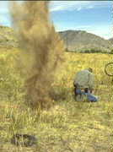
The principle advantages of explosive sources are
- Pound for pound, these types of sources impart the most amount of seismic energy into the ground of any of the sources described here.
- The energy tends to be very high frequency, and because the explosives are usually placed in a shallow borehole, it tends not to be contaminated by surface waves.
- Explosive sources are very repeatable.

The principle disadvantages of explosive sources are
- Safety.
- Permitting. Landowners tend to be nervous about allowing the use of explosives on their property.
- Data acquisition using explosive sources is much slower than using impact or gun sources. This is primarily because boreholes must be drilled within which the explosives are to be placed.
- Explosives tend to be expensive to acquire and maintain.

4.3 Geophones
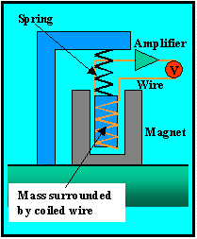
Contrary to what you might think, geophones are remarkably simple (yet ingenious) devices. Like gravity meters, the active element of the device consists of a mass hanging on a spring. When the ground moves, the mass (because it has inertia) wants to remain motionless. If you were watching the seismometer as the ground moved, it would look like the mass itself was moving. But, in reality, you are moving with the ground, and the mass is remaining motionless. Obviously, this is a simplification of what really happens. Because the spring is not perfectly compliant, the mass does in fact move when the Earth moves. It moves in a very complex fashion that can be relatively easily quantified. For our purposes, however, we can make the assumption that the mass remains motionless without loss of generalization.

Now for the ingenious part. Wrapped around the mass is a strand of wire. Surrounding the wire-wrapped mass is a magnet that is fixed to the Earth. As the Earth moves, the magnet moves up and down around the mass. The magnetic field of this moving magnet produces an electrical voltage in the wire. This voltage can be amplified and recorded by a simple voltmeter. It is relatively easy to show that the voltage recorded by the voltmeter is proportional to the velocity (speed) at which the ground is moving. This type of geophone was first invented in 1906 by a prince of the Russian empire by the name of B. B. Galitizin.

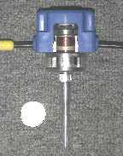
Shown to the right is an example of a geophone that is representative of those typically used in seismic refraction and reflection work. A quarter is shown for scale. This particular seismometer has had its side cut out so that you can see its working parts. The wire- (copper wire in this case) wrapped mass can be clearly seen inside the geophone. The spring connecting the geophone to the case can not be seen but is just above the mass. The silver colored case just inside the blue plastic external case is magnetized. The black wires coming out from either side of the blue case transmit the variations in voltage to the recording system. The long silver spike below the blue case is used to firmly attach the geophone to the ground. This spike is pressed into the ground by stepping on the top of the geophone until it is completely buried.

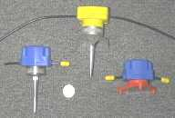
Different styles of geophone cases are available for use in different environments. Several examples are shown to the right. The geophone shown to the far right (the one without the spike), for example, is designed for use on hard surfaces into which spikes can not be pushed.

Geophones used in exploration seismology are relatively inexpensive. Although cost per geophone is small, remember that many (1000's) of geophones may be used in the large reflection seismic surveys conducted for the petroleum industry. Near-surface investigations are typically much smaller in scale, both in terms of area covered and in terms of equipment needed. For a near-surface refraction survey, one could use as few as twelve or as many as a hundred geophones. Near-surface reflection surveys use only a moderately greater (24 to 150) amount of geophones at any one time.

4.4. Multi-channel Recording
The data required for interpretation when using the seismic refraction method consists of a set of travel times versus distance between the source and the geophone. This distance is usually referred to as offset. Obviously, when looking at the travel-time curves that we have seen so far, if we were to determine the time of arrival of the first arrival at one distance we would not have enough information to determine the subsurface structure.

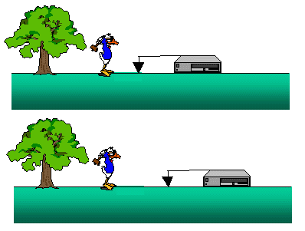
So, how do we actually collect the observations we need? As shown below, one strategy would be to place a single geophone at some location and record the ground motion produced by a source at another location. We could then move the geophone to a new location, keep the source at the same location, and repeat the experiment as shown to the right.

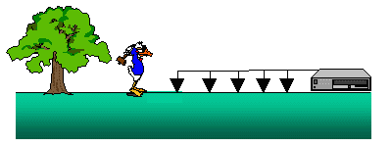
With this acquisition scheme, for each source location we would have to pick up and move the receiver and the recording instrument many times to collect enough observations to define the shape of the travel-time curve with offset. A better (i.e., less time consuming) strategy would be to build a recording instrument that could record the ground motion at many different receivers at the same time. We could then connect receivers at all of the offsets we want in order to record data to this system and acquire all of the observations at once. This scheme is shown below.

This is how seismic observations are actually collected in the field. Recording systems used in the oil industry are now capable of measuring the ground motion of thousands of geophones at once. For environmental and shallow refraction surveys, recording systems capable of recording the ground motion from as few as 12 or 24 stations are used, but systems capable of recording input from 48 to 96 geophones are more typical.

4.5 Recording Systems
Multi-channel seismic recording systems are widely available from a number of different manufacturers. Seismic recording systems come in two varies; traditional and distributed.
- Traditional seismic recording systems utilize a central system to collect and process all of the information collected from a series of geophones. This limits the number of geophones you can record information from in two ways,
- Because each geophone is connected to the central recording system by a separate pair of wires, as the number of geophones increases the weight of the cable containing these wires increases. At some point, the weight of the cable becomes too heavy to be handled efficiently. And,
- Because the central recording system must process and record the information from signals arriving simultaneously from a large number of geophones, there is a limitation to how much information can be processed before the recording system becomes overloaded.
- Distributed systems rely on a series of smaller processing systems distributed with the geophones to do much of the data processing required. These processed data streams are then sent to a central processing unit, as digital data, where they are collated and stored. While distributed systems are more expensive, it is possible for them to handle the signals recorded from many more geophones.

Over the past 15 years, distributed recordings systems have become the standard in the oil and mineral exploration industries. These industries have found that distributed systems allow for a more flexible distribution of geophones on the ground, and because the central system is not required to do all of the processing, these systems allow for recording of many more geophones at any one time. The maximum number of geophones that can be recorded using traditional systems, because of the limitations described above, is about 200. Using a distributed system, however, oil exploration surveys now routinely record information from 1000's of geophones. In a distributed system, geophones are connected to the recording system by electrical cable. Each cable is capable of carrying the signals produced by several (10's to 100's) of geophones at once, rather than having a single cable go to each geophone separately.

Examples of two systems currently available for use in near-surface surveys are shown below. By-in-large, near surface surveys use traditional recording systems. The Seistronix system shown below, however, is a distributed system designed for near-surface exploration work. If you are working in the engineering and environmental industries, you will probably begin seeing more systems like this in the near future.

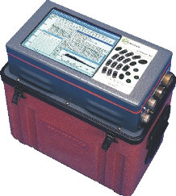  Geometrics StrataVisor | 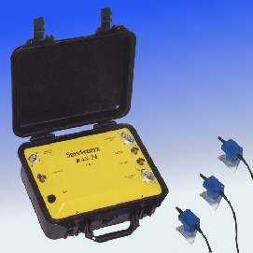  Seistronix RAS-24

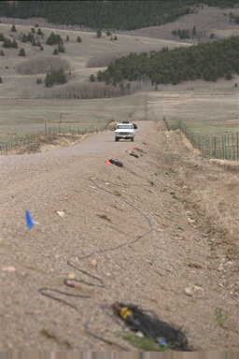
An example of a set of geophones connected to seismic cable is shown to the right. This particular cable was commonly used for deep exploration, such as was done in the oil and gas industries during the 1970's through the 1980's. If you look carefully, you might notice that along the cable there are orange strips. These strips are actually plastic connectors into which the geophones connect. In this case, the orange connectors (called take-outs) are spaced every 110 feet along the cable. For near-surface exploration work, this spacing can be reduced to as little as 5 feet.

Most modern recording systems can display the ground motion recorded by each geophone almost immediately after recording it. Ground motion is stored either directly to digital recording tape or to a computer hard disk in the recording system itself. The recording systems typically used in near-surface exploration are capable of recording ground motion from between 24 and 142 geophones.

4.6 Noise
As with all geophysical methods, a variety of noises can contaminate our seismic observations. Because we control the source of the seismic energy, we can control some types of noise. For example, if the noise is random in occurrence, such as some of the types of noise described below, we may be able to minimize its affect on our seismic observations by recording repeated sources all at the same location and averaging the result. We've already seen the power of averaging in reducing noise in the other geophysical techniques we have looked at. Beware, however, that averaging only works if the noise is random. If it is systematic in some fashion, no amount of averaging will remove it.

The noises that plague seismic observations can be lumped into three catagories depending on their source.

- Uncontrolled Ground Motion: This is the most obvious type of noise. Anything that causes the ground to move, other than your source, will generate noise. As you would expect, there could be a wide variety of sources for this type of noise. These would include traffic traveling down a road, running engines and equipment, and people walking. Other sources that you might not consider include wind, aircraft, and thunder. Wind produces noise in a couple of ways but of concern here is its affect on vegetation. If you are surveying near trees, wind causes the branches of the trees to move, and this movement is transmitted through the trees and into the ground via the trees' roots. Aircraft and thunder produce noise by the coupling of ground motion to the sound that we hear produced by each.

- Electronic Noise: As you've already seen, geophones convert the ground motion they detect to electrical signals. These signals are then transmitted down the cable, amplified by the recording system, and recorded. Thus, anything that can cause changes in the electrical signal in the cable or the recording system causes noise in our recorded data. Electrical noise can come from a variety of sources. For example, dirty or loose connections between the geophones and the cable or the cable and the recording system can produce noise. Wet connections anywhere in the system can cause electrical noise. Wind can also cause electrical noise. This occurs if, for example, the cable is suspended in bushes. As the wind blows the bushes, this moves the cable. The cable is nothing more than a long electrical conductor. As it moves in the Earth's magnetic field, an electrical current is produced in the cable.

- Geologic Noise: Finally, we can consider any type of subsurface geologic structure that we can not easily interpret to be a source of noise. In seismic refraction surveying, we will assume that the subsurface structure varies laterally only along the line connecting the source to the geophones. If the Earth actually varies significantly away from our line, it is possible for us to misinterpret the seismic waves we record as structure below the geophones instead of structure to the side of the geophones. We will interpret our seismic observations as if they had been generated from relatively simple earth models. Although these models can be more complex than those used to interpret resistivity observations (we can have dipping layers and topography on the layers), in interpreting refraction seismic observations we must assume that variations occur along the line in which data is collected only.

5. Interpretation of Seismic Data

5.1 Reading First Arrivals
As we have already described, we obtain records of ground motion detected at each geophone over some time interval. The relevant piece of information that we would like to extract from these records is the time of arrival for the first arriving seismic energy.

One such record is shown to the right. A discussion on how first arrivals can be chosen has already been given. Suffice it to say that on this record it is fairly easy to see that the first arriving seismic energy comes in at the time corresponding to the blue line. The record shown, however, is noise free. With the inclusion of noise, the choice of time of the first arrival becomes much more complicated and, in truth, should be considered part of the interprational process.

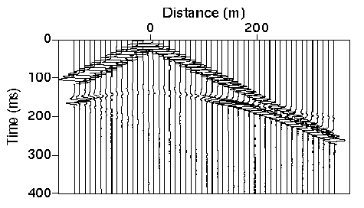With noisy data, it is often easier to choose first arrivals by comparing ground motion recorded at a variety of offsets. In the example shown below, for instance, it is much easier to distinguish the small refracted arrivals on the far offset traces when a group of these traces are plotted together in a record section.

The best way to begin to understand how to pick the first arrivals is to actually try picking a few. Record section from a data sets is shown to the right.

5.2 Waves In Multiple Layers
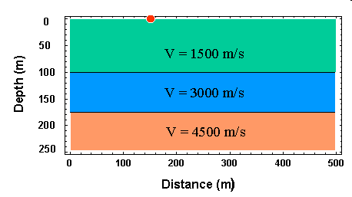
We have already considered seismic wave propagation through a simple model of the Earth consisting of a low velocity layer overlying a higher velocity halfspace. At some surface locations, we can observe three separate seismic arrivals in this model: the direct, reflected, and critically refracted (head wave) arrivals. Only the direct arrival and the head wave are observed as first arrivals. We can determine the speed at which seismic waves propagate through the layer and the halfspace and the thickness of the layer from observations of first arrival times at various source/receiver distances (offsets).

Now, what if the Earth is more complex? Consider the slightly more complicated model shown to the right.

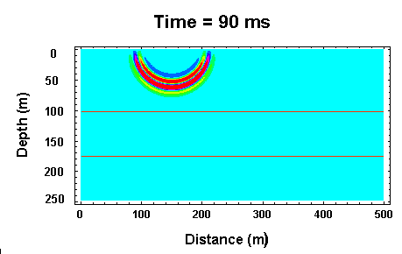
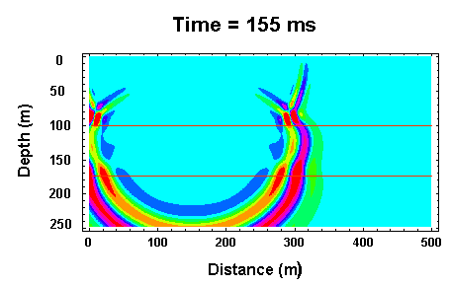
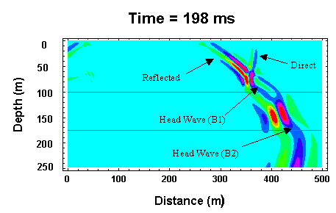
This model consists of two layers overlying a halfspace. The speed of wave propagation of the halfspace is greater than either layer, and the speed of propagation in the middle halfspace is greater than the speed in the top halfspace (i.e, velocity increases with depth). For this model, will observations of first arrival times provide us with enough information to estimate all of the relevant model parameters? The answer is yes!

Three snapshots of the wavefield at various times after initiation of the source are shown to the right.

Examine the 198 ms snapshot. Several seismic waves are apparent. First notice that like the one layer model, there are direct, reflected, and critically refracted (head wave - B1) arrivals originating from the top interface. The head wave generated off of this top interface propagates horizontally with a speed equal to that of the middle layer.

Now, because there is a second interface below this, we generate additional arrivals that can be observed at the Earth's surface. There exists a second reflected arrival and critically refracted (head wave - B2) arrival originating from the bottom interface. The reflected arrival is too small in amplitude to be observed in the snapshot. The second head wave is just beginning to develop at a distance of about 450 m. Like the head wave off of the top interface, this head wave will propagate horizontally with a speed equal to that of the halfspace.

Thus, at any distance we could observe one of three separate first arrivals.
- At short offsets, we will observe the direct arrival. This arrival propagates horizontally along the Earth's surface at a speed equal to that of the top layer.
- At intermediate offsets, we will observe the head wave off of the top interface (B1) as a first arrival. This arrival propagates horizontally along the Earth's surface at a speed equal to that of the middle layer.
- At large offsets, we will observe the head wave off of the top of the half space (B2) as the first arrival. This arrival propagates horizontally along the Earth's surface at a speed equal to that of the halfspace.

Although this model contains only two layers, if it contained more layers we could, in general, detect the presence of these layers from first arrival times only. It is important to note, however, that there will be specific instances where this isn't true.

5.3 Travel Time Curves From Multiple Layers
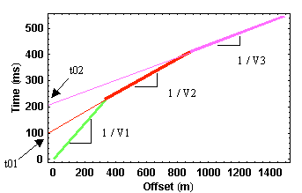
The travel time curve for the first arrivals that we would observe from the model given on the previous page is shown to the right. The green line segment represents travel times associated with the direct arrival, the red line are times associated with the head wave off of the top interface, and the purple line represents times for the head wave off of the bottom interface. Notice that in this example, although our bottom interface is only 175 meters deep, we do not see arrivals from this interface as first arrivals until we reach offsets in excess of 900 meters!! A general rule of thumb is that you need offsets of 3 to 5 times the depth down to which you would like to see.

As you would expect, we can determine the speeds of seismic wave propagation in the two layers and the halfspace from the slopes of the travel time curves. This is the identical procedure that we used in interpreting the more simple curves that arose from the simple layer over a halfspace model. The depths to each interface, again like the simple model we have described previously, can be computed from the intercept times, t01 and t02, and the velocities.

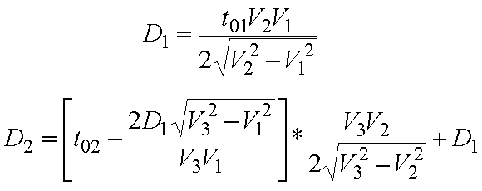
Although we will not derive them, the equations for computing the depths are given below. D1 is the depth to the first interface and D2 is the depth to the second interface.

Additional layers simply add additional linear segments to the observed travel time curve. From these segments and their respective zero offset times, we can compute the velocities within each layer and the depths to each interface.

5.4 Hidden Layers
Can layers exist in the subsurface that are not observable from first arrival times? As you may have guessed from the wording used on the previous page, the answer is yes!! Layers that can not be distinguished from first arrival time information are known as hidden layers. There are two possible scenarios that produce hidden layers.
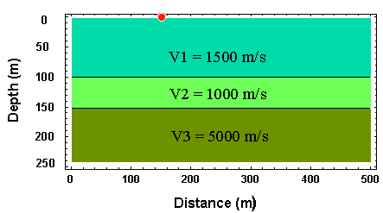
- Low Velocity Layers: This is the most obvious cause of hidden layers. Consider the model shown to the right.

Because the velocity decreases downward across the first interface, no head wave is generated at this boundary (as was the case for the first model we considered). At the second interface, however, a head wave is generated that can be
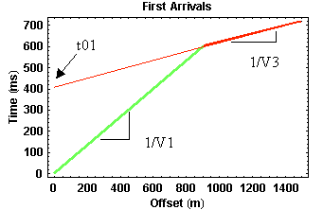
observed at sufficiently large offsets. Thus, our first arrival time observations will consist of direct arrivals at small offsets and head wave arrivals from the deeper interface at larger offsets. The first arrival travel-time curve generated from this model is shown to the right.

Notice that this travel-time curve is indistinguishable from the curves produced by a model containing a single interface. Hence, from this data alone you would be unable to detect the presence of the middle layer. Using the methodology described earlier, you would interpret the subsurface as consisting of a single layer with a velocity of 1500 m/s (from the slope of the travel-time curve for the direct arrival) underlain by a halfspace with a velocity of 5000 m/s (from the slope of the head wave travel-time curve). Using the value of t01 from the graph and the values of the velocities, you would guess that the thickness of the layer is 314 m!! You would be wrong.

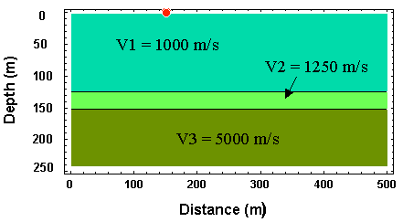
- Thin, Large Velocity Constrast Layers: Another type of hidden layer is produced by media whose velocity greatly increases with a small change in depth. Consider the model shown to the right.

Notice that in this model there is a thin layer that is underlain by the halfspace, and the halfspace has a velocity much larger than the upper layer.

Unlike the previous example, head waves are produced at both interfaces just as described previously. Because the layer is thin and the velocity of the underlying medium is larger, however, the head wave coming from the top boundary is never observed as a first arrival!! It is overtaken by the rapidly traveling head wave coming from the bottom boundary before it can overtake the direct arrival. The travel-time curve you would observe is shown below.

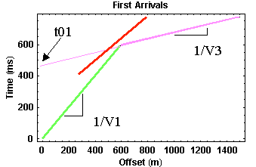
The red line in the figure shows the travel times for the head wave coming off of the top boundary. As described above, it is never observed as a first arrival. Therefore, like before, you would interpret the first arrivals as being generated from a subsurface structure that consists of a single layer over a halfspace. Again, like before, you can correctly estimate the velocities in the top layer and the halfspace, but because you missed the middle layer, the depth you would compute from t01 to the top of the halfspace would be incorrect.

In both of these cases, notice that the existence of the hidden layer can not be determined from the travel-time observations you are collecting. So, in practice you probably will never know that hidden layers existed under your survey.

5.5 Shooting Down Dip
Understanding how a dipping interface will affect refraction observations is a simple extension of the principles that we've already described. Consider the structure and the acquisition geometry shown below.

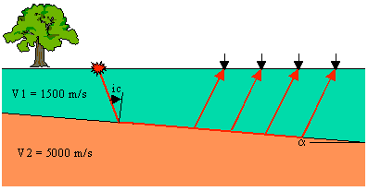
A high velocity halfspace underlies a lower velocity layer. The boundary between the layer and the halfspace dips from left to right. Notice that in this example, the source is to the left (up dip) of the receivers.

As was the case in the other examples where velocity increases with depth, in this case, head waves will be generated along the top of the halfspace that will propagate back up through the layer and be observed on the surface of the Earth. Raypaths for the head wave are shown in red in the figure.

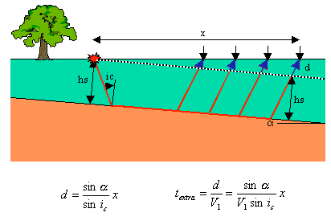
Notice, if we were able to put geophones inside the Earth along a line that passes through the source and parallels the top of the halfspace (black dashed line), we would observe the head wave as if it had been generated on a flat boundary. Thus, the times that it takes the head wave to travel from the source back up to the black dashed line are identical to the times we've discussed for flat boundaries.

Our geophones, however, are not sitting within the Earth. They're sitting on the surface of the Earth. The head waves must travel an extra distance beyond the black dashed line to reach our geophones (blue extensions to the red ray paths). Notice that the distance the head wave must travel beyond the black dashed line increases with offset. Therefore, when compared to the travel times we would expect from a flat layer, the dipping layer causes the travel times of the refracted arrival to be delayed. The size of the delay increases with offset.

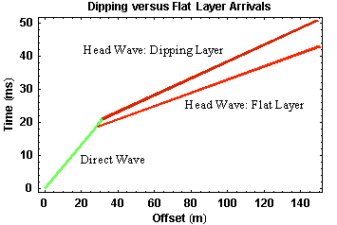
It is easy to approximate how much later the head wave is observed at every offset. Knowing the dip of the layer, &αλπηα, and the offset, x, the extra ray path traveled, d, can be easily computed. Dividing this distance by the velocity, V1, gives us the extra travel time. An equation for this extra time is shown in the figure above. Notice that the amount of extra travel time increases in proportion to the offset, x. Thus, like the flat layer case, we would expect the travel-time curve for the head wave off of a dipping layer to define a straight line versus offset.

The travel times observed from this dipping layer are shown to the right, along with the times that would be observed if geophones were placed along the black dashed line (the flat layer equivalent).
Direct arrivals are shown in green. They are not affected by dip on the layer. The head wave generated from the dipping layer as observed on the surface of the Earth is shown in dark red. Shown in bright red is what be observed on the black dashed line. As expected, the head wave observed on the Earth's surface arrives at later times, and this time difference increases with offset.

Thus, if we were to collect data over a dipping layer by shooting down dip, the following points would be true:
- We would not be able to tell the layer was dipping from the shape of the travel-time curve. In both the dipping and non-dipping layer case, the curve consists of two linear segments,
- We could compute the velocity of the layer from the slope of the travel-time curve that defines the direct arrival,
- When using the slope of the travel-time curve for the head wave, we would compute a velocity for the halfspace that is too small, and
- Using the velocity calculated above and the zero offset time, t0, we would compute a depth to the layer boundary larger than the distance to the interface beneath the source, hs.

5.6 Shooting Up Dip
Now what happens if we place the source down dip, to the right, and the receivers up dip? The geometry and the ray paths (red) for the head wave observed at four different offsets are shown in the figure below.

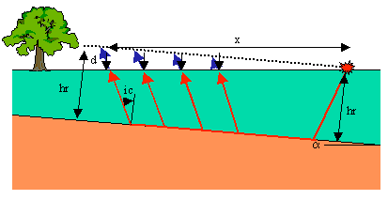
As we did when shooting down dip, we can examine how the dip affects the observed travel times by comparing them to the times we would observe along a line passing through the source and paralleling the boundary (dashed line). In this case, notice that when shooting up dip, the actual ray paths are smaller than we would observe along the black dashed line.

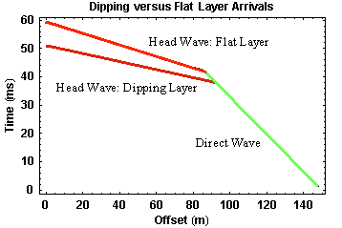
Thus, the travel times at any offset for the head wave observed on the surface of the Earth are less than those we would observe for an equivalent flat layer. The time deficit increases with increasing offset and has the same size as the time increase at a given offset when shooting down dip. The travel-time curve we would observe over this structure is shown to the right.

As before, direct arrivals are shown in green. They are not affected by dip on the layer. The head wave generated from the dipping layer as observed on the surface of the Earth is shown in dark red. As it would be observed on the black dashed line is shown in bright red. As described above, the head wave observed on the Earth's surface arrives at earlier and earlier times with increasing offset. As before, the travel-time curves collected over a dipping layer when shooting up dip consist of the exact same components as those observed over a flat layer (two straight line segments).

If we were to interpret this data with having no other information, the following results would occur:
- We would not be able to tell the layer was dipping from the shape of the travel-time curve. In both the dipping and non-dipping layer cases, the curve consists of two linear segments. Thus, we would most like misinterpret the observations as being indicative of a simple flat-lying interface,
- We could compute the velocity of the layer from the slope of the travel-time curve that defines the direct arrival,
- When using the slope of the travel-time curve for the head wave, we would compute a velocity for the halfspace that is too large, and
- Using the velocity calculated above and the zero offset time, t0, we would compute a depth to the layer boundary smaller than the distance to the interface beneath the source, hr.

5.7 Recognizing Dipping Layers
On the previous two section we've seen that the travel-time curves collected over dipping layers have the same shape as those collected over horizontal layers. Given this, is it possible to tell from the travel-time observations alone whether the layers are dipping or not?

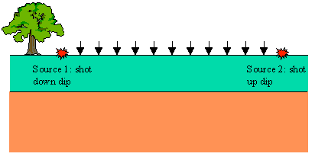
Well, to make a long story short, the answer is yes. Although the form of the curves is the same, notice that the slope of the travel-time curve defined by the refracted arrival and the intercept time of the refracted arrival differs depending on whether you are shooting up dip or down dip.

Imagine we were to acquire refraction seismic observations over a flat, horizontal boundary as shown in the figure to the right.

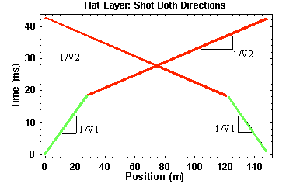
We set out a line of geophones spaced at some interval from right to left as shown by the black arrows. We then placed our source to the left of the line of geophones and acquired travel-time observations. Next, we moved our source an equal distance to the right of the line of geophones and re-acquired the observations. In comparing the two sets of data, what would you expect them to look like?

In this case, since the layer is horizontal and the distances between the two sources are the same, just reversed, I would expect the travel times acquired from each source to be identical when plotted versus source/receiver offset but reversed when plotted versus receiver location. A plot of the latter is shown to the right.

Seismic

In this particular example, the first source was at a position of 0 meters, and the second source was at a position of 150 meters. Because the geometry of the layer is the same under all of the sources and all of the receivers, no matter what positions the sources and receivers are in, as long as the offsets are constant, the travel-time curves have the exact same shape.

Now imagine doing the same experiment over a dipping layer as shown below.

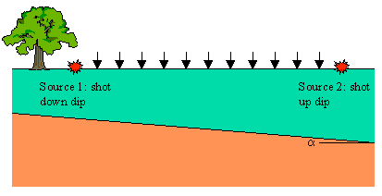
The travel-time curves derived in this case are shown below. Recall that when shooting down dip, the travel-time curve defining the head wave off of the boundary has a slope greater than 1/V2 and a zero offset time from which you would compute a depth to the boundary greater than the depth to the boundary underneath the source. When shooting up dip, the travel-time curve defining the head wave off of the boundary has a slope of less than 1/V2 and a zero offset time from which you would compute a depth to the boundary less than the depth of the boundary underneath the source.
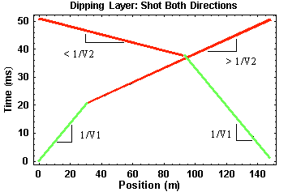
Thus, by acquiring refraction seismic observations in two directions, we can immediately determine whether or not subsurface layers are dipping. If dipping layers are present, the travel-time curves obtained in the two directions are no longer mirror images of each other.

5.8 Estimating Dip and Depth
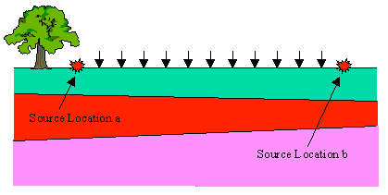
Although we could derive exact expressions from which to compute the depths and dips of multiple dipping layers from first arrival observations, for our purposes, all we really need to be able to do is to estimate these parameters from the field records. The procedure for estimating these parameters described on this page is only valid if the layers do not have excessive dips.

Like the multiple horizontal layer case, multiple dipping layers will also produce head waves that can be observed on the surface of the Earth from which subsurface Earth structure can be determined. The same caveats hold in this case concerning those structures that can not be resolved from first arrival observations.

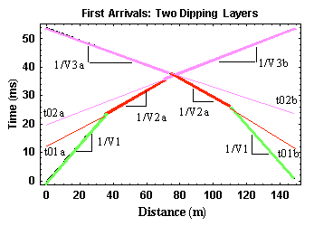
So, in general, Earth structures like the one shown above produce travel-time curves like those shown to the right that can be used to estimate the depths and dips of each layer. Again, to identify the presence of dipping layers, you must acquire the data by shooting in two directions. Notice that in this example, the dip effect on the observed travel-times is quite subtle. Each layer in this model dips at a half degree.

If the dips are small, then we can estimate the structure under each source by assuming the dips are zero and by using the expressions we have already derived. After doing this for each source, we can then estimate the dip of each layer. The general flow for such a procedure would include the following:

- Determine the slope of each line segment in the observed travel-time curves for both source locations,
- The slopes of the nearest offset portions of the two travel-time curves should be equal to each other with a value of 1/V1,
- For the travel-time segments representing the refracted arrival, average the slopes of the refracted arrival traveling up dip with that of the arrival traveling down dip on each refractor. This requires that you identify on the travel-time curves those portions of the curve originating from the same boundary. In this case, you would average the slopes of the two red line segments (1/V2a and 1/V2b) and the slopes of the two purple line segments (1/V3a and 1/V3b). Use the absolute value of the slope in this calculation,
- Compute your estimate for V2 and V3 by taking the reciprocal of the averages generated in the preceding step,
- Using these velocities, the zero intercept times at each source (t01a and t02a for the source to the left and t01b and t02b for the source to the right) and the equations given previously estimate the depth to each layer underneath each source, and
- From these depths and knowing the separation between the two sources, estimate the dip on each layer.

Remember this procedure will give you estimates of the depth to each layer and the dip on the layer. The modeling codes used in the exercise will provide more rigorous estimates that do not depend on the small dip assumption made here.

5.9 Observational Errors and Limitations
Of all of the geophysical methods investigated so far, the acquisition, processing, and interpretation of seismic observations tend to be the most time, equipment, and manpower intensive. As a consequence, compared to the other geophysical techniques, seismic methods tend to be rather expensive. Even though the seismic method investigated in this particular project, refraction seismology, is inexpensive compared to some of the more comprehensive seismic investigations (i.e., reflection seismic methods), given its expense, you will rarely employ even a refraction seismic investigation before doing other, less expensive, reconnaissance investigations.

In the investigations undertaken thus far, the relevant observations have been measured by sophisticated instrumentation and provided to the user as a single number: the gravitational acceleration, magnetic field intensity, or the apparent resistivity at some spatial location. In collecting seismic observations, no such simple number is provided. In refraction surveying, for example, the instrument does not simply display the time required for a wave to propagate from
The source to a fixed receiver location. Rather, seismic instruments measure and provide records of the time-history of ground motion at a particular location. This has two consequences:

- First, the amount of data collected during a seismic investigation is orders of magnitude larger than collected while conducting the other geophysical investigations described. Along with this increase in data flow comes logistical concerns regarding data storage and data access that we haven't had to deal with in the past. Also, with the increased data flow collected from seismic investigations comes a much greater ability to constrain the details of the underlying geologic structure than we have seen with the other methods.

- Second, it is up to the data processor or interpreter to determine from the records of ground motion the relevant physical parameters; in a refraction survey these would be the times of arrival of particular seismic waves. Thus, unlike the other techniques, the determination of the relevant physical parameters from seismic observations requires human intervention and, as a result, is in itself an interpretative process.

Although reliable interpretations from all geophysical observations require an accurate knowledge of field parameters, the equipment and logistical scope involved in conducted seismic surveys make this issue particularly thorny. Extensive field notes, known as OB (Observer) sheets, are routinely recorded while conducting ALL seismic investigations. The quality and accuracy of these OB sheets can vary greatly and can directly affect the interpretability of the observations collected. For example, the personnel responsible for the processing and interpretation of seismic data may only interact with the acquisition crew through the OB sheets produced during data acquisition. If the information included on these sheets is incorrect or incomplete, it may be impossible to process or interpret the observations or the final interpretation may be biased.

To gain a better appreciation of the importance of providing adequate documentation of the field activities, the interpretive process that is required to extract travel-time information from the field observations, and the noise inherent to all seismic observations, a series of shot records were recorded in the CSM survey field using a variety of seismic sources and array configurations. With this knowledge, and adequate observer sheets, you should be able to determine everything you need about this survey, extract the relevant travel-time information, and construct estimates of the typical uncertainties associated with travel-time observations.

