RED BULL
CASE STUDY

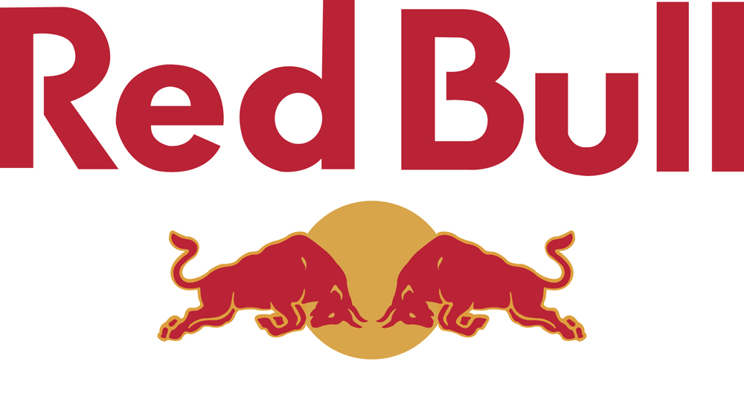

Q1-Discuss Advantages disadvantages of red bull targeting and distribution strategy?
Answer
The key target market of Red Bull is male and female customers aged between 17 and 23 years old who are active, dynamic and have drives. Red bull targeting the sports athletes, young socialites and students in colleges, young and energetic people. Sponsoring many events like race game Formula1,snow boarding, cliff driving, car racing and street luge with trendy appearance and mysterious image musical fans the main advantage of targeting such a market was people of target market was willing to pay high prices for the product . Red Bull gives people the perception or ability to achieve one of these things by creating an opportunity for people to enter the extreme sport competitions they hold and then develop a hilarious viral video as the viral marketing adverts and as the marketing message for people to pass it around, with hope that one of the receivers will pass it to others. To promote Red Bull brand as the youthful energy drink, its logo is designed to be eye-catching. The marketing of red bull was through the among the one of the 16 marketing campaigns that was Viral marketing ,to make viral marketing work well, Red Bull has ensured that its brand is visible on the street by doing the following.
- To promote Red Bull brand as the youthful energy drink, its logo is designed to be eye-catching.
- Free Red Bull is given to club DJs. They are asked to leave the empty cans on the hot spots, such as trendy bars, pubs and clubs.
- Cans of Red Bull are given to people on the street who have been identified as being in need of energy.
Despite the poor reputation of the red bull related to many cases in the medical framework of the death of many people in Sweden and Germany and banned in many counties with the warning of not consuming with the alcohol and many other medical warnings and investigation was relating to in many countries the advantages of targeting the young costumers with they are willing to pay high prices for the product like in the case mentioned that the student of college said that he is willing to pay $3 for the pathetic product but it became trend for the young college girls and boys to consume the product . Red Bull promoted its brand differently. Rather than relying on the usual methods of marketing, Red Bull focuses mainly on using 'buzz marketing' or word-of-mouth. To do this effectively, it creates a brand image that is associated with the youth culture and extreme and adventure-related sports, such as mountain biking, snowboarding
The main disadvantage of the targeting the Niche market by the red bull was that if the product fails as the situation portrayed in the case then whole of the design of the marketing and the targeting the special group would have failed and the whole of the business plan of red bull would have been failed but luckily Red bull 's marketers had a good integrated marketing strategy because they had a good product , and presented it to the right target market at the right time using the right procedures.
The distribution strategy was that in the US red bull divided the area into eight local decentralized units making sales and distribution as well as marketing responsibilities they tend to hire the sales forces of the area HIP LOCALS and used to distribute at the hot spot and night clubs and universities. Had a clear audience in mind because they had produced an energy drink, mateschitz’s target audience was a group of people who used a lot of energy and hence needed more. This is why he decided to target youth and people in their
late teens red bull picked five venues to distribute the product like students acted as the brand manager or ambassadors of the red bull the main advantage of using this type of distribution channel informally or formally was that red bull target market was also the young people who are energetic either the students or athletes so by hiring the Hip Locals who is used to distribute the product on promotional basis to their peers
Similarly as their target market was also the young and energetic people which tend to attach a trendy and prestigious look by consuming the product. The main advantage they also used their distribution channel independent if other soft drinks like Pepsi and Coke distributors to arrange for the loyalty and distribution network strong
The main disadvantage of using this type of distribution network was that they were poorly failed to communicate the original brand value and functioning of the product despite it seemed that people only consumed it as a prestigious and trendy brand as a Fashion rather making the distribution channel of untrained Hip Locals there might be a possibility that they would be better be able to have a positive image in the market by hiring the trained salespersons and distribution channel members
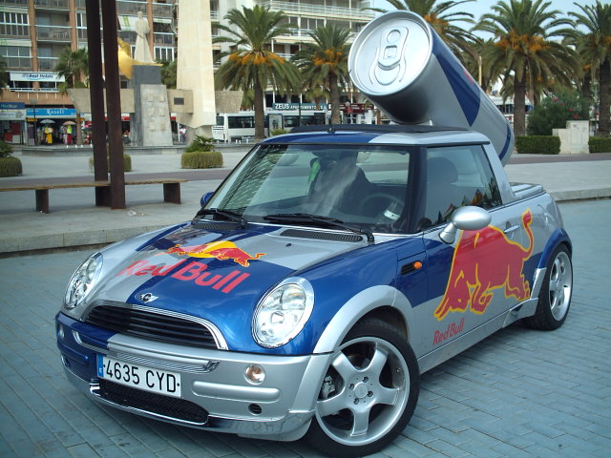
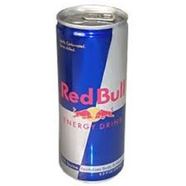

Q2-How did red bull effectively and efficiently dealth with rumors of health risks and deaths?
Answer
The red bull could possibly be able to deal with risks by designing the advertising or marketing campaign in which the performance and product elements could have been described to make people aware that there is not any of the risk associated with the consumption of the product instead the death of people would not a issue related to any of the consumption if the product as the survey in the Sweden reveals that the death of athletes was not because of the consuming the product but rather than the immediate heart stroke that might have caused by consuming the different medicines that might that have consumed but have no link with the consumption of the product . On the one hand, they loose some customers due to health fears, as countries such as Denmark,
France and Australia ban the drink. On the other hand, along with the bans, negative press related to the ingredients, nicknames, adverse affects and deaths, has not only made Red Bull talking point.
Giving them free publicity, it has also allowed the drink to keep its edge, and remain “cool”. this was purely a CSR case issue in which the company might also display the warnings related with the product the For example it contained a high amount of the caffeine that it might not be consumed with the alcohol of other that when you have already consumed more of the coffee that it might probably increase the caffeine level and makes your blood thick and stick that might cause the heart stroke the case of the CSR(cooperate social responsibility) that the possible precaution might have been mentioned on the product label that people may become aware before consuming the product
Q3-What other target markets red bull may have neglected? What are the potential of those “untapped” markets?
Answer
According to our group consultation and after brain storming we come to the possible targets markets that red bull might or can tap can be the professionals like previously the red bull targeting the students hippies and young and energetic people and most of all in all important segments of major chunk for them was the athletes also that red bull main advertising and promotional campaigns targeted the events like snow boarding, hill cliff and sponsoring the Nescar Formula one races red bull might come up with the professionals like most of all prince of all princes are the Doctors and other professionals like engineers and business man who work in the continuous and hazardous work to give them instant relief and energy mainly focusing on the doctors might also come up with the possibility that they might also become the brand ambassador of the red bull and the lost confidence of the target market and also the upcoming the increase share of the same niche market that possibly have lost because of the health issues rose. Associating or making the another target market if the professionals mainly the doctors can possibly revive the lost confidence in the brand and can increase the share of the red bull in the energy drink market though still the red bull is of the 70 % market leader but still can raise the market share of red bull in the market
Q4-Should Red bull be concerned by Cooperate Social Responsibility (CSR) issues?
Answer
This is the issue of the pure CSR (cooperate social responsibility) as though there was nothing wrong with the product the death caused in the united states or Ross Cooney a basketball player confirmed after the investigation that there was nothing wrong with the product only some negative correlations are attached with the product like in united states like FDA issued no warning regarding the consumption of the product like red bull included no harmful integrants like epheridine and gurana. Several health officials and other organizations believed that the harmful effect of consumption of red bull when combined with the Alcohol like it contained the caffeine and when combined with the alcohol causes dehydration and stuck in the nervous system which makes the blood sticky and can possibly cause the death so red bull might have warned this on the label or packaging of the red bull the different warning like not to be consumed with the alcohol this was the CSR responsibility of the Red bull . To make its brand even more unique, Red Bull should use the highly motivated and well-educated employees to develop the samples to support the viral brand image of the energy drink . The brief concept that the marketing team of Red Bull uses is simple: 'Find tired and exhausted people' and give them Red Bull samplings. There is no harm in distributing the free samples to the young people in fact it is good that if may increase the awareness that there is nothing wrong with the consumption of product but in fact ct when consumed with some combined effect of alcohol or the coffee can increase the level of caffeine in the blood and can cause the heart stroke and ultimately the death also while distributing the free samples the awareness or training sessions should be given to the people that how to use the product and in which cases not to be used to regain the confidence in the people and also avoid the possible unpleasant surprises with the consumption of the product

