Chapter 10:
REPORTING OF STUDENT ASSESSMENT

Upon completion of this chapter, you should be able to:
Explain how assessment results are used
List the types of information included in an assessment report
Discuss the format of the assessment report
Explain the need for confidentiality

CHAPTER OVERVIEW

10.1 “Pencils down”
10.2 How is Student Assessment
Results Used?
10.3 Who is the Audience
Addressed in the Report?
10.4 What Type of Information
Should be Included in the
Report?
10.5 What Should be the Format
of the Report?
10.6 How is Information in the
Report Used?
10.7 Confidentiality
Summary
Key Terms
References

Chapter 1: Introduction
Chapter 2: Deciding What to Assess
Chapter 3: Assessing Learning Outcomes
Using Objective Tests
Chapter 4: Assessing Learning Outcomes
Using Essay Tests
Chapter 5: Assessing Learning Outcomes
Using Projects and Practicals
Chapter 6: Assessing Learning Outcomes
Observation Checklists, Oral
Tests and Portfolios
Chapter 7: Reliability and Validity of
Assessment Methods
Chapter 8: Planning a Test and Item
Analysis
Chapter 9: Analysis and Interpretation of
Assessment Scores
Chapter 10: Reporting Student Assessment

After having collected and analysed the assessment data collected about students, the next step is to make the information available to relevant stakeholders such as parents, school administrators, government authorities, potential employers and the community. The format of the report and the information included will depend on the audience addressed. The information should be presented in a form that will encourage the audience concerned to read and understand. The level of detail included in the report will depend on the demands of the audience and whether it will be use effectively.

10.1 “Pencils down!”


“Pencils down” is commonly used phrase to mark the end of a testing session. But, your testing programme does not end with these words. Actually, is the beginning of a comprehensive plan is devised to report the results of your assessment or testing programme. The planned and active use of test results is an important part of the instructional process. It is not enough to analyse assessment data and report the results to students. If this is the case, then the assessment process is incomplete.

10.2 How Is Student Assessment Results Used?

After having analysed assessment data that you have collected at the end of a semester or end of the year, the next task is to make a report of the information to improve decisions and help the school or institution to improve and help students learn even more (Morris Fritz-Gibbon and Freeman, 1987). Based on the report the school or institution is able to determine:
- the extent to which it has met all learning outcomes or objectives,
- the strengths and weaknesses of individual subject areas,
- the learning needs of students
- whether individual students should be promoted to the grade or level
- which part of the school’s curriculum that needs help.

These decisions are critical and educators should give careful thought to how assessment results are reported and to whom. They are the only source of information that some audiences receive about actual student learning. Therefore, educators should thoughtfully design and prepare reports about assessment results. Otherwise, they might mislead audience and cause them to misinterpret and/or misuse the results.

10.3 Who Is The Audience Addressed In The Report?

When preparing the assessment report, you should be aware who is the audience as there are many stakeholders involved in any school or educational institution. Any report reporting of assessment results will depend on what a particular audience wants and needs. Among the audiences are:
- students
- teaching staff
- curriculum review committees
- school administrators
- school districts
- parents
- government authorities
- teachers
- associations or unions
- community
- accrediting bodies
You should be aware as to what each audience members want to know and what you want them to know. You should determine the kind of data hey understand, how much do they want, what format(s) will be most effective (narrative summary, graphs & charts, numerical). In some instances, you may produce only one report serving multiple audiences and in other instances there are several reports, each tailored to one specific audience.
10.4 What Types Of Information Should Be Included In The Report?

Depending on the audience, an assessment report can include enough information to answer four basic questions:
- What did we do?
- Why did we do it?
- What did we find?
- How will we use it

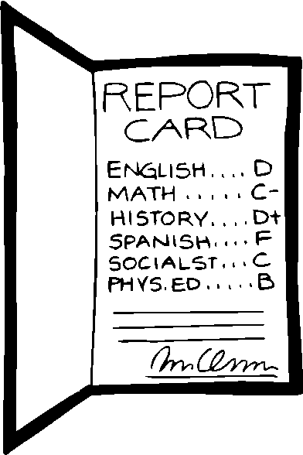
Most important is to establish who needs the information. i.e. what the audience wants. Regardless of who is the audience, it is important to ensure that the information will give meaningful understanding of the performance of the educational institution and the students. The following are key components that should be included in the report:
- What students have learned and the school's effectiveness. In other words the proportion of students meeting learning outcomes or objectives.
  - Percentage fully meeting expectations
  - Percentage substantially meeting expectations
  - Percentage substantially failing to meet expectations
- Demographic data that helps describe the school population and identify special problems or needs (e.g., mobility rate, proportion of students from low-income families).
- Other indicators of school effectiveness (e.g., attendance, dropout, and graduation rates; academic awards; satisfaction),
- Analyses showing the proportion of students in various groups (e.g., income level, minority groups, students with disabilities) who meet objectives/outcomes,
10.5 What Should Be The Format Of The Report?
The format of the assessment report will influence readers' motivation to read the report as well as the perceptions that readers acquire from the reports. Points to consider when designing the report:
- Level of detail
  - Some audiences may prefer brief, easy-to-read summaries
  - Some readers want considerable detail.
  - May be necessary to prepare different reports for different audiences.
- Avoid reporting results that can be linked to individual teachers. Tendency for readers to interpret results as indicators of the effectiveness of individual teachers.
- Decide whether each learning outcome always be reported separately or should they be clustered
- Decide if each grade always be reported separately
- Charts, graphs, and tables to be used
  - Visual aids are used to present information more efficiently and meaningfully than text.
  - Visual aids should be used carefully because charts and graphs are sometimes misleading (e.g. the scale used is much smaller than the range of scores on a test)
- There should be a balance between charts, graphs, and tables to text
  - Some people prefer to examine charts, graphs, or tables in order to obtain quantitative information.
  - Some people may be bored when information is repeated in the text.
  - Some people need the contextual information that is presented when numbers are embedded in text.

Example:
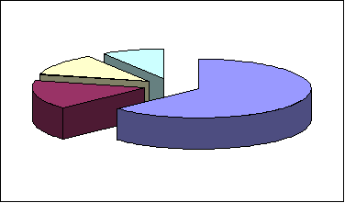
Pie charts are an excellent way to show parts of a whole. They emphasize general findings, but do not make small differences apparent. Pie charts with more than five or six slices should be avoided. For this reason, pie charts are used only with categorical data with a relatively small number of values or categories. Use a bar chart when you are showing several categories.

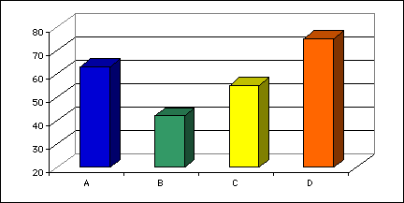
Example:
Bar charts are often used to compare differences between groups. This type of chart, like the pie chart, is also used with categorical data, and can illustrate up to about 15 categories very effectively. Bar charts make small differences between categories easily distinguishable.

The choice of report format should be based on the material in the report and its audience. Full reports are useful to audiences interested in the details of an assessment. They can also serve as complete records of assessment activities. Assessment summaries are used to highlight particular findings, to focus on specific issues, and to summarise assessment activities for audiences not inclined to read a full report. Results can also be used in assessment notes, brochures, or flyers to publicise an assessment project or finding or highlight a particular programme. Web reporting provides easy access to a wide range of audiences, makes specific data available and interactive, and enables audiences to answer customised questions.

- Data is to presented as comparisons with standards and expectations or with results from previous years; or with state assessment or commercial norm-referenced tests
- Statements regarding why some students are not meeting outcomes/objectives, and descriptions of efforts to improve student learning (future, current, or previous).
- Length of report - Avoid allowing reports to become so long that few people will read them.
- To facilitate reading organise and index reports so that readers can quickly locate information they need. Devices such as executive summaries with page or chapter number references and detailed tables of contents can be very effective.

10.6 How Is Information In The Reports Used?
People who use assessment results often draw conclusions about content domains that are much broader than those actually included in the assessment. For example, they may make statements about student achievement in world history or environmental sciences based on responses to just a few forced-choice test questions. Or, they may make general statements about student writing skills based on responses to a single prompt that required only expository writing, or about artistic abilities based on a crayon drawing of a house. These examples clearly represent unwarranted generalizations. Other inappropriate generalizations and discovers too late that there are not enough assessments for all students. The sources of error are likely to vary from one testing situation to another. If errors resulting from different sources of information – such as different kinds of assessment procedures--are random, they are likely to balance one another. For this reason, assessment interpretation and use will probably be improved if they are based on multiple sources of information.
Multiple sources of information also help compensate for the shortcoming that information does not cover the assessed content comprehensively (Freeman and Lewis. 1998). It occurs because, as discussed in the previous section about generalization, the assessment is brief and covers only a small portion of the content. Or, perhaps the content includes both knowledge and skills, and different types of assessment procedures (such as a paper-and-pencil test and a performance-based examination) should be used with different portions of it. Again, multiple sources of information should enable educators to make more valid interpretations and uses.
To illustrate, one could draw firmer conclusions about students' knowledge and skills related to a civil war from the results of several assessments that each focused on different aspects of the war. The assessments were of several types, such as multiple-choice or matching tests and essays about the causes of the war, social conditions during it, or the impact of it on the country. Together, the assessments covered the war comprehensively. Multiple performance-based assessments might be used--for example, requiring students to level assessments only after determining that such uses are appropriate.
Faculty, staff, and administrators who are involved in assessment planning will be more likely to use the results. Findings should be shared with department faculty members in a written report that could be used to generate discussions at faculty meetings or annual retreats. (What does the report tell you about your course or program? What possible changes are indicated? How could our department use these results to best advantage?) Additional reports or presentations can be prepared for different audiences, depending on their assessment needs.

10.7 Confidentiality

Confidentiality is extremely important in assessment result reporting. Who will have access to the results? Open reporting will probably be appropriate if an assessment is focused on a university-wide program and results are aggregated at the university level. Reporting to program directors only may be most appropriate if assessment is focused on improving a particular program. The assessment team must be concerned with participant confidentiality, also. Data should be aggregated to protect individuals and comments and open-ended survey responses revised to remove individual identifiers.


10.1 ACTIVITY
a) What kind of assessment reports are prepared by your
institution?
b) How is the information in the assessment used?
c) Who uses the information in the assessment report?

SUMMARY

- The planned and active use of test results is an important part of the instructional process.

- The aim of the assessment report is to improve decisions and help the school or institution to improve and help students learn even more.

- Educators should thoughtfully design and prepare reports about assessment results.

- When preparing the assessment report, onee should be aware who is the audience.

- The format of the assessment report will influence readers' motivation to read the report as well as the perceptions that readers acquire from the reports.

- People who use assessment results often draw conclusions about content domains that are much broader than those actually included in the assessment.

- Confidentiality is extremely important in assessment result reporting.

KEY TERMS
“Pencils down” Visual aids Stakeholders
Assessment Length of report Format of report
report Confidentiality

REFERENCES:

- Morris, L., Fritz-Gibbon, C. and Freeman, M. (1987). How to communicate evaluation findings. Newbury Park: SAGE Publications.

- Freeman, R., & Lewis, R. (1998). Planning and implementing assessment. London: Kogan Page Limited.

