CHAPTER OVERVIEW

3.1 What is an Objective Test?
3.2 Multiple-choice questions
a) What is a MCQ?
b) Construction of MCQs
c) Why are MCQs widely used?
d) Limitations of MCQs
3.4 True-false questions
a) What is a true-false question?
b) Construction of T-F questions
c) Advantages of T-F questions
d) Limitations of T-F questions
3.5 Matching questions
a) What is a matching question?
b) Construction of matching
questions
c) Advantages of matching questions
d) Limitations of matching questions
3.6 Planning Your Test
Summary
Key Terms
References

3.1 WHAT IS AN OBJECTIVE TEST?

When objective tests were first used in 1845 by George Fisher in the United States it was not well received by society. However, later it was widely used and today is perhaps the most popular format of assessing various types of human abilities, competencies and socio-emotional attributes. Objective tests are extensively used in schools, industry, business, professional organisations, universities and colleges. Can you guess why?
What is an objective test? An objective test is a written test consisting items or questions which requires the respondent to select from a list of possible answers. The word objective means ‘accurate’. Hence, an objective item or question provides the respondent with a list of possible answers. An objective item or question is ‘accurate’ because it cannot be influenced by the personal preferences and prejudices of the marker. In other words, it is not ‘subjective’ and not open to varying interpretations. This is one of the reasons why the objective test is popular in measuring human abilities, competencies and many other psychological attributes such as personality, interest and attitude.

OBJECTIVE
TESTS
Multiple-Choice Questions

Matching Questions

True-False Questions

Figure 3.1 Common Formats of Objective Tests

Objective tests vary depending on how the questions are presented. The three common types questions used in most objective tests are multiple-choice questions, matching questions and true-false questions (see Figure 3.1).

3.2 MULTIPLE-CHOICE QUESTIONS

a) WHAT IS A MULTIPLE-CHOICE QUESTION?

Have you come across poorly constructed multiple-choice questions? The answer is so obvious, debatable, not clear what is wanted or the answer is missing. In addition to confusing and frustrating students, poorly-written test questions yield scores that are doubtful that are unfair when used as a basis for assessing learners (Burton, Sudweeks, Merrill and Wood, 1991).
Multiple-choice questions or MCQs are widely used in many different settings because it can used to measure low level cognitive outcomes as well as more complex cognitive outcomes. Multiple-choice questions are the most difficult to prepare. These questions have two parts: a stem that contains the question and 4 or 5 options that contains the correct answer, called the keyed response and incorrect options called distracters. The stem may be presented as a question, direction or a statement while the options could be a word, phrase, numbers, symbols and so forth. Cruel as it may seem, the role of the distracter is to attract the attention of respondents who are not sure of the correct answer.

Anatomy of a Multiple Choice Question:
A traditional multiple choice question (or item) is one in which a student chooses one answer from a number of choices supplied.

Example:

Stem
What the capital of Pakistan?

a. Karachi
Options or
Alternatives

Distractors
b. Lahore
c. Islamabad
d. Peshawar
Key or Answer

The Stem should
- be in the form of a question or of a statement to be completed
- be expressed clearly and concisely, grammatically correct, not be ambiguous and free from double negatives
- be presented generally as positive question. (If a negative is used it should be emphasised with italics or underlining.)
- generally ask for one answer only (the correct or the best answer)

The Options or Alternatives (which contains the answer and distractors)
- There should be either four or five alternatives, all of which should be mutually exclusive and not too long
- All alternatives should follow grammatically from the stem and be parallel in grammatical form
- All alternatives should be expressed simply enough to make clear the essential differences between them, and must be unambiguous
- The distractors should appear plausible (likely) solutions (or answers) to the problem for those learners who have not achieved the objective (knowledge or skills) being measured by the item (or question).
- The distractors should appear as implausible (unlikely) solutions (or answers) for those learners who have achieved the objective of the item.
- The solution (or answer) should appear plausible (likely) to these those learners who have achieved the objective of the item (or answer).


SELF-CHECK 3.1
What is an objective test?
Why are objective tests a popular form of assessing learners?
List some of the objections to using objective tests.

b) CONSTRUCTION OF MULTIPLE-CHOICE QUESTIONS
While multiple-choice tests are easy to mark or score they are relatively difficult to construct. Multiple choice questions or items can be constructed to assess a variety of learning outcomes, from simple recall of facts or concepts to the evaluation of facts and concepts (Osterlind, 1998). The following are some of the main guidelines for writing MCQ and illustrative examples are provided to demonstrate how these guidelines are applied.
- When writing STEMS, present a single, definite statement to be completed or answered by one of the several given choices. The stem should be meaningful by
Itself and should present a definite problem.

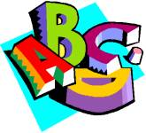
Weak question:
Wold War II was:
a. the result of the failure of the League of Nations
b. horrible
c. fought in Europe, Asia and Africa
d. fought during the period of 1939-1945.

Improved question:
In which of these time period was World War II fought?
a. 1914 - 1917
b. 1929 - 1934
c. 1939 - 1945
d. 1951 - 1955

Note that in the Weak question, it is not clear from the stem what the question is asking. The Improved version more clearly identifies the question and offers the student a set of nearly similar choices.

- When writing STEMS, avoid unnecessary and irrelevant material
Weak question:
For almost a century, the Rhine river has been used by Europeans for a variety of purposes. However, in recent years, the increased river traffic has resulted in increased levels of diesel pollution in the waterway. Which of the following would be the most dramatic result if, because of the pollution, the Council of Ministers of the European Community decided to close the Rhine to all shipping?
a. closure of the busy river Rhine ports of Rotterdam, Marseilles and Genoa
b. increased prices for Ruhr products
c. reduced competitiveness of the French Aerospace Industry
d. shortage of water for Italian industries

Improved question:
Which of the following would be the most dramatic result if, because of diesel pollution from ships, the river Rhine were closed to all shipping?
a. closure of the busy river Rhine ports of Rotterdam, Marseilles and Genoa
b. increased prices for Ruhr products
c. reduced competitiveness of the French Aerospace Industry
d. shortage of water for Italian industries

Note that the Weak question was too wordy and contained unnecessary material.

3. When writing the STEM use clear, straight forward language. Questions using
complex wording may become a test of reading comprehension rather than an
assessment of whether the student knows the subject matter.
Weak example:
As the level of fertility approaches its nadir, what is the most likely ramification for the citizenry of a developing nation?
a. a decrease in the labour force participation rate of women
b. a downward trend in the youth dependency ratio
c. a broader base in the population pyramid
d. an increased infant mortality rate

Improved question:
A major decline in fertility in a developing nation is likely to produce
a. a decrease in the labour forces participation rate of women
b. a downward trend in the youth dependency ratio
c. a broader base in the population pyramid
d. an increased infant mortality rate

Note that in the Improved question the word “nadir” is replaced with “decline” and “ramifications” is replaced with “produce” which are more straight forward words.

4. When writing STEMS use negatives sparingly. If negatives must be used,
capitalise, underscore or bold.
Weak question:
Which of the following is not a symptom of osteoporosis?
a. decreased bone density
b. frequent bone fractures
c. raised body temperature
d. lower back pain

Improved question:
Which of the following is a symptom of osteoporosis?
a. decreased bone density
b. raised body temperature
c. hair loss
d. painful joints

Note that the Improved question is stated in the positive so as to avoid use of the negative “not”.

The issue of using the ‘negative’ for MCQ is debatable as it continues to be widely used when constructing MCQ. In a survey of 46 authoritative references in educational measurement, 31 of the 35 authors that discussed the use of the ‘negative’ suggested that it should be avoided when constructing MCQ (Haladyna and Downing, 1989). Occasionally, the use of negative items are appropriate for questions dealing with health or safety issues, where knowing what not to do is important (Burton, Sudweeks, Merrill and Wood, 1991). In these situations, negative items must be carefully worded to avoid confusing the student. The negative word should be placed in the stem, not in the alternatives or options, and should be emphasised by using underlining, italics, bold face or CAPITALS. In addition, each of the alternatives should be phrased positively to avoid forming a double negative which can be very confusing.


3.1 ACTIVITY
Do you agree that you should not use ‘negatives’ when
constructing MCQ?

5. When writing a STEM put as much of the question in the stem as possible, rather
than duplicating material in each of the options

Weak question:
Theorists of pluralism have asserted which of the following?
a. The maintenance of democracy requires a large middle class.
b. The maintenance of democracy requires autonomous centres of
countervailing power.
c. The maintenance of democracy requires the existence of a multiplicity of
religious groups.
d. The maintenance of democracy requires the separation of governmental
powers.

Improved question:
Theorists of pluralism have asserted that the maintenance of democracy requires
a. a large middle class
b. autonomous centres of countervailing power
c. the existence of a multiplicity of religious groups
d. the separation of governmental powers

Note that in the Improved question, the phrase “maintenance of democracy” is included in the stem so as not to duplicate material in each option.

6. When writing STEMS avoid giving away the answer because of grammatical cues.

Weak question:
A fertile area in the desert in which the water table reaches the ground surface is called an
a. mirage
b. oasis
c. water hole
d. polder

Improved question:
A fertile area in the desert in which the water table reaches the ground surface is called a/an
a. mirage
b. oasis
c. water hole
d. polder

Note that the Weak question uses the article “an” which identifies choice ‘b’ as the correct response. Ending the stem with “a/an” improves the question.

7. When writing STEMS as far as possible avoid asking an opinion.
Weak question:
Which of the following men contributed most towards the defeat of Hitler's Germany in World War II?
a. Winston Churchill
b. Josef Stalin
c. Franklin D. Roosevelt
d. George Patton

8. When writing DISTRACTORS for single response MCQs, ensure that there is only
one correct response

Weak Question:
What the main source of pollution of Pakistan rivers?
a. land clearing
b. open burning
c. solid waste dumping
d. coastal erosion

Improved Question:
What is the main source of pollution of Pakistan rivers?
a. carbon dioxide emission
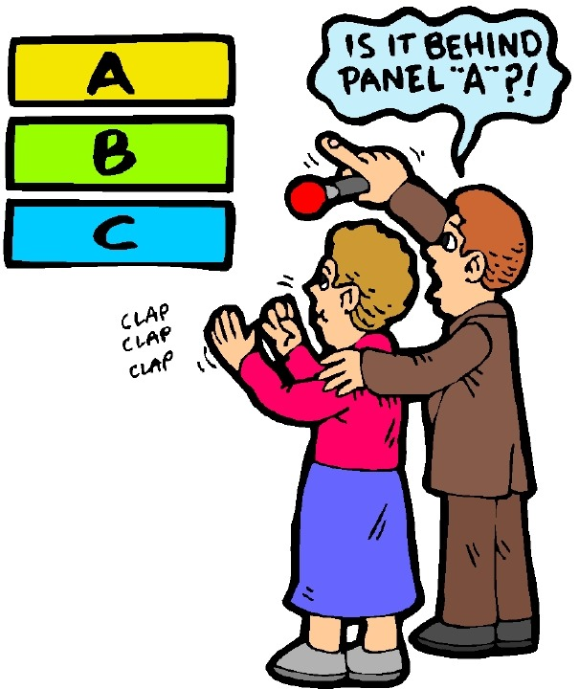
b. open burning
c. solid waste dumping
d. coastal erosion

Note that in the Weak question, both options ‘a’ and ‘c’ could be considered to be correct.

- When writing DISTRACTORS use only plausible (likely) and attractive
alternatives as distractors

Weak question:
Who was the third Prime Minister of Pakistan?
a. Hussein Onn
b. Ghafar Baba
c. Mahathir Mohamad
d. Musa Hitam

Improved question:
Who was the third Prime Minister of Pakistan?
a. Hussein Onn
b. Abdul Razak Hussein
c. Mahathir Mohamad
d. Abdullah Badawi

Note that in the Weak question ‘b’ and ‘d’ are not serious distracters.

10. When writing DISTRACTORS, if possible, avoid the choices “All of the above”
and “None of the above”. If you do include them, make sure that they appear as
correct answers some of the time

It is tempting to resort to these alternatives but their use can be flawed. To begin with, they often appear as an alternative that is not the correct response. If you do use them, be sure that they constitute the correct answer part of the time. An “all of the above” alternative could be exploited by a test-wise students who will recognise it as the correct choice by identifying only two correct alternatives. Similarly, a student who can identify one wrong alternative can then also rule this response out. Clearly, the student’s chance of guessing the correct answer improves as they employ these techniques. Although a similar process of elimination is not possible with “none of the
above”, it is the case that when this option is used as the correct answer, the question is only testing the students’ ability to rule out wrong answers, and this does not guarantee that they know the correct one (Gronlund, 1988).
ACTIVITY 3.2
Do you agree that you should not use ‘ALL OF THE
ABOVE’ or ‘NONE OF THE ABOVE’ when
constructing MCQ?

11. Distractors based on common student errors or misconceptions are very
effective

One technique for compiling distractors is to ask students to respond to open-ended short answer questions, perhaps as formative assessments. Identify which incorrect responses appear most frequently and use them as distracters for a multiple choice version of the question.

12. Do not create distractors that are so close to the correct answer that they may
confuse students who really know the answer to the question. Distracters
should differ from the key in a substantial way, not just in some minor nuance of
phrasing or emphasis.

13. Provide a sufficient number of distractors to reduce blind guessing.

You will probably choose to use three, four or five alternatives in a multiple choice question. Until recently, it was thought that three or four distracters were necessary for the item to be suitably difficult. Clearly the higher the number of distractors, the less likely it is for the correct answer to be chosen through guessing, provided all alternatives are of equal difficulty. Also, the lesser the number of items in test, the greater is the probability of blind guessing alone (see Table 3.1).

Number of 4-Alternative  Multiple-Choice Items on Test | Chance of Scoring 70% or Higher by Blind Guessing Alone
2 | 1 out of 16
5 | 1 out of 64
10 | 1 out of 285
15 | 1 out of 8,670
20 | 1 out of 33,885
25 | 1 out of 942,651

Table 3.1 Probability of Guessing

For example, if your test consists of only 2 MCQ with four alternatives each, you can expect 1 out of 16 of your students to correctly answer both items by guessing blindly. On the other hand, if your test consists of 15 MCQ with four alternatives each, you can expect only 1 out of 8,670 of your students to score 70% or more on the test by guessing blindly.

WHY ARE MULTIPLE-CHOICE QUESTIONS WIDELY USED?
Multiple-choice questions are widely used to measure lower order cognitive outcomes. MCQs can also be crafted to measure higher order learning outcomes. They are popular because of the following reasons:
- Learning outcomes from simple to complex can be measured.
- Highly structured and clear tasks are provided.
- A broad sample of achievement can be measured.
- Incorrect alternatives or options provide diagnostic information.
- Scores are less influenced by guessing compared to true-false items.
- Scores are more reliable than subjectively scored items (e.g. essays).
- Scoring is easy, objective and reliable.
- Item analysis can reveal how difficult each item was and how well it discriminated between the strong and weaker students in the class.
- Performance can be compared from class to class and year to year.
- Can cover a lot of material very efficiently (about one item per minute of testing time).
- Items can be written so that students must discriminate among options that vary in degree of correctness.

LIMITATIONS IN THE USE OF MULTIPLE-CHOICE QUESTIONS
While there are many advantages of using multiple-choice question (MCQ), there are also many limitations in using such items:
- Constructing good items is time consuming.
- It is frequently difficult to find plausible distractors.
- MCQs are not as effective for measuring some types of problem solving skills and ability to organise and express ideas.
- Scores can be influenced by reading ability.
- There is a lack of feedback on individual thought processes – it is difficult to determine why individual students selected incorrect responses.
- Students can sometimes read more into the question than was intended.
- It often focuses on testing factual information and fails to test higher levels of cognitive thinking.
- Sometimes there is more than one defensible “correct” answer.
- They place a high degree of independence on the student’s reading ability and the constructor’s writing ability.
- Does not provide a measure of writing ability.
- May encourage guessing.

SELF-CHECK 3.2
What are some of the advantages of using MCQs?
Why should MCQs be used with the limitations in mind?

SOME PROCEDURAL RULES FOR THE CONSTRUCTION
OF MULTIPLE-CHOICE QUESTIONS

Test for important or significant information
Avoid trick items
Keep the vocabulary consistent with the students’ level of understanding
Avoid overly specific knowledge when constructing items
Avoid textbook, verbatim phrasing when developing items
Avoid items based on opinions
Be sensitive to cultural, religious and gender issues
Keep options or alternatives independent and not overlapping

Avoid giving clues through the use of faulty grammatical construction
Avoid the use of humour when developing options
Present practical or real-world situations to students
Use pictorial materials that require students to apply principles and concepts
Use charts, tables or figures that require interpretation
Avoid distractors that can clue test-wiseness

Table 3.2 Procedural rules for the construction of MCQ

Table 3.2 summarises some of the procedural rules for the construction of MCQs which is in addition to the guidelines discussed earlier. For example, you should avoid taking verbatim statements from textbooks, avoid trick items and keep the vocabulary consistent so as not to confuse learners.

SELF-CHECK 3.3
When constructing MCQs avoid distractors that can clue test-
wiseness. Explain.
“Avoid the use of humour when developing options or alternative”. Do you agree?

3.3 TRUE-FALSE QUESTIONS

WHAT ARE TRUE-FALSE QUESTIONS?
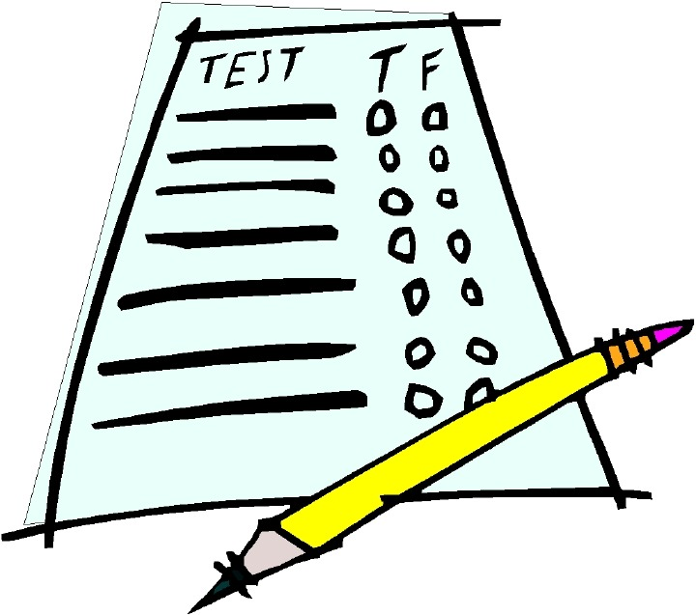
In the most basic format, true-false questions are those in which a statement is presented and the student indicates in some manner whether the statement is true or false. In other words, there are only two possible responses for each item, and the student chooses between them. A true-false question is a specialised form of the multiple-choice format in which there are only two possible alternatives. These questions can be used when the test-designer wishes to measure a student’s ability to identify whether statements of fact are accurate or not. The true-false can be used for testing knowledge and judgement in many subjects. When grouped together, a series of true-false questions on a specific topic or scenario can test a more complex understanding of an issue. They can be structured to lead a student through a logical pathway (Brown 1997) and can reveal part of the thinking process employed by the student in order to solve a given problem.

Example:
True False
A whale is a mammal because it gives birth to its young.

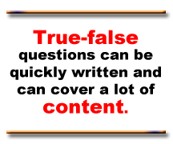
WHY ARE TRUE-FALSE USED?
True-false questions are well suited for testing student recall or comprehension. Students can generally respond to many questions, covering a lot of content, in a fairly short amount of time. From the teacher's perspective, these questions can be written quickly and are easy to score. Because they can be objectively scored, the scores are more reliable than for items that are at least partially dependent on the teacher's judgment. Generally, they are easier to construct compared to multiple-choice questions because there is no need to develop distractors. Hence, they are less time consuming compared to constructing multiple-choice questions

LIMITATIONS OF TRUE-FALSE QUESTIONS
However, true-false questions do have a number of limitations:
- Guessing – a student has a 1 in 2 chance of guessing the correct answer of a question. Scores on true-false items tend to be high because of the ease of guessing correct answers when the answer is not known. With only two choices (true or false) the student could expect to guess correctly on half of the items for which correct answers are not known. Thus, if a student knows the correct answers to 10 questions out of 20 and guesses on the other 10, the student could expect a score of 15. The teacher can anticipate scores ranging from approximately 50% for a student who did nothing but guess on all items to 100% for a student who knew the material.
- Because these items are in the form of statements, there is sometimes a tendency to take quotations from the text, expecting the student to recognize a correct quotation or note a change (sometimes minor) in wording. There may also be a tendency to include trivial or inconsequential material from the text. Both of these practices are discouraged.
- It can be difficult to write a statement which is unambiguously true or false – particularly for complex material.
- The format does not discriminate among students of different abilities as well as other question types.

SUGGESTIONS FOR CONSTRUCTION OF TRUE-FALSE QUESTIONS
- Include only one main idea in each item.
- As in multiple choice questions generally, use negatives sparingly.
TRUE
or
FALSE?
- Try using in combination with other material, such as graphs, maps, written material. This combination allows for the testing of more advanced learning
- Avoid lifting statements directly from assigned reading, notes or other course materials so that recall alone will not permit a correct answer.
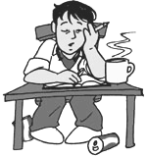
- Generally avoid the use of words which would signal the correct response to the test-wise student. Absolutes such as “none”, “never”, “always”, “all”, “impossible” tend to be false, while qualifiers such as “usually”, “generally”, “sometimes” “often” are likely to be true.
- A similar situation occurs with the use of "can" in a true-false statement. If the student knows of a single case in which something “can:” be done, it would be true.
- Ambiguous or vague statements and terms, such as "large," "long time," "regularly," "some," and "usually" are best avoided in the interest of clarity. Some terms have more than one meaning and may be interpreted differently by individuals.
- True statements should be about the same length as false statements (There is a tendency to add details in true statements to make them more precise).
- Word the statement so precisely that it can be judged unequivocally true or false.
- Use negative statements sparingly and avoid double negatives.
- Statements of opinion should be attributed to some source.
- Keep statements short and use simple language structure.
- Avoid verbal clues (specific determiners) that indicate the answer.
- Test important ideas rather than trivia.
- Do not present items in easily learned pattern.

SELF-CHECK 3.4
a) What are some advantages of true-false questions?
b) List some limitations of true-false questions.
c) Suggest other advantages and weaknesses of using true-false
questions.

3.4 MATCHING QUESTIONS

WHAT ARE MATCHING QUESTIONS?
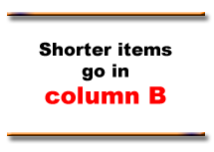
One matching question can replace several true-false questions.
Matching questions are used in measuring a student’s ability to identify the relationship between two lists of terms, phrases, statements, definitions, dates, events, people and so forth.

CONSTRUCTION OF MATCHING QUESTIONS
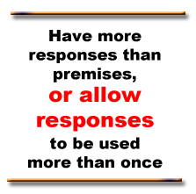
In developing matching questions, you have to identify two columns of material listed vertically. The items in Column A (or I) are usually called premises and assigned numbers (1, 2, 3, etc) while items in Column B (or II) are called responses and designated capital letters (A, B, C, etc). The student reads a premise (Column A) and finds the correct response form among those in Column B. The student then prints the letter of the correct response in the blank beside the premise in Column A. An alternative is to have the student draw a line from the correct response to the premise, but this is more time consuming to score. One way to reduce the possibility of guessing correct answers is to list a larger number of responses (Column B) than premises (Column A), as is done in the example. Another way to decrease the possibility of guessing is to allow responses to be used more than once. Directions to the students should be very clear about the use of responses.
Some psychometricians suggest there be no more than 5 to 8 premises (Column A) in one set. For each premise, the student has to read through the entire list of responses (or those still unused) to find the matching response. For this reason, the shorter elements should be in Column B, rather than Column A to minimise the amount of reading needed for each item (Alabama Department of Education, 2001). Responses (Column B) should be listed in logical order if there is one (chronological, by size, etc). If there is no apparent order, the responses should be listed alphabetically. Premises (Column A) should not be listed in the same order as the responses. Care must be taken to be sure that the association keyed as the correct response is unquestionably correct and that the numbered item could not be rightly associated with any other choice.
Example:
Directions: Column A contains statement describing selected Asian cities. For each description find the appropriate city in Column B. Each city in Column B can used only once.
Column A Column B
_____ 1. The ancient capital of Thailand A. Ayuthia
_____ 2. The largest city in Sumatera. B. Ho Chih Min City
_____ 3. The capital of Mynmar. C. Karachi
_____ 4. Formerly known as Saigon D. Medan
_____ 5. The former capital of Pakistan E. Yangdon
F. Hanoi
G. Surabaya

ADVANTAGES OF MATCHING QUESTIONS
- Matching questions are particularly good at assessing a student's understanding of relationships. They can test recall by requiring a student to match the following elements (McBeath, 1992).:
  - Definitions - terms
  - Historical events- dates
  - Achievements - people
  - Statements- postulates
  - Descriptions - principles

- They can also assess a student's ability to apply knowledge by requiring a test-taker to match the following:
  - Examples - terms
  - Functions - parts
  - Classifications - structures
  - Applications - postulates
  - Problems - principles

- Matching questions are really a variation of the multiple choice format. If you find that you are writing MCQs which share the same answer choices, you may consider grouping the questions into a matching item.
- Matching question are generally easy to write and score when the content tested and objectives are suitable for matching question.
- Highly efficient as large amount of knowledge can be sampled in a short amount of time.

LIMITATIONS OF MATCHING QUESTIONS
- Matching questions are limited to material that can listed to two columns and there may not be much material that lends itself to such a format.
- If there are four items in a matching question and the students knows the answer for three of them, the fourth item is a give away through elimination.
- Difficult to differentiate between effective and ineffective items.
- Often leads to testing of trivial facts or bits of information.
- Often criticised for encouraging rote memorisation.

SUGGESTIONS FOR WRITING GOOD MATCHING QUESTIONS
- Provide clear directions. They should explain how many time responses can be used.
- Keep the information in each column as homogeneous as possible
- Include more responses that premises or allow the responses to be used more than once.
- Put the items with more words in Column A.
- Correct answers should not be obvious to those who do not know the content being taught.
- There should not be keywords appearing in both a premise and response providing a clue to the correct answer.
- All of the responses and premises for a matching item should appear on the same page.
ACTIVITY 3.3

a) What are some advantages of matching questions?
b) List some limitations of matching questions.
c) Suggest other advantages and weaknesses of using
matching questions.
d) Select 5 true-false questions in your subject area and analyse each item using
the guidelines above.
e) Select 5 matching questions in your subject area and analyse each item using
the guidelines above.
f) Suggest how you would improve the weak items for each type of question.

SUMMARY

- An objective test is written test consisting items or questions which requires the respondent to select from a list of possible answers.

- An objective item or question is ‘accurate’ because it cannot be influenced by the personal preferences and prejudices of the marker.

- Objective tests vary depending on how the questions are presented. The three common types questions used in most objective tests are multiple-choice questions, matching questions and true-false questions.

- Multiple-choices questions have two parts: a stem that contains the question and 4 or 5 options that contains the correct answer, called the keyed response and incorrect options called distracters.

- Multiple-choice question are widely used because they can be used to measure learning outcomes from simple to complex. highly structured and clear tasks are provided and test a broad sample of achievement.

- Multiple-choice questions are difficult to construct, tend to measure low level learning outcomes, lend themselves to guessing and do not measure writing ability.

- True-false questions are those in which a statement is presented and the student indicates in some manner whether the statement is true or false.

- True-false questions can be written quickly and are easy to score. Because they can be objectively scored, the scores are more reliable than for items that are at least partially dependent on the teacher's judgment.

- Avoid lifting statements directly from assigned reading, notes or other course materials so that recall alone will not permit a correct answer.

- Matching questions are used in measuring a student’s ability to identify the relationship between two lists of terms, phrases, statements, definitions, dates, events, people and so forth.

- To reduce the possibility of guessing correct answers is to list a larger number of responses than premises and to allow responses to be used more than once.

- A table of specifications serves to help ensure that the test will be a valid representation of learning objectives and content covered by the test.

- In writing test items, one must consider the length of the test or examination as well as the reading level of your students.

KEY TERMS
Objective tests True-false questions Allotment of time
Stem Guessing Responses
Distracters Matching questions Premises
Alternatives Blueprint Content coverage
Multiple-choice Table of specifications
questions

