Effects of Climate Change on Sugarcane Production, and its Mitigation
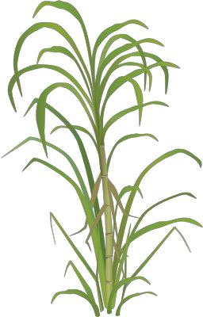
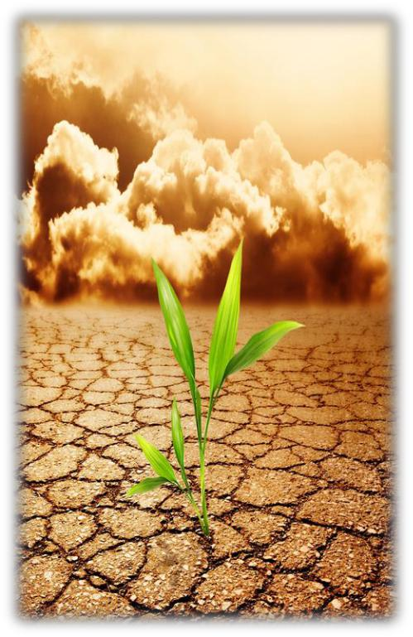

Dr. Amjed Ali


Climate Change
Major area of concern of scientific community

Poses greater threat than terrorism

As per Dr. David King- Every economic decision has a climate consequence,

and every climate decision has an economic consequence.

- Rising surface temperature: Last century- 0.6-1.0 °C; – Projections for 2100-1.6-5.8 °C

- Increasing atmosphere [CO₂] 280 ppm (1789); 380 ppm (2004); 550 ppm (2050)

- Rainfall patterns

- Rising sea levels
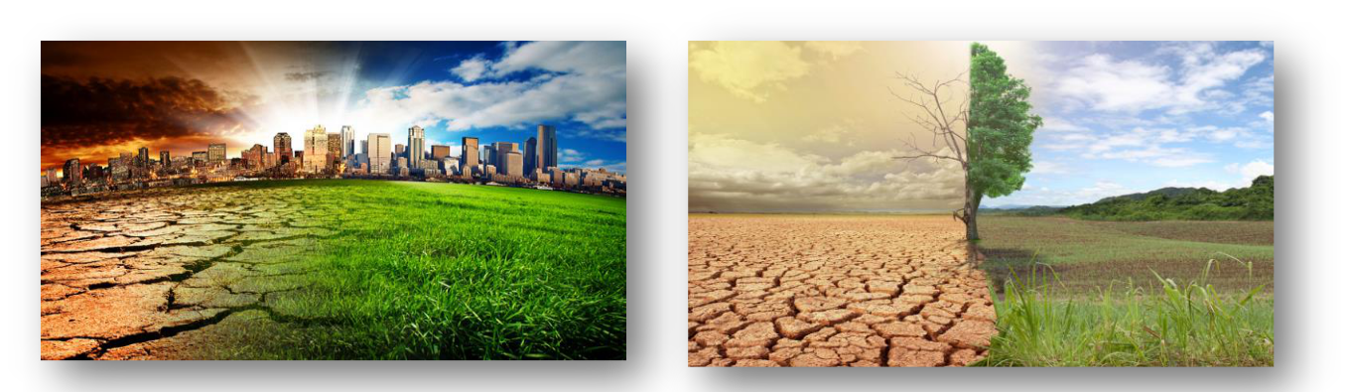

2

Impact of Climate Change on Agriculture
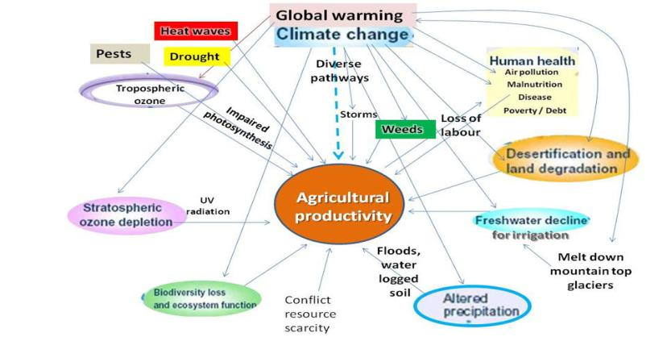

3

Climate Change in Pakistan
- Among top 10 countries effected by climate change

- Listed as one of the most vulnerable countries in the world to climate change,

UNDP

- List of countries at most risk of climate related threats

  - Floods

  - Agriculture

- Droughts are more intense

- Glaciers are melting in the region

- Freshwater availability is also projected to decrease

- Climate change is estimated to decrease crop yields in Pakistan which in turn will affect livelihoods and food production
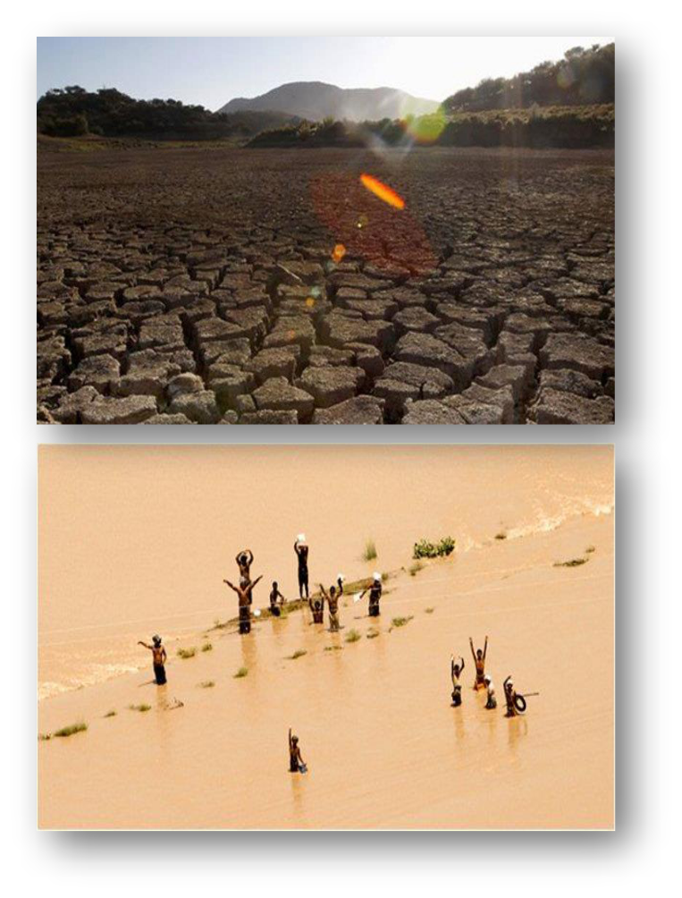

Verisk Maplecroft, UK; UNDP,
2015; IPCC Report; | 5

Effects on Sugarcane Production

- World’s largest commodity with respect to production; 70% global sugar production

- Major cash crop of Pakistan, 0.7% value addition in GDP , 3.4 % in agriculture sector, 99% sugar production
- Water stress

  - Reduction of rainy days (400 -700 mm); Dry seasons

- Increasing temperature

  - Cane and sugar yield decline 10% for every 1°C increase

  - Irrigation demand 10% for an increase in 1°C

- Precipitation extremes

- Winds

- Sudden weather changes

- Higher input costs- pesticides, fuels, water
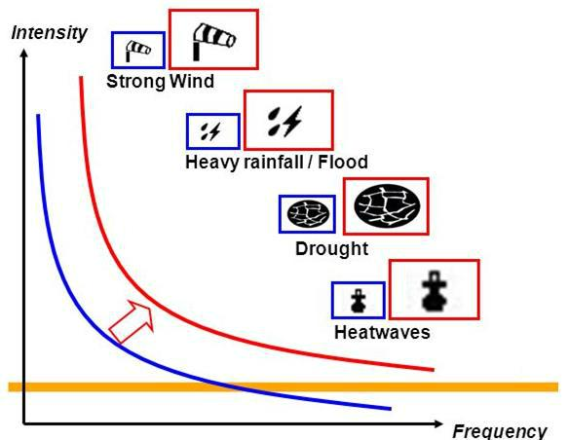

Zhao and Li, 2015
6

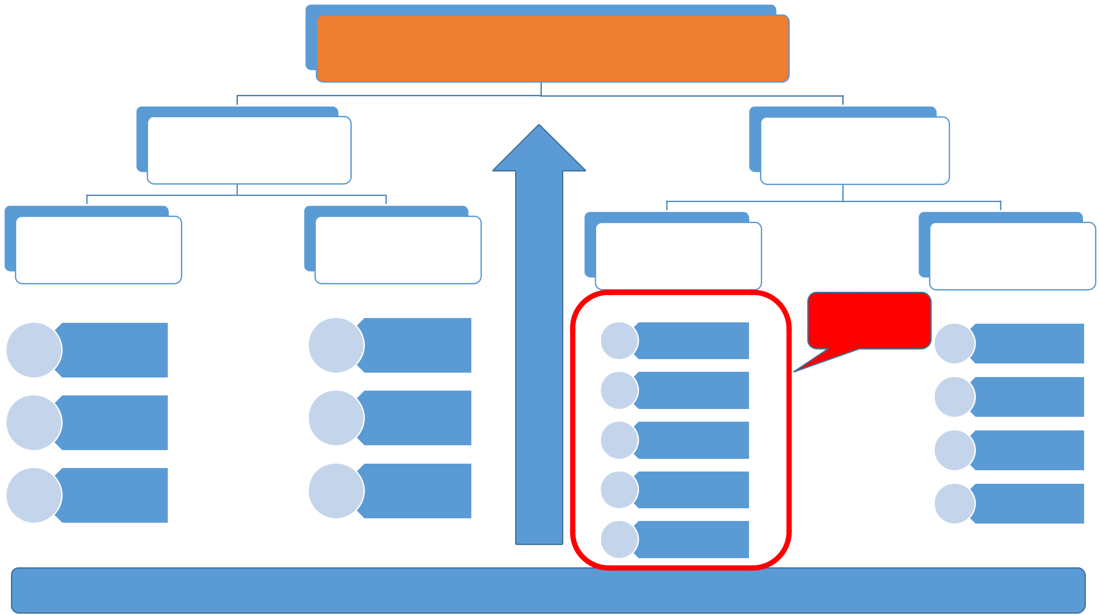
Climate-Sugarcane Linkage,
Yield

Genotype

Development of stress | Novel methodologies
Development of stress | to evaluate and
tolerant genotypes | to evaluate and
tolerant genotypes | screen cultivars

Breeding | Molecular
Breeding | Selection

Rate of
_{Genetics} Photosynthetic
activity

Biotechnology | Rate of starch
Biotechnology | accumulation

Environment

Abiotic stress Biotic stress

 | Climate
Temperature | Change | Fungi
Water |  | Bacteria
Humidity |  | Insects
Wind |  | Weeds
CO₂

Management Practices ₇

Mitigation of Climate Impact on Sugarcane

- Climate is the key factor determining sugarcane production ▪ Adaptive, and stress tolerance capacity

- Development of the stress tolerant and high yielding sugarcane cultivars that can contribute to adaptation to climate change events

- Tissue Culture, Conventional Breeding, GM Sugarcane

- Irrigation efficiency

- Management practices

- Nutrient use efficiency

- Agricultural weather information systems; climate predictions

8

Production, Area, and Yield, in Sugarcane Growing Countries of the World


Country | Production | Rank | Area | Rank | Yield | Rank
Country | (Million Tonnes) | Rank | (X1000 ha) | Rank | (t ha⁻¹) | Rank
Brazil | 739.27 | 1 | 9835.2 | 1 | 75.17 | 29
India | 341.20 | 2 | 5060.0 | 2 | 67.43 | 40
China | 126.14 | 3 | 1827.3 | 3 | 69.03 | 39
Thailand | 100.10 | 4 | 1321.6 | 4 | 75.74 | 26
Pakistan | 63.75 | 5 | 1128.8 | 5 | 56.48 | 51
Mexico | 61.18 | 6 | 782.8 | 6 | 78.16 | 25
Colombia | 34.88 | 7 | 405.7 | 9 | 85.95 | 19
Indonesia | 33.70 | 8 | 450.0 | 7 | 74.89 | 31
Philippines | 32.00 | 9 | 435.4 | 8 | 73.49 | 37
USA | 27.91 | 10 | 368.6 | 11 | 75.71 | 27
World total | 2165.23 |  | 26522.7 |  | 81.64

Ranked at 8th position in sugar recovery and sugar yield (9.2 %, 4.63 t/ ha; against 13.8 %, and 13.85 t/ ha of Australia, and 9.9 %, 6.62 t/ ha of India)

FAO, United Nations, FAOSTAT, and Factfish ₉

Options for Sugarcane Improvement to Cope with Changing Climatic Conditions
- Conventional breeding?

- Non flowering or sporadic flowering with poor seed setting under natural conditions

- If seed setting occurs, germination is very poor and mortality rate is very high

- Lack of facilities for induction of flowering by artificial means

- Solution: Biotechnology, Exotic germplasm evaluation, Mutagenesis,

10

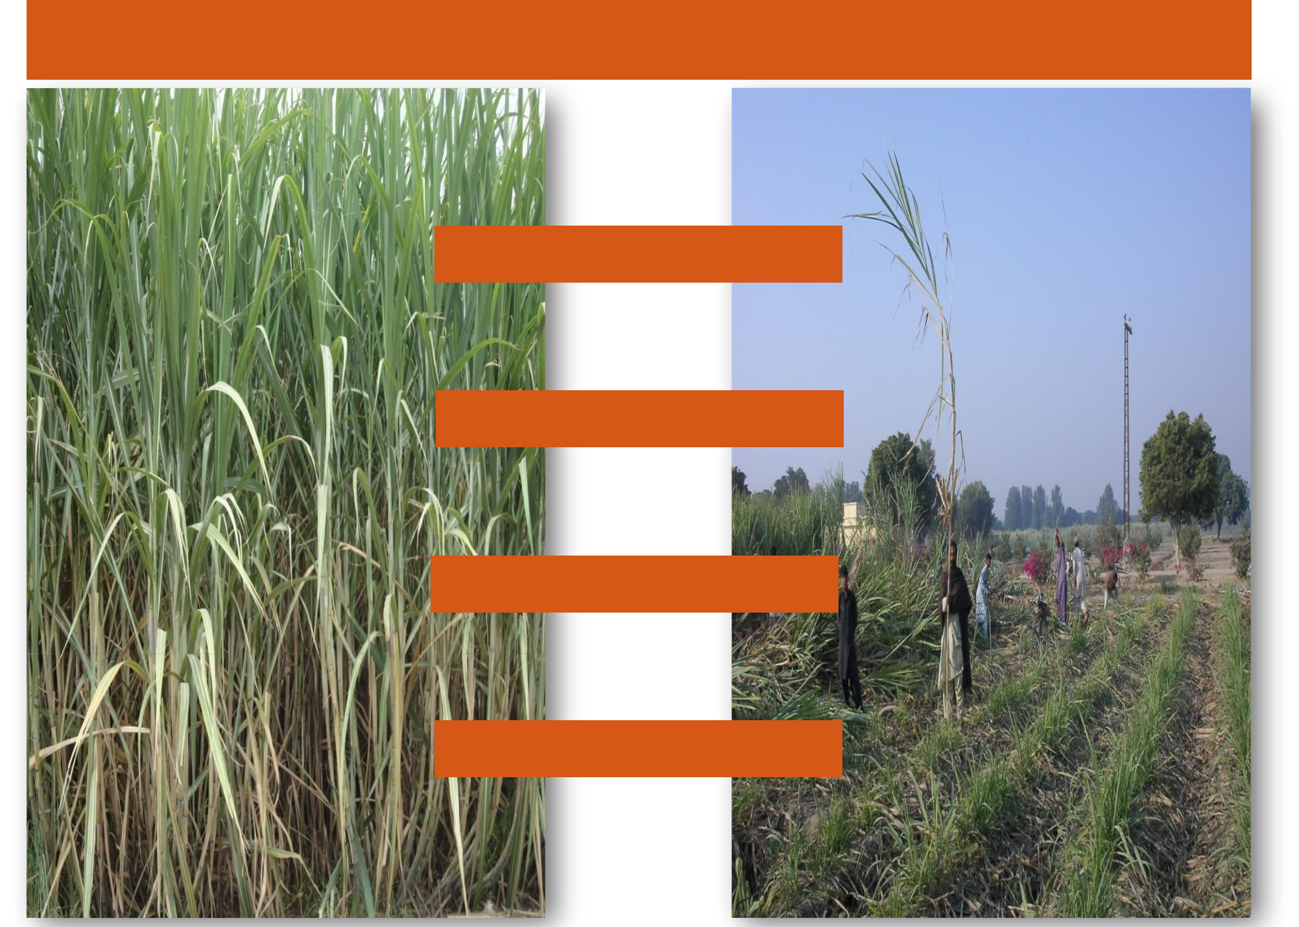

Sugarcane Improvement Against Climate Change

