Truss – Assumptions

There are four main assumptions made in the analysis of truss

- Truss members are connected together at their ends only.

- Trusses are connected together by frictionless pins.

- The truss structure is loaded only at the joints.

- The weights of the members may be neglected.
Simple Truss

The basic building block of a truss is a triangle. Large truss are constructed by attaching several triangles together A new triangle can be added truss by adding two members and a joint. A truss constructed in this fashion is known as a simple truss.
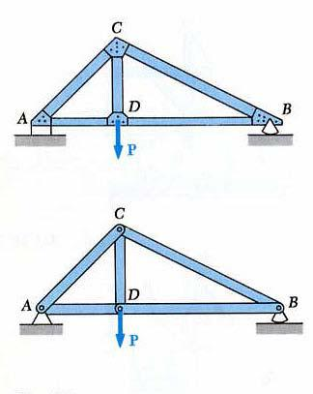
Method of Joints -Truss

The truss is made up of single bars, which are either in compression, tension or no-load. The means of solving force inside

the truss use equilibrium equations at a joint. This method is known as the method of joints.
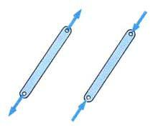
Method of Joints -Truss

The method of joints uses the summation of forces at a joint to solve the force in the members. It does not use the

moment equilibrium equation to solve the problem. In a two dimensional set of equations,
∑ F_{x} = 0 ∑ F_{y} = 0

In three dimensions,

∑ F_{z} = 0
Truss – Example Problem

Determine the loads in each of the members by using the method of joints.
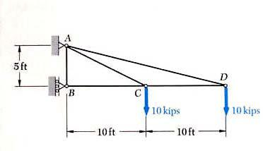
Truss – Example Problem
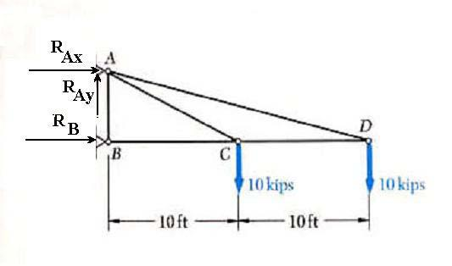

Draw the free-body diagram. The summation of forces and moment about B result in

  - F_{x} = 0 = R_{Ax} + R_{B}

  - F_{y} = 0 = R_{Ay} −10 kips −10 kips ⇒ R_{Ay} = 20 kips

- M _{A} = 0 = R_{B} ( 5 ft ) −10 kips (10 ft ) −10 kips (20 ft )

    - R_{B} = 60 kips

    - R_{Ax} = −60 kips
Truss – Example Problem

Look at Joint B

- F_{x} = 0 = T_{BC} + R_{B} = T_{BC} + 60 kips ⇒ T_{BC} = −60 kips

- F_{y} = 0 = T_{BA} ⇒ T_{BA} = 0 kips
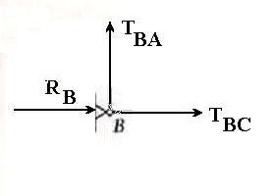
Truss – Example Problem

Look at Joint D and find

the angle

  - = tan⁻¹ ^{5 ft.} = 14.04⁰ 20 ft.

- F_{x} = 0 = −T_{DC} − T_{DA} cosα

- F_{y} = 0 = T_{DA} sinα −10 kips ⇒ T_{DA} = 41.231 kips
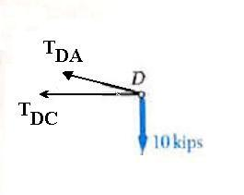

T_{DC} = −40 kips
Truss – Example Problem
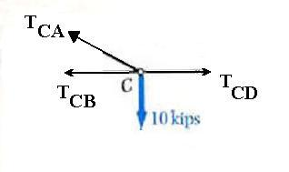

Look at Joint C and find the angle

  - = tan⁻¹ ^{5 ft.} = 26.565⁰ 10 ft.

- F_{y} = 0 = T_{CA} sin β −10 kips ⇒ T_{CA} = 22.361 kips

- F_{x} = 0 = T_{CD} − T_{CA} cos β − T_{CB}

    - ( −40 kips) − (22.361 kips) cos ( 26.565º ) − ( −60 kips)

    - 0

Example Problem
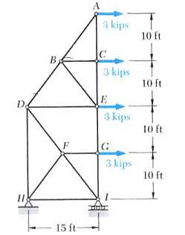

Determine the forces in members FH, DH,EG and BE in the truss using the method of sections.
Truss – Example Problem
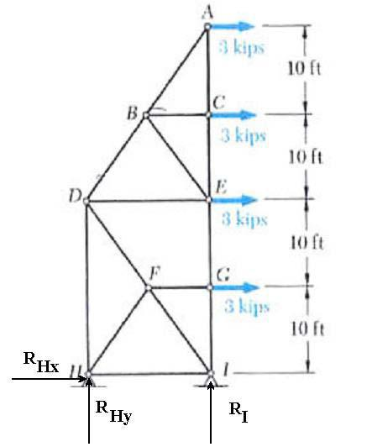

Draw the free-body diagram. The summation of forces and moment about H result in

  - F_{x} = 0 = R_{Hx} + 3 kips + 3 kips + 3 kips + 3 kips

    - R_{Hx} = −12 kips

  - F_{y} = 0 = R_{Hy} + R_{I}

- M _{H} = 0 = R_{I} (15 ft) − 3 kips (10 ft ) − 3 kips ( 20 ft ) − 3 kips (30 ft ) − 3 kips ( 40 ft )

    - R_{I} = 20 kips

    - R_{Hy} = −20 kips
Truss – Example Problem

Do a cut between BD and CE
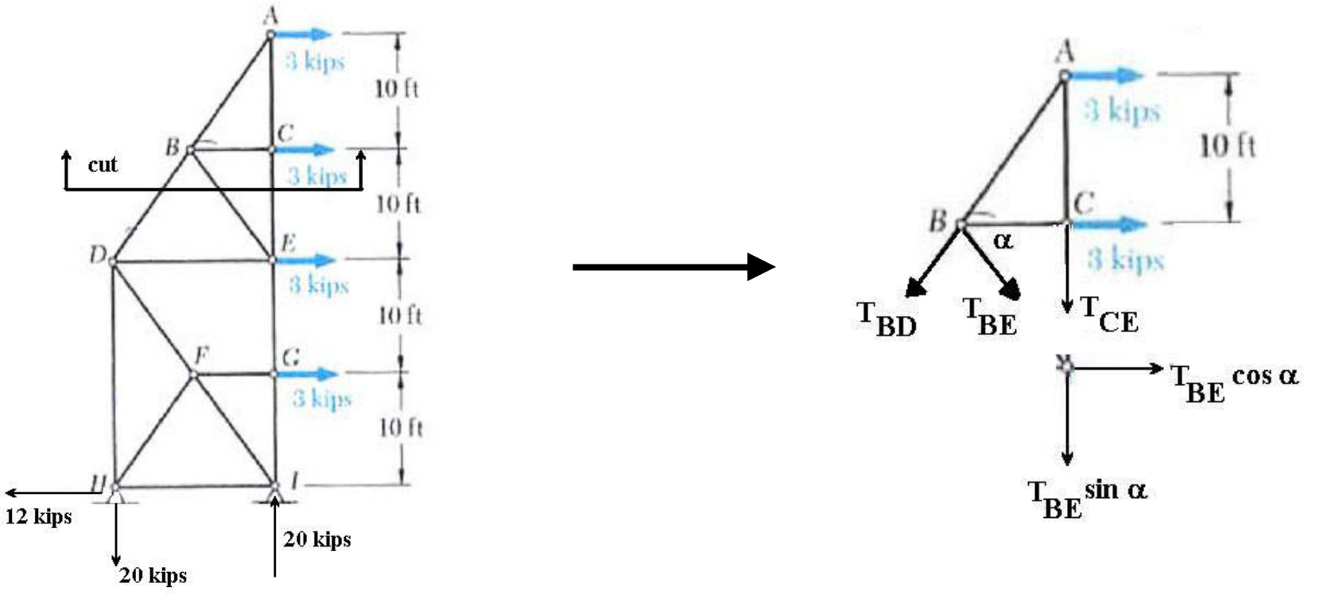
Truss – Example Problem

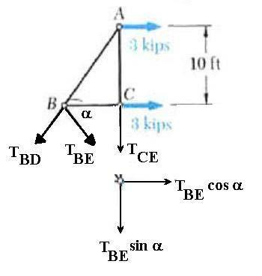
Take moment about A

  - = tan⁻1 ^{10 ft} = 53.13⁰ 7.5 ft

- M _{A} = 0 = T_{BE} cos ( 53.13⁰ )( 10 ft ) + 3 kips (10 ft )

    - T_{BE} = −5.0 kips
Truss – Example Problem

Do a cut between HD and GE
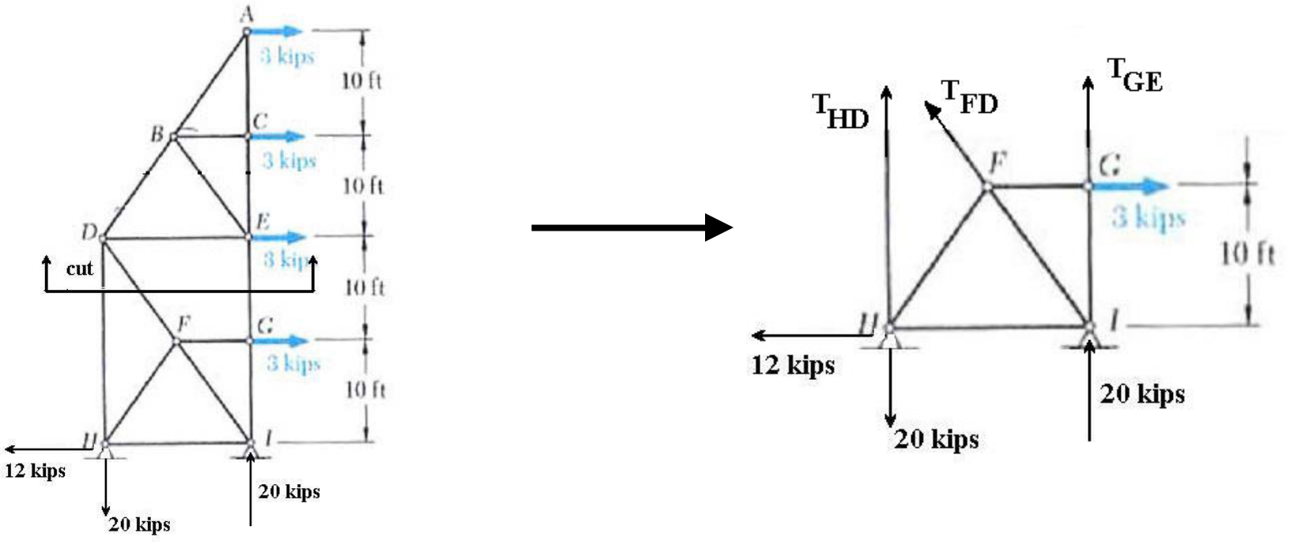
Truss – Example Problem
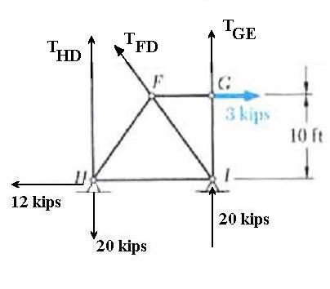

Take the moment about I

- M _{I} = 0 = 20 kips (15 ft ) − T_{HD} (15 ft ) − 3 kips (10 ft )

  - T_{HD} = 18 kips

Take the moment about D

- M _{D} = 0 = −12 kips ( 20 ft ) + 20 kips (15 ft ) + 3 kips (10 ft ) + T_{GE} (15 ft )

  - T_{GE} = −6 kips
Truss – Example Problem

Do a cut between HD and HI
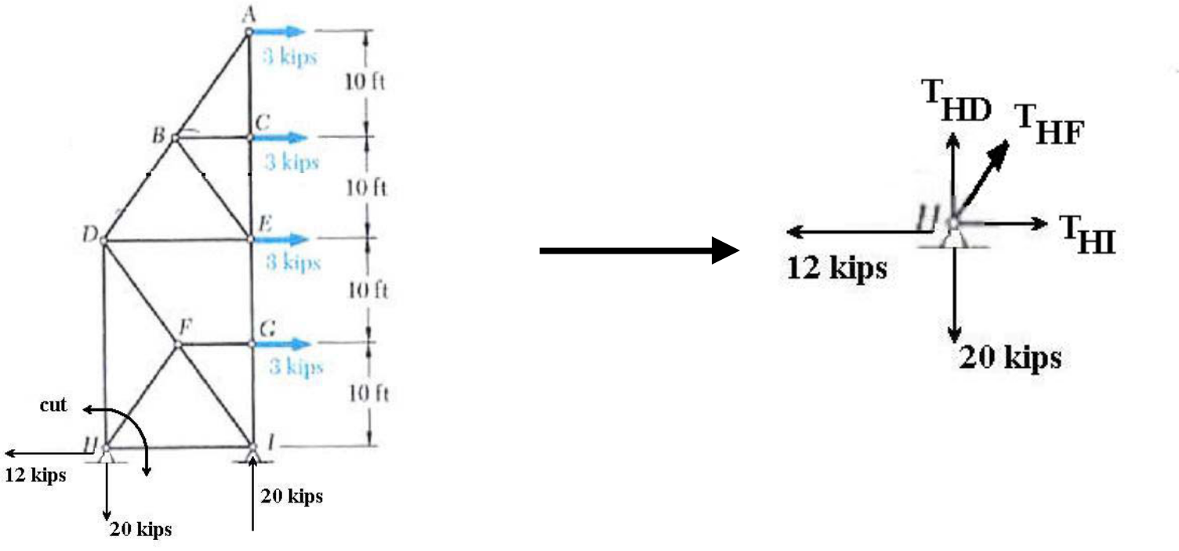
Truss – Example Problem

Take the sum of forces in y direction
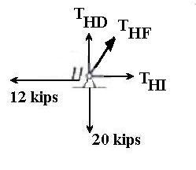
  - = tan⁻1 ^{10 ft} = 53.130 7.5 ft

- F_{y} = 0 = T_{HF} sin ( 53.13⁰ ) + T_{HD} − 20 kips

⇒ T_{HF} | = | 20 kips −18 kips |  | = 2.5 kips
 |  | sin | 53.13⁰

