3. Spawning
As a mushroom matures, it produces millions of microscopic spores on mushroom gills lining the underside of a mushroom cap. These spores function roughly similar to the seeds of a higher plant. However, growers do not use mushroom spores to 'seed' mushroom compost because they germinate unpredictably and therefore, are not reliable. Fortunately, mycelium (thin, thread-like cells) can be propagated vegetatively from germinated spores, allowing spawn makers to multiply the culture for spawn production. Specialized facilities are required to propagate mycelium, so the mushroom mycelium remains pure. Mycelium propagated vegetatively on various grains or agars is known as spawn, and commercial mushroom farmers purchase spawn from companies specializing in its manufacture.
Spawn makers start the spawn-making process by sterilizing a mixture of millet grain plus water and chalk; rye, wheat, and other small grain may be substituted for millet. Sterilized horse manure formed into blocks was used as the growth medium for spawn up to about 1940, and this was called block or brick spawn, or manure spawn; such spawn is not used today. Once sterilized grain has a bit of mycelium added to it, the grain and mycelium is shaken 3 times at 4-day intervals over a 14-day period of active mycelial growth. Once the grain is colonized by the mycelium, the product is called spawn (Fig. 3). Spawn can be refrigerated for a few months, so spawn is made in advance of a armer's order for spawn.
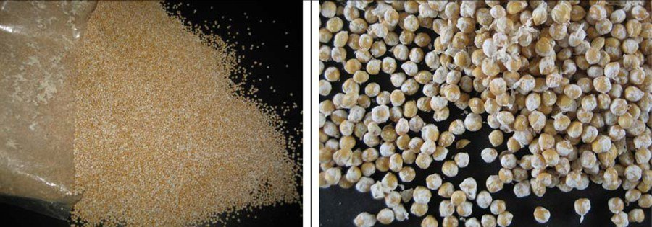
Figure 3. Mushroom spawn from open bag (left); close up of millet spawn (right).
Spawn is distributed on the compost and then thoroughly mixed into the compost. For years this was done by hand, broadcasting the spawn over the surface of the compost and ruffling it in with a small rake-like tool. In recent years, however, for the bed system, spawn is mixed into the compost by a special spawning machine that mixes the compost and spawn with tines or small finger-like devices. In a tray or batch system, spawn is mixed into the compost as it moves along a conveyer belt or while falling from a conveyor into a tray. The spawning rate is expressed as a unit or quart per so many square feet of bed surface; 1 unit per 5 ft² is desirable. The rate is sometimes expressed on the basis of spawn weight versus dry compost weight; a 2 percent spawning rate is desirable.

3.1 Supplementation at spawning
In the early 1960s, yield increases were observed when compost was supplemented with protein and/or lipid rich materials at spawning, casing and later. Up to a 10% increase in yield was obtained when small amounts of protein supplements were added to the compost at spawning. Excessive heating and stimulation of competitor molds in the compost substantially limited the amount of supplement and corresponding benefit that could be achieved. It was these limitations that were overcome by the invention of delayed release supplements for mushroom culture (Carroll and Schisler 1976). The disadvantages associated with the supplementation of non-composted nutrients to mushroom compost at spawning were largely overcome by encapsulating micro-droplets of vegetable oil within a protein coat that was denatured with formaldehyde. Increases of as much as 60% were obtained. Today, several commercial supplements are available that can be used at spawning or at casing to stimulate mushroom yield.
Amendment of mushroom substrate with Micromax® is another potential opportunity for growers to improve the yield capacity of their Phase II compost. Micromax® contains a mixture of nine micronutrients including (percentage dry wt basis): Ca (12%), Mg (3%), S (12%), B (0.1%), Cu (1%), Fe (17%), Mn (2.5%), Mo (0.05%), Zn (1%), and inert ingredients (57.35%). Research has shown that approximately 70% of the yield increase observed is due to Mn. Commercial supplement makers have begun to add Mn to their delayed release nutrients for mushroom culture.
Once the spawn and supplement have been mixed throughout the compost and the compost worked so the surface is level, the compost temperature is maintained at 75- 80°F and the relative humidity is kept high to minimize drying of the compost surface or the spawn. Under these conditions the spawn will grow - producing a thread-like network of mycelium throughout the compost. The mycelium grows in all directions from a spawn grain, and eventually the mycelium from the different spawn grains fuses together, making a spawned bed of compost one biological entity. The spawn appears as a white to blue-white mass throughout the compost after fusion has occurred. As the spawn grows it generates heat, and if the compost temperature increases to above 80° to 85°F, depending on the cultivar, the heat may kill or damage the mycelium and eliminate the possibility of maximum crop productivity and/or mushroom quality. At temperatures below 74°F, spawn growth is slowed and the time interval between spawning and harvesting is extended.

3.2 Phase III and Phase IV compost
Phase III compost is Phase II compost spawn run in bulk in a tunnel, and ready for casing when removed from the tunnel and delivered to the grower. If the Phase III compost then is cased and the spawn allowed to colonize the casing layer before sending to the growing unit or delivering to growers, it is called Phase IV compost. The successes of both Phase III and Phase IV compost depend, to a large extent, on the quality of Phase I and Phase II composts. Use of Phase III compost may also improve mushroom quality, as fragmentation of the colonized compost tends to improve initial color and mushroom shelf life. In recent years, the use of bulk Phase III compost has increased in popularity because it allows an increase in the number of crops a grower can expect from his production rooms. Phase II production on shelves allows an average of about 4.1 crops per year whereas growers using Phase III bulk spawn run compost averages about 7.1 crops per year. An additional gain can be made in the number of crops (10-12 crops per year) when Phase IV is used (Dewhurst 2002; Lemmers 2003; Chang 2006).

3.3 Mushroom varieties
In the United States, mushroom growers use three major mushroom cultivars: a) Smooth white hybrid - cap smooth, cap and stalk white; b) Off-white hybrid - cap scaly with stalk and cap white; and c) Brown - cap smooth, cap chocolate brown with a white stalk. Within each of the three major groups, there are various isolates, so a grower may have a choice of up to eight strains within each variety. Generally, white and off-white hybrid cultivars are used for processed foods like soups and sauces, but all isolates are good eating as fresh mushrooms. In recent years, the brown varieties have gained market share among consumers. The Crimini variety is similar in appearance to the white mushroom except it is brown and has a richer and earthier flavor. The Portobello variety is a large, open, brown-colored mushroom that can have caps up to 6 inches in diameter. The Portobello offers a rich flavor and meaty texture.
The time needed for spawn to colonize the compost depends on the spawning rate and its distribution, the compost moisture and temperature, compost supplementation, and the nature or quality of the compost. Complete spawn run usually requires 13 to 20 days. Once the compost is fully-grown with spawn, the next step in production is at hand.

4. Casing
Casing is a top-dressing applied to the spawn-run compost on which the mushrooms eventually form. A mixture of peat moss with ground limestone can be used as casing. Casing does not need nutrients since casing acts as a water reservoir and a place where rhizomorphs form. Rhizomorphs look like thick strings and form when the very fine mycelium fuses together. Mushroom initials, primordia, or pins form on the rhizomorphs, so without rhizomorphs there will be no mushrooms. Casing should be able to hold moisture since moisture is essential for the development of a firm mushroom. The most important functions of the casing layer are supplying water to the mycelium for growth and development, protecting the compost from drying, providing support for the developing mushrooms and resisting structural breakdown following repeated watering. Supplying as much water as possible to the casing as early as possible without leaching into the underlying compost provides the greatest yield potential.
Sphagnum peat moss is the most commonly used material for casing. Sphagnum can range from brown (young, less decomposed, loose textured, surface peat) to black (compact, more decomposed, deep dug) and may be processed differently at the harvest site. Milled peat is partially dried before packaging and transport while wet-dug peat is transported in a saturated form. Some growers prefer wet-dug peat because of the higher water holding capacity compared to milled peat.
Peat moss-based casing does not require pasteurization because the material is free from pathogens, weed molds and nematodes that may reduce mushroom yield. One 6-ft³ compressed bale when mixed with water and 40 lb of limestone will cover about 125 ft² of compost surface at about 2 inches depth.

4.1 Casing inoculum (CI)
Casing inoculum is a sterilized mixture of peat, vermiculite and wheat bran that has been colonized by mushroom mycelium. It is mixed with casing to decrease cropping cycle time, improve uniformity of mushroom distribution over the bed and improve mushroom cleanliness. Mycelium from the CI colonizes the casing layer while it fuses with the underlying mycelium of the compost. This allows more breaks per crop or more crops per year.
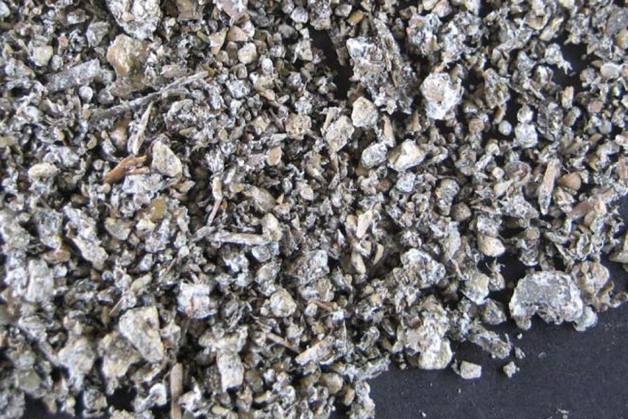
Figure 4. Casing inoculum used to inoculate casing for more rapid mycelial colonization.

4.2 Supplementation at casing
The addition of nutrients at casing was first tried in the early 1960s. Results showed that much greater amounts of nutrients could be added at casing than at spawning and that yield increases were almost proportional to the amount added. Although yield increases as high as 100% may be realized, certain potential problems and limitations exist for supplementation at casing. Weed molds, nematodes and pathogens must not be present in the compost when supplementing at casing. These organisms will be dispersed throughout the compost when it is fragmented prior to supplementation and can multiply very rapidly before the mushroom mycelium recovers its growth.
Managing the crop after casing requires that the compost temperature be kept at around 75°F for up to 5 days after casing, and the relative humidity should be high. Thereafter, the compost temperature should be lowered about 2°F each day until small mushroom initials (pins) have formed. Throughout the period following casing, water must be applied intermittently to raise the moisture level to field capacity before the mushroom pins form. Knowing when, how, and how much water to apply to casing is an "art form" which readily separates experienced growers from beginners.

5. Pinning
Mushroom initials develop after rhizomorphs have formed in the casing. The initials are extremely small but can be seen as outgrowths on a rhizomorph. Once an initial quadruples in size, the structure is a pin. Pins continue to expand and grow larger through the button stage, and ultimately a button enlarges to a mushroom (Fig. 5). Harvestable mushrooms appear 18 to 21 days after casing. Pins develop when the carbon dioxide content of room air is lowered to 0.08 percent or lower, depending on the cultivar, by introducing fresh air into the growing room. Outside air has a carbon dioxide content of about 0.04 percent.
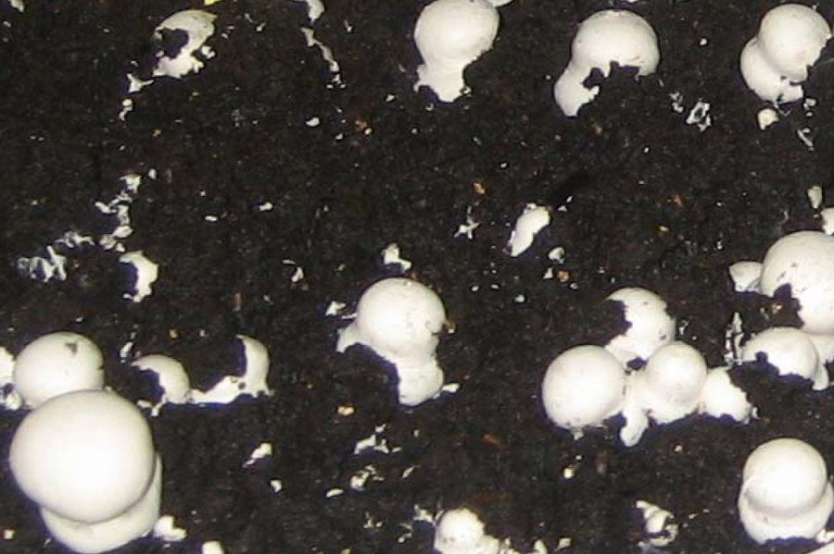
Figure 5. Mushrooms forming and maturing on the casing - a 2-inch layer of neutralized peat. Both "pins" and young mushrooms are visible.
The timing of fresh air introduction is very important and is something learned only through experience. Generally, it is best to ventilate as little as possible until the mycelium has begun to show at the surface of the casing, and to stop watering at the time when pin initials are forming. If the carbon dioxide is lowered too early by airing too soon, the mycelium will stop growing through the casing and mushroom initials form below the surface of the casing. As such mushrooms continue to grow, they push through the casing and are dirty at harvest time. Too little moisture can also result in mushrooms forming below the surface of the casing. Pinning affects both the potential yield and quality of a crop and is a significant step in the production cycle.

6. Cropping
The terms flush, break, or bloom are names given to the repeating 3- to 5-day harvest periods during the cropping cycle; these are followed by a few days when no mushrooms are available to harvest. This cycle repeats itself in a rhythmic fashion, and harvesting can go on as long as mushrooms continue to mature. Most mushroom farmers harvest for 35 to 42 days, although some harvest a crop for 60 days, and harvest can go on for as long as 150 days.
Air temperature during cropping should be held between 57° to 62°F for good results. This temperature range not only favors mushroom growth, but cooler temperatures can lengthen the life cycles of both disease pathogens and insects pests. It may seem odd that there are pests that can damage mushrooms, but no crop is grown that does not have to compete with other organisms. Mushroom pests can cause total crop failures, and often the deciding factor on how long to harvest a crop is based on the level of pest infestation. These pathogens and insects can be controlled by cultural practices coupled with the use of pesticides, but it is most desirable to exclude these organisms from the growing rooms.
The relative humidity in the growing rooms should be high enough to minimize the drying of casing but not so high as to cause the cap surfaces of developing mushrooms to be clammy or sticky. Water is applied to the casing so water stress does not hinder the developing mushrooms; in commercial practice this means watering 2 to 3 times each week. Each watering may consist of more or fewer gallons, depending on the dryness of the casing, the cultivar being grown, and the stage of development of the pins, buttons, or mushrooms. Most first-time growers apply too much water and the surface of the casing seals; this is seen as a loss of texture at the surface of the casing. Sealed casing prevents the exchange of gases essential for mushroom pin formation. One can estimate how much water to add after first break has been harvested by realizing that 90 percent of the mushroom is water and a gallon of water weighs 8.3 lb. If 100 lb of mushrooms were harvested, 90 lb of water (11 gal.) were removed from the casing; and this is what must be replaced before second break mushrooms develop.
Outside air is used to control both the air and compost temperatures during the harvest period. Outside air also displaces the carbon dioxide given off by the growing mycelium. The more mycelial growth, the more carbon dioxide produced, and since more growth occurs early in the crop, more fresh air is needed during the first two breaks. The amount of fresh air also depends on the growing mushrooms, the area of the producing surface, the amount of compost in the growing room, and the condition or composition of the fresh air being introduced. Experience seems to be the best guide regarding the volume of air required, but there is a rule of thumb: 0.3ft/ft²/hr when the compost is 8 inches deep, and of this volume 50 to 100 percent must be outside air.
Ventilation is essential for mushroom growing, and it is also necessary to control humidity and temperature. Moisture can be added to the air by a cold mist or by live steam, or simply by wetting the walls and floors. Moisture can be removed from the growing room by: 1) admitting a greater volume of outside air; 2) introducing drier air; 3) moving the same amount of outside air and heating it to a higher temperature since warmer air holds more moisture and thus lowers the relative humidity. Temperature control in a mushroom growing room is no different from temperature control in your home. Heat can originate from hot water circulated through pipes mounted on the walls. Hot, forced air can be blown through a ventilation duct, which is rather common at more recently built mushroom farms. There are a few mushroom farms located in limestone caves where the rock acts as both a heating and cooling surface depending on the time of year. Caves of any sort are not necessarily suited for mushroom growing, and abandoned coalmines have too many intrinsic problems to be considered as viable sites for a mushroom farm. Even limestone caves require extensive renovation and improvement before they are suitable for mushroom growing, and only the growing occurs in the cave with composting taking place above ground on a wharf.
Mushrooms are harvested in a 7- to 10-day cycle, but this may be longer or shorter depending on the temperature, humidity, cultivar, and the stage when they are picked (Fig. 6). When mature mushrooms are picked, an inhibitor to mushroom development is removed and the next flush moves toward maturity. Mushrooms are normally picked at a time when the veil is not too far extended. Consumers in North America want closed, tight, and white or brown (Crimini) mushrooms while open browns (Portobello) are preferred by some consumers. The maturity of a mushroom is assessed by how far the veil is stretched, and not by how large the mushroom is. Consequently, mature mushrooms are both large and small, although farmers and consumers alike prefer medium- to large-size mushrooms.
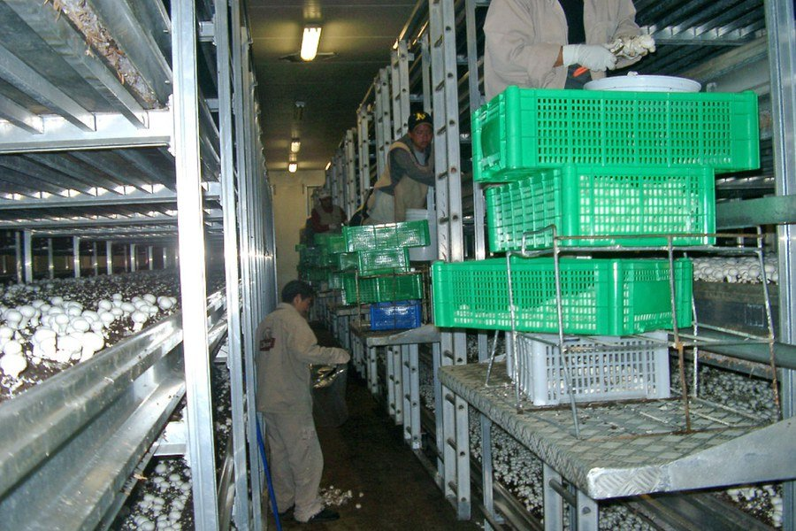
Figure 6. Harvesting of mushrooms. Each mushroom is hand harvested, the base of the mushroom is trimmed, and the clean, mature mushroom placed in a basket.
Picking and packaging methods often vary from farm to farm. Freshly harvested mushrooms must be kept refrigerated at 35° to 45°F. To prolong the shelf life of mushrooms, it is important that mushrooms "breathe" after harvest, so storage in a non-waxed paper bag is preferred to a plastic bag.
A question frequently arises concerning the need for illumination while the mushrooms grow. Mushrooms do not require light to grow; only green plants require light for photosynthesis. However, growing rooms can be illuminated to facilitate harvesting or cropping practices.

Environmental Concerns

Odors
Nuisance complaints, a result of mushroom compost preparation in close proximity to residential areas, are a problem for some mushroom farms. Offensive odors associated with the preparation of mushroom compost are the primary reasons for these complaints. A combination of suburbanization and the heightened sensitivity of the general population to environmental issues have focused public attention on this issue. Growers have adopted several measures to reduce the environmental impact of mushroom farming, including the practice of forced aeration of Phase I compost contained in bunkers or tunnels. However, the issue of offensive odor generation continues to place pressure on mushroom growers.

Disposal of post-crop mushroom compost
After the last flush of mushrooms has been picked, the growing room should be closed off and the room pasteurized with steam. This final pasteurization is designed to destroy any pests that may be present in the crop or the woodwork in the growing room, thus minimizing the likelihood of infesting the next crop.
Post-crop mushroom compost (MC) is the material left over after the crop has been terminated (Fig. 8). It has many uses and is a valued product in the horticultural industry. One of the major uses of MC is for suppression of artillery fungi in landscape mulch. The artillery fungi grow rapidly throughout moist landscape mulch, and produce sticky spore masses about the size of a pinhead. These spores are forcibly discharged toward light colored surfaces such as house siding and cars. Once the spores dry they are nearly impossible to remove without leaving an unsightly brown stain on the surface. The incorporation of 20-40% MC into mulch effectively suppress the artillery fungi.

Figure 8. Post-crop mushroom compost (MC) being loaded onto a truck as it is removed from a mushroom house.

Conclusion
It takes approximately 14 weeks to complete an entire production cycle, from the start of composting to the final steaming off after harvesting has ended. For this work a mushroom grower can expect anywhere from 0 to 8 lb per ft²; the national average for 2006 was 5.92 lb per square foot. Final yield depends on how well a grower has monitored and controlled the temperature, humidity, pests, and so on. All things considered, the most important factors for good production appear to be experience plus an intuitive feel for the biological rhythms of the commercial mushroom. The production system used to grow a crop can be chosen after the basics of mushroom growing are understood.

Related Readings
Beelman, R.B., D.J. Royse, and N. Chikthimmah. 2004. Bioactive components in Agaricus bisporus of nutritional, medicinal or biological importance. Mushroom Science16:1-16.
Beyer, D.M. 2003. Basic procedures for Agaricus mushroom growing. College of Agricultural Sciences, The Pennsylvania State University, University Park, PA.
Carroll, A.D. and L.C. Schisler. 1976. Delayed release nutrient supplement for mushroom culture. Applied and Environmental Microbiology 31:499-503.
Chang, S.T. 2006. The world mushroom industry: trends and technological development. International J. Medicinal Mushrooms 8:297-314.
Davis, D.D., Kuhns, L.J., Harpster, T.L., 2005. Use of mushroom compost to suppress artillery fungi. J. Environ. Hort. 23 (4), 212-215.
Dewhurst, M. 2002. Phase III-the future? Mushroom J. 626:17-18.
Lemmers, G. 2003. The merits of bulk Phase III. Mushroom J. 642:17-22.
Van Griensven, L.J.LD (Ed.). 1988. The Cultivation of Mushrooms. Mushroom Experimental Station, Horst, The Netherlands.
Wuest, P.J. and G.D. Bengtson (Eds.). 1982. Penn State Handbook for Commercial Mushroom Growers. College of Agricultural Sciences, The Pennsylvania State University, University Park, PA.

