Selection of mother plant:
It is necessary to select the mother tree/plant with the care. The explants should be taken from mother plants possessing superior phenotypes such as disease resistance , stress tolerance , high yield and product quality.
Selection of Ex-plant:
Appropriate selection of explants is very important for rapid in vitro propagation
The genotype, age and physiological state of the explant respond differently to cultures.
Explants should proliferate readily. Even materials with strong ability to proliferate should be screened continuously
Some explants, like the root tip, are hard to isolate and are contaminated with soil microflora that become problematic during the tissue culture process. Certain soil microflora can form tight associations with the root systems, or even grow within the root. Soil particles bound to roots are difficult to remove without injury to the roots that then allows microbial attack. These associated microflora will generally overgrow the tissue culture medium before there is significant growth of plant tissue.
Aerial (above soil) explants are also rich in undesirable microflora. However, they are more easily removed from the explant by gentle rinsing, and the remainder usually can be killed by surface sterilization. Most of the surface microflora do not form tight associations with the pant tissue. Such associatons can usually be found by visual inspection as a mosaic, de-colorization or localized necrosis on the surface of the explant.
An alternative for obtaining uncontaminated explants is to take explants from seedlings which are aseptically grown from surface-sterilized seeds. The hard surface of the seed is less permeable to penetration of harsh surface sterilizing agents, such as hypochlorite, so the acceptable conditions of sterilization used for seeds can be much more stringent than for vegetative tissues.
Location of explants: (Position of explants i.e., developmental stage is very important.)
Size of Explant:
- the surface size
- volume
- cell number
Season and Time of explant collection:
The season during which the bud is collected is another factor to be considered. In general buds about to sprout are suitable for culture. For embryo culture the dormancy state of seeds should be considered

CALLUS INDUCTION AND MAINTANANCE
What is a callus?
It is an unorganized or undifferentiated mass of proliferative cells produced either in culture or in nature
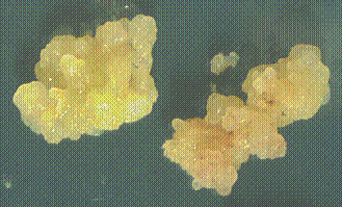

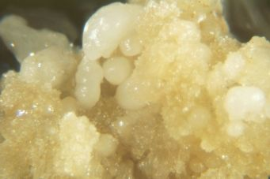
What is callus culture ?
Tissues and cells cultured on an agar medium form an unorganized mass of cells i.e., callus
Callus formation from explant involves the development of progressively more random planes of cell division , less frequent specialization of cells and loss of organized structures.
Callus culture is often performed in the dark and the light can encourage differentiation of the callus.
Micro callus
The initial colony of cells visible but too small to transfer by direct manipulation recovered from cultured of protoplasts single cells or very small aggregate cells.
Induction and maintenance
When freshly cut pieces of surface sterilized plant tissues are grown in agar medium with appropriate nutrients with suitable proportion of auxin and cytokinin they exhibit callusing at cut ends, which gradually extends to the entire surface of the tissue. Callus cultures need to be subcultured every 3 – 5 weeks in view of cell growth , nutrient depletion and medium drying. Repeated subculture on an agar medium improves the friability of the callus
Habituation of callus tissue
In some plant species the callus tissue is able to grow on a standard maintenance medium or basal medium which is devoid of growth hormones. This property of the callus tissue is known as habituation and the callus tissue is known as habituated callus tissue.
During the long term culture, the culture may lose the requirement for auxin and or cytokinin.
Callus culture are extremely important in plant biotechnology. Manipulation of the auxin to cytokinin ratio in the medium can lead to the development of shoots, roots or somatic embryos from which whole plants can subsequently be produced. Callus cultures can also be used to initiate cell suspensions, which are used in a variety of ways in plant regeneration studies.
Applications of callus culture
- to study nutrition requirement of plants
- to study cell and organ differentiation and morphogenesis
- somaclonal variations and its exploitation
- developing cell suspension cultures and protoplasts cultures
- genetic transformation using ballistic particle gun technology
- in the production of secondary metabolism and regulation
Factors affecting Callogenesis:
- source of explant
- nutrient media and constituents
- plant growth regulators
- Light
- Temperature
- Sub-culturing

Caulogenesis
It is a type of organogenesis by which only adventitious shoot bud initiation takes place in the callus culture
de novo
It literally means “arise a new”. New plants arising from unorganized cells or tissues to form unorganized cells and tissues

http://www.pssc.ttu.edu/plantprop/lecnotes/section4/topic19.htm

Plant Secondary Metabolites
Introduction
The purpose of this file is to introduce the topic of secondary plant metabolites,this subject is considered as a separate topic for different reasons.People who are studying different aspects of plants will find it useful to consider the complex higher molecules of plants without becoming too involved in the primary production of the building blocks of these compounds.It also allows people interested in an aspect of plants to find the information without having it swamped in different information of plant biochemistry.
The file is written for myself and hopefully for others interested in plants.The file will contain information of the many different complex compounds plants produce that are useful to people and are quite unique to particular plants.It is intended to be of use to herbalists,medical students,crop protectionists and interested gardeners.
The file will give practical information that will allow people studying to carry out simple tasks with little expensive equipment to obtain plant products for their own use.Some mention will also be made of the products of fungi that have similar uses to those mentioned.
Primary plant metabolites can be considered as those metabolites essential to the life of the plant.The plant synthesizes sugars,amino acids and nucleotides.These simple molecules are used to produce polymers essential in the life of the plant.This aspect of the plants biochemistry can be considered as distinct from the production of more complex molecules produced by more diverse pathways.Secondary metabolites are unique to plants or a group of plants,it was initially thought they were of use to a plant but morphine produced by poppies is of no use to the plant but is of use in medicine to help heal people who are suffering.
Secondary metabolites are also used as food,flavours,colour dyes,poisons,perfumes,scented oils in aromatherapy, industrial products such as rubber and oils.It is estimated that 1/4 of prescription drugs contain at least one chemical originally identified and extracted from a plant.
Review
It can be seen that plant secondary metabolites have been used in a wide variety of uses,they have been used for centuries in cases and only more recently discovered in other instances.Herbal remedies have been used for centuries but more recently the compounds that are active have been identified and this has enabled them to be extracted and purified,synthetic organic chemists have then been able to produce the molecules in vitro and so produce them on larger scales.The technologies used in this process are quite complex and beyond the scope of small scale producers.However with a pestle and mortar a fine oil to extract the organicly soluble molecules it is possible to get some solutions of useful products.More refined techniques would involve the use of chromatography to separate the different molecules present and infrared spectroscopy to correctly identify the molecules.Mass spectroscopy can also be used to identify molecules.
Gas chromatography and high performance liquid chromatography are techniques that can be used to test the quality of the extracts as these will vary from crop to crop.In the production of products it is not always necessary to produce very pure samples.Some oils are obtained by mechanical expression but this is only possible when the oils are at high percentage in the part of the plant where they reside.
With Chamomile oil the oil resides in the flowers and stalks and is extracted by steam distillation.This will involve heating a water solution containing the stalks and flowers to boiling and passing the steam through a condenser.The oils that are required will liquify at a temperature lower than the water and so the oils can be collected from the condenser with something like a bubble cap and tray at the point where the temperature is correct.
It is important that the scale of the production is matched to the system for which it is intended.The sustainability of the production and the technology involved in the production of the product must be gauged.The end user will want to pay a price that makes the use of the product beneficial.The producer will want to ensure the product is sold at a price that will ensure return on time and investment.Considering the diversity of the secondary plant metabolite products it is difficult to list them all here,but the technologies used are similar and the market for a widely used product quickly determine acceptable prices of a given quality to supply demand.
The marketing of many of these products is also a difficult area,an open market scenario where aggressive advertising and market techniques stimulate demand are ethically questionable dealing with many of the plant products.There are different laws in different countries that define what is acceptable and what is not.Chamomile oil for example is used as a flavouring,as a scent,a hair dye and as a medicinal product for stomach cramps,period pains,insomnia, skin irritation and for ulcers.The investment in Chamomile oil production should not therefore lead to aggressive marketing leading to its over use for medicinal purposes when it might not be the best solution for an individuals needs.The amount of oil likely to be needed should be estimated and the level of investment in the production of chamomile oil made to give a return on investment with a suitable profit margin.
Considering these problems home production becomes attractive in that consumers are directly linked to production.They are not therefore likely to become over dependant on a product when they know how much is involved in its production.
Plants produce secondary metabolites as defences against fungi,bacteria,insects and viruses.They also produce them as colourful pigments to attract insects for pollination.The exact nature of the role of many secondary metabolites is not known although they have been identified and extracted.
Plant Protection Agents
Plants produce a range of complex molecules in response to attack from pathogens or insects.Tannins and thick oils may exude from wounds in plants these help prevent infection and help heal the wound.Plants may also produce chemicals that prevent attack from harmful organisms.There are now hundreds of cases of secondary metabolites that have been isolated and identified that are responsible for the plants resistance to attack from a particular organism.
Plant Dyes
Plants produce dyes to colour their petals,fruits and sometimes their stems and foliage.These have been extracted for centuries and used to dye wool and cotton.Modern chemistry has allowed the production of modern dyes to colour faabric but the soft natural colours are often sought after are still used today.


  

Scientia Agricola
Print ISSN 0103-9016

Sci. agric. (Piracicaba, Braz.) vol.61 no.4 Piracicaba 2004  →download article in PDF format  doi: 10.1590/S0103-90162004000400012
  Curriculum ScienTI
  How to cite this article
PLANT PHYSIOLOGY AND BIOCHEMISTRY

Micropropagation and callogenesis of Curcuma zedoaria Roscoe

Micropropagação e calogênese de Curcuma zedoaria Roscoe

Jeanette Inamine Miachir; Vera Lúcia Moretti Romani; Antônio Francisco de Campos Amaral; Marcia Ometto Mello; Otto Jesu Crocomo; Murilo Melo*
USP/ESALQ/CEBTEC - Depto. de Ciências Biológicas, C.P. 9 - 13418-900 - Piracicaba, SP - Brasil

ABSTRACT
Curcuma zedoaria Roscoe (zedoary) is a medicinal properties-bearing Zingiberaceae from which rhizomes are commercially exploited. The objective of this work was to establish an in vitro protocol for micropropagation and callogenesis of Curcuma zedoaria Roscoe as alternative to improve plant production, turning economically feasible the exploitation of its secondary metabolites which present medicinal properties. Micropropagation by using shoot apexes produced by rhizome and from in vitro plants were carried out on Murashige & Skoog medium supplemented with 2.0 mg L⁻¹ benzyl amino purine and 30 g L⁻¹ sucrose. Plantlets were satisfactorily acclimated to greenhouse conditions by using plastic cover for at least 10 days. Treatment with endomycorrhiza at the ex vitro transferring time was beneficial to acclimatization, improving plant growth and development. Callus induction and growth were obtained by inoculating root segments on Murashige & Skoog medium supplemented with 1.0 mg L⁻¹ naphtalene acetic acid and incubation in the dark at 25 ± 2ºC. Cell suspension cultures were established on liquid medium of same chemical composition and same culture conditions and a growth curve was obtained.
Key words: Zingiberaceae, in vitro culture, plant production, cells suspension, callus

RESUMO
Curcuma zedoaria Roscoe (zedoaria) é uma Zingiberaceae com propriedades medicinais, da qual o rizoma é explorado comercialmente. O objetivo deste trabalho foi estabelecer um protocolo in vitro para a micropropagação e calogênese de Curcuma zedoaria Roscoe, como alternativa para melhorar a obtenção de plantas, tornando economicamente possível a exploração de seus compostos secundários que apresentam propriedades medicinais. A micropropagação usando ápices caulinares produzidos por rizoma ou por plantas cultivadas in vitro foi obtida em meio de cultura contendo os sais básicos de Murashige & Skoog suplementado com 2.0 mg L⁻¹ de benzil amino purina e 30 g L⁻¹ de sacarose. As plântulas obtidas foram aclimatadas em casa de vegetação utilizando-se cobertura plástica por no mínimo 10 dias. O tratamento das plântulas com endomicorrizas, no momento de transferência das plantas para casa de vegetação, foi benéfico para o processo de aclimatização, melhorando o crescimento e desenvolvimento das plantas. Calos foram obtidos pela inoculação de segmentos de raízes em meio de cultura contendo os sais básicos de Murashige & Skoog suplementado com 1.0 mg L⁻¹ de ácido naftaleno acético e mantidos no escuro. Culturas de células em suspensão foram estabelecidas em meio líquido de mesma composição e sob as mesmas condições de cultivo e uma curva de crescimento foi estabelecida para a espécie.
Palavras-chave: Zingiberaceae, cultura in vitro, produção, suspensão celular, calo

INTRODUCTION
Curcuma zedoaria Roscoe (zedoary) is a medicinal properties-bearing Zingiberaceae from which rhizomes are commercially exploited. Natural products from this species are widely used in perfumary, in food industry as condiment and dye, and medicine as well. In addition to the well-known effect of zedoary as a stomachical, it has been recently studied by its anti tumor (Kim et al., 2000), hepatoprotective (Matsuda et al., 2001), anti inflammatory (Jang et al., 2001) and analgesic (Navarro et al., 2002) effects. In spite of the great interest in exploiting more intensively this natural resource, several factors make its commercial exploitation unfeasibility. The propagation of this plant species has been only performed through rhizomes. Since Curcuma species are plants from tropical and subtropical regions, it is difficult for the rhizomes to elicit plant formation in the winter season. Furthermore, this vegetative propagation character confers low genetic variability to the species, reducing the chances of selecting a naturally-occurring clone, overproducing a desirable metabolite. A well established protocol including plant regeneration from cell would help plant population genetic variability.
As a source of fine chemicals, plants have traditionally been grown in large plantations. Recently, new technologies have been developed which may replace plantation systems as a source of plant chemical products. The key to technical and economic feasibility rests on the ability to induce and select genetically stable whole plants or cell cultures that overproduce specific chemicals and the development of scale-up technology that exploits the biological capabilities of plant cells and promotes efficient production (Whitaker & Evans, 1987). To reach these goals, several reports of in vitro culture of species from the Zingiberaceae family have been published (Illg & Faria, 1995; Sharma & Singh, 1997; Borthakur et al., 1998, Shirin et al., 2000; Mello et al., 2001; Salvi et al., 2002). This work reports the feasibility of the utilization of tissue culture techniques to establish a protocol for micropropagation and cell suspension culture of Curcuma zedoaria Roscoe, which can be a source for secondary metabolites production.

MATERIAL AND METHODS
Plant material
After cleaned with brush and tap water, randomly collected fresh rhizomes from areas of the greater São Paulo (23°32'51''S; 46°38'10''W) were planted on plastic trays filled with sterilized vermiculite and allowed to sprout in greenhouse for 10 days. Intact buds and young shoots were excised from rhizomes and washed with tap water and with 2.0% sodium hypochloride solution for five minutes. Under aseptically conditions, shoots had their external leaves removed and together with buds were washed a second time in 2.0% sodium hypochloride solution and left under agitation for 10 minutes, following by washing the plant materials three times with sterile distilled water. Finally the meristem and shoot apexes were excised and inoculated on culture medium.
Micropropagation
Test of different growth regulators - Rhizome bud meristems and shoot apexes from greenhouse or in vitro growing plants were inoculated on a modified Murashige & Skoog (1962) medium (MS) containing 0.5 mg L⁻¹ nicotinic acid, thiamine and pyridoxine, 20 mg L⁻¹ glycine, 100 mg L⁻¹ myo-inositol, 30 g L⁻¹ sucrose and 8.0 g L⁻¹ agar as solidifying agent. Several concentrations of the growth regulators benzyl amino purine (BAP) (0; 0.5; 1.0; 1.5; 2.0; and 3.0 mg L⁻¹) and naphthalene acetic acid (NAA) (0; 0.2; 0.5 and 1.0 mg L⁻¹), either alone or in combination, were also added to the culture medium. The inoculated materials (rhizome bud meristems and shoot apexes) were cultured in growth room at 25 ± 2ºC, 31 µmol m⁻² s⁻¹, and a photoperiod of 16/8hours (light/dark) conditions. Transfer to fresh medium and subculturing were carried out every 30 days.
Test of different phenological age of shoots - To test the effect of the phenological age of shoots on micropropagation, shoot apexes were excised from shoots at different development stages and classified as bud, young shoot, developed shoot and adult plant. They were cultured on MS medium containing 2.0 mg L⁻¹ of BAP and development was evaluated as fresh matter accumulation and number of new shoots/explant at 0, 10, 30, 60 and 90 days.
Acclimatization
The in vitro micropropagated plants were grouped in three different sizes (Table 1) and individually transferred to 200-mL plastic cups filled with a mixture of vermiculite and sand (3:1 v/v) as substrate for acclimatization. Plants were then covered with plastic bags and moistened with Hoagland & Arnon (1950) nutrient solution. The plastic cover was removed at 0, 5, 10, 15 and 20 days.

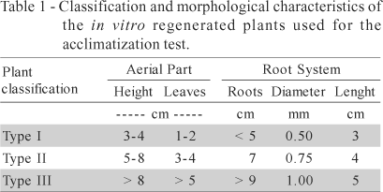

Fifty days after acclimatization started, plants were tested to the effect of mycorrhiza treatment on the acclimatization and development of the in vitro obtained zedoary plants; acclimatization was also carried out on substrate inoculated with vesicle arbuscular endomycorrhizal fungus Glomus etunicatum (400-spore per 5 mL for inoculum). The effect was monitored by comparing the size and dry matter of the aerial part and of the root system of the treated and non-treated plants.
Callus induction
The induction of callus was pursued by inoculating leaf tissue (blade discs, sheath base, sheath top), root tissue (apex and medium region) and shoot apex, on a modified MS medium containing 0.5 mg L⁻¹ nicotinic acid, thiamine and pyridoxine, 20 mg L⁻¹ glycine, 100 mg L⁻¹ myo-inositol, 30 g L⁻¹ sucrose, and 8.0 g L⁻¹ agar as solidifying agent. Concentrations (0; 1.0; 5.0; 10.0 and 20.0 mg L⁻¹) of the growth regulators 2,4 dichloro phenoxyacetic acid (2,4-D) or NAA were supplemented to the culture medium. The inoculated materials were cultured in growth room at 25 ± 2ºC, 31 ¼mol m⁻² s⁻¹, in the dark or under a photoperiod of 16/8hours (light/dark) conditions. The evaluation of callus formation was performed 50 days after inoculation.
Cell suspension culture
Callus formed on MS solid medium supplemented with 1.0 mg L⁻¹ NAA (the best callus inducing concentration; see Results and Discussion) were transferred into 250-mL Erlenmeyer flasks containing 75 mL of basic MS liquid medium and kept under agitation (100 rpm), in the dark at 25 ± 2ºC for cell suspension culture establishment. Cell multiplication was monitored in experiments containing 1.0 g of fresh weight of cells per 75 mL of medium at 0, 4, 7, 11, 14, 18, 21, 25, 29, and 32 days after transfer, by measuring dry weight accumulation. The cell viability in the cell suspension culture was followed by the tetrazolium test (Dixon, 1985). This test consists of adding 8 mL of 0.5% 2,3,5 triphenil-tetrazolium chloride solution (pH 7.5) to variable amounts of cells. After incubation and centrifugation, the pellet of cells is ressuspended on 3 mL etanol (95%). Cells are incubated and centrifugated and the supernadant used to read the absorbanse at 485 nm against etanol (95%) as a control.
Statistical Parameters
Trials were performed in totally randomized design. The test of growth regulators consisted of 24 treatments (six BAP concentrations and four NAA concentrations) with 20 replicates, and for different phenological age of shoots, four treatments with ten replicates. Acclimatization consisted of 30 treatments (three plant sizes, five time intervals of cover and the presence or absence of mycorrhiza) with ten replicates each. The experiments for callus induction consisted of 120 treatments (six explants, five concentrations of two growth regulators 2.4-D and NAA - and two light conditions - light and dark) with 18 replicates each. The stablishment of cell suspension cultures and their growth were evaluated at ten time intervals, with three replicates. All graphics were based on treatment means.

RESULTS AND DISCUSSION
Zedoary has quickly micropropagation response in vitro by the diverse type of explants (Figures 1 and 2) producing plants that can be easily acclimated (Figure 3). Callus is also promptly induced by using root segments as explant, and when transferred to liquid medium, cell suspension culture is readily established (Figure 4).

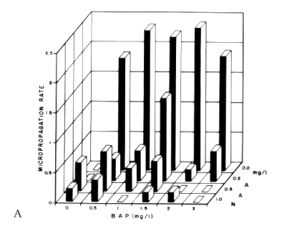
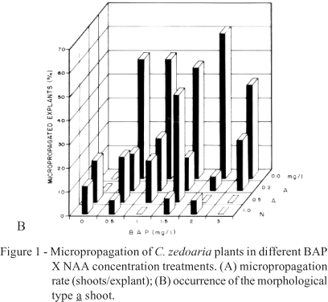

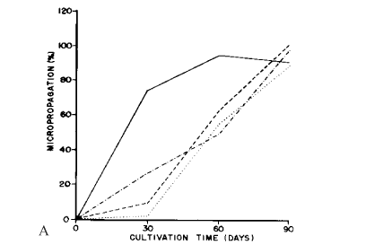
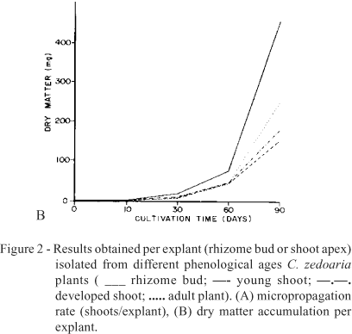

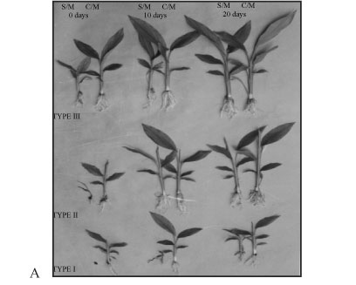
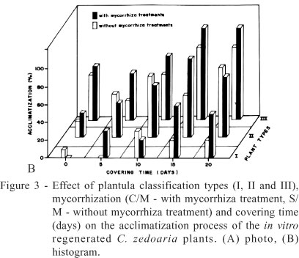

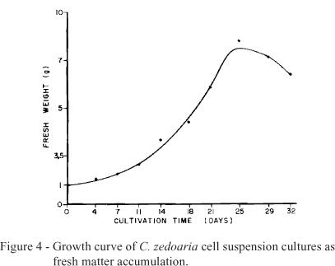

Micropropagation
Test of growth regulators - The best results were obtained using rhizome bud meristems for the micropropagation of C. zedoaria Roscoe. The explants response to BAP and NAA, individually and in combination, were evaluated 60 days after inoculation (Figure 1). The occurrence of diverse morphogenetic types was observed, and could basically be classified into three classes: a) explants presenting different levels of development with high micropropagation rate (> 2.0) and variable number of leaves, occurring in the presence of high BAP concentrations and absence of NAA; b) explants with no development or low level of development and low micropropagation rate (< 0.5), amorphous and oxidized, occurring in the presence of high concentration of both BAP and NAA; c) explants presenting root formation and low or no aerial part development and also low micropropagation rate (< 0.5), occurring in the presence of high NAA concentration and absence of BAP. The two last morphogenic types did not show complete developmental stages and were discarded. Culture media containing high BAP and NAA concentration or absence of BAP are not recommended for C. zedoaria micropropagation.
Micropropagation quantified by the number of shoots/explant was higher in the absence of NAA but was BAP-dependent when the NAA concentration was less than 1.0 mg L⁻¹, remaining itself steady until BAP concentration of 2.0 mg L⁻¹ and decreasing thereafter (Figure 1A). The frequency of plants with well-formed shoot (hereafter called morphogenetic type a) is shown in Figure 1B. Micropropagation of Curcuma zedoaria Roscoe is BAP-dependent and is inhibited by NAA.
Being a monocotyledonous crop, Curcuma zedoaria does not allow great explant diversity for micropropagation. Shoot apexes have been the responsive explant often used. Rhizome bud meristems were the best explant source for micropropagation (Figure 2). However, rhizome explants may not be the ideal ones, hence they add to the protocol septic problems resulting from the presence of soil residues. Additionally, zedoary rhizomes are dormant during winter. Therefore, micropropagated plant shoot apexes are preferred since sterile explants would be available all year-round.
Test of phenological age of shoots - The effect of the phenological development stage of the explant on the micropropagation rate (number of shoots per explants) and dry matter produced per explant of zedoary are shown in Figures 2A and 2B, respectively. Rhizome buds are more efficient for both parameters evaluated. At 30 days of culture, rhizome buds showed 72.3% microrpopagation while young shoot, developed shoot and shoot from adult plants presented 10.3%, 25.3% and 1.6%, respectively. However, at 90 days after inoculation, similar micropropagation rate was observed for all explants (Figure 2A). As far as micropropagation potencial is concerned, rhizome bud present a greater advantage since it responds rapidly producing plantlets in a shorter period of time in comparison to other explant types. The dry matter accumulation was similar for all four types of explants until 30 days after inoculation. Then, shoots originated from buds started to accumulate dry matter and, at 90 days, it presented three times more dry matter than the explants from young and developed shoot and twice more than explants from adult plants.
Acclimatization
Questions always arise concerning the appropriate size or age of the plants leaving the in vitro condition to overcome stress conditions occurring during acclimatization. Also, how long should they stay in greenhouse before they can be transferred to the field? These questions were satisfactorily answered herein. Furthermore, the possible beneficial effect of plant treatment with mycorrhiza on the acclimatization capacity was also tested with good results.
The results of the acclimatization of the micropropagated plants carried out with plants of three different sizes (Table 1) in the presence or absence of the endomycorrhizal fungus Glomus etunicatum are shown in Figure 3 (A and B). A direct relationship was found among plant size, length of the period under plastic cover, mycorrhiza treatment and the acclimatization ability of the plants. Plants of type III size were the most successful (97% acclimatization after 15 days under plastic cover) and of type I the least (20% acclimatization after 10 days covering) on overcoming the ex vitro stress conditions. Micorrhiza treatment consistently improved performance of types I and II plants, while micorrhiza treatment of type II plants did not show consistent response. The accumulation of dry matter by the aerial part and by the root system showed that mycorrhiza-treated plants were able to accumulate twice as much dry matter than untreated plants, in both parts of the plants, and for all three types. This difference was more pronounced around the 5th and the 10th day after inoculation.
The highest acclimatization rate occurs after 15 days in greenhouse and apparently independ on the plant size tested for both treated and untreated mycorrhiza conditions. According to other investigations carried out in our laboratory (results not reported here) this seems to be true for plant species such as African violet, pineapple, and strawberry. There is a minimal size, in the case of zedoary type III plants, that will confer acclimatization higher than 90% after 15 days in greenhouse. It also became apparent that the higher the stress, the better the mycorrhiza treatment response, apparently to the type I plants (Figure 3). The enhanced development of zedoary plants by mycorrhiza treatment probably results from the increase of the root absorption area, which results in high absorption of water and nutrients (Vidal et al., 1992; Estrada-Luna et al., 2000; Locatelli & Lovato, 2002). Untreated zedoary plants required a much longer time under plastic covers to show complete acclimatization, and their survival rate was always under 25%. On the other hand, the mycorrhiza-treated plants had survival rate two to three times higher than those untreated (Figure 3).
Longer time under plastic cover showed to be a requirement for the acclimatization of all three types of plants, mainly, the smaller type I.
Callus induction
Concentrations of 2.4-D did not show any positive response for callus induction in any of the tested types of explants when evaluation was carried out 50 days after inoculation. On the other hand, treatment of diverse tissues of Curcuma zedoaria with different NAA concentrations produced variable callus induction responses. Callogenesis occurred on the shoot apex, leaf sheath base, root apex and root medium region explants. Occurrence of relevant callogenesis was inversely proportional to NAA concentration. Best results were observed when explants from roots (root apexes and median portion of roots) were maintained at NAA concentrations of 1.0 mg L⁻¹ (Table 2). Complete absence of light was a requirement for best callus induction. The calli were yellowish and nodular with morphogenic aspects. Plant can be regenerated from these calli by indirect organogenesis (Mello et al., 2001). According to these authors, histological analysis revealed that callus was formed from hypertrophied cortical parenchyma cells of the explant. Some of these cells underwent division while the surrounding cells accumulated starch. Callus was capable of shoot bud regeneration after 70 days.

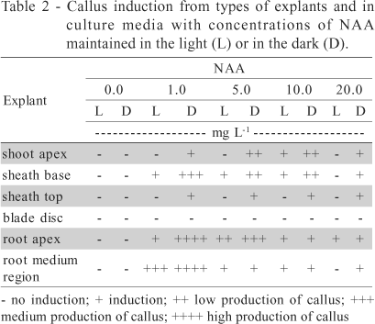

Cell suspension culture
Calli obtained on solid MS culture medium containing 1.0 mg L⁻¹ NAA when transferred to a same liquid medium did not show any significant cell multiplication before four weeks after transfer. At the end of the 4th week, whitish granular cell aggregates started to be formed in the culture medium and maintained during subsequent subculturings. A typical cell growth curve constructed from any of subsequent subculturings is shown in Figure 4. This curve shows a lag phase of around five days, followed by an exponential phase of growth lasting approximately 15 days, ending up in the stationary phase. The whole growth curve took approximately 25-30 days to be completed and presented about 8 to 10 folds fresh matter accumulation. The cell viability determined by the tetrazolium test was, on average, above 70%.
A system for using plants of a particular species for production of phytochemicals should provide a choice to use either plant tissue or cell suspension. The crop biomass production depends on a very reliable plant propagation method not always already developed for every plant species. Some of the factors limiting the feasibility of this procedure are geographic location of the target species, absence of seed production, seed dormancy and length of the species cycle (Babu et al., 1992; Kackar et al., 1993; Illg & Faria, 1995). Plant tissue culture techniques could be a reliable strategy to supply any required amount of micropropagated plants at cost not exceeding the conventional way to propagate plant species (Mello et al., 2000). Cell suspension culture is a requirement for the production of chemicals from plants in a way quite similar to that used for microorganisms, where the utilization of bioreactor becomes feasible. The bottleneck of this biotechnological process lies on the ability of metabolites excretion by plant cells.

ACKNOWLEDGMENTS
To FAPESP and CNPq, for providing financial support for this project, and Mr. Eraldo Negri for help with photographs.

REFERENCES
BABU, K.N.; SAMSUDEEN, K.; RATNAMBAL, M.J. In vitro plant regeneration from leaf-derived callus in ginger (Zingiber officinale Rosc.). Plant Cell, Tissue and Organ Culture, v.29, p.71-74, 1992.
BORTHAKUR, M.; HAZARIKA, J.; SINGH R.S. A protocol for micropropagation of Alpinia galanga. Plant Cell, Tissue and Organ Culture, v.55, p.231-233, 1998.
DIXON, R.R. Isolation and maintenance of callus and cell suspension cultures. In: DIXON, R.A. (Ed.) Plant cell culture: a practical approach. Oxford: Irl Press, 1985. cap.1, p.1-20.
ESTRADA-LUNA, A.A.; DAVIES, F.T.; EGILLA, J.N. Mycorrhizal fungi enhancement of growth and gas exchange of micropropagated guava plantlets (Psidium gualava L.) during ex vitro acclimatization and plant establishment. Mycorrhiza, v.10, p.1-8, 2000.
HOAGLAND, D.; ARNON, D.I. The water-culture method for growing plants without soil. Berkley: California Agriculture Experimental Station, 1950. (Circular, 347)
ILLG, R.D.; FARIA, R.T. Micropropagation of Alpinia purpurata from inflorescence buds. Plant Cell, Tissue and Organ Culture, v.40, p.183-185, 1995.
JANG, M.K.; SOHN, D.H.; RYU J.H. A curcuminoid and sesquiterpenes as inhibitors of macrophage TNF-alpha release from Curcuma zedoaria. Planta Medica, v.67, p.550-552, 2001.
[ Medline ]
KACKAR, A.; BHAT, S.R.; CHANDEL, K.P.S.; MALIK, S.K. Plant regeneration via somatic embryogenesis in ginger. Plant Cell, Tissue and Organ Culture, v.32, p.289-292, 1993.
KIM, K.I.; KIM, J.W.; HONG, B.S.; SHIN, D.H.; CHO, Y.; KIM, H.K.; YANG, H.C. Antitumor, genotoxicity and anticlastogenic activities of polysaccharide from Curcuma zedoaria. Molecules and Cells, v.10, p.392-398, 2000.
[ Medline ]
LOCATELLI, L.M.; LOVATO, P.E. Mycorrhizal inoculation and acclimatization of two micropropagated apple rootstocks. Pesquisa Agropecuária Brasileira, v.37, p.177-184, 2002.
[ SciELO ]
MATSUDA, H.; MORIKAWA, T.; NINOMIYA, K.; YOSHIKAWA, M. Hepatoprotective constituents from Zedoariae rhizoma: absolute stereostructures of three new carabrane-type sesquiterpenes, curcumenolactones A, B and C. Bioorganic and Medicinal Chemistry, v.9, p.909-916, 2001.
[ Medline ]
MELLO, M.O.; AMARAL, A.F.C.; MELO, M. Quantificação da micropropagação de Curcuma zedoaria Roscoe. Scientia Agricola, v.57, p.703-703, 2000.
[ SciELO ]
MELLO, M.O.; MELO, M.; APPEZZATO-DA-GLÓRIA, B. Histological analysis of the callogenesis and organogenesis from root segments of Curcuma zedoaria Roscoe. Brazilian Archieves of Biology and Technology, v.44, p.197-203, 2001.
MURASHIGE, T.; SKOOG, F. A revised medium for rapid growth and bioassays with tobacco tissue culture. Physiologia Plantarum, v.15, p.473-497, 1962.
NAVARRO, D.D.; SOUZA, M.M.; NETO, R.A.; GOLIN, V.; NIERO, R.; YUNES, R.A.; DELLE MONACHE, F.; CECHINEL, V. Phytochemical analysis and analgesic properties of Curcuma zedoaria grown in Brazil. Phytomedicine, v.9, p.427-432, 2002.
[ Medline ]
SALVI, N.D.; GEORGE, L.; EAPEN, S. Micropropagation and field evaluation of micropropagated plants of tumeric. Plant Cell, Tissue and Organ Culture, v.68, p.143-151, 2002.
SHARMA, T.R.; SINGH, B.M. High-frequency in vitro multiplication of disease-free Zingiber officinale Rosc. Plant Cell Reports, v.17, p.68-72, 1997.
SHIRIN, F.; KUMAR, S.; MISHRA, Y. In vitro plantlet production system for Kaempferia galanga, a rare Indian medicinal herb. Plant Cell, Tissue and Organ Culture, v.63, p.193-197, 2000.
VIDAL, M.T.; AZCONAGUILAR, C.; BAREA J.M.; PLIEGOALFARO, F. Mycorrhizal inoculation enhances growth and development of micropropagated plants of avocado. Hortscience, v.27, p.785-787, 1992.
WHITAKER, R.J.; EVANS, D.A. Plant biotechnology and the production of flavor compounds. Food Technology-Chicago, v.41, p. 86-101, 1987.

Received February 20, 2003
Accepted April 23, 2004

* Corresponding author <mmelo@esalq.usp.br>

© 2007 Scientia Agricola
Av. Pádua Dias, 11
Caixa Postal 9
13418-900 Piracicaba SP Brazil
Tel.: +55 19 3429-4401 / 3429-4486
Fax: +55 19 3429-4401
scientia@esalq.usp.br
http://journals.tubitak.gov.tr/botany/issues/bot-02-26-4/bot-26-4-1-0104-9.pdf cell suspension cultures

http://www.fao.org/docrep/t0831E/t0831e07.htm

http://www.telmedpak.com/agricultures.asp?a=medplantpak&b=med_plant13#4
http://pubs.acs.org/hotartcl/chemtech/98/jan/safety.html

http://www.biomedcentral.com/1472-6750/6/45

