Chestnut Blight
Native range of American chestnut. From Little, E.L., Jr., 1977, Atlas of United States trees, volume 4, Minor Eastern Hardwoods: U.S. Department of Agriculture Miscellaneous Publication 1342, 17 p., 230 maps.

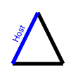
Hosts
American chestnut (Castanea dentata), whose native range is shown at left, is highly susceptible to the disease. European chestnut (C. sativa) is also quite susceptible. Chinese chestnut (C. mollissima) is resistant; a small canker can occur. Some oak species (Quercus spp.) get minor bark infections that can produce inoculum.
If you could custom design the ideal tree species, you couldn't come up with a better one than American chestnut. It was a huge, majestic tree, with a very straight stem. The wood was nearly ideal. As George Hepting (Δ) has written, "Not only was baby's crib likely made of chestnut, but chances were, so was the old man's coffin." One of its good qualities was high durability. The heartwood could be used in situations where decay was a hazard. The tree was common. It made up about 50% of most eastern hardwood forests. It grew fast, and would regenerate itself by root sprouts vigorously. The nuts were edible, not only by wildlife but also by humans. It was an important food source for all. "The farmer's hogs were fattened on chestnuts, and, to no small degree, his children were also" (Δ). Chestnut was also prized as a landscape tree.

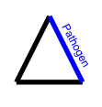
Pathogen
The pathogen is Cryphonectria parasitica. It is an ascomycete, and produces perithecia in small stromata. They can appear at any time of year when conditions are suitable. The perithecial necks are very long and come together where they protrude through the bark. The ascospores are forcibly ejected and wind-dispersed.
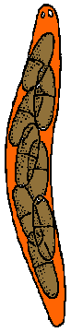
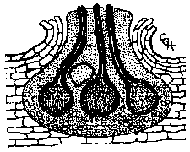
Perithecia of Cryphonectria parasitica in a stroma. The perithecia contain many asci with 8 ascospores each. The ascospores are forcibly ejected and carried in air currents.
Usually prior to perithecia, pycnidia are produced in the same small stroma or in other stromata. They also can appear any time of year. The conidia ooze out in a tendril after rains. They are quite small, as small as 4 x 1 µm wide. In that little conidium is all the information and machinery necessary to wipe out one of the most important tree species in North America. Conidia may be carried by rain splash or catch a ride on an insect or bird.
In 1913 a USDA plant explorer found the fungus in its native land of China. There it was hardly a pathogen, colonizing dying twigs and small patches of bark.
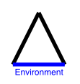
Environment
Within the range of environmental conditions found in the geographic range of chestnut, there do not appear to be important differential effects of the environment. Environmental conditions are conducive to disease throughout the range of chestnut.

Disease Cycle
Conidia and ascospores can infect wounds, even very small ones that don't go all the way to cambium. It is thought that insects of various kinds make most of the infection courts.
The fungus grows in the inner bark and cambium, producing small brownish mycelial fans. Even after the branch or stem is girdled and killed, the fungus continues to colonize it, producing ever more inoculum.
Symptoms
Chestnut blight is a canker disease. Perhaps it is called blight because infected branches and stems die quickly, as in a shoot blight. But it doesn't just infect shoots; it infects branches and stems of any size.
The cankers are of the diffuse type. They grow rapidly and in most cases continue to develop until the stem is girdled and killed; then they continue to colonize the dead tree.

Distribution
In North America, chestnut blight is present in the entire native range of the host and has moved to areas of planted chestnut far from the native range. It is also present in Europe, and the pathogen is native to China, where it causes an inconsequential disease of Chinese chestnut.

