Table of contents
What is citizenship education?????????
Goals of citizenship education:
Citizenship education and development of character:
What is community engagement:
Goal of community engagement:
What is active citizenship?????

Steps to become A good citizen:
Diversity of active citizenship:
What is concept of philosophy?????
What is concept of idea????
What is orientation?????
What is mean by learning outcomes??????

What is citizenship education?????????
Citizenship education is education that provides background knowledge necessary to create an ongoing stream of new citizen participating and Engaging with creation of civilised society.
The idea of citizenship has been defined as the capacity of individuals to defend their rights in front of the governmental authority.
A person may have multiple citizenships. A person who does not have citizenship of any state is said to be stateless, while one who lives on state borders whose territorial status is uncertain is a border-lander.
Skills of citizenship
- Cooperation. "We the people"; not the individuals work together as a group.
- Strength. Provide for common defense.
- Balance. Secure the blessings of liberty to ourselves and our prosperity.
- Self-improvement. Promote to general welfare, seek knowledge and skills.
- Respect. ...
- Patience. ...
- Fairness.
Goals of citizenship education:
- Learning Goals (Access, Engage and Express) to develop independent skills to support their own learning;
- Personal Goals to explore their interests, talents, or passions;
- College and Career Goals to gain first-hand experiences in career areas where they have strong interests; and
- Citizenship Goals to become an active citizen in the local or global community.
Citizenship education and development of character:
Effective citizenship education programme provide students with opportunities for the development of desirable trait of public and private sectors.
Certain learning activities can promote characteristics needed to participate effectively and responsibility in civic life.
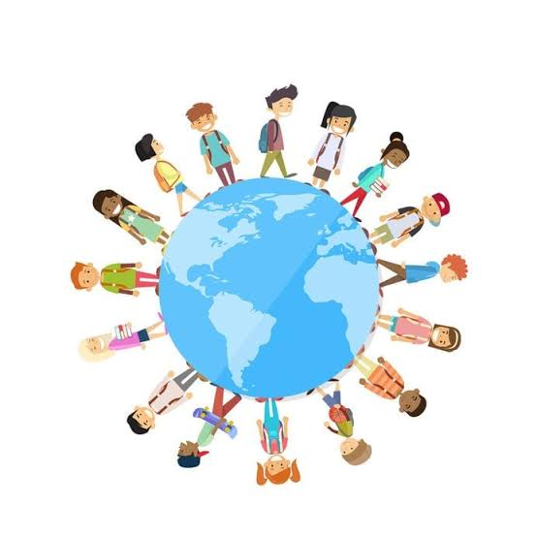
For examples:
- Civility, courage,self discipline, persistence and other trait relevant to citizenship can be promoted through student government and cooperative learning in such activities as class meeting and students council.
- Self discipline, respect for other , civility, personal responsibility and other trait can be fostered in school and service learning project.
- Classroom discussion of common problems can foster a recognition of shared value and sense of community.
.
What is community engagement:
It defined as:-
Community engagement is "a dynamic relational process that facilitates communication, interaction, involvement, and exchange between an organization and a community for a range of social and organizational outcomes".
Types of community engagement
- Community Building
Projects that intentionally bring people together to simply get to know one another.
- Community Education
Projects that provide instructional services or curricula, or serve to educate the public about a social issue.
- Economic Development
Projects that work on developing the regional economy in a sustainable way.
- Community Organizing
Projects that bring people together with the goal of solving a community issue.
Goal of community engagement:
- Maximise transmission bit rate.
- Minimise bit error probability.
- Maximum system utilization.
- Minimize require transmission power.
- Minimize system complexity and system cost.
Some other goal of community engagement given in graphic form.

Goal of communityy engagement in different fields with different purposes:
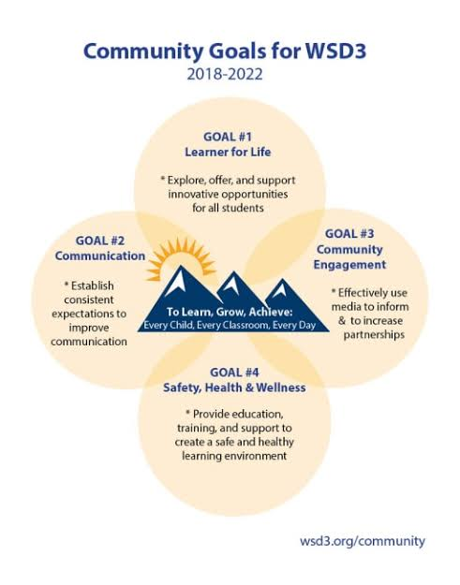
Role of community engagement in different fields:
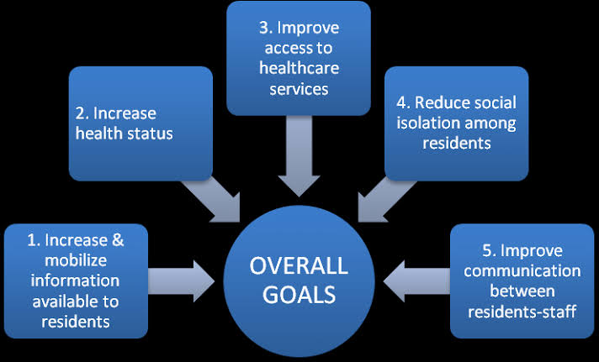
What is active citizenship?????
Active citizenship refers to a philosophy espoused by organizations and educational institutions which advocates that members of charitable organizations, companies or nation-states have certain roles and responsibilities to society and the environment, although those members may not have specific governing roles.
Active citizenship can be seen as an articulation of the debate over rights versus responsibilities
Examples of active citizenship:
- Global examples of active citizen groups working together include international organisations such as Oxfam, The Red Cross and Teachers without Borders.
- National groups working for the common good include events such as Clean Up Australia Day, Australia's Biggest Morning Tea and the annual Red Shield Appeal.
Steps to become A good citizen:
- Get a library card and check out the library programs.
- Support and read the local paper.
- Attend city council meetings.
- Write letters to the editor of your local paper.
- Start a blog about local issues.
- Organize a community garden.
Four dimensions of active citizenship;
- Protest and social changing.
- Community life
- Representative democracy.
- Democratic value.
Diversity of active citizenship:

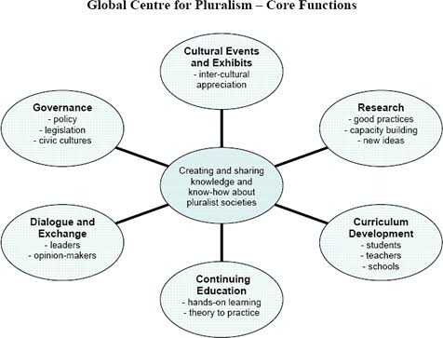
What is concept of idea????
- A thought or collection of thoughts that generate in the mind.
- An idea is usually generated with intent, but can also be created unintentionally. Ideas often form during brainstorming sessions or through discussions.
What is idea generation and why it's important?????

- Idea generation is described as the process of creating, developing and communicating abstract, concrete or visual ideas.

- It’s the front end part of the idea management funnel and it focuses on coming up with possible solutions to perceived or actual problems and opportunities.
What is concept of philosophy?????
- The word Philosophy is derived from two Greek words; Philo meaning love and Sophia meaning wisdom.
- In general, it means love of wisdom.
- Philosophy is a broad field of knowledge in which the definition of knowledge itself is one of the subjects investigated.

Diversity of Philosophy:
- It spans the nature of the universe, the mind, and the body; the relationships between all three, and between people.
- Philosophy is a field of inquiry – the pursuit of wisdom; the predecessor and complement of science, developing the issues which underlie science and pondering those questions which are beyond the scope of science.
- Philosophy provides the foundations upon which all belief structures and fields of knowledge are built.
Main objective of Philosophy:
- clarity and coherence in explaining philosophical concepts, theories, and policies;
- ability to criticize assumptions and arguments;
- ability to evaluate the adequacy and justifiability of concepts, theories, and policies;
What is concept of skills????????
A skill is the ability to carry out a task with determined results often within a given amount of time, energy, or both.

Types of skills:
- Domain general skill.........
- Domain spacific skill........
Domain General skill:
Skills can often be divided into domain-general and domain-specific skills. For example, in the domain of work, some general skills would include time management, teamwork and leadership, self-motivation.
Domain spacific skill:
Domain-specific skills would be used only for a certain job.
Categories of skill:
Three broad categories of skills are suggested and these are technical, human, and conceptual.
The first two can be substituted with hard and soft skills, respectively.
Hard skills
Hard skills, also called technical skills, are any skills relating to a specific task or situation.
It involves both understanding and proficiency in such specific activity that involves methods, processes, procedures, or techniques.
Soft skills:
Soft skills are a combination of interpersonal people skills, social skills, communication skills, character traits, attitudes, career attributes and emotional intelligence quotient (EQ) among others.

What is orientation?????
- Person's basic attitude, beliefs, or feelings in relation to a particular subject or issue.
- For example, Portrait and Landscape are two common orientations found in some software applications, especially word processors.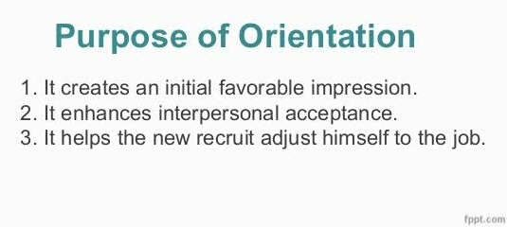
What is mean by learning outcomes??????
Learning outcomes describe the measurable skills, abilities, knowledge or values that students should be able to demonstrate as a result of a completing a course.
Example of learning outcomes:
- Knowledge/Remembering: define, list, recognize;
- Comprehension/Understanding: characterize, describe, explain, identify, locate, recognize, sort;
- Application/Applying: choose, demonstrate, implement, perform;
- Analysis/Analyzing: analyze, categorize, compare, differentiate;

Characteristics of learning outcomes:
- produce professional quality writing.
- effectively communicate the results of their research findings and analyses to fellow classmates in an oral presentation.

.

