Department of Sociology
University of Sargodha
BS Mid Term Examination 2020
Semester: BS(II)
Max. Marks:30 Paper: English II
Instructor:Ms Anam Javed
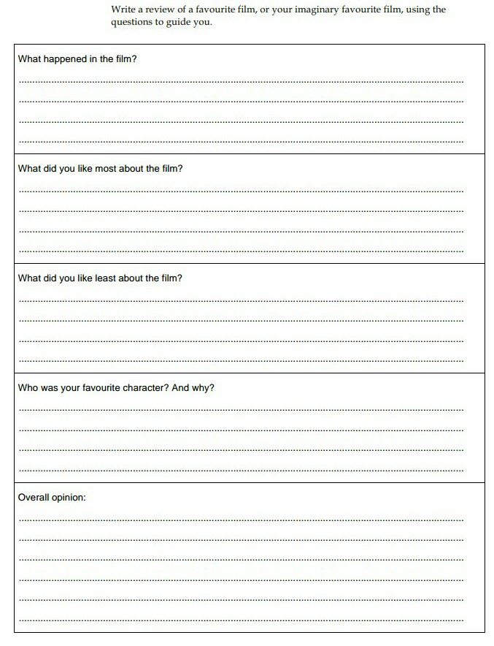
Q.No. Write a review of your favourite film by using the question to guide you:(15)

1

Q.No.2 Write a comprehensive note on the topic "My culture and lifestyle".(15)
