Six Steps to Mushroom Farming
Mushroom farming consists of six steps, and although the divisions are somewhat arbitrary, these steps identify what is needed to form a production system.

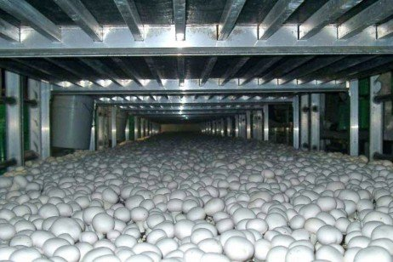

Preface
The second edition of Six Steps to Mushroom Farming recognizes that much progress in mushroom farming has taken place over the last 25 years since the original edition was published. Trends such as use of forced aeration Phase I, Phase II tunnels, Phase III bulk spawn run, casing inoculum, compost supplementation, hybrids, improved nutritional status of mushrooms, and alternative uses of post-crop mushroom compost necessitates an updated, reorganized, and expanded second edition of Six Steps to Mushroom Farming.
Mushroom farming consists of six steps, and although the divisions are somewhat arbitrary, these steps identify what is needed to form a production system. The six steps are Phase I composting, Phase II composting, spawning, casing, pinning, and cropping. These steps are described in their naturally occurring sequence, emphasizing the salient features within each step. Compost provides nutrients needed for mushrooms to grow. Two types of material are generally used for mushroom compost, the most used and least expensive being wheat straw-bedded horse manure. Synthetic compost is usually made from hay and wheat straw, although the term often refers to any mushroom compost where the prime ingredient is not horse manure. Both types of compost require the addition of nitrogen supplements and a conditioning agent, gypsum.
The preparation of compost occurs in two steps referred to as Phase I and Phase II composting. The discussion of compost preparation and mushroom production begins with Phase I composting.

1. Phase I: Making Mushroom Compost
Phase I composting is initiated by mixing and wetting the ingredients as they are stacked in a rectangular pile with tight sides and a loose center. Normally, the bulk ingredients are put through a compost turner. Water is sprayed onto the horse manure or synthetic compost as these materials move through the turner. Nitrogen supplements and gypsum are spread over the top of the bulk ingredients and are thoroughly mixed by the turner. Once the pile is wetted and formed, aerobic fermentation (composting) commences as a result of the growth and reproduction of microorganisms, which occur naturally in the bulk ingredients. Heat, ammonia, and carbon dioxide are released as by-products during this process. The use of forced aeration, where the compost is placed on a concrete floor or in tunnels or bunkers and aerated by the forced passage of air via a plenum, nozzles or spigots located in the floor has become nearly universal in the mushroom industry (Fig. 1).
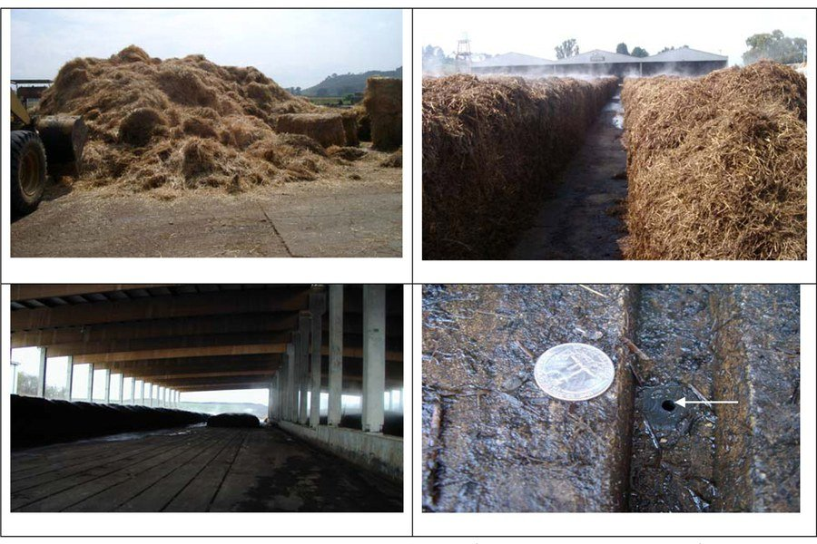
Figure 1. Loose straw ready for incorporation into compost windrow (top left); compost windrow (top right); aerated Phase I compost wharf under roof (note groves in concrete, bottom left); grove showing aeration nozzle (bottom right, arrow).
Mushroom compost develops as the chemical nature of the raw ingredients is converted by the activity of microorganisms, heat, and some heat-releasing chemical reactions. These events result in a food source most suited for the growth of the mushroom to the exclusion of other fungi and bacteria. There must be adequate moisture, oxygen, nitrogen, and carbohydrates present throughout the process, or else the process will stop. This is why water and supplements are added periodically, and the compost pile is aerated as it moves through the turner.
The quality of raw materials used to make mushroom compost are highly variable and are known to influence compost performance in terms of spawn run and mushroom yield. The geographical source of wheat straw, the variety (winter or spring) and the use of nitrogen fertilizer, plant growth regulators and fungicides may affect compost productivity. Wheat straw should be stored under cover to minimize growth of unwanted and potentially detrimental fungi and bacteria prior to its use to produce compost.
Gypsum is added to minimize the greasiness compost normally tends to have. Gypsum increases the flocculation of certain chemicals in the compost, and they adhere to straw or hay rather than filling the pores (holes) between the straws. A side benefit of this phenomenon is that air can permeate the pile more readily, and air is essential to the composting process. The exclusion of air results in an airless (anaerobic) environment in which deleterious chemical compounds are formed which detract from the selectivity of mushroom compost for growing mushrooms. Gypsum is added at the outset of composting at 40 lb per ton of dry ingredients.
Nitrogen supplements in general use today includes corn distiller's grain, seed meals of soybeans, peanuts, or cotton, and chicken manure, among others. The purpose of these supplements is to increase the nitrogen content to 1.5 percent for horse manure or 1.7 percent for synthetic, both computed on a dry weight basis. Synthetic compost requires the addition of ammonium nitrate or urea at the outset of composting to provide the compost microflora with a readily available form of nitrogen for their growth and reproduction.
The initial compost pile should be 5 to 6 feet wide, 5 to 6 feet high, and as long as necessary. A two-sided box can be used to form the pile (rick), although some turners are equipped with a "ricker" so a box isn't needed. The sides of the pile should be firm and dense, yet the center must remain loose throughout Phase I composting. As the straw or hay softens during composting, the materials become less rigid and compactions can easily occur. If the materials become too compact in the traditional Phase I process, air cannot move through the pile and an anaerobic environment will develop. The problem of an anaerobic center core in the compost has largely been overcome by using forced aeration.
Turning and watering are done at approximately 2-3 day intervals, but not unless the pile is hot (145° to 170°F). Turning provides the opportunity to water, aerate, and mix the ingredients, as well as to relocate the straw or hay from a cooler to a warmer area in the pile, outside versus inside. Supplements are also added when the compost is turned, but they should be added early in the composting process. The number of turnings and the time between turnings depends on the condition of the starting material and the time necessary for the compost to heat to temperatures above 145°F.
Water addition is critical since too much will exclude oxygen by occupying the pore space, and too little can limit the growth of bacteria and fungi. As a general rule, water is added up to the point of leaching when the pile is formed and at the time of first turning, and thereafter either none or only a little is added for the duration of composting. On the last turning before Phase II composting, water can be applied generously so that when the compost is tightly squeezed, water drips from it. There is a link between water, nutritive value, microbial activity, and temperature, and because it is a chain, when one condition is limiting for one factor, the whole chain will cease to function.
Phase I composting lasts from 6 to 14 days, depending on the nature of the material at the start and its characteristics at each turn. There is a strong ammonia odor associated with composting, which is usually complemented by a sweet, moldy smell. When compost temperatures are 155°F and higher, and ammonia is present, chemical changes occur which result in a food rather exclusively used by the mushrooms. As a by-product of the chemical changes, heat is released and the compost temperatures increase. Temperatures in the compost can reach 170° to 180°F during the second and third turnings when a desirable level of biological and chemical activity is occurring. At the end of Phase I the compost should: a) have a chocolate brown color; b) have soft, pliable straws, c) have a moisture content of from 68 to 74 percent; and d) have a strong smell of ammonia. When the moisture, temperature, color, and odor described have been reached, Phase I composting is completed.

2. Phase II: Finishing the Compost
There are two major purposes to Phase II composting. Pasteurization is necessary to kill any insects, nematodes, pest fungi, or other pests that may be present in the compost. And second, it is necessary to condition the compost and remove the ammonia that formed during Phase I composting. Ammonia at the end of Phase II in a concentration higher than 0.07 percent is often inhibitory to mushroom spawn growth, thus it must be removed; generally, a person can smell ammonia when the concentration is above 0.10 percent.
Phase II takes place in one of three places, depending on the type of production system used. For the zoned system of growing, compost is packed into wooden trays, the trays are stacked six to eight high, and are moved into an environmentally controlled Phase II room. Thereafter, the trays are moved to special rooms, each designed to provide the optimum environment for each step of the mushroom growing process. With a bed or shelf system, the compost is placed directly in the beds, which are in the room used for all steps of the crop culture. The most recently introduced system, the bulk system, is one in which the compost is placed in an insulated tunnel with a perforated floor and computer-controlled aeration; this is a room specifically designed for Phase II composting (Fig. 2).
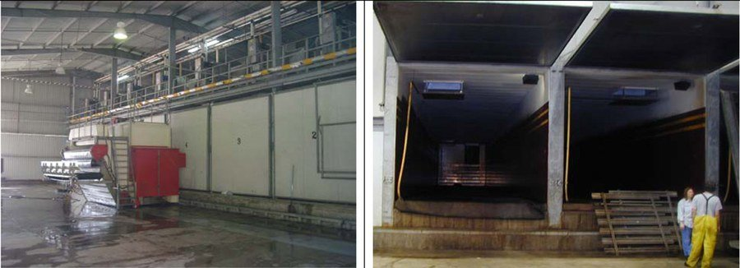
Figure 2. Phase II tunnels used to pasteurize and condition compost for mushroom production. Left: filling machine in front of closed tunnel, Right: open tunnel ready for filling.
The compost, whether placed in beds, trays, or bulk, should be filled uniformly in depth and density or compression. Compost density should allow for gas exchange, since ammonia and carbon dioxide will be replaced by outside air.
Phase II composting can be viewed as a controlled, temperature-dependent, ecological process using air to maintain the compost in a temperature range best suited for microorganisms to grow and reproduce. The growth of these thermophilic (heat-loving) organisms depends on the availability of usable carbohydrates and nitrogen, some of the nitrogen in the form of ammonia. These microorganisms produce nutrients or serve as nutrients in the compost on which the mushroom mycelium thrives and other organisms do not.
Completing Phase II in tunnels has become more popular in recent years. Tunnel composting has the advantage of treating more compost per ft² compared to more expensive production rooms. When coupled with bulk spawn run, tunnel composting offers the advantage of more uniformity and greater use of mechanization. However, transfer of the finished compost from the pasteurization tunnel to the bulk spawn run tunnel may increase the risk of infestation of unwanted pathogens and pests compared to compost that remains in the same room. Thus, higher levels of sanitation may be required with tunnel composting compared to in-room composting.
It is important to remember the purposes of Phase II when trying to determine the proper procedure and sequence to follow. One purpose is to remove unwanted ammonia. To this end the temperature range from 125° to 130°F is most efficient since de-ammonifying organisms grow well in this temperature range. A second purpose of Phase II is to remove any pests present in the compost by use of a pasteurization sequence.
At the end of Phase II the compost temperature must be lowered to approximately 75° to 80°F before spawning (planting) can begin. The nitrogen content of the compost should be 2.0 to 2.4 percent, and the moisture content between 68 and 72 percent. Also, at the end of Phase II it is desirable to have 6 to 8 lb of dry compost per square foot of bed or tray surface to obtain profitable mushroom yields. It is important to have both the compost and the compost temperatures uniform during the Phase II process since it is desirable to have as homogenous a material as possible.

3. Spawning
As a mushroom matures, it produces millions of microscopic spores on mushroom gills lining the underside of a mushroom cap. These spores function roughly similar to the seeds of a higher plant. However, growers do not use mushroom spores to 'seed' mushroom compost because they germinate unpredictably and therefore, are not reliable. Fortunately, mycelium (thin, thread-like cells) can be propagated vegetatively from germinated spores, allowing spawn makers to multiply the culture for spawn production. Specialized facilities are required to propagate mycelium, so the mushroom mycelium remains pure. Mycelium propagated vegetatively on various grains or agars is known as spawn, and commercial mushroom farmers purchase spawn from companies specializing in its manufacture.
Spawn makers start the spawn-making process by sterilizing a mixture of millet grain plus water and chalk; rye, wheat, and other small grain may be substituted for millet. Sterilized horse manure formed into blocks was used as the growth medium for spawn up to about 1940, and this was called block or brick spawn, or manure spawn; such spawn is not used today. Once sterilized grain has a bit of mycelium added to it, the grain and mycelium is shaken 3 times at 4-day intervals over a 14-day period of active mycelial growth. Once the grain is colonized by the mycelium, the product is called spawn (Fig. 3). Spawn can be refrigerated for a few months, so spawn is made in advance of a armer's order for spawn.
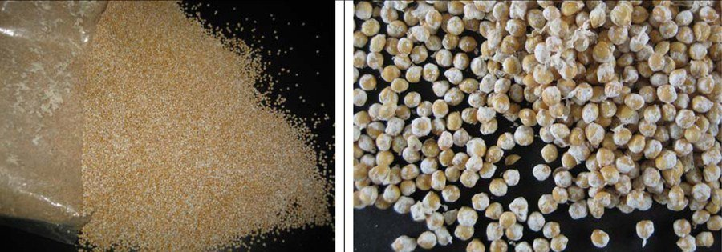
Figure 3. Mushroom spawn from open bag (left); close up of millet spawn (right).
Spawn is distributed on the compost and then thoroughly mixed into the compost. For years this was done by hand, broadcasting the spawn over the surface of the compost and ruffling it in with a small rake-like tool. In recent years, however, for the bed system, spawn is mixed into the compost by a special spawning machine that mixes the compost and spawn with tines or small finger-like devices. In a tray or batch system, spawn is mixed into the compost as it moves along a conveyer belt or while falling from a conveyor into a tray. The spawning rate is expressed as a unit or quart per so many square feet of bed surface; 1 unit per 5 ft² is desirable. The rate is sometimes expressed on the basis of spawn weight versus dry compost weight; a 2 percent spawning rate is desirable.

3.1 Supplementation at spawning
In the early 1960s, yield increases were observed when compost was supplemented with protein and/or lipid rich materials at spawning, casing and later. Up to a 10% increase in yield was obtained when small amounts of protein supplements were added to the compost at spawning. Excessive heating and stimulation of competitor molds in the compost substantially limited the amount of supplement and corresponding benefit that could be achieved. It was these limitations that were overcome by the invention of delayed release supplements for mushroom culture (Carroll and Schisler 1976). The disadvantages associated with the supplementation of non-composted nutrients to mushroom compost at spawning were largely overcome by encapsulating micro-droplets of vegetable oil within a protein coat that was denatured with formaldehyde. Increases of as much as 60% were obtained. Today, several commercial supplements are available that can be used at spawning or at casing to stimulate mushroom yield.
Amendment of mushroom substrate with Micromax® is another potential opportunity for growers to improve the yield capacity of their Phase II compost. Micromax® contains a mixture of nine micronutrients including (percentage dry wt basis): Ca (12%), Mg (3%), S (12%), B (0.1%), Cu (1%), Fe (17%), Mn (2.5%), Mo (0.05%), Zn (1%), and inert ingredients (57.35%). Research has shown that approximately 70% of the yield increase observed is due to Mn. Commercial supplement makers have begun to add Mn to their delayed release nutrients for mushroom culture.
Once the spawn and supplement have been mixed throughout the compost and the compost worked so the surface is level, the compost temperature is maintained at 75- 80°F and the relative humidity is kept high to minimize drying of the compost surface or the spawn. Under these conditions the spawn will grow - producing a thread-like network of mycelium throughout the compost. The mycelium grows in all directions from a spawn grain, and eventually the mycelium from the different spawn grains fuses together, making a spawned bed of compost one biological entity. The spawn appears as a white to blue-white mass throughout the compost after fusion has occurred. As the spawn grows it generates heat, and if the compost temperature increases to above 80° to 85°F, depending on the cultivar, the heat may kill or damage the mycelium and eliminate the possibility of maximum crop productivity and/or mushroom quality. At temperatures below 74°F, spawn growth is slowed and the time interval between spawning and harvesting is extended.

3.2 Phase III and Phase IV compost
Phase III compost is Phase II compost spawn run in bulk in a tunnel, and ready for casing when removed from the tunnel and delivered to the grower. If the Phase III compost then is cased and the spawn allowed to colonize the casing layer before sending to the growing unit or delivering to growers, it is called Phase IV compost. The successes of both Phase III and Phase IV compost depend, to a large extent, on the quality of Phase I and Phase II composts. Use of Phase III compost may also improve mushroom quality, as fragmentation of the colonized compost tends to improve initial color and mushroom shelf life. In recent years, the use of bulk Phase III compost has increased in popularity because it allows an increase in the number of crops a grower can expect from his production rooms. Phase II production on shelves allows an average of about 4.1 crops per year whereas growers using Phase III bulk spawn run compost averages about 7.1 crops per year. An additional gain can be made in the number of crops (10-12 crops per year) when Phase IV is used (Dewhurst 2002; Lemmers 2003; Chang 2006).

3.3 Mushroom varieties
In the United States, mushroom growers use three major mushroom cultivars: a) Smooth white hybrid - cap smooth, cap and stalk white; b) Off-white hybrid - cap scaly with stalk and cap white; and c) Brown - cap smooth, cap chocolate brown with a white stalk. Within each of the three major groups, there are various isolates, so a grower may have a choice of up to eight strains within each variety. Generally, white and off-white hybrid cultivars are used for processed foods like soups and sauces, but all isolates are good eating as fresh mushrooms. In recent years, the brown varieties have gained market share among consumers. The Crimini variety is similar in appearance to the white mushroom except it is brown and has a richer and earthier flavor. The Portobello variety is a large, open, brown-colored mushroom that can have caps up to 6 inches in diameter. The Portobello offers a rich flavor and meaty texture.
The time needed for spawn to colonize the compost depends on the spawning rate and its distribution, the compost moisture and temperature, compost supplementation, and the nature or quality of the compost. Complete spawn run usually requires 13 to 20 days. Once the compost is fully-grown with spawn, the next step in production is at hand.

4. Casing
Casing is a top-dressing applied to the spawn-run compost on which the mushrooms eventually form. A mixture of peat moss with ground limestone can be used as casing. Casing does not need nutrients since casing acts as a water reservoir and a place where rhizomorphs form. Rhizomorphs look like thick strings and form when the very fine mycelium fuses together. Mushroom initials, primordia, or pins form on the rhizomorphs, so without rhizomorphs there will be no mushrooms. Casing should be able to hold moisture since moisture is essential for the development of a firm mushroom. The most important functions of the casing layer are supplying water to the mycelium for growth and development, protecting the compost from drying, providing support for the developing mushrooms and resisting structural breakdown following repeated watering. Supplying as much water as possible to the casing as early as possible without leaching into the underlying compost provides the greatest yield potential.
Sphagnum peat moss is the most commonly used material for casing. Sphagnum can range from brown (young, less decomposed, loose textured, surface peat) to black (compact, more decomposed, deep dug) and may be processed differently at the harvest site. Milled peat is partially dried before packaging and transport while wet-dug peat is transported in a saturated form. Some growers prefer wet-dug peat because of the higher water holding capacity compared to milled peat.
Peat moss-based casing does not require pasteurization because the material is free from pathogens, weed molds and nematodes that may reduce mushroom yield. One 6-ft³ compressed bale when mixed with water and 40 lb of limestone will cover about 125 ft² of compost surface at about 2 inches depth.

4.1 Casing inoculum (CI)
Casing inoculum is a sterilized mixture of peat, vermiculite and wheat bran that has been colonized by mushroom mycelium. It is mixed with casing to decrease cropping cycle time, improve uniformity of mushroom distribution over the bed and improve mushroom cleanliness. Mycelium from the CI colonizes the casing layer while it fuses with the underlying mycelium of the compost. This allows more breaks per crop or more crops per year.
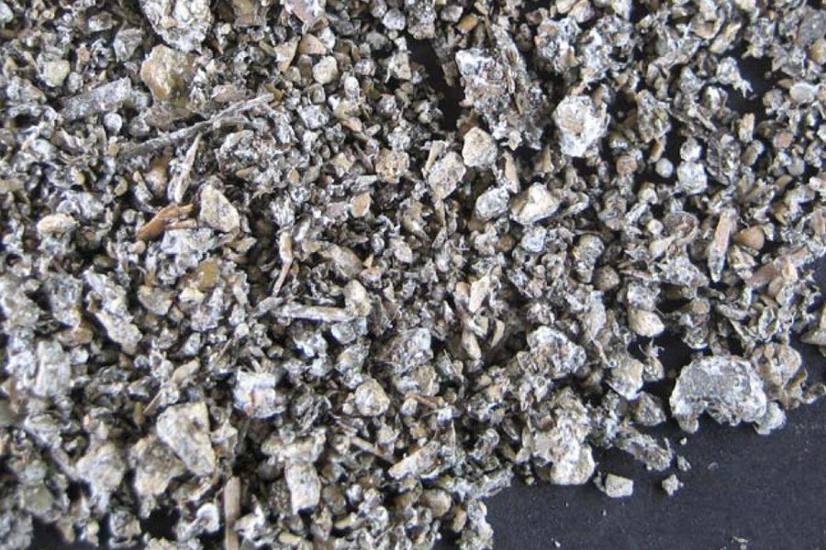
Figure 4. Casing inoculum used to inoculate casing for more rapid mycelial colonization.

4.2 Supplementation at casing
The addition of nutrients at casing was first tried in the early 1960s. Results showed that much greater amounts of nutrients could be added at casing than at spawning and that yield increases were almost proportional to the amount added. Although yield increases as high as 100% may be realized, certain potential problems and limitations exist for supplementation at casing. Weed molds, nematodes and pathogens must not be present in the compost when supplementing at casing. These organisms will be dispersed throughout the compost when it is fragmented prior to supplementation and can multiply very rapidly before the mushroom mycelium recovers its growth.
Managing the crop after casing requires that the compost temperature be kept at around 75°F for up to 5 days after casing, and the relative humidity should be high. Thereafter, the compost temperature should be lowered about 2°F each day until small mushroom initials (pins) have formed. Throughout the period following casing, water must be applied intermittently to raise the moisture level to field capacity before the mushroom pins form. Knowing when, how, and how much water to apply to casing is an "art form" which readily separates experienced growers from beginners.

5. Pinning
Mushroom initials develop after rhizomorphs have formed in the casing. The initials are extremely small but can be seen as outgrowths on a rhizomorph. Once an initial quadruples in size, the structure is a pin. Pins continue to expand and grow larger through the button stage, and ultimately a button enlarges to a mushroom (Fig. 5). Harvestable mushrooms appear 18 to 21 days after casing. Pins develop when the carbon dioxide content of room air is lowered to 0.08 percent or lower, depending on the cultivar, by introducing fresh air into the growing room. Outside air has a carbon dioxide content of about 0.04 percent.
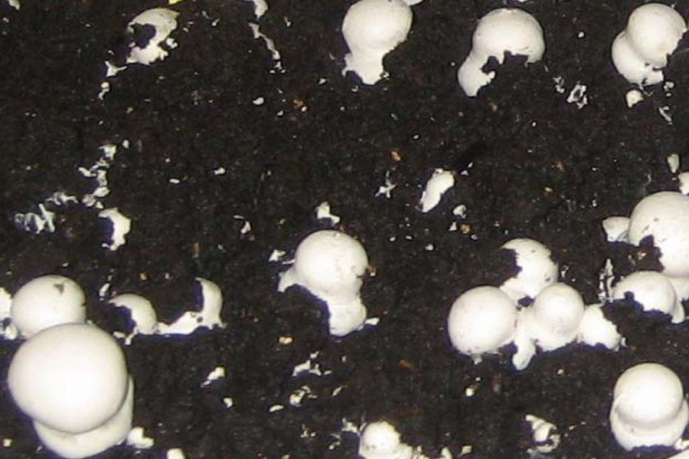
Figure 5. Mushrooms forming and maturing on the casing - a 2-inch layer of neutralized peat. Both "pins" and young mushrooms are visible.
The timing of fresh air introduction is very important and is something learned only through experience. Generally, it is best to ventilate as little as possible until the mycelium has begun to show at the surface of the casing, and to stop watering at the time when pin initials are forming. If the carbon dioxide is lowered too early by airing too soon, the mycelium will stop growing through the casing and mushroom initials form below the surface of the casing. As such mushrooms continue to grow, they push through the casing and are dirty at harvest time. Too little moisture can also result in mushrooms forming below the surface of the casing. Pinning affects both the potential yield and quality of a crop and is a significant step in the production cycle.

6. Cropping
The terms flush, break, or bloom are names given to the repeating 3- to 5-day harvest periods during the cropping cycle; these are followed by a few days when no mushrooms are available to harvest. This cycle repeats itself in a rhythmic fashion, and harvesting can go on as long as mushrooms continue to mature. Most mushroom farmers harvest for 35 to 42 days, although some harvest a crop for 60 days, and harvest can go on for as long as 150 days.
Air temperature during cropping should be held between 57° to 62°F for good results. This temperature range not only favors mushroom growth, but cooler temperatures can lengthen the life cycles of both disease pathogens and insects pests. It may seem odd that there are pests that can damage mushrooms, but no crop is grown that does not have to compete with other organisms. Mushroom pests can cause total crop failures, and often the deciding factor on how long to harvest a crop is based on the level of pest infestation. These pathogens and insects can be controlled by cultural practices coupled with the use of pesticides, but it is most desirable to exclude these organisms from the growing rooms.
The relative humidity in the growing rooms should be high enough to minimize the drying of casing but not so high as to cause the cap surfaces of developing mushrooms to be clammy or sticky. Water is applied to the casing so water stress does not hinder the developing mushrooms; in commercial practice this means watering 2 to 3 times each week. Each watering may consist of more or fewer gallons, depending on the dryness of the casing, the cultivar being grown, and the stage of development of the pins, buttons, or mushrooms. Most first-time growers apply too much water and the surface of the casing seals; this is seen as a loss of texture at the surface of the casing. Sealed casing prevents the exchange of gases essential for mushroom pin formation. One can estimate how much water to add after first break has been harvested by realizing that 90 percent of the mushroom is water and a gallon of water weighs 8.3 lb. If 100 lb of mushrooms were harvested, 90 lb of water (11 gal.) were removed from the casing; and this is what must be replaced before second break mushrooms develop.
Outside air is used to control both the air and compost temperatures during the harvest period. Outside air also displaces the carbon dioxide given off by the growing mycelium. The more mycelial growth, the more carbon dioxide produced, and since more growth occurs early in the crop, more fresh air is needed during the first two breaks. The amount of fresh air also depends on the growing mushrooms, the area of the producing surface, the amount of compost in the growing room, and the condition or composition of the fresh air being introduced. Experience seems to be the best guide regarding the volume of air required, but there is a rule of thumb: 0.3ft/ft²/hr when the compost is 8 inches deep, and of this volume 50 to 100 percent must be outside air.
Ventilation is essential for mushroom growing, and it is also necessary to control humidity and temperature. Moisture can be added to the air by a cold mist or by live steam, or simply by wetting the walls and floors. Moisture can be removed from the growing room by: 1) admitting a greater volume of outside air; 2) introducing drier air; 3) moving the same amount of outside air and heating it to a higher temperature since warmer air holds more moisture and thus lowers the relative humidity. Temperature control in a mushroom growing room is no different from temperature control in your home. Heat can originate from hot water circulated through pipes mounted on the walls. Hot, forced air can be blown through a ventilation duct, which is rather common at more recently built mushroom farms. There are a few mushroom farms located in limestone caves where the rock acts as both a heating and cooling surface depending on the time of year. Caves of any sort are not necessarily suited for mushroom growing, and abandoned coalmines have too many intrinsic problems to be considered as viable sites for a mushroom farm. Even limestone caves require extensive renovation and improvement before they are suitable for mushroom growing, and only the growing occurs in the cave with composting taking place above ground on a wharf.
Mushrooms are harvested in a 7- to 10-day cycle, but this may be longer or shorter depending on the temperature, humidity, cultivar, and the stage when they are picked (Fig. 6). When mature mushrooms are picked, an inhibitor to mushroom development is removed and the next flush moves toward maturity. Mushrooms are normally picked at a time when the veil is not too far extended. Consumers in North America want closed, tight, and white or brown (Crimini) mushrooms while open browns (Portobello) are preferred by some consumers. The maturity of a mushroom is assessed by how far the veil is stretched, and not by how large the mushroom is. Consequently, mature mushrooms are both large and small, although farmers and consumers alike prefer medium- to large-size mushrooms.
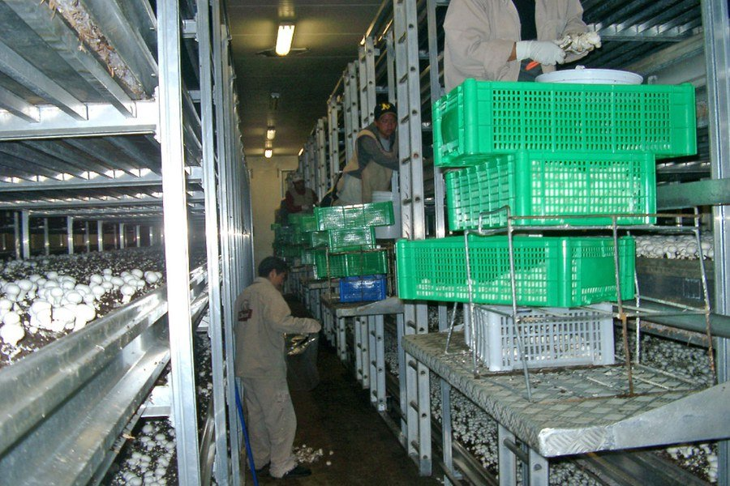
Figure 6. Harvesting of mushrooms. Each mushroom is hand harvested, the base of the mushroom is trimmed, and the clean, mature mushroom placed in a basket.
Picking and packaging methods often vary from farm to farm. Freshly harvested mushrooms must be kept refrigerated at 35° to 45°F. To prolong the shelf life of mushrooms, it is important that mushrooms "breathe" after harvest, so storage in a non-waxed paper bag is preferred to a plastic bag.
A question frequently arises concerning the need for illumination while the mushrooms grow. Mushrooms do not require light to grow; only green plants require light for photosynthesis. However, growing rooms can be illuminated to facilitate harvesting or cropping practices.

Environmental Concerns

Odors
Nuisance complaints, a result of mushroom compost preparation in close proximity to residential areas, are a problem for some mushroom farms. Offensive odors associated with the preparation of mushroom compost are the primary reasons for these complaints. A combination of suburbanization and the heightened sensitivity of the general population to environmental issues have focused public attention on this issue. Growers have adopted several measures to reduce the environmental impact of mushroom farming, including the practice of forced aeration of Phase I compost contained in bunkers or tunnels. However, the issue of offensive odor generation continues to place pressure on mushroom growers.

Disposal of post-crop mushroom compost
After the last flush of mushrooms has been picked, the growing room should be closed off and the room pasteurized with steam. This final pasteurization is designed to destroy any pests that may be present in the crop or the woodwork in the growing room, thus minimizing the likelihood of infesting the next crop.
Post-crop mushroom compost (MC) is the material left over after the crop has been terminated (Fig. 8). It has many uses and is a valued product in the horticultural industry. One of the major uses of MC is for suppression of artillery fungi in landscape mulch. The artillery fungi grow rapidly throughout moist landscape mulch, and produce sticky spore masses about the size of a pinhead. These spores are forcibly discharged toward light colored surfaces such as house siding and cars. Once the spores dry they are nearly impossible to remove without leaving an unsightly brown stain on the surface. The incorporation of 20-40% MC into mulch effectively suppress the artillery fungi.
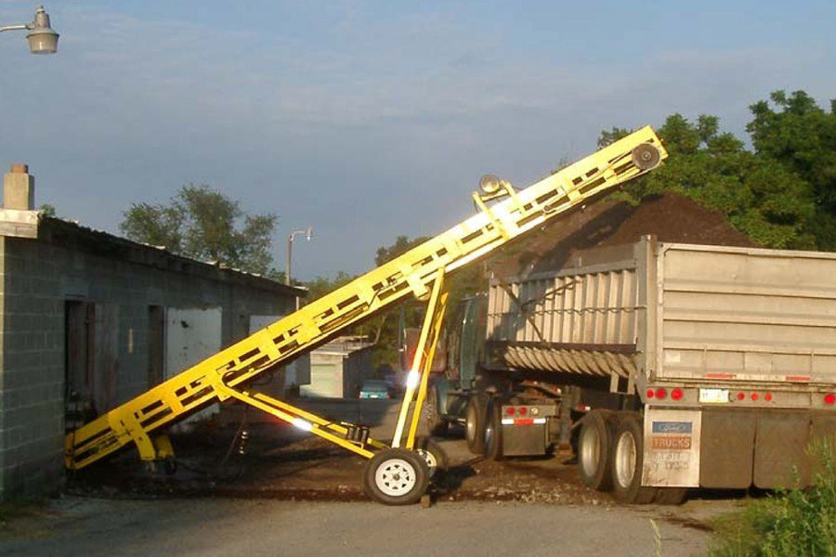
Figure 8. Post-crop mushroom compost (MC) being loaded onto a truck as it is removed from a mushroom house.

Conclusion
It takes approximately 14 weeks to complete an entire production cycle, from the start of composting to the final steaming off after harvesting has ended. For this work a mushroom grower can expect anywhere from 0 to 8 lb per ft²; the national average for 2006 was 5.92 lb per square foot. Final yield depends on how well a grower has monitored and controlled the temperature, humidity, pests, and so on. All things considered, the most important factors for good production appear to be experience plus an intuitive feel for the biological rhythms of the commercial mushroom. The production system used to grow a crop can be chosen after the basics of mushroom growing are understood.

Related Readings
Beelman, R.B., D.J. Royse, and N. Chikthimmah. 2004. Bioactive components in Agaricus bisporus of nutritional, medicinal or biological importance. Mushroom Science16:1-16.
Beyer, D.M. 2003. Basic procedures for Agaricus mushroom growing. College of Agricultural Sciences, The Pennsylvania State University, University Park, PA.
Carroll, A.D. and L.C. Schisler. 1976. Delayed release nutrient supplement for mushroom culture. Applied and Environmental Microbiology 31:499-503.
Chang, S.T. 2006. The world mushroom industry: trends and technological development. International J. Medicinal Mushrooms 8:297-314.
Davis, D.D., Kuhns, L.J., Harpster, T.L., 2005. Use of mushroom compost to suppress artillery fungi. J. Environ. Hort. 23 (4), 212-215.
Dewhurst, M. 2002. Phase III-the future? Mushroom J. 626:17-18.
Lemmers, G. 2003. The merits of bulk Phase III. Mushroom J. 642:17-22.
Van Griensven, L.J.LD (Ed.). 1988. The Cultivation of Mushrooms. Mushroom Experimental Station, Horst, The Netherlands.
Wuest, P.J. and G.D. Bengtson (Eds.). 1982. Penn State Handbook for Commercial Mushroom Growers. College of Agricultural Sciences, The Pennsylvania State University, University Park, PA.

