Organizational Behavior - MGT502 VU

Lesson 17

FOUNDATIONS OF GROUP BEHAVIOR

Overview

Organizations are not just collections of individuals working alone; members are usually clustered into groups or teams. Groups can accomplish things that are difficult for individuals working alone. The use of groups poses special challenges for management. Thus, this focuses on the nature and functioning of work groups and teams, such as how work groups develop and how group membership affects individual behavior.

Two basic attributes define a group: (1) group members interact with one another; and (2) group members perceive that they can accomplish certain goals in a group. A group is a set of two or more people who interact to achieve certain goals or meet certain needs. Although members share some goals, they differ on others. A group goal is one that all or most group members agree on as a common goal.
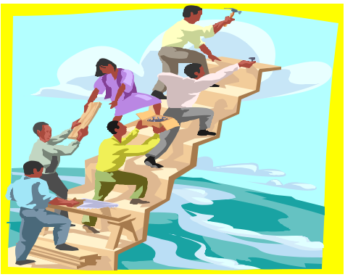

Any predictions about a group’s performance must begin by recognizing that work groups are part of a larger organization
and those factors such as the organization’s strategy, authority structure, selection procedures, and reward system can

provide a favorable or unfavorable climate for the group to operate within. For example, if an organization is characterized by distrust between management and workers,

it is more likely that work groups in that organization will develop norms to restrict effort and output than will work
groups in an organization where trust is high. Managers should not look at any group in isolation. Rather, they should
begin by assessing the degree of support external conditions provide the group. It is obviously a lot easier for any work group to be productive when the overall organization of which it is a part is growing and it has both top management’s support and abundant resources. Similarly, a group is more likely to be productive when its members have the requisite skills to do the group’s tasks and the personality characteristics that facilitate working well together.

A number of structural factors show a relationship to performance. Among the more prominent are role perception, norms, status inequities, the size of the group, its demographic makeup, the group’s task, and cohesiveness.

There is a positive relationship between role perception and an employee’s performance evaluation. The degree of congruence that exists between an employee and his or her boss in the perception of the employee’s job influences the degree to which that employee will be judged as an effective performer by the boss. To the extent that the employee’s role perception fulfills the boss’s role expectations, the employee will receive a higher performance evaluation.

Norms control group member behavior by establishing standards of right and wrong. If managers know the norms of a given group, they can help to explain the behaviors of its members. Where norms support high output, managers can expect individual performance to be markedly higher than where group norms aim to restrict output. Similarly, acceptable standards of absenteeism will be dictated by the group norms. Status inequities create frustration and can adversely influence productivity and the willingness to remain with an organization. Among those individuals who are equity sensitive, incongruence is likely to lead to reduced motivation and an increased search for ways to bring about fairness (i.e., taking another job).

The impact of size on a group’s performance depends upon the type of task in which the group is engaged. Larger groups are more effective at fact-finding activities. Smaller groups are more effective at action- taking tasks. Our knowledge of social loafing suggests that if management uses larger groups, efforts should be made to provide measures of individual performance within the group.

© Copyright Virtual University of Pakistan 77

Organizational Behavior - MGT502 VU

Work groups are the basic building blocks of an organization. Work groups use roles, rules, and norms to control their members’ behavior, and they use several socialization tactics to turn newcomers into effective group members. Groups contribute to organizational effectiveness when group goals are aligned with organizational goals. This makes the following points:

Two attributes separate work groups from random collections of individuals in an organization. Members of a work group (a) interact with each other and (b) perceive the potential for mutual goal accomplishment. Work groups vary in whether they are formal or informal. Formal work groups include command groups, task forces, teams, and self-managed work teams. Informal work groups include friendship groups and interest groups.

Groups develop and change over time. The five-stage model of group development proposes that groups develop in five sequential stages: forming, storming, norming, performing, and adjourning. Research, however, has not indicated that there is a universal set of stages that all groups experience in the same order.

Four important characteristics of groups are size, composition, function, and status. Each has the potential to affect how a group achieves its goals, performs at a high level, and is effective in helping an organization attain its goals. Social facilitation is a characteristic effect that the presence of other group members has on individual performance such that having others present enhances performance of well-learned tasks and impairs performance of difficult tasks.

All groups, regardless of their type or characteristics, need to control their members’ behaviors to be effective and attain their goals. Roles and rules can control behavior in groups.

A role is a set of behaviors or tasks that a person is expected to perform by virtue of holding a position in a group or organization. Roles have rights and responsibilities attached to them. Role relationships are the ways in which group and organizational members interact with each other to perform their specific roles.

Written rules specify behaviors that are required of group members or are forbidden. They also specify how particular tasks should be performed.

Groups also control their members’ behavior by developing and enforcing group norms. Group norms are shared expectations for behaviors within a group. There are three bases for conformity to group norms: compliance, identification, and internalization.

To accomplish goals and perform at a high level, groups need both conformity to and deviance from norms. Whether group norms result in high levels of group performance depends on the extent to which group goals are consistent with organizational goals. To facilitate goal alignment, group members should benefit or be rewarded when the group performs at a high level and contributes to the achievement of organizational goals.

Group members learn roles, rules, and norms through the process of socialization. Collective, formal, sequential, fixed, serial, and divestiture socialization tactics tend to lead to an institutionalized role orientation. Individual, informal, random, variable, disjunctive, and investiture socialization tactics tend to lead to an individualized role orientation.

Groups Dynamics

Group

“Two or more individuals interacting with each other in order to accomplish a common goal”

© Copyright Virtual University of Pakistan 78

Organizational Behavior - MGT502 VU

A group is two or more individuals, interacting and interdependent, who perceive themselves as being a group and have come together to achieve particular objectives. A group is effective when it satisfies three criteria:

Production output: the product of the group’s work must meet or exceed standards of quality and quantity
Member satisfaction: membership in the group must provide people with short-term satisfaction and facilitate their long-term growth and development

Capacity for continued cooperation: how the group completes a task should maintain or enhance the group’s ability to work together; groups that don’t cooperate cannot survive

Team

“A small number of people with complementary skills who are committed to a common mission, performance goals, and approach for which they hold themselves mutually accountable”

One of the truly remarkable things about work groups/teams is that they can make 2+2=5. Of course, they also have the capability of making 2+2=3.

Types of Groups

Types of Work Groups

Work groups can be formal or informal. Formal work groups are established to achieve organiza-tional goals. Managers form a product quality committee to handle health and safety concerns in a manufacturing organization. Informal work groups

Command Groups
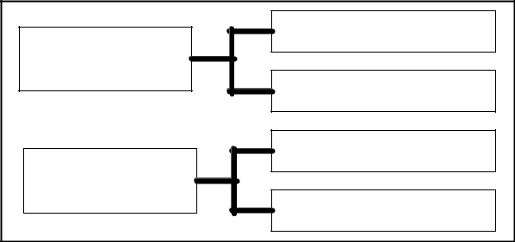

Formal

Task Groups

Interest Groups

Informal

Friendship Groups

emerge naturally when group members perceive that a group can achieve goals or meet their needs.
Coworkers eat lunch each day to satisfy needs for affiliation and friendship.
Formal work groups include command groups, task forces, teams, and self-managed work teams. A command group is a collection of subordinates who report to the same supervisor. Command groups are based on formal reporting relationships and often consist of departments.

Formal Groups

Result from the demands and processes of an organization
Designated by the organization as a means to an end

– Command group
Comprises subordinates reporting directly to a give supervisor

– Task group
Comprises employees who work together to complete a particular task or project

Informal Groups

Result from natural groupings of people in work environments in response to social needs
Are important for their own sake

– Interest groups
Comprises workers coming together to achieve a mutual objective

– Friendship groups
Comprises workers who share something in common

© Copyright Virtual University of Pakistan 79

Organizational Behavior - MGT502 |  |  |  |  |  | VU
Formal | groups—those | defined | by | the | Informal groups—alliances that are neither
organization’s structure, with designated work |  |  |  |  | formally | structured nor organizationally
assignments establishing tasks |  |  |  |  | determined
 | a. The behaviors that one should engage |  |  |  | a. | Natural formations in the work
 | in are stipulated by and directed |  |  |  | a.
 | toward organizational goals. |  |  |  |  | environment in response to the need
 | b. An airline flight crew is an example |  |  |  |  | for social contact
 | of a formal group. |  |  |  | b. Three employees from different
 |  |  |  |  | departments who regularly eat lunch
 |  |  |  |  | together is an informal group.

Stages of Group Development

Forming:

Characterized by a great deal of uncertainty about the group’s purpose, structure, and leadership.
Members are trying to determine what types of behavior are acceptable.

Stage is complete when members have begun to think of themselves as part of a group.

Initial entry of members to a group.

Members concern’s include:

Getting to know each other.
Discovering what is considered acceptable behavior.

Determining the group’s real task.

Defining group rules.

Storming:

Stages of Group Development
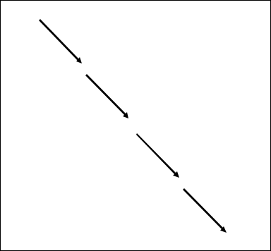

Forming

Storming

Norming

Performing

Adjorning

One of intra-group conflict. Members accept the existence of the group, but there is resistance to constraints on individuality.
Conflict over who will control the group.

When complete, there will be a relatively clear hierarchy of leadership within the group.

A period of high emotionality and tension among group members.

Members concern’s include:

Formation of coalitions and cliques.
Dealing with outside demands.
Clarifying membership expectations.
Dealing with obstacles to group goals.
Understanding members’ interpersonal styles.

Norming:

One in which close relationships develop and the group demonstrates cohesiveness.

There is now a strong sense of group identity and camaraderie.

© Copyright Virtual University of Pakistan 80

Organizational Behavior - MGT502 VU

Stage is complete when the group structure solidifies and the group has assimilated a common set of expectations of what defines correct member behavior.
The point at which the group really begins to come together as a coordinated unit.

Members concern’s include:

Holding the group together.

Dealing with divergent views and criticisms.

Dealing with a premature sense of accomplishment.

Performing:

The structure at this point is fully functional and accepted.

Group energy has moved from getting to know and understand each other to performing.

For permanent work groups, performing is the last stage in their development.

Marks the emergence of a mature, organized, and well-functioning group.

Members deal with complex tasks and handle internal disagreements in creative ways.

Primary challenge is to continue to improve relationships and performance.

Adjourning:

For temporary committees, teams, task forces, and similar groups that have a limited task to perform, there is an adjourning stage.
In this stage, the group prepares for its disbandment. Attention is directed toward wrapping up activities.
Responses of group members vary in this stage. Some are upbeat, basking in the group’s accomplishments. Others may be depressed over the loss of camaraderie and friendships.

Particularly important for temporary groups.

A well-integrated group is:
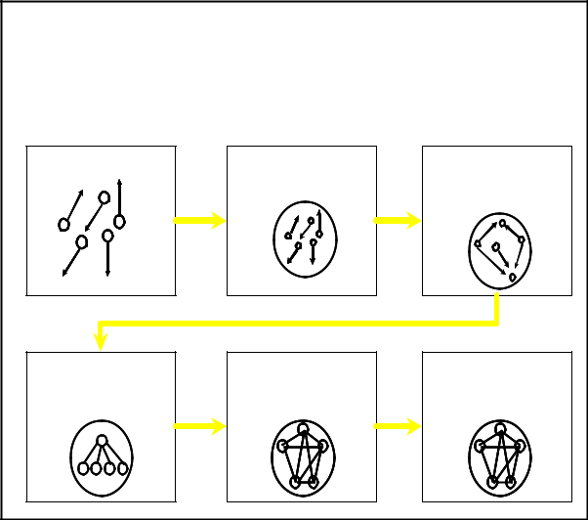
• | Able to disband when its work is finished | Stages of Group/Team
• | Willing to work together in the future | Development
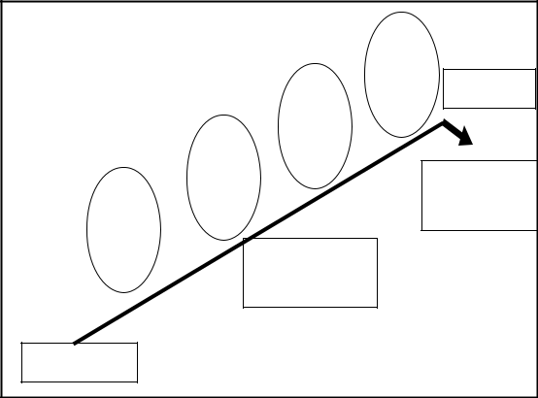

 |  | Prestage I | Stage I | Stage II
^{Performing} Adjourning |  |  | Forming | Storming
Norming
Storming | Return to
Forming | Independence
Dependence/ |  | Stage III | Stage IV | Stage V
interdependence |  | Norming | Performing | Adjourning
Independence
Forming | Storming | Norming | Performing


Individual | “How do I fit | “What’s my |  | “What do the |  | “How can I best
Individual | “How do I fit | “What’s my |  | others expect |  | perform my
Issues | in?” | role here?” |  | others expect |  | perform my
Issues | in?” | role here?” |  | me to do?” |  | role?”
 |  | “Why are we |  | “Can we agree
Group |  | fighting over
Group | “Why are we |  |  | on roles and |  | “Can we do the
Group | “Why are we | who’s in |  |  |  | “Can we do the
Issues | here?” |  |  | work as a |  | job properly?”
Issues | here?” | charge and who |  |  |  | job properly?”
 |  |  |  | team?”
 |  | does what?”

© Copyright Virtual University of Pakistan 81

Organizational Behavior - MGT502 VU

Group Task and Group Productivity

The more complex the task, the more it is non-routine and requires a range of skills, the more important group process becomes!

People can be more productive when working in groups than when working alone, if the obstacles to group productivity are avoided.
Synergy is a biological term referring to an action of two or more substances that result in an effect that is more than the mere summation of the individual substances; the whole is more than the sum of its parts (2 + 2 = 5).

Process loss is the difference between what is actually produced by a group and what could have been produced by the group when you consider its inputs (2 + 2 = 3).

Example of Synergy90

The social facilitation effect can either enhance group productivity (synergy) or restrict it (process loss):

The performance of simple, routine tasks tends to be speeded up and improved by the presence of other people (synergy)

When tasks are complex and require closer attention, the presence of other people will hurt performance (process loss)

Process Losses

Production blocking occurs when people get in each other’s way as they try to perform a task

Group-maintenance roles must be filled in order to smooth group relations, but these roles divert time and effort from producing and thus cause process loss

Social loafing or free riding occurs when a group member decides to loaf, hoping that someone else will pick up the slack (usually occurs when group rewards are shared equally, without regard to individual performance)

Social loafing

In groups, individual performance is difficult to identify. There is a strong potential for social loafing, the tendency to exert less effort in a group. Social loafing can impact work-group effectiveness.

Social loafing occurs because workers feel that high-level performance goes unrewarded. This occurs because individual performance goes unidentified, and low-level performance goes unpunished. Motivation theories suggest that performance is high when outcomes are based on individual performance. Workers in a group believe that their efforts are unimportant and that others can do the work.

Social loafing results in performance below the group potential. Lack of motivation makes some workers exert less effort than if they worked individually. Social loafing by one leads to reduced effort by others. The sucker effect occurs when members, not inclined to social loafing, reduce efforts because they refuse to become the “suckers” of social loafers. This reflects the equity theory of motivation; inequity leads to restoring equity by changing inputs or outcomes.

Group Size and Social Loafing

Studies indicate that, as group size increases, group members put forth less effort. Identifying and rewarding individual performance are difficult, and members feel their efforts are unimportant in a large group. Group size contributes to other process losses, such as conflict and coordination problems.

Ways to Reduce Social Loafing

Managers can reduce or eliminate social loafing by making individual contributions to a group identifiable so that individual performance can be evaluated and appropriate outcomes delivered. Group members can complete peer evaluations, or the level of group supervision can increase.

© Copyright Virtual University of Pakistan 82

Organizational Behavior - MGT502 VU

When individual performance cannot be separated, managers can make each individual feel that contribution to the group is valuable. A manager can remind each member of unique contributions and indicate when group success or failure hinges on individual efforts. Managers can remind members that their selection hinged on their unique contributions. Keeping the group as small as possible reduces social loafing. If process losses increase with group size, managers should reduce size by dividing the work into two groups. Group members will no longer perceive their efforts as unidentifiable or unnecessary.

© Copyright Virtual University of Pakistan 83

